QA Space postcard 1440 mvsii5z2

I can see blue oceans and bright white clouds.
I can see blue oceans and bright white clouds.I can see blue oceans and bright white clouds on Earth.
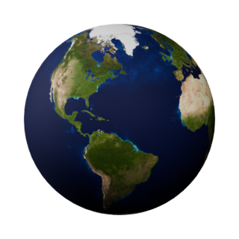
Deferred edit mvsih9jc

