AlloyClusterVis: An Interactive Visualization Platform for Sustainable Aluminum Alloy Discovery
Manuel Perez* |  | Tommy Dang‡
Texas Tech University |  | Texas Tech University
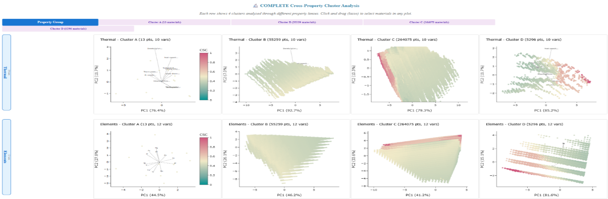
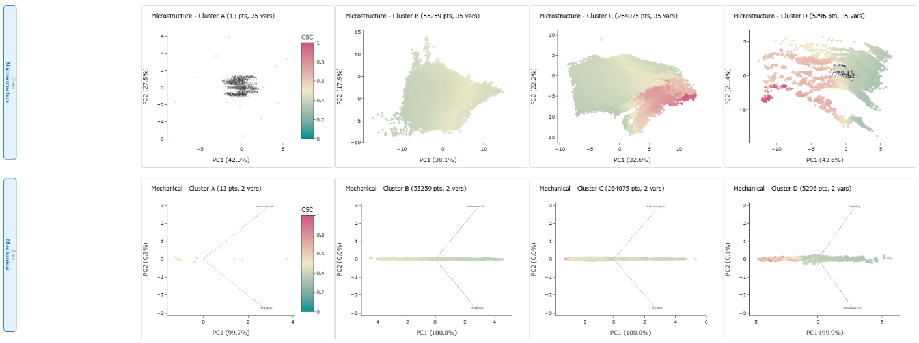
Figure 1: AlloyClusterVis

ABSTRACT
AlloyClusterVis is an interactive visualization platform designed to accelerate the discovery of sustainable aluminum alloys from recycled scrap. By integrating Principal Component Analysis (PCA), manual clustering, and parallel coordinate plots, the tool enables material scientists to explore complex relationships between alloy compositions, microstructure, and resulting properties across over 320,000 simulated materials. Users can interactively select clusters in PCA space, zoom into regions of interest, and analyze materials across mechanical and thermal domains. The platform supports user driven exploration that reveals hidden trends, facilitates trade off analysis, and promotes data guided decision making in alloy design. AlloyClusterVis advances circular economy goals by enabling the rapid identification of viable recycled alloy candidates through high dimensional, coordinated analysis.
Index terms: Interactive visualization, PCA, cluster analysis, parallel coordinates, dimensionality reduction, alloys, sustainability, materials informatics
1 INTRODUCTION
The growing emphasis on sustainable manufacturing and circular economy practices has heightened the need to recover and redesign alloys from aluminum scrap, particularly from the automotive sector. Existing visualization methods struggle to expose high-dimensional relationships critical to this process. AlloyClusterVis addresses this gap by enabling users to interactively explore alloy datasets through linked PCA projections, clustering, and property wise comparisons. This approach empowers rapid material screening and hypothesis generation, advancing sustainable alloy design.
2 METHODS
2.1 Data preprocessing
The dataset contains 324,632 aluminum alloy compositions with 64 measured properties, including elemental, microstructural, mechanical, and thermal features. Prior to analysis, missing values were handled by complete case deletion to ensure PCA and clustering performance remained robust. All data were standardized using z-score normalization to center the mean and scale variance uniformly.
2.2 Dimensionality Reduction and Clustering
Principal Component Analysis (PCA) was applied both globally and within each of the four major property groups (Thermal, Elements, Microstructure, and Mechanical) to capture latent trends while reducing dimensionality. The first two principal components (PC1 and PC2) were retained for visualization. Clusters were manually defined based on visual groupings in the PCA space and labeled A through D. This manual approach preserved control over edge cases and sparse zones that algorithmic clustering might misclassify.
2.3 Interactive Visualization Platform
AlloyClusterVis was developed using Python with Dash and Plotly. The platform integrates:
- Linked PCA scatter plots per property group with lasso based selection
- Dynamic parallel coordinate plots for real time comparison of selected materials
- User controls for property group, sample size filtering, and variable inclusion
- Color encoding based on Composite Sustainability Criterion (CSC), normalized per cluster
All views are interconnected, allowing users to trace selected points across domains to evaluate multidimensional property behavior in context. To enhance interpretability, the parallel coordinates plot automatically displays the top 10 variables by variance among the currently selected data points. High variance dimensions best highlight the differences between materials, surfacing meaningful patterns, trade offs, and subgroupings. In addition, the CSC_clipped variable is always included, ensuring that the primary sustainability related criterion remains visible for comparison, even if it does not rank among the top 10 by variance.

3 RESULTS AND DISCUSSION
PCA projections of the dataset revealed distinct clusters that correlate with varying alloy compositions and behaviors. For instance, clusters with elevated CSC (hot crack susceptibility coefficient) tend to concentrate in areas with high solidification intervals and elevated Mg/Zn content, consistent with factors known to increase hot cracking risk during processing.
The coordinated platform allowed users to select a subset of materials in one PCA view and simultaneously observe its behavior across other domains. For example, selecting a dense microstructure region in the Microstructure PCA showed wide variance in mechanical strength in the Mechanical PCA, suggesting that high volume fractions of certain intermetallic phases do not always translate into mechanical robustness.
The parallel coordinates plot, dynamically filtered to show the top 10 variables by variance in the current selection (plus CSC), revealed key patterns. For instance, alloys with the lower CSC tended to have lower values in delta_T_Si, delta_T_Al15Si2M4, and delta_T_FCC, indicating a narrower and more stable solidification range, which reduces the risk of hot cracking. In one selected cluster, materials with moderate hardness but low thermal conductivity emerged as candidates for structural applications where heat retention is favorable.
Using AlloyClusterVis, designers can pre-select alloys that balance thermal and mechanical properties while minimizing hot crack susceptibility. A notable example includes a cluster with high electrical conductivity and low CSC making them an ideal profile for lightweight electrical components with improved processability. The tool also enabled identification of outliers, such as high CSC alloys with unexpectedly low yield strength, which may indicate modeling artifacts or suggest directions for further experimental validation.
Conclusion
Figure 2: PCA projection of thermal properties
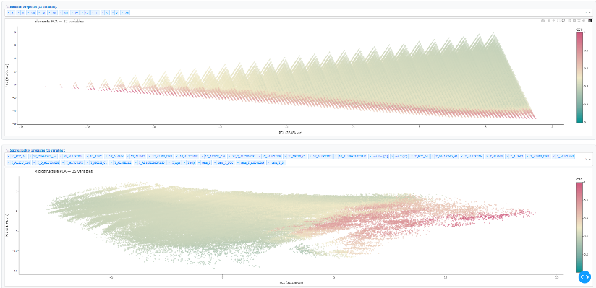
AlloyClusterVis offers a scalable and intuitive platform for analyzing high-dimensional alloy datasets. Through PCA based cluster exploration and coordinated multi view analysis, it supports sustainable alloy design by identifying promising recycled compositions. The system encourages informed exploration and contributes directly to the goals of circular economy in materials engineering.
Figure 3: PCA projections of elemental and microstructural properties
References
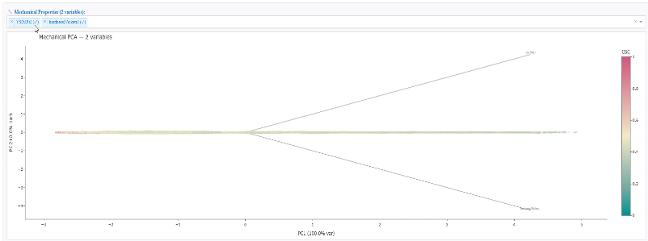
[1] EUROPEAN ALUMINIUM | A strategy for achieving aluminium’s full potential for circular economy by 2030 (2022) Available here
[2] D. Raabe (2023) The Materials Science behind Sustainable Metals and Alloys, Chem. Rev. 123, 2436−2608, Available here
[3] K. Bugelnig, H. Germann, T. Steffens, F. Sket, J. Adrien, E. Maire, E. Boller, G. Requena (2018) Revealing the Effect of Local Connectivity of Rigid Phases during Deformation at High Temperature of Cast AlSi12Cu4Ni(2,3)Mg Alloys, Materials.11(8), 1300. Available here
[4] K. Bugelnig, F. Sket, H. Germann, T. Steffens, R. Koos, F. Wilde, E. Boller, G. Requena (2018) Influence of 3D connectivity of rigid phases on damage evolution during tensile deformation of an AlSi12Cu4Ni2 piston alloy, Mater. sci. eng. A 709, 193-202. Available here
[5] K. Bugelnig, H. Germann, T. Steffens, R. Koos, E. Boller, F. Wilde, G. Requena (2023), 3D Investigation of Damage During Strain-Controlled Thermomechanical Fatigue of Cast Al–Si Alloys, Adv. Eng. Mater., 2300339. Available here
Figure 4: PCA projection of mechanical properties

6 APPENDIX

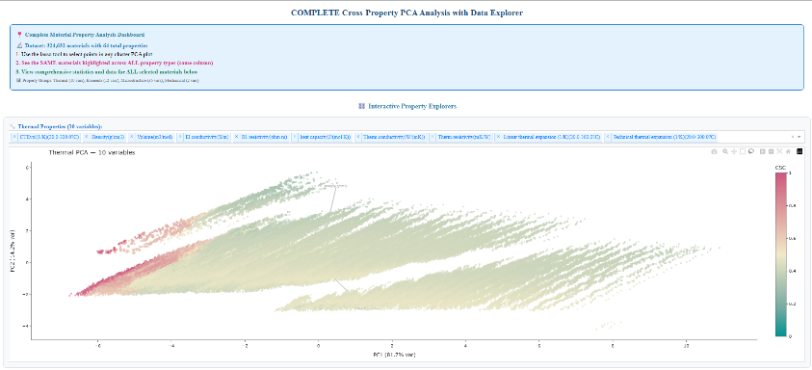
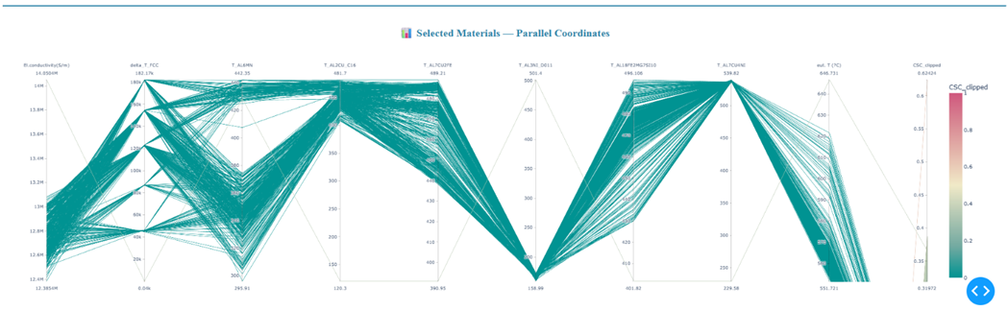
Figure 5: Parallel coordinates plot of selected materials showing the top 10 variables by variance

