MONITOR :

A computer monitor is an output device which displays information in pictorial form. A monitor usually comprises the display device, circuitry, casing, and power supply. It is used for data processing.

This type of monitor was possible due to a German scientist named Karl Ferdinand Braun that in **1897** invented the first cathode ray tube.

TYPES OF MONITOR :

At present, computer monitors are available in a variety of shapes, designs, and colors. However, based on the technology used to make computer monitors, they can be broadly categorized into three types.

* CRT (Cathode Ray Tube)
* LCD (Liquid Crystal Display)
* LED (Light-Emitting Diodes)

CRT (Cathode Ray Tube) :

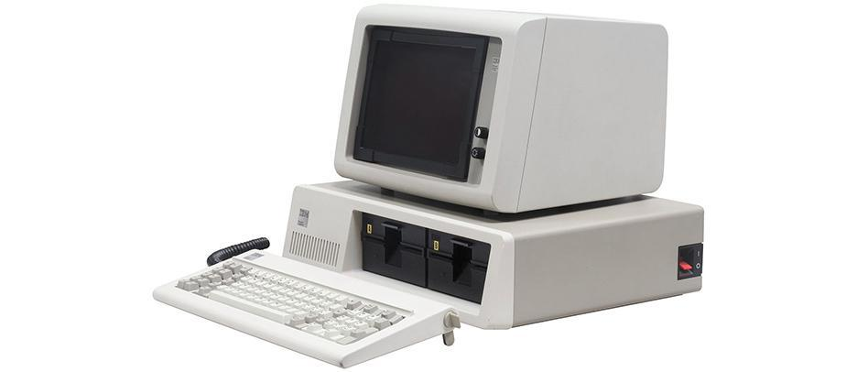

* High energy electrons used to form a fluorescent screen.
* Highly Reliable and efficient.
* Resolution 2048 x 1536 pixels.
* Affordable , Cost effective.

Advantages:

* High Refresh Rates
* Color Clarity and Depth
* Multisync Capable

Disadvantages:

* Very Heavy and Large
* Generate Excess Heat
* Use Large Amounts of Energy

LCD (Liquid Crystal Display) :

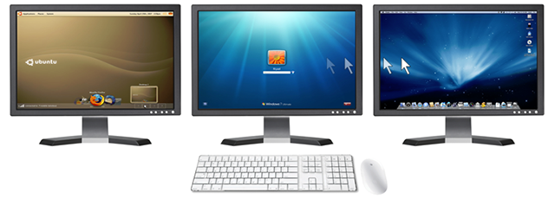

* Monochrome Pixels.
* Couple of transparent electrodes & two polarizing filters.
* Optical effect is achieved by polarizing the light in varied amounts and making it pass through the liquid crystal layer.
* Comes in 15-65 inch size.

**Advantages** :

* Uses Less Power. LCDs also produce less heat, which means less load on air conditioning.
* Takes up less space. LCD monitors are small, thin, and weigh less.
* Highly adjustable. Many LCD models can be rotated 90 degrees, allowing you to view websites in portrait mode. LCDs can also be mounted on the wall or on an arm.
* No flicker. LCDs don't have lines that need to be scanned like in CRTs. Less eye strain & Less glare.
* Brightness. LCD monitors are brighter than the traditional CRTs.
* Less distortion & Energy Efficient.

Disadvantages :

* Blurry Images Outside Native Resolution
* Motion Blur on Fast Moving Images
* Lower response time when playing a video
* Another problem of LCD monitors is color clarity
* More expensive

LED (Light-Emitting Diodes) :

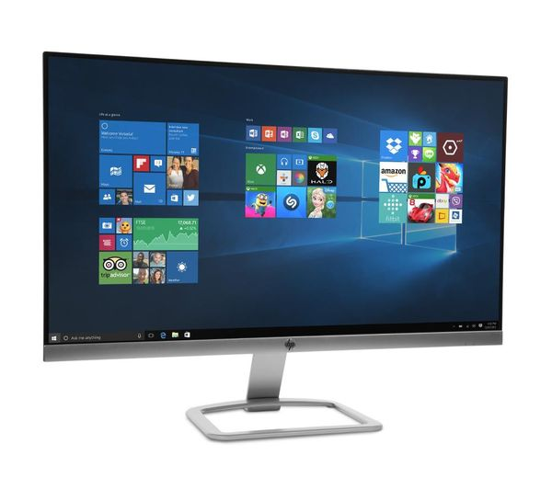

* Use emitting diodes at back for displaying anything on screen.
* You can watch the screen clear by viewing from any angle.
* Led has good contrast and is very close to natural view of picture.
* Comes in 17-70 inch size.

Types Of LED Monitors :

Three types of led are in market.

* RGB dynamic led
* Edge led and
* Full array led.

Edge led is thinner than the RGB dynamic led.

Advantages :

* They produce images with higher contrast.
* They have less negative environmental impact when disposed.
* Lifespan and durability of LED monitors is more than CRT or LCD monitors.
* Because of the technology, the monitor panels can be made very thin.
* Do not produce much heat while running.
* Better display of black areas.

Disadvantages:

* White-edge LEDs are fixed around the rim of the monitor. It used a special diffusion panel to spread light evenly behind the screen.
* An array of LEDs are placed behind the screen. Their brightness is not controlled individually.
* Again an array of LEDs are placed behind the screen, but the brightness of each individual LED is controlled separately.

Monitor Connectors :

* VGA (Video Graphics Array) .
* DVI (Digital Visual Interface) .
* HDMI (High Definition Multimedia Interface) .
* USB (Universal Serial Bus) .
* IDE (Integrated Drive Electronics) .
* SATA (Serial Advanced Technology Attachment).
* eSATA (External Serial Advanced Technology Attachment).
* Fire Wire.
* Ethernet.

VGA (Video Graphics Array) :

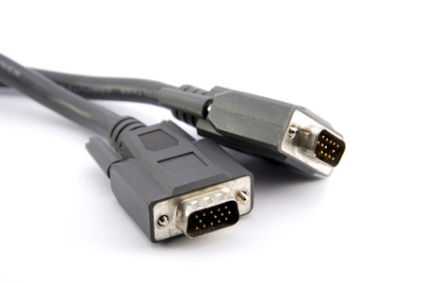

Created way back in the 1980’s, the VGA connection cable was the standard cable used to connect a computer to a monitor. More recently, it has faded out of popularity due to the gradual shift towards digital connections over analog. Still, if you look on any video card or display apparatus, there is a good chance you’ll see a VGA port.

VGA connections can be identified by 15 pins arranged in 3 rows with 5 on each row. Each row corresponds to the 3 different color channels used in display: red, green, and blue.

DVI (Digital Visual Interface) :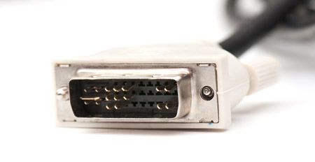

The DVI connection became the successor to VGA as technology moved away from analog towards digital. Digital displays, like LCD, proved to be higher quality, which soon became the market standard for home pictures.

DVI connectors come in 3 varieties.

* DVI-A can transmit analog signals, allowing it to be backwards compatible with VGA (useful for CRT monitors and LCDs of lower quality).
* DVI-D can transmit the newer digital signals.
* DVI-I is capable of both analog and digital.

In certain cases, you may need a VGA-to-DVI or DVI-to-VGA converter cable.

HDMI (High Definition Multimedia Interface) :

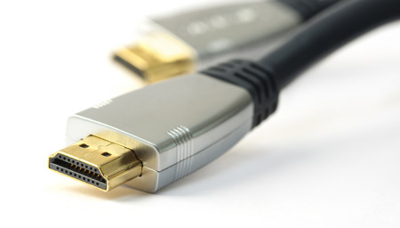

In the past decade, high-definition broadcasts became the new standard of what it means to be high quality. Unlike VGA and DVI, HDMI sends both video and audio signals together. The signals are digital only; thus, HDMI is only compatible with newer devices.

HDMI connectors come in 4 types:

* Type A is the most popular. This connector can be identified by its 19 pins on the male head. Type A is compatible with single-link DVI-D connections.
* Type B is larger than Type A, coming in at 29 pins on the male head. Type B is compatible with dual-link DVI-D connections.
* Type C is a 19-pin connector that’s most often used with portable devices, like camcorders and digital cameras.
* Type D looks similar to a micro-USB cord. It also has 19 pins.

USB (Universal Serial Bus) :

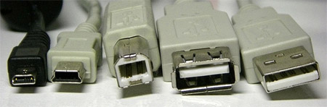

*From left to right: micro USB, mini USB, type B standard USB, and type A standard USB (both female and male).*

The USB connection is quite possibly the most pervasive connection type in today’s world. Nearly every form of computer peripheral device — keyboards, mice, headsets, flash drives, wireless adapters, etc. — can be connected to your computer through a USB port. The design has evolved over the years, which means there are multiple versions of USB available:

* USB 1.0/1.1 can transmit data at speeds up to 12 Mbps.
* USB 2.0 can transmit data at speeds up to 480 Mbps and is compatible with older versions of USB. At the time of this article, USB 2.0 is the most common type found in the market.
* USB 3.0 can transmit data at speeds up to 4.8 Gbps. It is compatible with previous versions of USB.

The mini and micro USB variants are most often used with smaller, portable devices like PDAs, phones, and digital cameras. The standard USB connectors are more often used on devices that tend to remain plugged in, like external hard drives, keyboards, and mice.

IDE (Integrated Drive Electronics) :

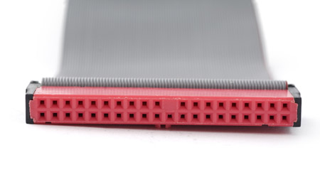

IDE cables were used to connect storage devices to a motherboard. If you’ve ever opened up a an old [**hard drive**](https://www.amazon.com/Blue-Cache-Desktop-Drive-WD10EZEX/dp/B0088PUEPK/ref=as_at?tag=viglinkmuo-20&linkCode=as2) then you likely know what an IDE connector looks like. It’s the wide cable that looks like a ribbon with more than 2 plugs.

The connectors on an IDE cable have 40 pins; the smaller 2.5” drive variety uses a form-factor version of the IDE that has 44 pins.

SATA (Serial Advanced Technology Attachment):

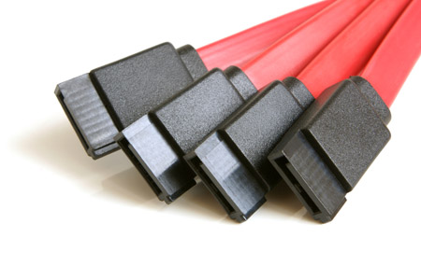

Newer hard drives will likely use SATA ports over IDE ports. In fact, SATA was designed to succeed IDE, and it has. Compared to IDE, SATA provides higher data transfer speeds. Your motherboard needs to be compatible with SATA, and nowadays most of them are.

A standard SATA cable can be identified by two connectors, each having 7 pins and an empty notch. It looks like a subtle L-shape.

eSATA (External Serial Advanced Technology Attachment):

eSATA technology is an extension of, or improvement on, the SATA cable — it makes SATA technology available in an external form. In reality, eSATA is not much different from SATA, but it allows connections to devices like external hard drives and optical drives. This is useful because eSATA offers speeds much faster than most FireWire and USB alternatives.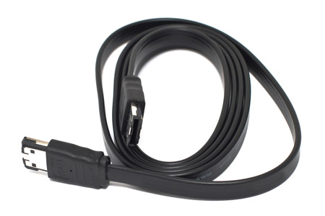

Fire Wire

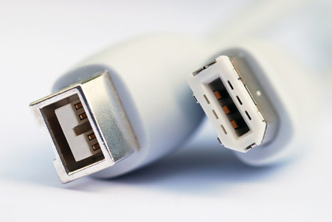

The purpose of FireWire is similar to that of USB: high speed data transfer for computer peripherals. High bandwidth devices, like printers and scanners, will benefit from FireWire. For whatever reason, FireWire is not as widespread as USB. FireWire cables come in two forms: 1394a (which has a transfer speed of 400 Mbps) and 1394b (which has a transfer speed of 800 Mbps).

Ethernet:

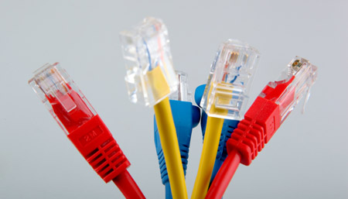

[**routers**](http://www.amazon.com/b/ref=as_at?tag=viglinkmuo-20&linkCode=as2&ie=UTF8&node=300189) to modems and computers. If you’ve ever tried to install or fix a home router, you’ve likely dealt with an Ethernet computer cable. Nowadays, they come in three varieties:

* Cat 5 cables are the most basic type and provide speeds of either 10 Mbps or 100 Mbps.
* Cat 5e, which means Cat 5 Enhanced, allows for faster data transmission than its predecessor. It caps at 1,000 Mbps.
* Cat 6 is the latest and offers the best performance of the three. It’s capable of supporting 10 Gbps speeds.

That should cover it. The cables in this article comprise approximately 99% of all the cables you’re likely to find lying around in your home. If there’s another cable type that isn’t mentioned here, feel free to ask about it in the comments. I’ll do my best to answer any questions.