**Memory**

A memory is just like a human brain. It is used to store data and instructions. Computer memory is the storage space in the computer, where data is to be processed and instructions required for processing are stored. The memory is divided into large number of small parts called cells. Each location or cell has a unique address, which varies from zero to memory size minus one.

For example, if the computer has 64k words, then this memory unit has 64 * 1024 = 65536 memory locations. The address of these locations varies from 0 to 65535.

**Types Of Memory**

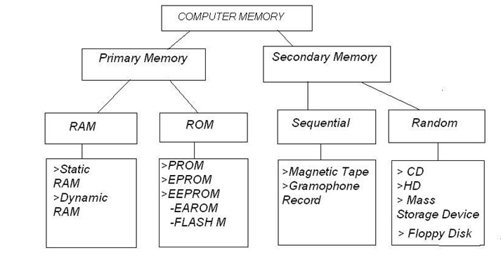

**Cache Memory :**

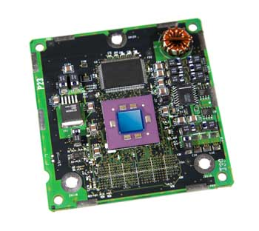

Cache memory is a very high speed semiconductor memory which can speed up the CPU. It acts as a buffer between the CPU and the main memory. It is used to hold those parts of data and program which are most frequently used by the CPU. The parts of data and programs are transferred from the disk to cache memory by the operating system, from where the CPU can access them.

**Advantages**

The advantages of cache memory are as follows

* Cache memory is faster than main memory.
* It consumes less access time as compared to main memory.
* It stores the program that can be executed within a short period of time.
* It stores data for temporary use.

**Disadvantages**

The disadvantages of cache memory are as follows

* Cache memory has limited capacity.
* It is very expensive.

**Primary Memory (Main Memory)**

Primary memory holds only those data and instructions on which the computer is currently working. It has a limited capacity and data is lost when power is switched off. It is generally made up of semiconductor device. These memories are not as fast as registers. The data and instruction required to be processed resides in the main memory. It is divided into two subcategories RAM and ROM.

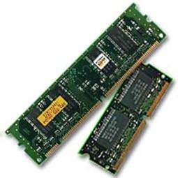

**Characteristics of Main Memory**

* These are semiconductor memories.
* It is known as the main memory.
* Usually volatile memory.
* Data is lost in case power is switched off.
* It is the working memory of the computer.
* Faster than secondary memories.
* A computer cannot run without the primary memory**.**

**Secondary Memory**

This type of memory is also known as external memory or non-volatile. It is slower than the main memory. These are used for storing data/information permanently. CPU directly does not access these memories, instead they are accessed via input-output routines. The contents of secondary memories are first transferred to the main memory, and then the CPU can access it. For example, disk, CD-ROM, DVD, etc.

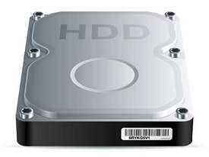

### **Characteristics of Secondary Memory**

* These are magnetic and optical memories.
* It is known as the backup memory.
* It is a non-volatile memory.
* Data is permanently stored even if power is switched off.
* It is used for storage of data in a computer.
* Computer may run without the secondary memory.
* Slower than primary memories.