**The Fox and the Crow**

In a vibrant meadow, a cunning **fox** and a majestic crow crossed paths. The **crow**

Perched on a high branch, held a piece of cheese in its beak. The **fox**, down by

Scent of the cheese, approached the **crow** with a sly grin.

Good day, dear **crow**, “the **fox** said with feigned politeness. “Your majestic presence

and beautiful voice have captivated me. Would you honor me with a song?”

Flattered by the **fox**’s flattery, the **crow** opened its beak to sing. As the first notes

Escaped, the cheese fell to the ground below.

Seizing the opportunity, the **fox** swiftly grabbed the cheese and dashed away,

Leaving the **crow** to rue its folly.

|  |  |
| --- | --- |
| ***Moral Lessons*** | ***Explanation*** |
| *Beware of Flattery* | * *The* ***crow*** *was deceived by the* ***fox****’s false compliments, leading to the loss of its cheese.* |
| *Do not be easily fooled by appearances* | *The* ***fox*** *appeared friendly but had ulterior motives, demonstrating the importance of being cautious and discerning.* |
| *Guard your possessions* | *The* ***crow*** *lost its cheese due to carelessness. This teaches the importance of protecting what belongs to you.* |

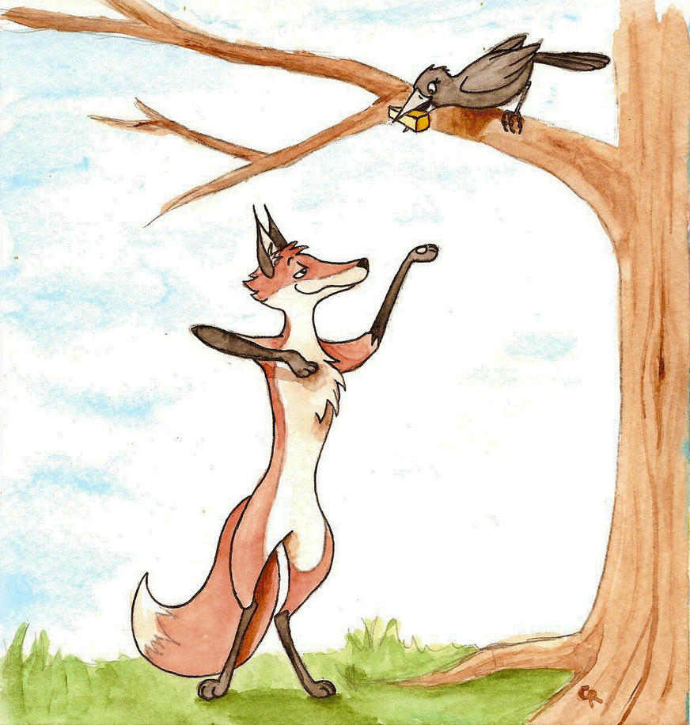

[This Photo](http://tee-kyrin.deviantart.com/art/The-Fox-and-the-Crow-287725321) by Unknown Author is licensed under [CC BY-NC-ND](https://creativecommons.org/licenses/by-nc-nd/3.0/)