There are three type of users, customer, insure manager and administrator

All the users need to login first, the customer can register, however insure manager and admin must be create background.

Customer register need his personal detail include a bank account, basic information, identification. They can also change some of the information after login.

Customers are able to access the homepage, get the broadcast information, get the previous order and select the new service they want. All the service (insurance) should read an agreement first which detailed instruct the service. Then create a insurance policy and customers must fill all the options on the list. After censorship the insurance takes effect.

Manager can list all the customers and check their detail and their history state. Also the submit from the customers should be check and give feedback. They can also cast the news to everyone.

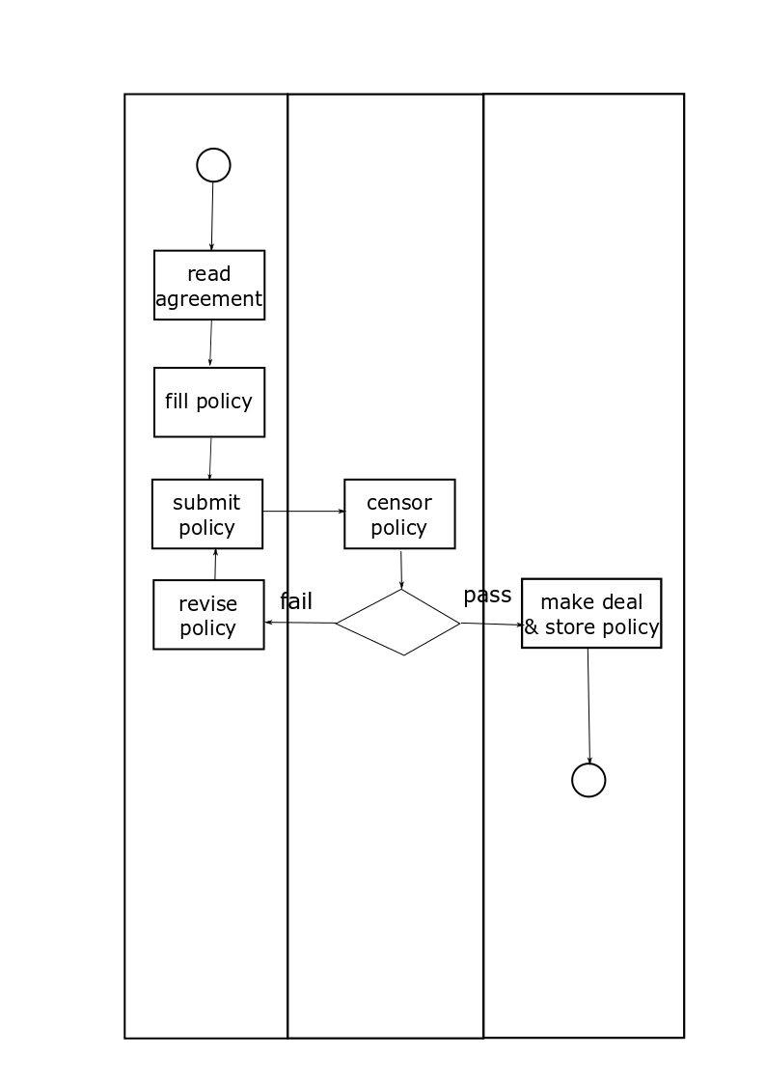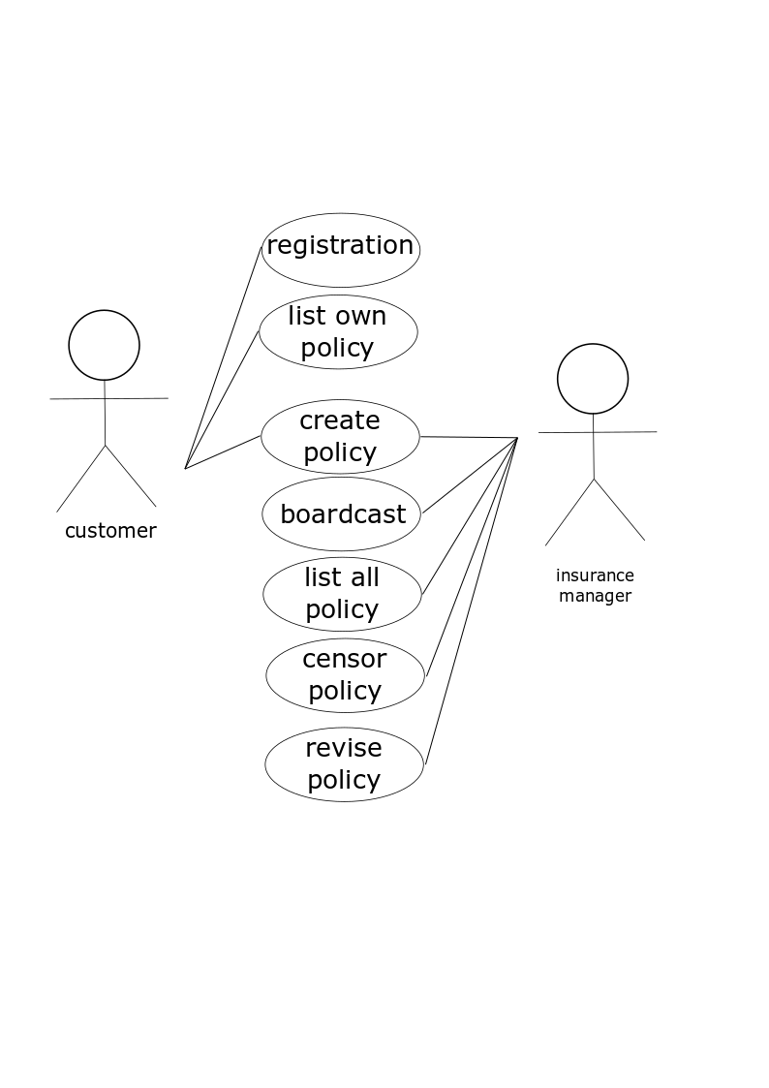

Class design

Customer

Int id @auto increase @primary key

Int priority @default 0 (0-customer 1-manager 2-stackholder)

String firstName @not null

String lastName @not null

String gender

Long creditCard @foreign key

Date birth @not null

String nationality @not null

String idNo @unique @not null

String address @not null

String phoneNo @unique @not null

CreditCard

String firstName @not null

String lastName @not null

String midName

Long cardNumber @primary key

String bank @not null

String branch @not null

String phoneNo @not null

Int CVV @not null

Luggage Policy

String policyId @primary key

String policyType @not null

Int holderId @foreign key

Int beneficiaryId @foreign key

Date insureDate @not null

Date insurePeriod @not null

String departure @not null

String destination @not null

String insuredProject @not null

Double sum @not null

String currency @not null

String policyPic @not null

String detail

Int version

Date update

Security Policy

String policyId @primary key

String policyType @not null

Int holderId @foreign key

Int beneficiaryId @foreign key

Date insureDate @not null

Date insurePeriod @not null

String departure @not null

String destination @not null

Int insuredId @not null

Double sum @not null

String currency @not null

String policyPic @not null

String detail

Int version

Date update