CANPiWi upgrade process
Table of Contents
Introduction 1
Tools needed 1
Copy the files to the existing CANPiWi 2
1. Open the Filezilla 2
2. Connect your computer to the CANPiWi 2
3. Connect the Filezilla to the CANPiWi 2
4. Copying the files 3
5. Restarting the service 4

Introduction

This document shows how to upgrade the existing CANPiWi components: the ED and CANGrid server and the webpage configuration.
There are 2 ways of doing that:
- copying the new files to an existing pi running the CANPiWi service
- flashing the SD card and restoring the configuration

Tools needed

We will use an existing and running pi with CANPiWi service running and the Filezilla.
Filezilla is a tool for windows and linux that supports file transfer using the FTP and SFTP protocol.
You can get the Filezilla for Windows10 from accessing the link below:
https://filezilla-project.org/download.php?platform=win64

The general link is https://filezilla-project.org/download.php?type=client

Download the Filezilla and install on your computer with windows or linux.
Connect your CANPiWi to the power source and make sure it is accepting the connections as AP mode or as WiFi mode.

You can get the last release files in the github (TODO find a place to store the release files)

Sumarizing:
- CANPiWi working
- Filezilla
- Files to upgrade

Copy the files to the existing CANPiWi

1. Open the Filezilla

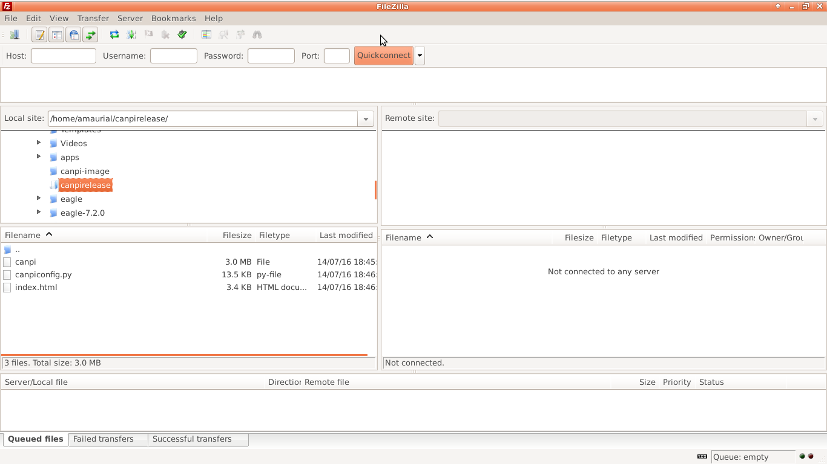
2. Connect your computer to the CANPiWi

If your CANPiWi is in Apmode, connect your computer to the CANPiWi via wifi. By default the SSID is “pi”. If you have changed the configuration, use the SSID you configured it. How to connect to the windows or linux to a wifi network can be found in many tutorials in internet or in the your OS manuals.

Once the computer is connected let's connect the Filezilla to the CANPiWi.

3. Connect the Filezilla to the CANPiWi

To connect the Filezilla to the CANPiWi, we need to know what is the ip address of the CANPiWi.
If the CANPiWi is in AP mode the address will be 192.168.45.1

If the CANPiWi is in Wifi mode the ip address can be found by using the EngineDrive.
Open the engine drive using a smartphone. On the main screen, it may detect the service announced by the CANPiWi. The screen will show the service name, the ip address and the tcp port.

We will use the CANPiWi in AP mode.

Enter the data in the Filezilla as show in the picture below. The data is on the top of the window, under the toolbar.
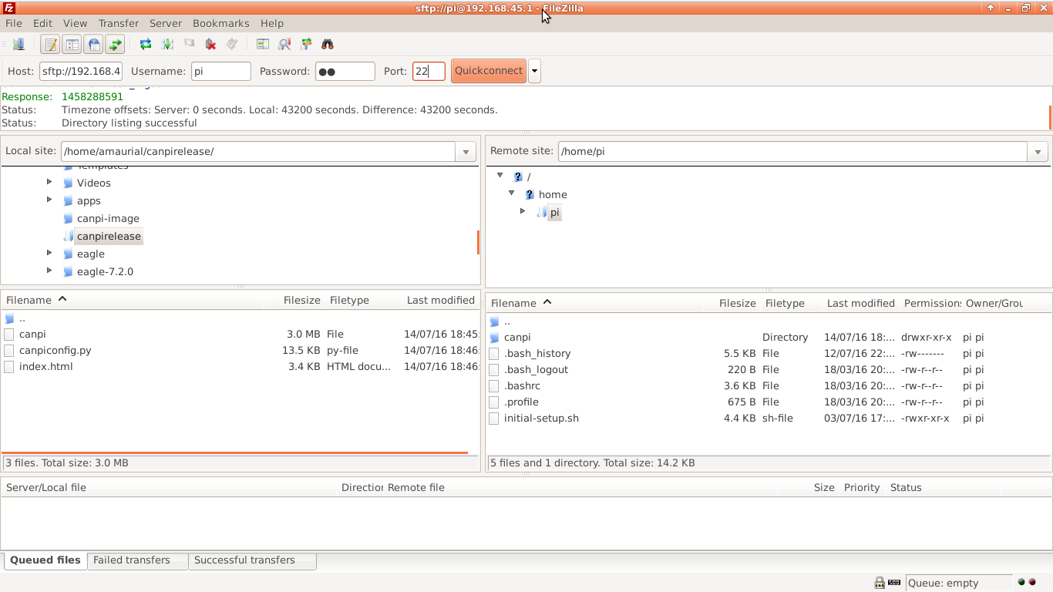
Hostname: pi
Password: pi
Port: 22

After you click the button Quickconnet the filezilla will prompt some screens. Press buttons “Yes” or “Ok” for them. After a while the Filezilla will make the connection to the CANPiWi. We can see tha the connection is done by checking the right part of the Filezilla screen where it shows the “Remote site”.

On the “Local site” screen select where the update data is. In this example it is the directory “canpirelease”. The files in the “canpirelease” are shown in the list “Filename”.

4. Copying the files

In this example we will update the service firmware and the webpage files.
- canpi
- canpiconfig.py
- index.html

The service firmware is the file “canpi” and the webpage files are “canpiconfig.py” and “index.html”.

On the “Remote site” screen we click on directory “/home/pi/canpi”. We may see a list of files under the “Remote site” list.

Now on the “Local site” select the file canpi and drag it to the “Filename” list under the “Remote site” list. You may see the screen below:
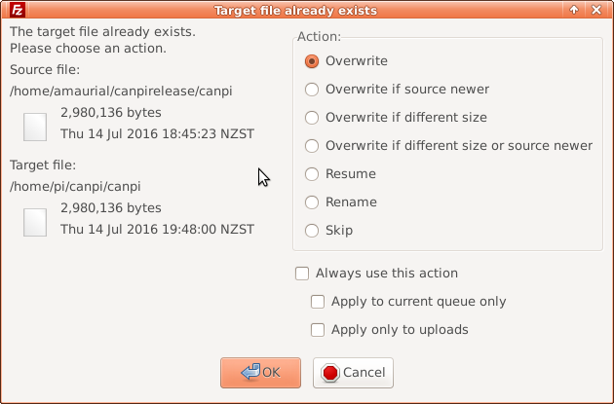

Press the “OK” button and it will transfer the file.

Now, on the “Remote site screen” select the directory “/home/pi/canpi/webserver”.
On the “Local site” click on the file “canpiconfig.py” and copy it using the same procedure already explained.

Now, on the “Remote site screen” select the directory “/home/pi/canpi/webserver/templates”.
On the “Local site” click on the file “index.html” and copy it using the same procedure already explained.

5. Restarting the service

You reboot the CANPiWi by powering it off or you can use the webpage to restart the service.
Access the webpage using the computer and it will show the screen below. Click on the button “Restart Throttle service”.

The upgrade is done.

