Flashing Orange Warning Lights
A colleague at the Basingstoke club is building a model of Ropley in the preservation era (Mid Hants Railway). He has a couple of road vehicles in the loco shed area, a coal loader and a fork lift truck, and said he would like to fit flashing orange lights. I gave him a couple of 3mm orange LEDs for him to whittle down to size to fit the vehicles, and I promised to provide electronics to make them flash.
I could have simply opted for Merg PMP 8 or PMP21 kits, but with Arduino Nano modules available so cheaply from China, I thought I would attempt something a little more sophisticated. I wanted to avoid having the lights on the two vehicles flashing in unison, which would look very un-prototypical. I also wanted to avoid having the lights flashing continuously. I thought it would look better if they flashed for a while, then turned off for a while, again not in unison with each other. Both these features would be simple enough in software.
The Hardware
The Arduino Nano is pretty self-contained, just requiring a 5-12 V DC power supply. Orange LEDs, with current limiting resistors can be attached between output pins of the Arduino, and the 0 V. I have used pins D5 and D6 in this instance. That is it for the hardware. I put the resistors on a scrap of Veroboard, and added some screw terminals to attach the LEDs and the power supply. I also added a diode in the power supply connection to avoid damage if incorrectly attached. The longer lead of the LEDs attach to the Arduino outputs, via the resistors, and the shorter lead attaches to the 0 V of the power supply.
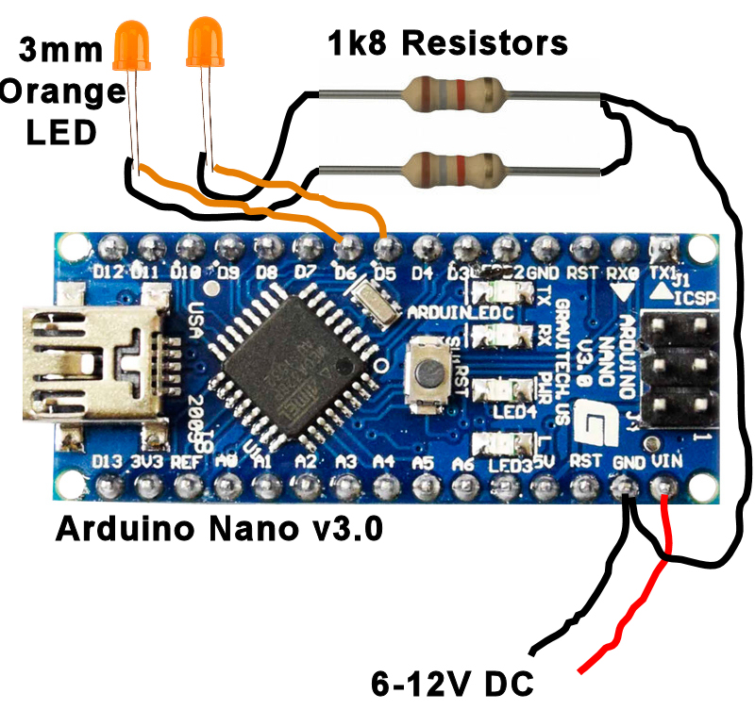
Logical Circuit
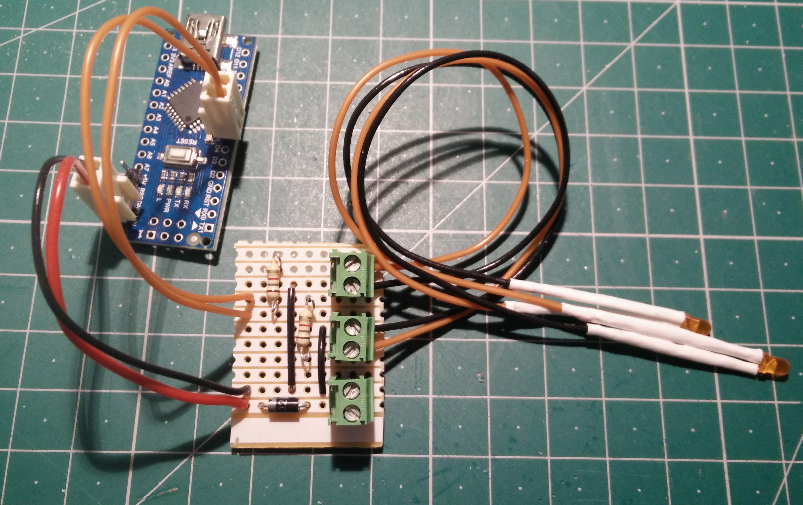
Circuit as Built
The Software
Software for an Arduino is called a sketch. A sketch consists of two main components:
- a routine called 'setup' that runs once when the Arduino is powered up or when the on-board reset button is pressed.
- A routine called 'loop' that will be run after 'setup' completes, and will re-run any time the routine 'loop' completes.
Extra routines can be added to sketch, or in separate 'library' files to be included in the sketch, but they will normally be called from either the 'setup' or 'loop' routines. The exception to this are optional interrupt handler routines, which can be activated by either external inputs or internal timers. The interrupt handler routines are associated with the interrupt sources by calling procedures in the 'setup' routine. When an interrupt handler is activated, any current activity in the 'loop' routine is paused until the interrupt handler completes. The 'loop' activity then resumes as if nothing had happened. Interrupt handlers are normally used for time-critical activities, and should be kept as concise as possible so as not to impede the normal activity of the 'loop' routine too much.
I started with the sketch I wrote for simulating fluorescent lighting in motive power depot pits. This uses a 1 kHz timer interrupt routine to actually turn the LEDs on and off at the required frequency, while the main loop process controls the periods of when the flashing effect is active or inactive. A number of preset arrays specify the flash frequencies and on and off periods for each of the LEDs. Although only two LEDs are required for Ropley, the sketch could be easily changed to control flashing LEDs on all the available Arduino I/O pins. The interrupt routine also implements multiplexing of the LEDs, so only one LED is ever lit at any moment in time, reducing the maximum current requirement of the module.
The sketch also causes the on-board LED to flash once per second, so the module can be seen to be working even when all the flashing LEDs off periods are coinciding. It can be found in the Merg GitHub repository https://github.com/MERG-DEV/FlashingOranges

Programming the Arduino

The common Arduino Nano V3 is based on the ATmega328P processor, and although the board layout of cheap clones may vary, the positions of pins around the edge should be constant. A mini USB connector on the end of the module is used to connect to a PC for programming and monitoring operation while testing. It can also supply the power to the module, so nothing else needs to be attached to program and test the module.

Depending on the source of the module, it may come with pins already soldered along its edges, or with strips of pins to be soldered to the module by the purchaser, or without pins. Most Arduino modules are delivered with a simple sample sketch, called 'Flash' that flashes the on board LED at about 1 Hz when powered up.

For programming, I use the Arduino IDE, which can be downloaded from https://www.arduino.cc/en/main/software to install on Windows, Mac or Linux. On running the IDE with the Arduino attached to a USB port, the IDE should automatically detect the Arduino type, and COM port used. If not, these can be selected manually from the 'Tools' menu.

Use the menu options 'File', 'Open' and select the sketch OrangeFlashers.ino which opens in the window:

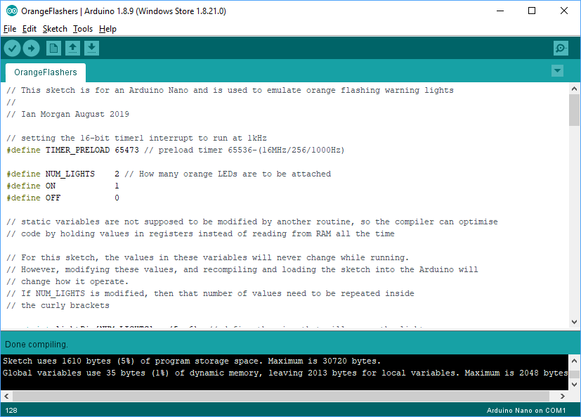
You can use the 'Verify' button to compile and verify the sketch, to see if any libraries need to be installed. Use the 'Upload' button to recompile and load the sketch into the Arduino. When complete, the on-board LED should flash steadily at 1 Hz to indicate the sketch is running. If any orange LEDs are connected, they should also start to flash.

The Sketch

// This sketch is for an Arduino Nano and is used to emulate orange flashing warning lights
//
// Ian Morgan August 2019

// setting the 16-bit timer1 interrupt to run at 1kHz
#define TIMER_PRELOAD 65473 // preload timer 65536-(16MHz/256/1000Hz)

#define NUM_LIGHTS 2 // How many orange LEDs are to be attached
#define ON 1
#define OFF 0

// static variables are not supposed to be modified by another routine, so the compiler can optimise
// code by holding values in registers instead of reading from RAM all the time

// For this sketch, the values in these variables will never change while running.
// However, modifying these values, and recompiling and loading the sketch into the Arduino will
// change how it operate.
// If NUM_LIGHTS is modified, then that number of values need to be repeated inside
// the curly brackets

const int lightPin[NUM_LIGHTS] = {5, 6}; // define the pins that will power the lights
const int flashDuration[NUM_LIGHTS] = {50, 300}; // milliseconds LED is on while flashing
const int flashOffDuration[NUM_LIGHTS] = {500, 575}; // milliseconds LED is off while flashing
const int workingTime[NUM_LIGHTS] = {11, 17}; // seconds the flasher is working for
const int inhibitedTime[NUM_LIGHTS] = {12, 19}; // seconds the flasher is inhibited for

// volatile variables may be modified and used by both interrupt and loop routines,
// so the compiler should not optimise code, but should always get the value from RAM every
// time it is used

// These values change as the program operates, so do not change these values.
// If NUM_LIGHTS is modified, then that number of values need to be repeated inside
// the curly brackets

volatile int lightNumber = 0; // the number of the LED to be refreshed by the interrupt routine
volatile int lightState[NUM_LIGHTS] = {OFF,OFF}; // should each light should currently be on or off
volatile int countdown[NUM_LIGHTS] = {1, 1}; // milliseconds LED has remaining before changing
volatile int inhibitCountdown[NUM_LIGHTS] = {1, 1}; // seconds left before changing state
volatile int active[NUM_LIGHTS] = {ON, ON}; // current state of the flashers, active or inhibited

// =============================================================================
void setup() {
// initialize digital pin LED_BUILTIN as an output.
pinMode(LED_BUILTIN, OUTPUT);

// initialize digital pins powering the orange LEDs as outputs.
for (int i = 0; i< NUM_LIGHTS; i++)
{
pinMode (lightPin[i], OUTPUT);
}

// initialize timer1 which will be used to run an
// interrupt handler every 1/1000 second

TCCR1A = 0;
TCCR1B = 0;

TCNT1 = TIMER_PRELOAD;
TCCR1B |= (1 << CS12); // 256 prescaler
TIMSK1 |= (1 << TOIE1); // enable timer overflow interrupt

interrupts(); // enable all interrupts

// light up the on-board LED
digitalWrite(LED_BUILTIN, ON);

} // end of setup ==========================================================================================

void loop() {

digitalWrite(LED_BUILTIN, OFF); // turn the on-board LED off
delay(500); // wait for a period of 1/2 second
digitalWrite(LED_BUILTIN, ON); // turn the on-board LED on again
delay(500); // wait for a period of 1/2 second

// because of the above delays, the following code will run about once every second.
// The code inside the 'for' loop will run for each orange LED
for (int i = 0; i< NUM_LIGHTS; i++)
{
inhibitCountdown[i]--; // decrease the countdown by 1 second

// has the countdown reached its end?
if (inhibitCountdown[i] == 0)
{
if (active[i] == ON)
{
active[i] = OFF; // flashing was active, so inhibit it
inhibitCountdown[i] = inhibitedTime[i]; // reset the countdown
}
else
{
active[i] = ON; // flashing was inhibited, so activate it
inhibitCountdown[i] = workingTime[i]; // reset the countdown
}

}
}

} // end of loop ============================================================================================

// timer interrupt service routine that runs every 1/1000 second
ISR(TIMER1_OVF_vect)
{
// Fires 1000 times per second
noInterrupts(); // disable any interrupts
TCNT1 = TIMER_PRELOAD; // preload timer

// switch off currently lit LED
digitalWrite(lightPin[lightNumber], OFF);

// point at the next LED
lightNumber++;
if (lightNumber >= NUM_LIGHTS) lightNumber = 0;

// is flashing activated for this LED?
if (active[lightNumber] == ON)
{
// Switch on the LED, if it is supposed to alight now
if (lightState[lightNumber] == ON)
{
digitalWrite(lightPin[lightNumber], ON);
}

countdown[lightNumber]--; // decrease the countdown for this LED

// Has the countdown reached its end?
if (countdown[lightNumber] == 0)
{

// change the current required state of the LED
if (lightState[lightNumber] == ON)
{
lightState[lightNumber] = OFF;
// reset the countdown value
countdown[lightNumber] = flashOffDuration[lightNumber];
}
else
{
lightState[lightNumber] = ON;
// reset the countdown value
countdown[lightNumber] = flashDuration[lightNumber];
}
}
}
interrupts(); // re-enable interrupts
}

