1. 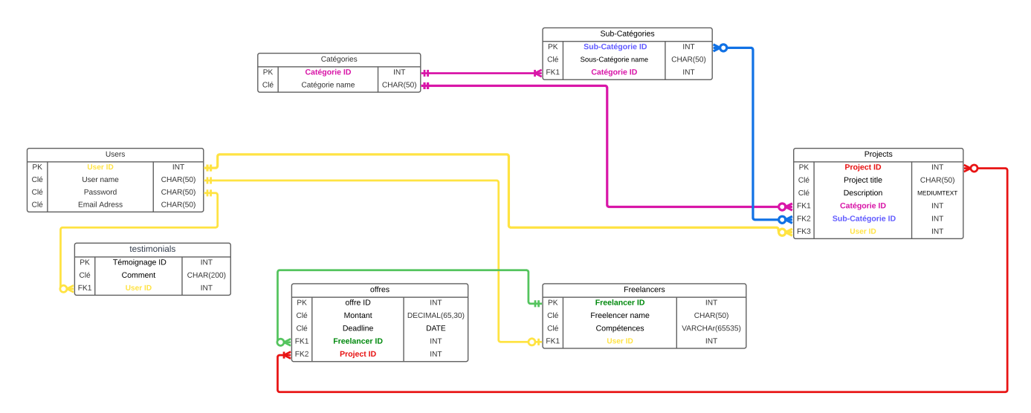Schéma de base de données :
2. Diagramme d’UML Use Case :

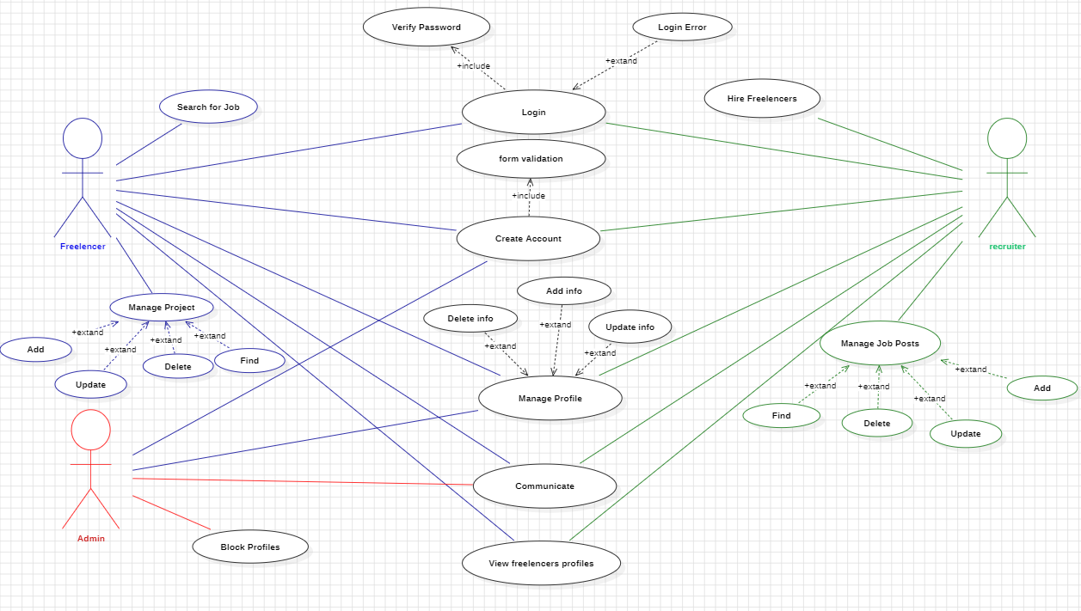

1. Diagramme d’UML Classes :

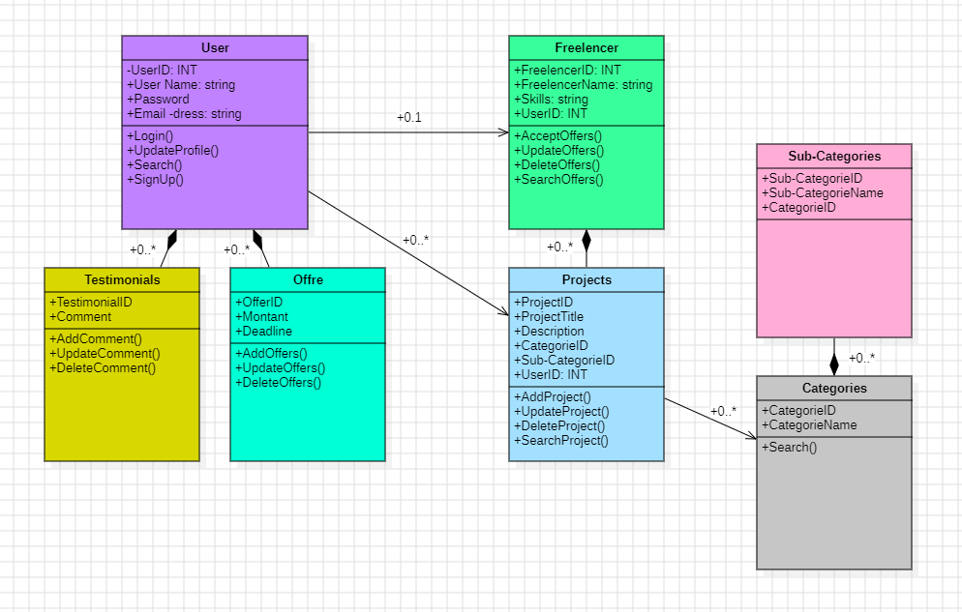

1. Requêtes SQL :
2. CREATE DATABASE IF NOT EXISTS People;
3. USE People;
4. CREATE TABLE IF NOT EXISTS User (
5. User_ID INT AUTO_INCREMENT PRIMARY KEY ,
6. User_Name varchar(100),
7. Pass_word varchar(100),
8. Email_Adress varchar(200)
9. );
10. INSERT INTO User(User_Name, Pass_word, Email_Adress)
11. VALUES
12. ('MERIEM','200001','merrybalibla@gmail.com'),
13. ('CHYPPO','200001','CHYPPOuser@gmail.com');
14. CREATE TABLE IF NOT EXISTS Testimonials(
15. Testimonials_ID INT PRIMARY KEY AUTO_INCREMENT,
16. Comment VARCHAR(225),
17. User_ID INT,
18. FOREIGN KEY (User_ID) REFERENCES User(User_ID)
19. );
20. INSERT INTO Testimonials (Comment, User_ID)
21. VALUES
22. ('HELLO WORLD',1);
23. CREATE TABLE IF NOT EXISTS Categories (
24. Categorie_ID INT PRIMARY KEY AUTO_INCREMENT,
25. Categorie_Name VARCHAR(100)
26. );
27. INSERT INTO Categories (Categorie_Name)
28. VALUES
29. ('Programming'),
30. ('Programming'),
31. ('Programming'),
32. ('Mecanical'),
33. ('Electrical');
34. CREATE TABLE IF NOT EXISTS Sub_Categories (
35. Sub_Categories_ID INT PRIMARY KEY AUTO_INCREMENT,
36. Sub_Categories_Name VARCHAR(100),
37. Categorie_ID INT,
38. FOREIGN KEY (Categorie_ID) REFERENCES Categories(Categorie_ID)
39. );
40. INSERT INTO Sub_Categories (Sub_Categories_Name, Categorie_ID)
41. VALUES
42. ('MEC DE BASE',1),
43. ('ELECRIQUE',2);
44. CREATE TABLE IF NOT EXISTS Project (
45. Project_ID INT PRIMARY KEY AUTO_INCREMENT,
46. Project_title VARCHAR(100),
47. Descriptions VARCHAR(225),
48. Categorie_ID INT,
49. FOREIGN KEY (Categorie_ID) REFERENCES Categories(Categorie_ID),
50. Sub_Categories_ID INT,
51. FOREIGN KEY (Sub_Categories_ID) REFERENCES Sub_Categories(Sub_Categories_ID),
52. User_ID INT,
53. FOREIGN KEY (User_ID) REFERENCES User(User_ID)
54. );
55. INSERT INTO Project (Project_title, Descriptions, Categorie_ID, Sub_Categories_ID, User_ID)
56. VALUES
57. ('MAZE GAME','funny game lol', 1, 1, 1);
58. CREATE TABLE IF NOT EXISTS Freelencers(
59. Freelencer_ID INT PRIMARY KEY AUTO_INCREMENT,
60. Freelencer_Name VARCHAR(100),
61. Skils VARCHAR(225),
62. User_ID INT,
63. FOREIGN KEY (User_ID) REFERENCES User(User_ID)
64. );
65. INSERT INTO Freelencers(Freelencer_Name, Skils, User_ID)
66. VALUES
67. ('JACK SPPAROW', 'PIRATE', 1);
68. CREATE TABLE IF NOT EXISTS Offres(
69. Offre_ID INT PRIMARY KEY AUTO_INCREMENT,
70. Montant DECIMAL(10,2),
71. Deadline DATE,
72. Freelencer_ID INT,
73. FOREIGN KEY (Freelencer_ID) REFERENCES Freelencers(Freelencer_ID),
74. Project_ID INT,
75. FOREIGN KEY (Project_ID) REFERENCES Project(Project_ID)
76. );
77. -- Challenge: Retrieve usernames and email addresses of all users from the 'Utilisateurs' table.
78. -- SELECT User_Name,Email_Adress FROM User
79. -- Challenge: Fetch project titles and descriptions from the 'Projets' table where the project category is 'Programming'.
80. -- SELECT Project_title, Descriptions
81. -- FROM Project
82. -- JOIN Categories ON Project.Categorie_ID = Categories.Categorie_ID
83. -- WHERE Categories.Categorie_Name = 'Programming';
84. -- LIMIT 1
85. -- Challenge: Count the total number of testimonials in the 'Témoignages' table.
86. -- SELECT COUNT(*)
87. -- FROM Testimonials
88. -- Challenge: Retrieve distinct categories available in the 'Catégories' table.
89. -- SELECT DISTINCT Categorie_Name FROM categories
90. SELECT COUNT(*)
91. FROM categories
92. WHERE Categorie_Name = 'Programming'
93. -- SELECT COUNT(*)
94. -- FROM categories
95. -- WHERE Categorie_Name = 'Mecanical'
96. -- SELECT COUNT(*)
97. -- FROM categories
98. -- WHERE Categorie_Name = 'Electrical'