**Controller part**

Since we could not complete that part,the design considerations will be explained but test results are not available. Firstly, the aim of controller design is making speed regulation and eliminating the disturbance on speed which can results from sudden torque changes like opening the kettle at some speed. To implement this firstly, we should have speed feedback that comes from the hall effect sensor (this is the only reason we could not implement controller because we could not get proper measurement from sensor instead we should have used optic encoder or voltage feedback which is directly proportional to speed) to obtain that we first try the simulink/arduino interface because in simulink the arduino library exist and also there are some special blocks that is designed for “RPM” measurement like “Tachometer” After measuring the speed we would want to make controller on the same environment because simulink has many control tools that makes easy for implement and no need for an embedded code that will perform the control task. However, we “Tachometer” block did not work in anyway. So, that strategy has been failed. As an alternative way, we tried to measure speed by an embedded code. In detail, code was working as follows, when a pulse is detected on the sensor the timer starts to count until the second pulse coming. That strategy had worked however measurement was not stable. To stabilize the measurement, we take the average of the last ten data as the speed data by that way, we achieve to measure. it worked but did not work at the demonstration. These operations are made on the arduino mega2560.

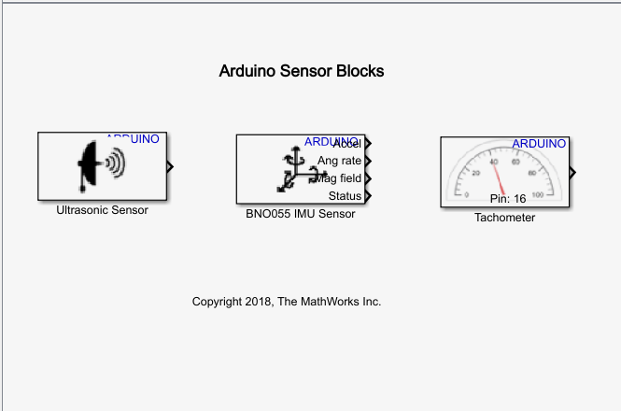

Figure??: arduino sensor library in simulink.

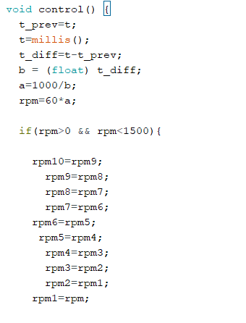

Figure??: some part of the the code (complete version is on the appendix.)

if we manage to measure the “RPM” earlier than we did, then we would make some test on the motor to extract some of the unknown parameters. Actually, in short we find directly to the transfer function of the motor by making “BUMP” test. In this method, we simply give motor to a Step input and observing the response. Since motor has 2 pole at the transfer function and also since one of the pole is extremely negligible compared to other pole, we can simply extract the transfer function, by finding the gain and response time of the system. However, since measurement has been failed we could not realize these.