
Department of Electrical Engineering
DEC50122 – EMBEDDED ROBOTIC
MINI PROJECT
(Chapter 3: Mobile Robot Design & Chapter 4: Mobile Robot Application)

NAME | 1)
 | 2)
 | 3)
 | 4)
REGISTRATION NO. | 1)
 | 2)
 | 3)
 | 4)
PROGRAMME
LECTURER’S NAME
REMINDER:
Cheating or plagiarism will not be tolerated. All parties involved in cheating or plagiarism will be given zero mark on the specified assessment.
Learning  Outcome | CLO1
Questions/ Marks | Q1 (a)  (3 marks)
Q1 (b)
(3 marks)
Q1 (c)
(3 marks)
Score (9m) | 9
Learning Outcome | CLO2
Questions/ Marks | Q2 (a)  (6 marks)
Q2 (b)
(10 marks)
Score (16m) | 16

/ 25

PRACTICAL SKILL ASSESSMENT  (PLO5, CLO3, P4) |  | ATTAINMENT | GENERIC SKILL  (PLO11, CLS4, CLO4)  – Project Management & Finance |  | ATTAINMENT
1. Able to upload programming code from Arduino IDE to Arduino Uno. (CLO3) | S1 | ④ ③ ② ① ⓪ | Time Management | S1 | - ⑧ ⑥ ④ ② ⓪
 | S2 | ④ ③ ② ① ⓪ |  | S2 | - ⑧ ⑥ ④ ② ⓪
 | S3 | ④ ③ ② ① ⓪ |  | S3 | - ⑧ ⑥ ④ ② ⓪
 | S4 | ④ ③ ② ① ⓪ |  | S4 | - ⑧ ⑥ ④ ② ⓪
2. Able to configure or connect components (Sensor and Actuator) to the Microcontroller according to programming code.  (CLO3) | S1 | ④ ③ ② ① ⓪ | Decision Making | S1 | - ⑧ ⑥ ④ ② ⓪
 | S2 | ④ ③ ② ① ⓪ |  | S2 | - ⑧ ⑥ ④ ② ⓪
 | S3 | ④ ③ ② ① ⓪ |  | S3 | - ⑧ ⑥ ④ ② ⓪
 | S4 | ④ ③ ② ① ⓪ |  | S4 | - ⑧ ⑥ ④ ② ⓪
- Able to test the sensor functionality: (CLO3)  - Ultrasonic/infrared functionality  - Line follower | S1 | ④ ③ ② ① ⓪ | Organization of Ideas | S1 | - ⑧ ⑥ ④ ② ⓪
 | S2 | ④ ③ ② ① ⓪ |  | S2 | - ⑧ ⑥ ④ ② ⓪
 | S3 | ④ ③ ② ① ⓪ |  | S3 | - ⑧ ⑥ ④ ② ⓪
 | S4 | ④ ③ ② ① ⓪ |  | S4 | - ⑧ ⑥ ④ ② ⓪
- Able to test the actuator functionality: (CLO3)  - Ackerman Drive  - Differentiate Drive | S1 | ④ ③ ② ① ⓪ | Delegation of Work | S1 | - ⑧ ⑥ ④ ② ⓪
 | S2 | ④ ③ ② ① ⓪ |  | S2 | - ⑧ ⑥ ④ ② ⓪
 | S3 | ④ ③ ② ① ⓪ |  | S3 | - ⑧ ⑥ ④ ② ⓪
 | S4 | ④ ③ ② ① ⓪ |  | S4 | - ⑧ ⑥ ④ ② ⓪
5. Robot function according to strategy (CLO3) | S1 | ④ ③ ② ① ⓪ | Motivation | S1 | - ⑧ ⑥ ④ ② ⓪
 | S2 | ④ ③ ② ① ⓪ |  | S2 | - ⑧ ⑥ ④ ② ⓪
 | S3 | ④ ③ ② ① ⓪ |  | S3 | - ⑧ ⑥ ④ ② ⓪
 | S4 | ④ ③ ② ① ⓪ |  | S4 | - ⑧ ⑥ ④ ② ⓪
Score (20m) | S1 |  | Score (50) | S1
 | S2
 | S3 |  |  | S2
 | S4
TOTAL SCORE (45m) (CLO 1 + CLO 2 + CLO 3) | S1 |  |  | S3
 | S2
 | S3 |  |  | S4
 | S4
Percentage (15%) | S1 |  | Percentage (5%) | S1
 | S2 |  |  | S2
 | S3 |  |  | S3
 | S4 |  |  | S4

PRACTICAL SKILL RUBRIC (CLO3, PLO5, P4)

NO. | SCORE  ASPECT | 0 | 1 | 2 | 3 | 4
 |  | NOT ACHIEVED | MODERATELY  COMPETENT | MODERATELY  COMPETENT | HIGHLY COMPETENT | OUTSTANDING
1. | Able to upload programming code from Arduino IDE to Arduino Uno. | Cannot able to upload programming code from Arduino IDE to Arduino Uno | Able to upload programming code from Arduino IDE to Arduino Uno with MORE errors | Able to upload programming code from Arduino IDE to Arduino Uno with SOME errors | Able to upload programming code from Arduino IDE to Arduino Uno with LESS errors | Able to upload programming code from Arduino IDE to Arduino Uno.
2. | Able to configure or connect components (Sensor and Actuator) to the Microcontroller according to programming code. | Can’t configure or connect components (Sensor and Actuator) to the Microcontroller according to programming code. | Able to configure or connect components EITHER Sensor OR Actuator to the Microcontroller according to programming code. | Able to configure or connect components BOTH Sensor and Actuator to the Microcontroller according to programming code with SOME error | Able to configure or connect components (Sensor and Actuator) to the Microcontroller according to programming code with A FEW error | Able to configure or connect components (Sensor and Actuator) to the Microcontroller according to programming code.
3. | Able to test the sensor functionality:  - Ultrasonic/infrared functionality  - Line follower. | Can’t test the sensor functionality ALL  - Ultrasonic/infrared functionality  - Line follower. | Able to test the sensor functionality EITHER  - Ultrasonic/infrared functionality OR  - Line follower. | Able to test the sensor functionality BOTH with some error  - Ultrasonic/infrared functionality  - Line follower. | Able to test the sensor functionality with A FEW error  - Ultrasonic/infrared functionality  - Line follower. | Able to test the sensor functionality:  - Ultrasonic/infrared functionality  - Line follower.
4. | Able to test the actuator functionality:  - Ackerman Drive  - Differentiate Drive | Can’t test the actuator functionality ALL  - Ackerman Drive  - Differentiate Drive | Able to test the actuator functionality EITHER:  - Ackerman Drive OR  - Differentiate Drive | Able to test the actuator functionality BOTH with some error  - Ackerman Drive  - Differentiate Drive | Able to test the actuator functionality with A FEW error  - Ackerman Drive  - Differentiate Drive | Able to test the actuator functionality:  - Ackerman Drive  - Differentiate Drive
5. | Robot function according to strategy | Robot CANNOT function according to strategy | Robot function EITHER sensor OR actuator part only  according to strategy | Robot function with SOME error according to strategy | Robot function with A FEW error according to  strategy | Robot function according to strategy

GENERIC SKILL RUBRIC (PLO11, CLS4, CLO4)

Project Management & | Very Good | Good | Fair | Weak | Very Weak
Finance | 10 | 8 | 6 | 4 | 2
Time Management | Completes tasks ahead of schedule by creating a plan and scheduling time to complete the work. | Completes work on time by taking advantage of the provided and by using time management skills. | Occasionally complete work on time. Tries to manage time. | Rarely complete work on time. Not able to manage time well. | NO attempt to complete work on time. Not able to manage time.
Decision Making | Able to make a very good decision based on excellent understanding of the situation and available options | Able to make a good decision based on good understanding of the situation and available options. | Satisfactory attempt to make decisions and satisfactory understanding of the situation and available options | Tries to make decision by understanding the situation. Decision made is based on limited understanding of the situation and available options | No attempt to make decision. Do not understand the situation and relate with options that are available
Organization of Ideas | Deliver ideas with excellent clarity, comprehensivess and organization | Deliver ideas with good clarity, comprehensivess and organization | Deliver ideas with satisfactory clarity, comprehensivess and organization | Deliver ideas with minimal clarity, comprehensivess and organization | Deliver ideas with unclearly, loosely and organization
Delegation of Work | Work was divided excellently amongst group members | Work was divided well amongst group members | Work was divided satisfactory amongst group members | Work was divided minimally amongst group members | Work was not divided equally. Only few members are doing the work while others are  ignored
Motivation | Very high motivation to complete task | High motivation to complete task | Satisfactory motivation to complete task | Minimal motivation to complete task | No motivation to complete task

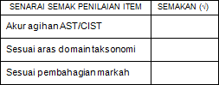
Your group are required to enter a Sumo Robotic Competition by your department. In order to develop a robot, there are several rules and regulation that your group need to follows:
Robot
- Robot can be operated autonomous or by wireless (Bluetooth/2.4Ghz).
- The size of the robot shall not exceed 150 mm (length) x 150 mm (width) x 150 mm (height) after extension (if any).
- The weight of the robot including power sources and other parts of the robot shall not exceed 1kg.
- Once the competition begins, no team member is permitted to touch the robot.
- The robot cannot split or separate into two (2) or more units.
Power supply for robot
- Each team shall prepare its own power supply for the robots.
- Voltage of the power supply for robots shall not exceed 24 VDC on load.
- A power supply that is considered dangerous or unsuitable by the competition committee shall not be permitted.
- The pressure of the compressed air power (if any) must be less than 6 bars. Robot specifications
Size and weight of the robot will be measured before the competition.
Robots that are not made in conformity with this rulebook will not be allowed to participate in the contest.

QUESTION 1
  - Sketch the design of your Mobile Robot Design for the competition.
(CLO1-C3) / (3 marks)
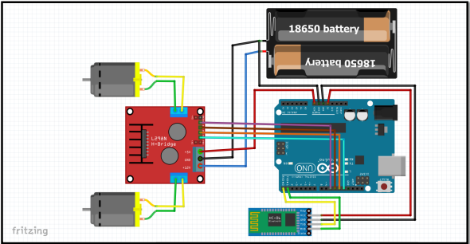

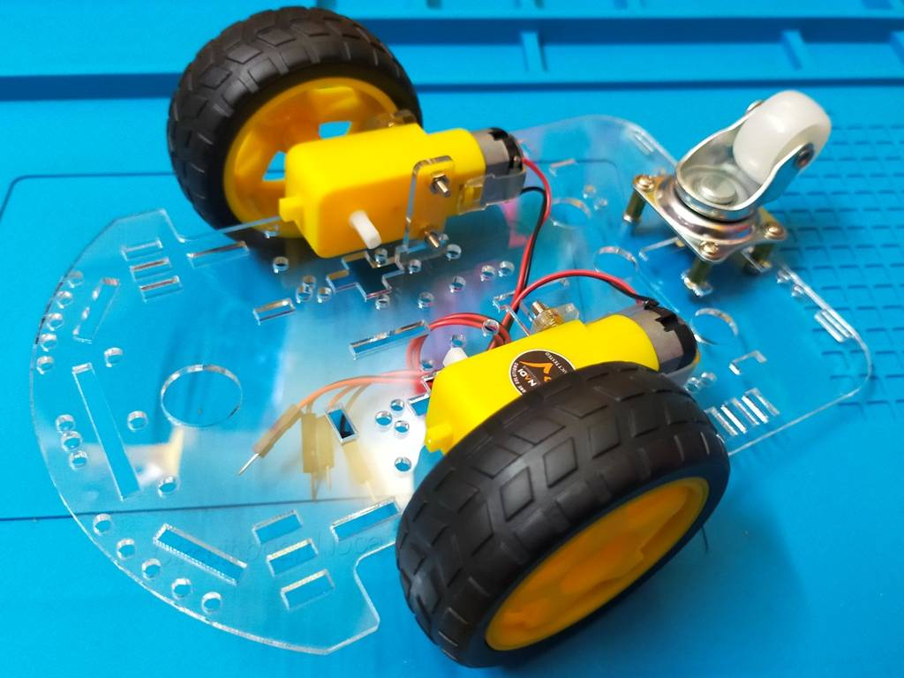

  - Write the programming code for your robot in arduino ide programming software.

(CLO1-C3) / (3 marks)

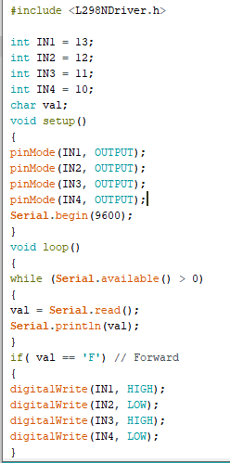

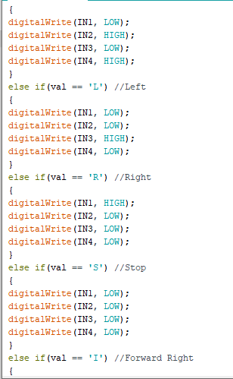

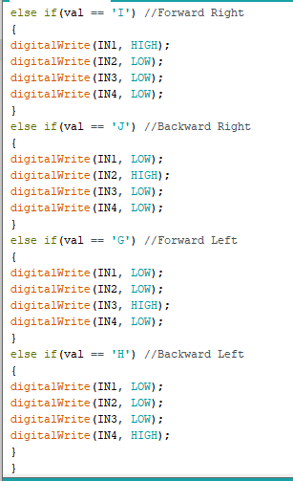

  - Simulate and upload your Arduino sketch to the robot that your group have design.

(CLO1-C3) / (3 marks)

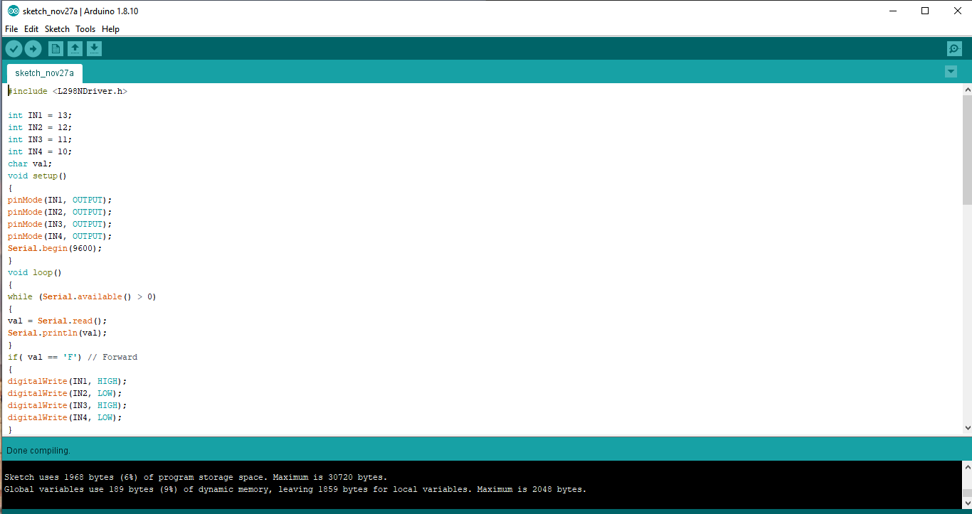

QUESTION 2
- Analyze your sumo robot communication process (autonomous / wireless / Bluetooth/2.4Ghz).

(CLO2-C4) / (6 marks)

In this mini project our group used Bluetooth Communication is a 2.4GHz frequency based RF Communication with a range of approximately 10 meters. It is one of the most popular and most frequently used low range communication. HC-05 Bluetooth Module is a simple Wireless Communication device based on the Bluetooth Protocol. We are using a simple Android App called “Bluetooth RC Car Controller” for pairing HC-05 with my Android Phone and transmitting data. Make the connections and power on the Bluetooth Module. If this is the first time you are using your Bluetooth Module, then the LED will blink rapidly. In order to pair the module with your phone, open Bluetooth Settings in your phone and connect to “HC-05” with pin “1234”. Once the Bluetooth Module is paired with your phone, you can start using the App to control your sumo robot

- Integrate all components, hardware, sensor and software for the sumo robot.

(CLO2-C6) / (10 marks)
……………

Arduino UNO board

Arduino UNO is a microcontroller board. It has 14 digital input/output pins (of which 6 can be used as PWM outputs)6 analog inputs, a 16 MHz ceramic resonator, a USB connection, a power jack, an ICSP header and a reset button. It contains everything needed to support the microcontroller; simply connect it to a computer with a USB cable or power it with a AC-to-DC adapter or battery to get started.

HC05 Bluetooth Module

HC-05 is a Bluetooth module which is designed for wireless comunication. This module can be used in a master or slave configuration. To communicate smartphone with HC-05 Bluetooth module, smartphone requires Bluetooth terminal application for transmitting and receiving data. You can find Bluetooth terminal applications for android and windows in respective app store

L298N Motor Driver

The L298N Motor Driver is a controller that uses an H-Bridge to easily control the direction and speed of up to 2 DC motors. The module has two screw terminal blocks for the motor A and B, and another screw terminal block for the Ground pin, the VCC for motor and a 5V pin which can either be an input or output. This depends on the voltage used at the motors VCC. The module have an onboard 5V regulator which is either enabled or disabled using a jumper. If the motor supply voltage is up to 12V we can enable the 5V regulator and the 5V pin can be used as output, for example for powering our Arduino board

Arduino IDE

The Arduino IDE is an open-source software, which is used to write and upload code to the Arduino boards. The IDE application is suitable for different operating systems such as Windows, Mac OS X, and Linux. It supports the programming languages C and C++. Here, IDE stands for Integrated Development Environment. The program or code written in the Arduino IDE is often called as sketching. We need to connect the Genuino and Arduino board with the IDE to upload the sketch written in the Arduino IDE software. The sketch is saved with the extension '.ino.'

PREPARED BY:  Course Lecturer | APPROVED BY:  Course Coordinator /Head of Programme
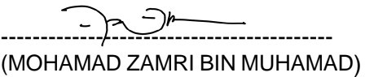 |   …………………  Siti Zalina Binti Mokhtar  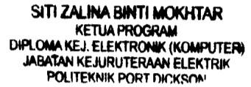  /  /  /
Date:19/8/2022 | Date:19/8/2022

