Hi there,  
  
Here you find a hopefully detailed enough series of steps to try out my user scripts for earth2.io  
I hope these steps are be easy enough to follow using Chrome and Edge, and should work the same way in other PC browsers like Firefox or Opera (though Step three might happen differently).  
  
Step zero: open <https://github.com/mihaj-scripts/earth2-tools> in your browser

Here you should be greeted with a screen like this:  
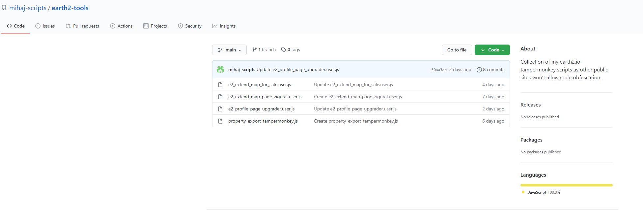

Step one: download the desired file  
Right click on the file, select “Save link as”, find a place where you’ll store it and save the file locally.

Step two: open the file in notepad, or notepad++  
Press CTRL+A (to select everything), CTRL+C to copy to the clipboard

Step three: open Developer Tools  
After loading app.earth2.io press F12, you should get the developer tools open similar to this:  
  
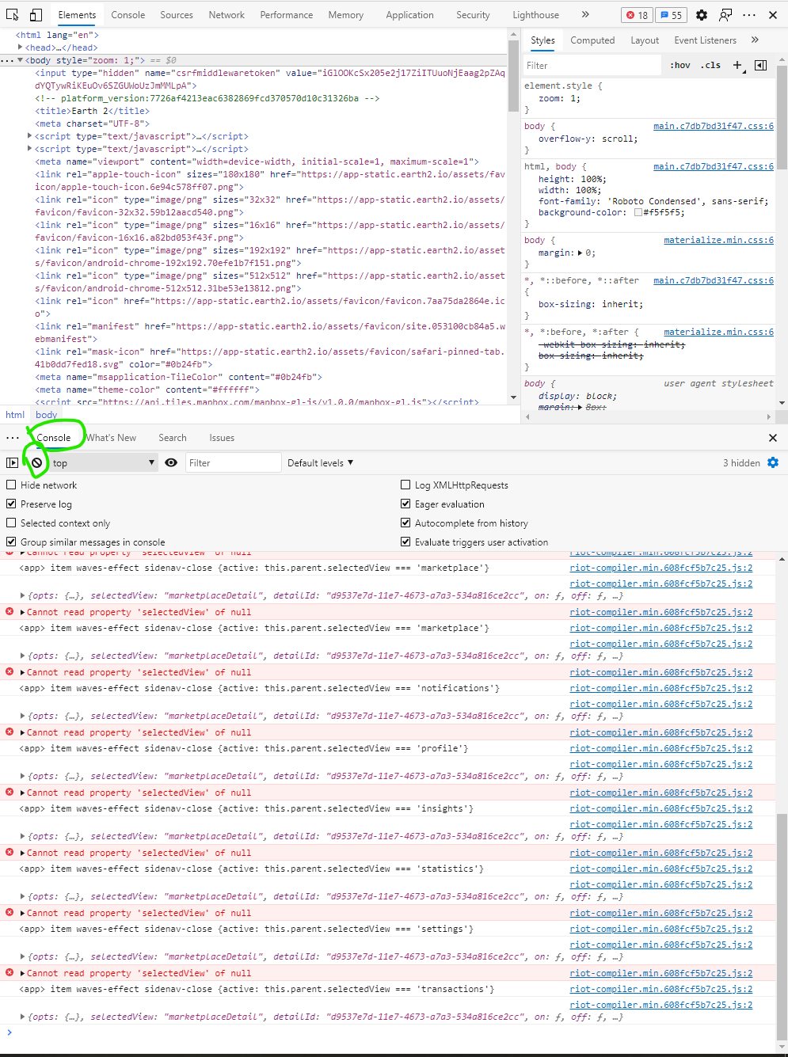

You are going to need the console (marked with green).  
First, press the clear button (to display only important bits, also marked with green)

Step four: click into the console area, you should see a blinking line cursor.

Press CTRL+V to paste the copied script into the console, and press enter. Now the script should be loaded and ready to use (unless you see some nasty error messages, in which case you can notify me and we’ll look into the issue 😊 )

Example of usage:  
1) go to your profile page in E2  
2) get the script copied from <https://github.com/mihaj-scripts/earth2-tools/blob/main/property_export_tampermonkey.js>  
3) paste into the developer console and press enter  
4) you should see a big and ugly button like this (above the text “Profile”):  
  
5) if you click the button and everything goes well you’ll get to see a prompt like this:  
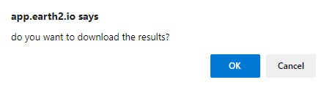  
If you click “Cancel” nothing happens.  
If you click “Ok” you’ll get to download your properties list in a csv format that you can open in Excel 😊

The downside of this approach is that you have to do this for every page refresh. If you are interested on how to install it as a Tampermonkey user script (layman terms: loads whenever you refresh the page), let me know and I write an another tutorial ☺

As usual, if the instructions are unclear feel free to dm me in discord (mihaj#5170)