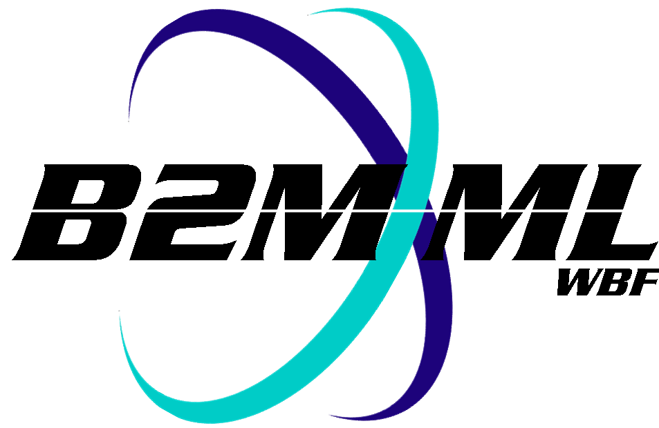
Business To Manufacturing
Markup Language
B2MML –Confirm BOD
Version 0500 – March 2011
Confirm BOD Schema
Documentation



IMPORTANT: While the information, data, and standards provided in this publication were developed and are presented in good faith in accordance with a reasonable process that was subject to intellectual property and antitrust policies to benefit the industry as a whole, the publication is provided “as is” for information and guidance only, and there is no representation or warranty of any type or kind, including but not limited to warranties of merchantability or fitness for a particular purpose, and no warranty that use of the information, data, or standards will not infringe patent, copyright, trademark, trade secret, or other intellectual property rights of any party.
Table of Contents

1 Schema Scope 3
1.1 Key Information Assumptions 3
1.2 BOD 3
1.3 ConfirmBOD 3
2 Element Definitions 4
3 Transaction Elements 5
4 B2MML - OAGiS Differences 5
5 Diagram Convention 6

Change History:
Change | Date | Person | Description
V04 | 04 June 2007 | Dennis Brandl | - Initial version with transaction elements
V0401 | Oct 2008 | Dennis Brandl | - Changed version number
V0500 | Mar 2011 | Dennis Brandl | Updated version number documentation and WBF name in copyright. No other changes made.

Copyright © 2011 WBF The Organization for Production Technology
All Rights Reserved. http://www.wbf.org

This WBF Work (including specifications, documents, software, and related items) referred to as the Business To Manufacturing Markup Language (B2MML) is provided by the copyright holders under the following license.

Permission to use, copy, modify, or redistribute this Work and its documentation, with or without modification, for any purpose and without fee or royalty is hereby granted provided the WBF is acknowledged as the originator of this Work using the following statement:

"The Business To Manufacturing Markup Language (B2MML) is used courtesy of the WBF."

In no event shall the WBF, its members, or any third party be liable for any costs, expenses, losses, damages or injuries incurred by use of the Work or as a result of this agreement.

Material from ANSI/ISA-88 and ANSI/ISA-95 series of standards used with permission of ISA - The Instrumentation, Systems, and Automation Society, www.isa.org

Schema Scope
This document defines the information about process segment definitions that may be exchanged between business systems and manufacturing operations systems. This information is based on the data models and attributes defined in the ANSI/ISA 95.00.02 Enterprise/Control System Integration standard. Contact ISA (The Instrumentation, System, and Automation Society) for copies of the standard. Additional information on the standard is available at www.isa.org.

Key Information Assumptions
The data represented in these schemas is derived from the model defined in the ANSI/ISA 95.00.05 standard and based on a subset of information defined in the OAGiS ConfirmBOD schema definition.

This schema uses a common schema for definition of elements that are used in multiple schemas. See the document defining the WBF95Common schema for definition of the common elements.

The ConfirmBOD message is a general response message that may be sent as a response from any other

BOD
A BOD is a general data type used to hold response information for a confirm message.

ConfirmBOD
The ConfirmBOD is the message that is returned when the confirmation option is specified in a message. The actual status of the response is contained in the actionCode attribute in the Confirm.ResponseCriteria.ResponseExpression. Addition information may be contained in the Description and Note areas in the BOD.

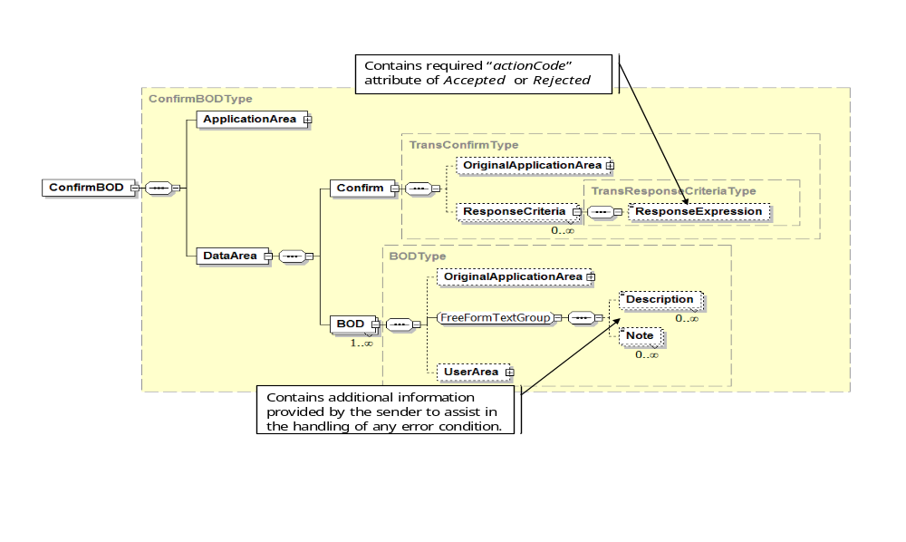

Element Definitions

Element/Type | Description
ConfirmBOD | The ConfirmBOD is a complex type that contains an application area and data area. The data area contains a Confirm element and a BOD element.  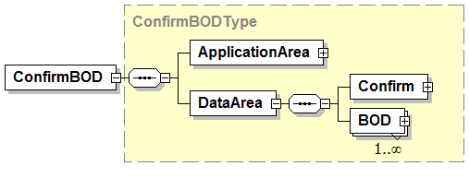
TransConfirmType | The TransConfirmType contains a copy of the original application area sent on the message requesting confirmation. It also contains a ResponseCriteria that contains a ResponseExpression that contains a actionCode attribute with the confirmation status.  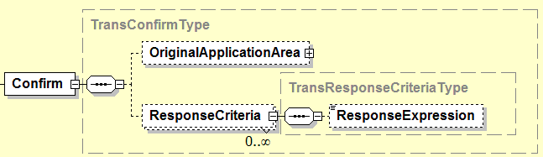
BOD | A general type that is used to contain additional return status information.  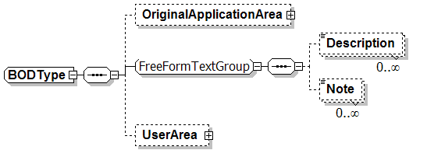
FreeFormTextGroup | A group of Descriptions and Notes that are related and contain additional return status information.  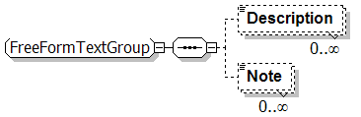

Transaction Elements
The following elements are defined to support the ISA 95 Part 5 transactions, using the transaction data types defined in the B2MML-Common.xsd schema.

Process Segment Information Elements | Description
ConfirmBOD | Confirmation status return from another transaction message.

B2MML - OAGiS Differences

There are several elements defined in the OAGiS 9.0 specification that are not included in the B2MML specification. The following figure illustrates the elements in OAGiS that are not included in B2MML. These include BODFailureMessage, BODSuccessMessage, and PartialBODFailreMessage elements.

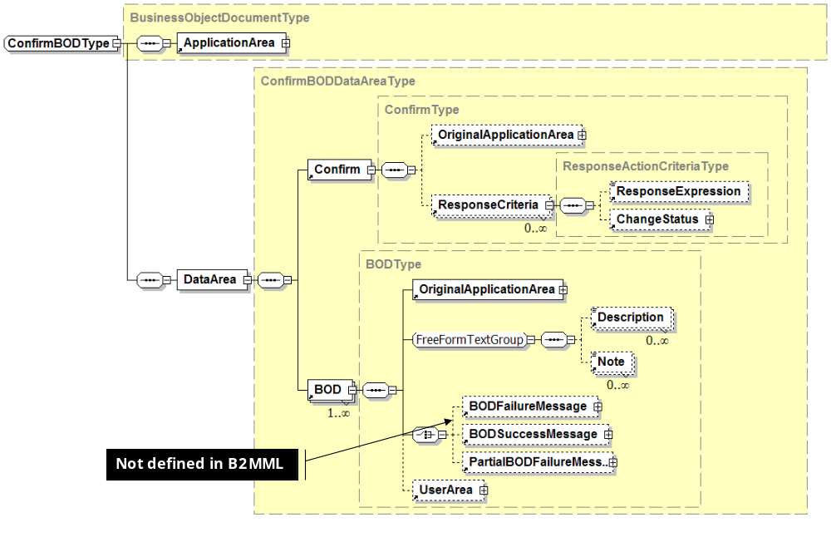

Diagram Convention
The schema diagrams using the following convention to illustrate the structure of the schema elements, the type of the elements and attributes, and the rules for optional elements and repetition.

