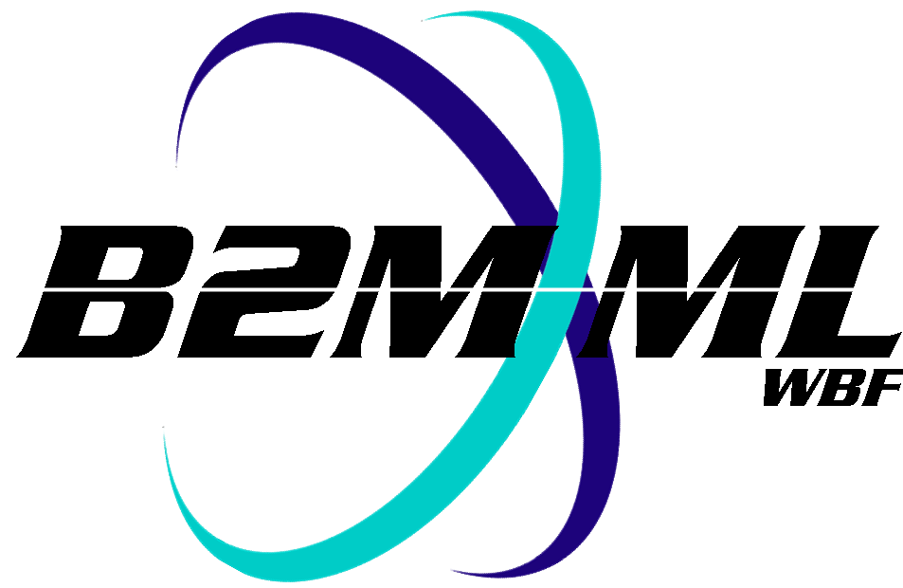
Business To Manufacturing
Markup Language
B2MML - Equipment
Version 0500 – March 2011
Equipment Schema
Documentation



IMPORTANT: While the information, data, and standards provided in this publication were developed and are presented in good faith in accordance with a reasonable process that was subject to intellectual property and antitrust policies to benefit the industry as a whole, the publication is provided “as is” for information and guidance only, and there is no representation or warranty of any type or kind, including but not limited to warranties of merchantability or fitness for a particular purpose, and no warranty that use of the information, data, or standards will not infringe patent, copyright, trademark, trade secret, or other intellectual property rights of any party.
Table of Contents

1 Schema Scope 3
1.1 Key Information Assumptions 3
1.2 Key Use Assumptions 4
1.3 EquipmentInformation 4
1.4 Equipment 4
1.5 EquipmentClass 5
1.6 EquipmentCapabilityTestSpecification 5
2 Element Definitions 6
3 Transaction Elements 10
4 Diagram Convention 12

Change History:
Change | Date | Person | Description
V01 | 7 April 2002 | Dennis Brandl  Dave Emerson | Initial release
V02 | 23 Sept 2003 | Dennis Brandl  Dave Emerson | - Added Location to EquipmentType  - Changed ##any to "Any" element of type "AnyType"
V03 | 26 Aug 2005 | Dennis Brandl  Dave Emerson | - Added substitution groups. One group added just before each Any element.
V0301 | 29 Dec 2005 | Dennis Brandl | - Only changed version to V0301
V04 | 04 June 2007 | Dennis Brandl | - Added transaction elements
V0401 | Oct 2008 | Dennis Brandl | - Changed version
V0500 | Mar 2011 | Dennis Brandl | - Updated to match ANSI/ISA 95.02-2010  - Added Equipment Asset Mapping

Copyright © 2011 WBF The Organization for Production Technology
All Rights Reserved. http://www.wbf.org

This WBF Work (including specifications, documents, software, and related items) referred to as the Business To Manufacturing Markup Language (B2MML) is provided by the copyright holders under the following license.

Permission to use, copy, modify, or redistribute this Work and its documentation, with or without modification, for any purpose and without fee or royalty is hereby granted provided the World Batch Forum is acknowledged as the originator of this Work using the following statement:

"The Business To Manufacturing Markup Language (B2MML) is used courtesy of WBF."

In no event shall the WBF, its members, or any third party be liable for any costs, expenses, losses, damages or injuries incurred by use of the Work or as a result of this agreement.

Material from ANSI/ISA-88 and ANSI/ISA-95 series of standards used with permission of ISA - The Instrumentation, Systems, and Automation Society, www.isa.org

Schema Scope
This document defines the information about equipment classes, equipment, and capability tests that may be exchanged between business systems and manufacturing operations systems. This information is based on the data models and attributes defined in the ANSI/ISA 95.00.02 Enterprise/Control System Integration standard. Contact ISA (The Instrumentation, System, and Automation Society) for copies of the standard. Additional information on the standard is available at www.isa.org.

Key Information Assumptions
The data represented in these schemas is derived from the UML model below. This model is defined in the ANSI/ISA 95.00.02 standard. The information model in the model below is not hierarchical, so the key assumption is that the information may be accessed from any of three starting points: equipment class, equipment, or capability test, as identified by the dotted collections in the figure.

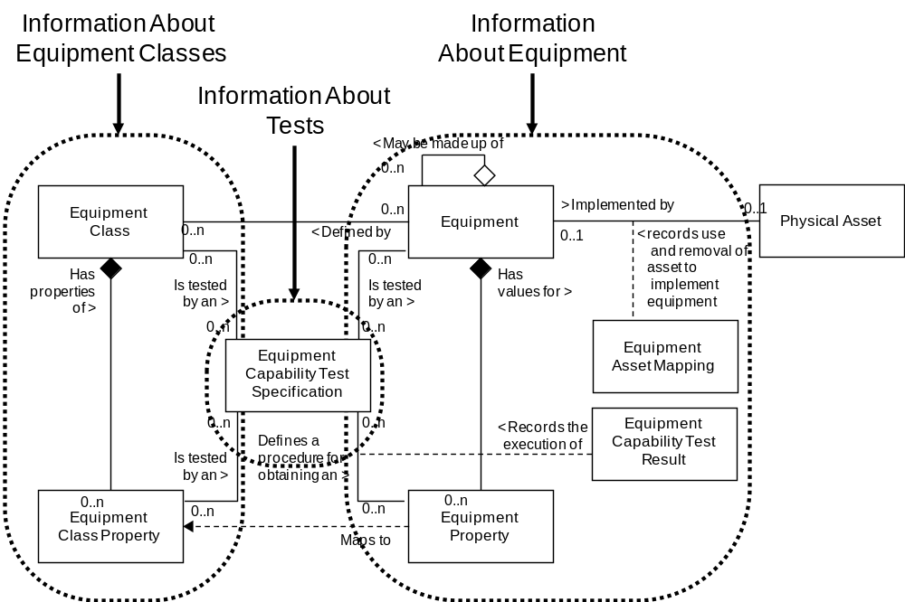
Model of Exchanged Equipment Information

This schema uses a common schema for definition of elements that are used in multiple schemas, such as ID, Description, and Value. See the documentation of the B2MML common schema for definition of the common elements.

Key Use Assumptions
The model only defines the exchanged information and does not define the use of the information or encapsulation of the information in any defining transactions.

The equipment follows the ANSI/ISA-95.00.01 model for the equipment hierarchy, as shown in the figure below. The terminology used in naming the equipment levels follows the ISA standard.

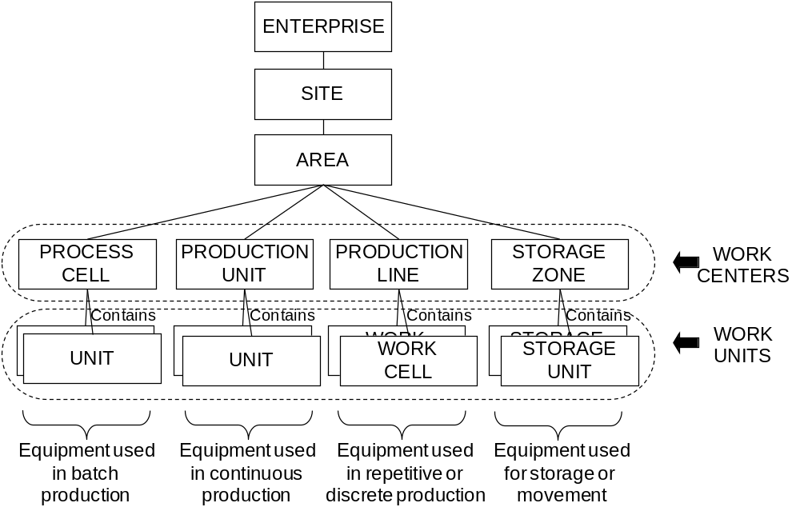

EquipmentInformation
The main structuring element of the schema definition is EquipmentInformation. Alternately, schemas may be made up an equipment, equipment class, or equipment capability test specification document.

EquipmentInformation elements define equipment, equipment classes, and/or equipment capability test specifications.

Equipment
Equipment represents the elements of the equipment hierarchy model defined in ANSI/ISA-95.00.01 Section 4.2. Equipment may be definitions of sites, areas, production units, production lines, work cells, process cells, or units.

Examples of equipment are “Reactor Unit #1”, “Bottling Line #1”, and “Horizontal Drill Press #4”

Equipment may be made up of other equipment, as defined in equipment hierarchy model. For example, a production line may be made up of work cells. Each may be defined as a separate equipment element with separate properties and capabilities.

Equipment elements may be used to contain information about specific equipment. Equipment elements may also include the definition of capability test results.

EquipmentClass
An equipment class is a means to describe a grouping of equipment with similar characteristics for purposes of scheduling and planning. Any piece of equipment may be a member of zero or more equipment classes. Examples of equipment classes are “Reactor Unit”, “Bottling Line”, and “Horizontal Drill Press”.

EquipmentClass information may be used to contain information about classes of Equipments. It may contain the list of equipment belonging to the class and the list of capability test specifications associated with equipment class properties.

EquipmentCapabilityTestSpecification
An equipment capability test specification may be associated with an equipment property. This is typically used where a test is required to ensure that the equipment has the rated capability. An equipment capability test specification may test for one or more equipment properties.

EquipmentCapabilityTestSpecification information may be used to contain information about equipment capability tests. It may contain identifications of the tested equipment properties and the tested equipment class properties.

Element Definitions

Element/Type | Description
Equipment  EquipmentType | A top-level object that may contain a definition of equipment, containing equipment, equipment properties, the ID’s of equipment classes the equipment belongs to, and the equipment to physical asset mapping. May also contain application specific elements.  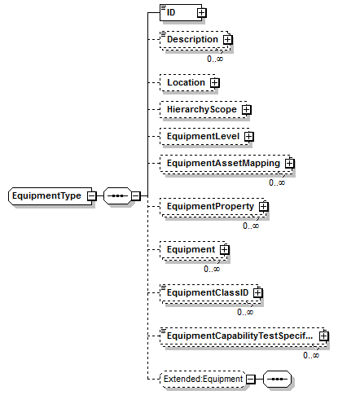
EquipmentCapabilityTestSpecification  EquipmentCapabilityTestSpecificationType | A top level object that contains the description of an equipment capability test specification. Containing the name of the test, version of the test, description of the test, the list of class properties tested by the test, the list of specific equipment properties tested by the test, and additional application specific information. May also contain application specific elements.  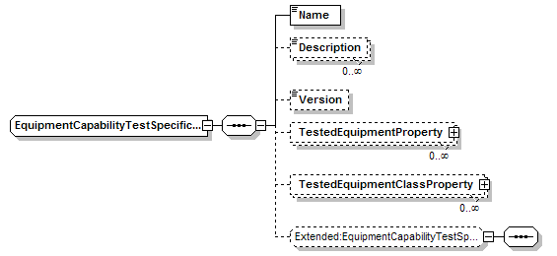
EquipmentClass  EquipmentClassType | A top-level object that may contain a definition of an equipment class, containing equipment properties, and the ID’s of equipment the belonging to the class. May also contain application specific elements.  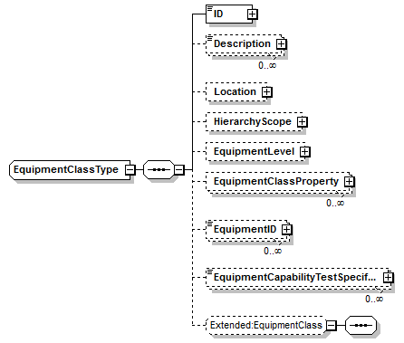
EquipmentClassPropertyType | Contains a definition of an equipment class property, consisting of an ID and a description. May include the capability test specification.  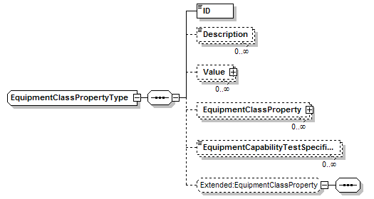
EquipmentInformation  EquipmentInformationType | A top-level object that may contain a list of equipment, equipment class, and/or equipment capability test specifications. May also contain application specific elements.  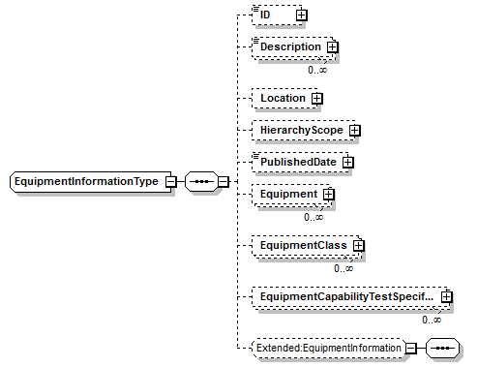
EquipmentProperty  EquipmentPropertyType | Contains a definition of an equipment property, consisting of an ID and a description. May include the capability test specification and test result.  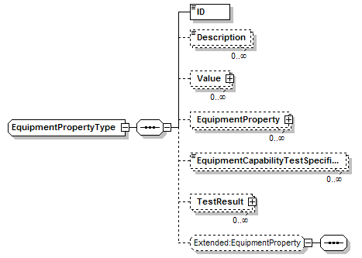
TestedEquipmentClassProperty  TestedEquipmentClassPropertyType | Contains a definition of a class property type tested by a qualification test specification. The ID defines the property.  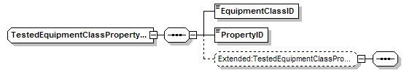
TestedEquipmentProperty  TestedEquipmentPropertyType | Contains a definition of a property type tested by a qualification test specification. The ID defines the property.  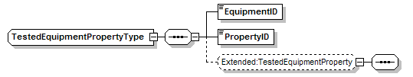
EquipmentAssetMapping  EquipmentAssetMappingType | Defines the mapping of equipment to a physical asset.  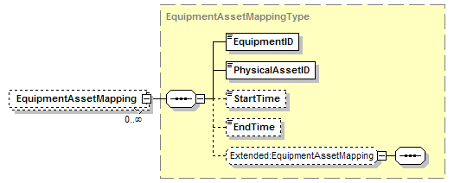

Transaction Elements
The following elements are defined to support the ISA 95 Part 5 transactions, using the transaction data types defined in the B2MML-Common.xsd schema.

Equipment Information Elements | Description
GetEquipmentInformation | Get EquipmentClass, Equipment, and EquipmentCapabilityTestSpecification definitions.
ShowEquipmentInformation | Returned information from the GetEquipmentInformation message.
ProcessEquipmentInformation | Process EquipmentClass, Equipment, and EquipmentCapabilityTestSpecification definitions.
AcknowledgeEquipmentInformation | Returned status from the ProcessEquipmentInformation message.
ChangeEquipmentInformation | Change EquipmentClass, Equipment, and EquipmentCapabilityTestSpecification definitions.
RespondEquipmentInformation | Returned status from the ChangeEquipmentInformation message.
CancelEquipmentInformation | Cancel EquipmentClass, Equipment, and EquipmentCapabilityTestSpecification definitions.
SyncEquipmentInformation | Published EquipmentClass, Equipment, and EquipmentCapabilityTestSpecification definitions.

Equipment Class Elements | Description
GetEquipmentClass | Get EquipmentClass definitions.
ShowEquipmentClass | Returned information from the GetEquipmentClass message.
ProcessEquipmentClass | Process EquipmentClass definitions.
AcknowledgeEquipmentClass | Returned status from the ProcessEquipmentClass message.
ChangeEquipmentClass | Change EquipmentClass definitions.
RespondEquipmentClass | Returned status from the ChangeEquipmentClass message.
CancelEquipmentClass | Cancel EquipmentClass definitions.
SyncEquipmentClass | Published EquipmentClass definitions.

Equipment Elements | Description
GetEquipment | Get Equipment definitions.
ShowEquipment | Returned information from the GetEquipment message.
ProcessEquipment | Process Equipment definitions.
AcknowledgeEquipment | Returned status from the ProcessEquipment message.
ChangeEquipment | Change Equipment definitions.
RespondEquipment | Returned status from the ChangeEquipment message.
CancelEquipment | Cancel Equipment definitions.
SyncEquipment | Published Equipment definitions.

EquipmentCapabilityTestSpec Elements | Description
GetEquipmentCapabilityTestSpec | Get EquipmentCapabilityTestSpecification definitions.
ShowEquipmentCapabilityTestSpec | Returned information from the GetEquipmentCapabilityTestSpec message.
ProcessEquipmentCapabilityTestSpec | Process EquipmentCapabilityTestSpecification definitions.
AcknowledgeEquipmentCapabilityTestSpec | Returned status from the ProcessEquipmentCapabilityTestSpec message.
ChangeEquipmentCapabilityTestSpec | Change EquipmentCapabilityTestSpecification definitions.
RespondEquipmentCapabilityTestSpec | Returned status from the ChangeEquipmentCapabilityTestSpec message.
CancelEquipmentICapabilityTestSpec | Cancel EquipmentCapabilityTestSpecification definitions.
SyncEquipmentCapabilityTestSpec | Published EquipmentCapabilityTestSpecification definitions.

Diagram Convention
The schema diagrams using the following convention to illustrate the structure of the schema elements, the type of the elements and attributes, and the rules for optional elements and repetition.

