
Business To Manufacturing
Markup Language
B2MML – Operations Capability
Version 0500 – March 2011
Operations Capability Schema
Documentation



IMPORTANT: While the information, data, and standards provided in this publication were developed and are presented in good faith in accordance with a reasonable process that was subject to intellectual property and antitrust policies to benefit the industry as a whole, the publication is provided “as is” for information and guidance only, and there is no representation or warranty of any type or kind, including but not limited to warranties of merchantability or fitness for a particular purpose, and no warranty that use of the information, data, or standards will not infringe patent, copyright, trademark, trade secret, or other intellectual property rights of any party.
Table of Contents

1 Schema Scope 3
1.1 Key Information Assumptions 3
1.2 Key Use Assumptions 3
1.3 Type Definitions 4
1.4 OperationsInformation 4
1.5 OperationsCapability 4
1.6 Personnel Capability 4
1.7 EquipmentCapability 4
1.8 PhysicalAssetCapability 5
1.9 MaterialCapability 5
1.10 ProcessSegmentCapability 5
1.11 Resource Identification 5
2 Element Definitions 7
3 Transaction Elements 15
4 Diagram Convention 16

Change History:
Change | Date | Person | Description
V0401 | Oct 2008 | Dennis Brandl | - Revised version number
V0500 | Mar 2011 | Dennis Brandl | - Initial version for ISA 95.02-2010

Copyright © 2011 WBF The Organization for Production Technology
All Rights Reserved. http://www.wbf.org

This WBF Work (including specifications, documents, software, and related items) referred to as the Business To Manufacturing Markup Language (B2MML) is provided by the copyright holders under the following license.

Permission to use, copy, modify, or redistribute this Work and its documentation, with or without modification, for any purpose and without fee or royalty is hereby granted provided the WBF is acknowledged as the originator of this Work using the following statement:

"The Business To Manufacturing Markup Language (B2MML) is used courtesy of the WBF."

In no event shall the WBF, its members, or any third party be liable for any costs, expenses, losses, damages or injuries incurred by use of the Work or as a result of this agreement.

Material from ANSI/ISA-88 and ANSI/ISA-95 series of standards used with permission of ISA - The Instrumentation, Systems, and Automation Society, www.isa.org

Schema Scope
This document defines the information about capability by resource, and by process segment, that may be exchanged between business systems and manufacturing operations systems. This information is based on the data models and attributes defined in the ANSI/ISA 95.00.02 Enterprise/Control System Integration standard. Contact ISA (The Instrumentation, System, and Automation Society) for copies of the standard. Additional information on the standard is available at www.isa.org.

Key Information Assumptions
The data represented in these schemas is derived from the UML model below. This model is defined in the ANSI/ISA 95.00.02 standard. The information model in the figure below is hierarchical, and the assumption is that any operations capability information will always be within a contained operations capability object.

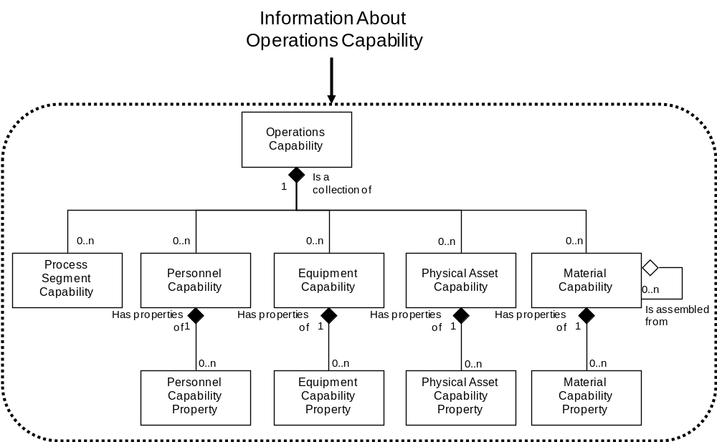
Model of Exchanged Operations Capability Information

This schema uses a common schema for definition of elements that are used in multiple schemas, such as ID, Description, and Value. See the document defining the Common schema for definition of the common elements.

Key Use Assumptions
The model only defines the exchanged information and does not define the use of the information or encapsulation of the information in any defining transactions.

Type Definitions
The XML schema uses a model that defines simple and complex data types for each element. The data types all follow the convention of a suffix of “Type” added to the element name. Elements that have the same name in other B2MML schemas are also prefixed with “Op” to uniquely identify the extension group.

Schema definition:

<xsd:element name = "OpPersonnelCapability" type = " OpPersonnelCapabilityType"/>

<xsd:complexType name = "OpPersonnelCapabilityType">
<xsd:sequence>
<xsd:element name = "PersonnelClassID" type = "PersonnelClassIDType"
minOccurs = "0" />
…
</xsd:complexType>

The method is a modification of the “Venetian Blind Model”, defined in the book Professional XML Schemas, 2001, published by WROX (ISBN 1-861005-47-4). It makes all of the type names global and usable in user derived works, without a loss of context or additional information required to identify the element as of being of the same type as related B2MML elements

OperationsInformation
An operations information element is a collection of OperationsCapability elements.

OperationsCapability
An operations capability is the collection of information about all resources for production for selected times and within a selected site, area, process cell, production unit, or production line. This is made up of capability information about equipment, material, personnel, and process segments. It describes the names, terms, status, and quantities of which the manufacturing control system has knowledge. Operations capability also defines the available capability, committed capability, and unattainable capability of each resource, and each resource within a process segment.

Personnel Capability
Personnel capability is defined as a set of references to persons or personnel classes committed, available, or unattainable for a defined time. Personnel capability contains references to persons or personnel classes. Personnel capability identifies the capability type (available, unattainable, committed), and the time associated with the capability (e.g. third shift on a specific date).

Specific personnel capabilities are defined in personnel capability properties. The personnel capability property may include the quantity of the resource referenced, such as 3 horizontal drill press operators available for the third shift on February 29, 2012.

EquipmentCapability
Equipment capability is defined as a set of references to equipment or equipment classes committed, available, or unavailable for a defined time. Equipment capability contains references to equipment or equipment classes. Equipment capability will usually identify the capability type (available, unattainable, committed) and the time associated with the capability (e.g. third shift on a specific date).

Specific equipment capabilities are defined in equipment capability properties. The equipment capability properties may include the quantity of the resource referenced, such as 3 horizontal drill presses currently available.

PhysicalAssetCapability
Physical asset capability is defined as a set of references to physical assets or physical asset classes committed, available, or unavailable for a defined time. Physical asset capability contains references to physical assets or physical asset classes. Physical asset capability will usually identify the capability type (available, unattainable, committed) and the time associated with the capability (e.g. third shift on a specific date).

Specific physical asset capabilities are defined in physical asset capability properties. The equipment capability properties may include the quantity of the resource referenced.

MaterialCapability
Material capability is defined as a set of references to material lots or sublots committed, available, or unavailable for a defined time. Material capability identifies the capability type (available, unattainable, committed) and the time associated with the capability (e.g. third shift on a specific date).

Specific material capabilities are defined in material capability properties. The material capability properties may include the quantity of the material referenced.

ProcessSegmentCapability
A process segment capability is defined as a logical grouping of personnel resources, equipment resources, physical asset resources and material that is committed, available, or unavailable for a defined process segment for a specific time.

Process segment capability identifies the capability type (available, unattainable, committed), the time associated with the capability (e.g. third shift on a specific date).

Resource Identification
The schemas follow the ANSI/ISA-95 standard by defining resources by class ID or instance ID, or by defining them by class ID and a property value that is used to define a subset of the resource. For example, the figure below illustrates that a segment may require a certain number of milling machine, an equipment class. Other segments may require a subset of milling machine, such as “Fine” milling machines only. In the first case the class name, “Mill”, is sufficient to identify the resource required. In the second case the class name, “Mill”, and property name and value, “Spec” and “Fine”, define the required resource. Alternately a specific resource may be specified for a operations capability, such as specifying milling machine with ID=”Miller#1”.

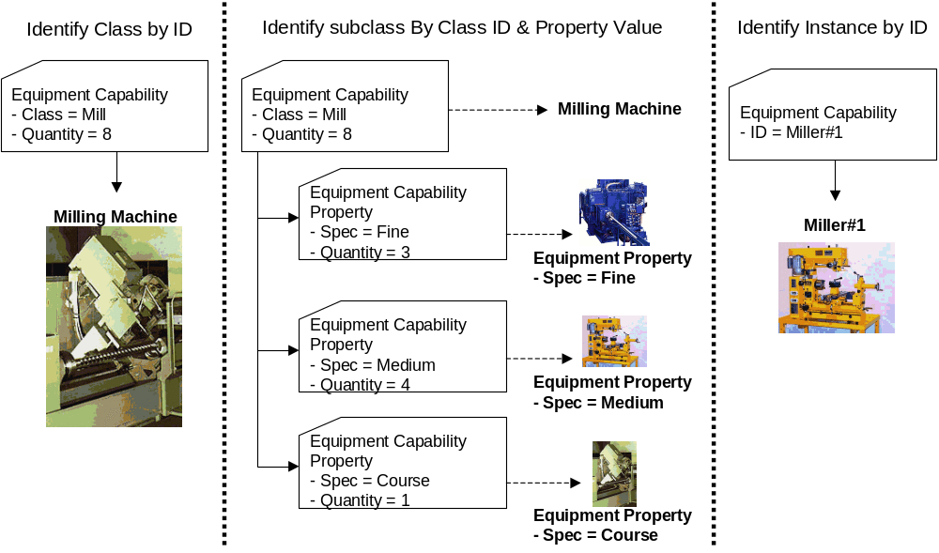

Element Definitions

Element/Type | Description
OperationsCapabilityInformation  OperationsCapabilityInformationType | Contains a collection of OperationsCapability elements. Contains an identification of the capability definitions, a description, the hierarchy scope in the role based equipment hierarchy, the published date of the information and a set of operations capability definitions.  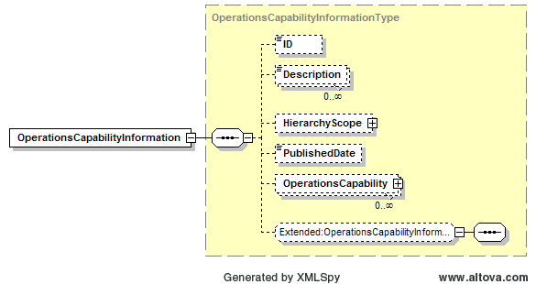
OperationsCapability  OperationsCapabilityType | Contains a description of an operations capability, including the location of the capability, the published date of the capability, the reason for the capability, the time range of the capability, the equipment, material, and personnel resources for the capability, and process segment capabilities within the operations capability.  May also include application defined extension elements.  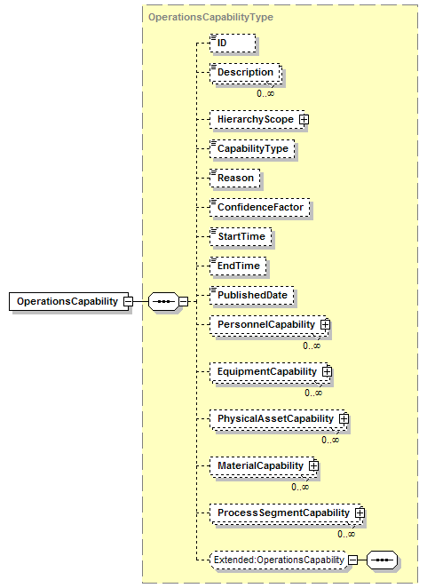
EquipmentCapability  OpEquipmentCapabilityType | Contains a definition of an equipment capability. Including the type of the capability, the hierarchy scope of the capability, the time duration of the capability, the quantity of the capability, and the properties that may be required to identify capabilities of subsets of the class.  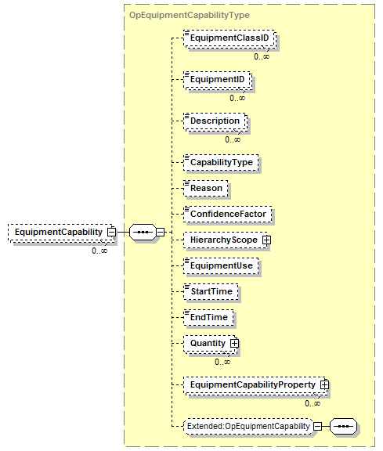
EquipmentCapabilityProperty  OpEquipmentCapabilityPropertyType | Contains a definition of the quantity of an equipment property, including the value used to identify the class subset of the capability, and the quantity of the capability.  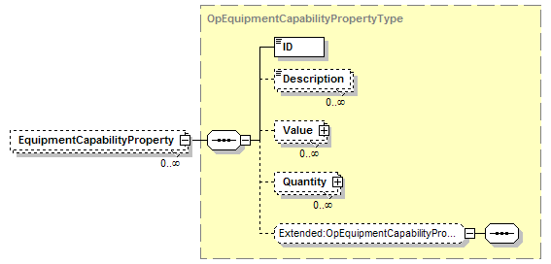
MaterialCapability  OpMaterialCapabilityType | Contains a definition of a material capability. Including the type of the capability, the hierarchy scope of the capability, the time duration of the capability, the quantity of the capability, the use of the material (consumed or produced), any contained material assembly capability definitions, and the properties that may be required to identify capabilities of subsets of the class.  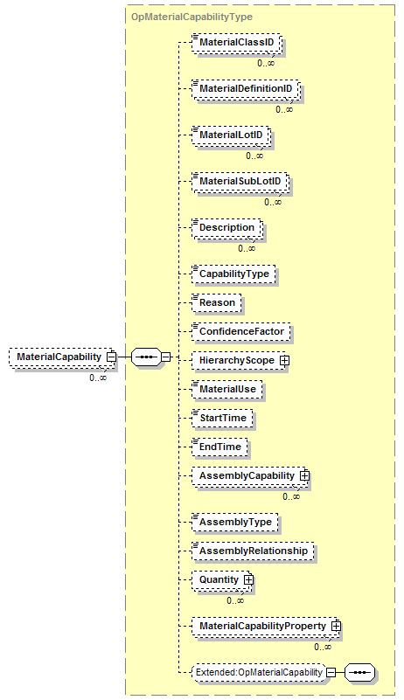
MaterialCapabilityProperty  OpMaterialCapabilityPropertyType | Contains a definition of the quantity of a material property, including the value used to identify the class subset of the capability, the use of the material in the capability, and the quantity of the capability.  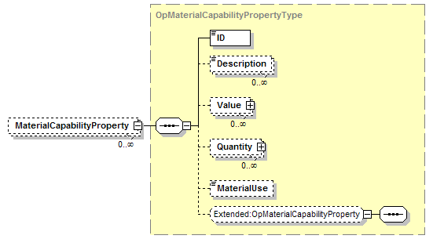
PersonnelCapability  OpPersonnelCapabilityType | Contains a definition of a personnel capability. Including the type of the capability, the hierarchy scope of the capability, the time duration of the capability, the quantity of the capability, and the properties that may be required to identify capabilities of subsets of the class.  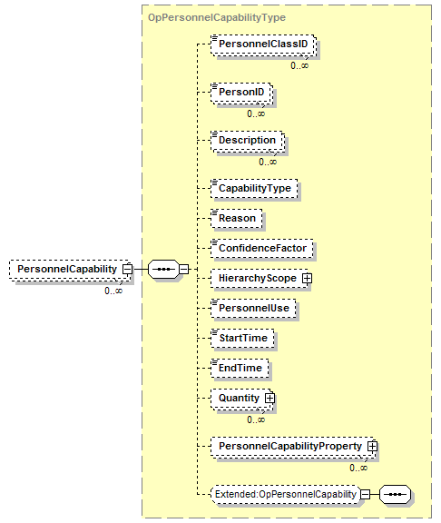
PersonnelCapabilityProperty  OpPersonnelCapabilityPropertyType | Contains a definition of the quantity of a personnel property, including the value used to identify the class subset of the capability, and the quantity of the capability.  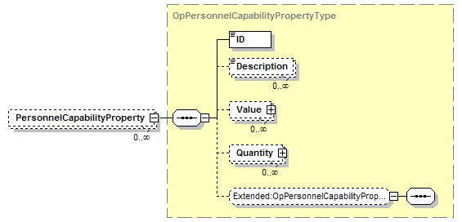
PhysicalAssetCapability  OpPhysicalAssetCapabilityType | Contains a definition of a physical asset capability. Including the type of the capability, the hierarchy scope of the capability, the time duration of the capability, the quantity of the capability, and the properties that may be required to identify capabilities of subsets of the class.  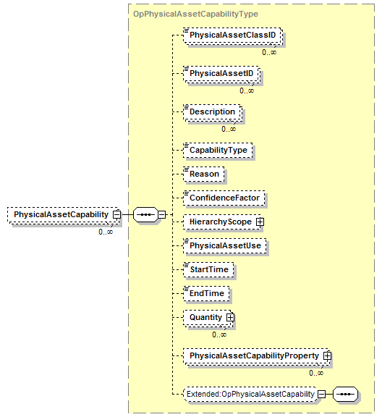
PhysicalAssetCapabilityProperty  OpPhysicalAssetCapabilityPropertyType | Contains a definition of the quantity of a physical asset property, including the value used to identify the class subset of the capability, and the quantity of the capability.  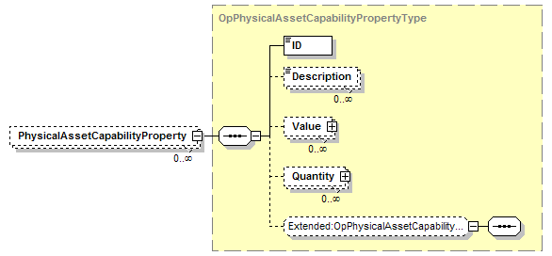
ProcessSegmentCapability  OpProcessSegmentCapabilityType | Contains a definition of a capability for a process segment, includes the identification of the associated process segment, the capability type, the reason for the capability, the location of the capability, the duration of the capability, the personnel, equipment, and material capability definitions, and any encapsulated process segment capabilities.  May also include application defined elements.  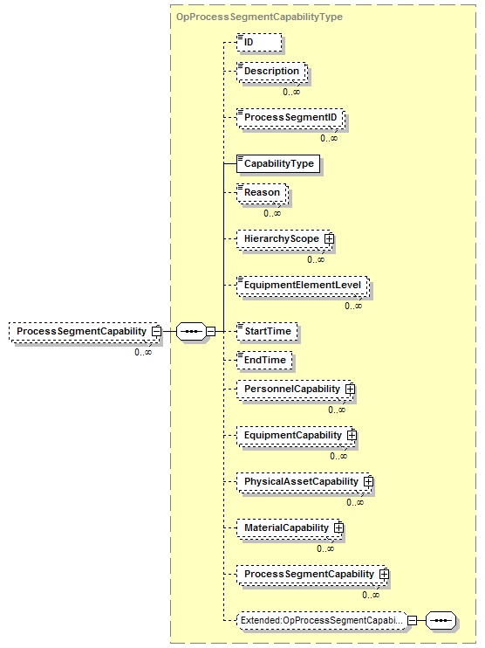

Transaction Elements
The following elements are defined to support the ISA 95 Part 5 transactions, using the transaction data types defined in the B2MML-Common.xsd schema.

Operations capabilityElements | Description
GetOperationsCapabilityInformation | Get an OperationsCapabilityInformation definition.
ShowOperationsCapabilityInformation | Returned information from the GetOperationsCapabilityInformation message.
ProcessOperationsCapabilityInformation | Process an OperationsCapabilityInformation definition.
AcknowledgeOperationsCapabilityInformation | Returned status from the ProcessOperationsCapabilityInformation message.
ChangeOperationsCapabilityInformation | Change an OperationsCapabilityInformation definition.
RespondOperationsCapabilityInformation | Returned status from the ChangeOperationsCapabilityInformation message.
CancelOperationsCapabilityInformation | Cancel an OperationsCapabilityInformation definition.
SyncOperationsCapabilityInformation | Published OperationsCapabilityInformation definition.
GetOperationsCapability | Get an OperationsCapability definition.
ShowOperationsCapability | Returned information from the GetOperationsCapability message.
ProcessOperationsCapability | Process an OperationsCapability definition.
AcknowledgeOperationsCapability | Returned status from the ProcessOperationsCapability message.
ChangeOperationsCapability | Change an OperationsCapability definition.
RespondOperationsCapability | Returned status from the ChangeOperationsCapability message.
CancelOperationsCapability | Cancel an OperationsCapability definition.
SyncOperationsCapability | Published OperationsCapability definition.

Diagram Convention
The schema diagrams using the following convention to illustrate the structure of the schema elements, the type of the elements and attributes, and the rules for optional elements and repetition.

