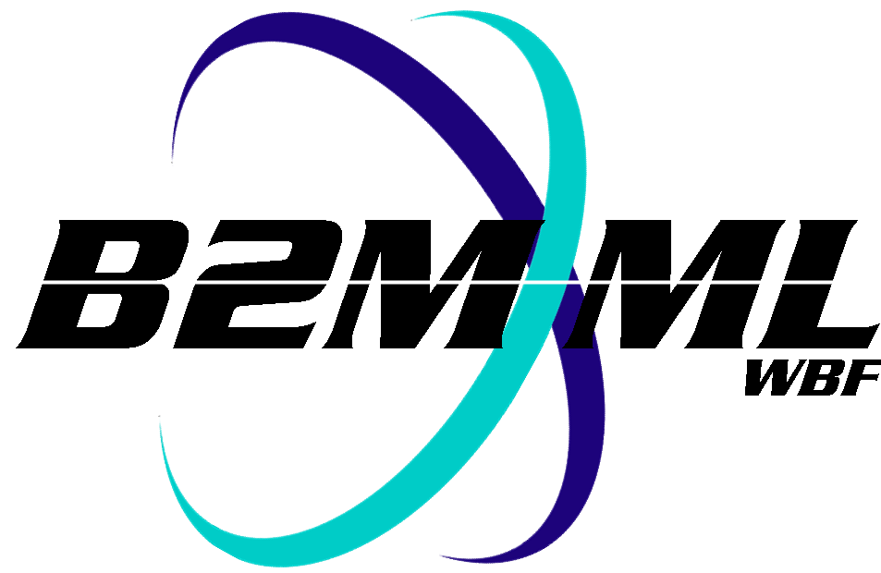
Business To Manufacturing
Markup Language
B2MML – Operations Definition
Version 0500 – March 2011
Operations Definition Schema
Documentation



IMPORTANT: While the information, data, and standards provided in this publication were developed and are presented in good faith in accordance with a reasonable process that was subject to intellectual property and antitrust policies to benefit the industry as a whole, the publication is provided “as is” for information and guidance only, and there is no representation or warranty of any type or kind, including but not limited to warranties of merchantability or fitness for a particular purpose, and no warranty that use of the information, data, or standards will not infringe patent, copyright, trademark, trade secret, or other intellectual property rights of any party.
Table of Contents

1 Schema Scope 3
1.1 Key Information Assumptions 3
1.2 Key Use Assumptions 4
1.3 Type Definitions 4
1.4 OperationsDefinition 4
1.5 ManufacturingBill 4
1.6 OperationsSegment 4
1.6.1 PersonnelSpecification 5
1.6.2 EquipmentSpecification 5
1.6.3 PhyscialAssetSpecification 5
1.6.4 MaterialSpecification 5
1.7 Resource Identification 5
2 Element Definitions 7
3 Transaction Elements 14
4 Diagram Convention 15

Change History:
Change | Date | Person | Description
V0500 | Mar 2011 | Dennis Brandl | - Initial version for ISA 95.02-2010

Copyright © 2011 WBF The Organization for Production Technology
All Rights Reserved. http://www.wbf.org

This WBF Work (including specifications, documents, software, and related items) referred to as the Business To Manufacturing Markup Language (B2MML) is provided by the copyright holders under the following license.

Permission to use, copy, modify, or redistribute this Work and its documentation, with or without modification, for any purpose and without fee or royalty is hereby granted provided the WBF is acknowledged as the originator of this Work using the following statement:

"The Business To Manufacturing Markup Language (B2MML) is used courtesy of the WBF."

In no event shall the WBF, its members, or any third party be liable for any costs, expenses, losses, damages or injuries incurred by use of the Work or as a result of this agreement.

Material from ANSI/ISA-88 and ANSI/ISA-95 series of standards used with permission of ISA - The Instrumentation, Systems, and Automation Society, www.isa.org

Schema Scope
This document defines the information about the definition of operations information that may be exchanged between business systems and manufacturing operations systems. This information is based on the data models and attributes defined in the ANSI/ISA 95.00.02 Enterprise/Control System Integration standard. Contact ISA (The Instrumentation, System, and Automation Society) for copies of the standard. Additional information on the standard is available at www.isa.org.

Key Information Assumptions
The data represented in these schemas is derived from the UML model below. This model is defined in the ANSI/ISA 95.00.02 standard. The information model in the figure below is hierarchical with references to, but does not include, the bill of materials and the bill of resources. The key assumption is that the information will be accessed by an Operations Definition.

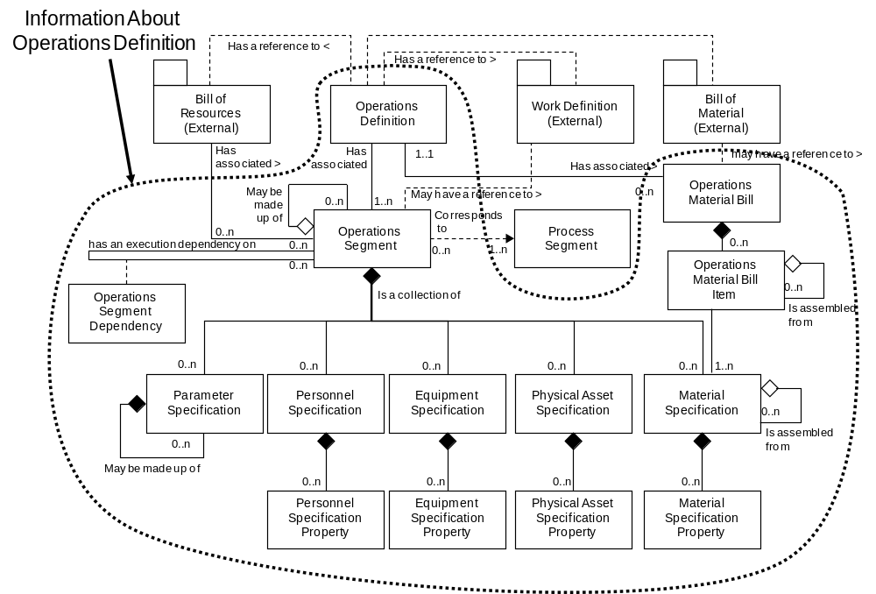
Model of Exchanged Operations Definition Information

This schema uses a common schema for definition of elements that are used in multiple schemas, such as ID, Description, and Value. See the document defining the Common schema for definition of the common elements.

Key Use Assumptions
The model only defines the exchanged information and does not define the use of the information or encapsulation of the information in any defining transactions.

Type Definitions
The XML schema uses a model that defines simple and complex data types for each element. The data types all follow the convention of a suffix of “Type” added to the element name. Elements that have the same name in other B2MML schemas are also prefixed with “Op” to uniquely identify the extension group.

Schema definition:

<xsd:element name = "OpPersonnelSpecification" type = " OpPersonnelSpecificationType"/>

<xsd:complexType name = "OpPersonnelSpecificationType">
<xsd:sequence>
<xsd:element name = "PersonnelClassID" type = "PersonnelClassIDType"
minOccurs = "0" />
…
</xsd:complexType>

The method is a modification of the “Venetian Blind Model”, defined in the book Professional XML Schemas, 2001, published by WROX (ISBN 1-861005-47-4). It makes all of the type names global and usable in user derived works, without a loss of context or additional information required to identify the element as of being of the same type as related B2MML elements

OperationsDefinition
The main structuring element of the schema definition is OperationsDefinition. OperationsDefinition is the container object for exchanged information and includes references to the Work Definitions, Bill Of Materials, and Bill Of Resources. The term Work Definitions is used in ANSI/ISA-95.00.01 to indicate the information that used within operations, such as assembly instructions, flow sheets, or recipes. Additional information exists in the bill of materials, bill of resources, and manufacturing operations systems, but is not defined in the exchange schemas.

ManufacturingBill
A manufacturing bill identifies a material or material class that is needed for operations.
The manufacturing bill includes all uses of the material in production of the product, while the operations segment’s material specification defines just the amount used.

For example: a manufacturing bill may identify 55 Type C left threaded screws, where 20 are used in one operations segment, 20 in another operations segment, and 15 used in a third operations segment.

ManufacturingBill elements define materials that make up the manufacturing bill. These materials may be identified by material class or by material definition.

OperationsSegment
The operations segment information defines what personnel, equipment, physical asset, or material resources are required for execution of the operations segment. It does this by defining the classes of resources, or in some cases the exact instance of a resource required. For example, an assembly segment may require 1 assembler for 2 hours, and 1 assembly machine for 2 hours. In some industries the exact assembly machine may have to be specified, such as “AssemblyMachine#1”.

A operations segment also defines parameters that may be specified when the segment is executed, such as a color specification or manufacturing options.

PersonnelSpecification
PersonnelSpecification elements define the personnel resources, by class or instance, required for production of the product within a operations segment. Such as 2 hours of a painter for a paint segment for a lot size of one widget.

EquipmentSpecification
EquipmentSpecification elements define the equipment resources, by class or instance, required for production of the product within a operations segment. Such as 2 hours for a paint station for a lot size of one widget.

PhyscialAssetSpecification
PhysicalAssetSpecification elements define the physical assets resources, by class or instance, required for operations. Such as 2 hours for a paint station for a lot size of one widget.

MaterialSpecification
MaterialSpecification elements define the material resources, by material class or material definition, required for production of the product within a operations segment. Such as 30 Kg of cooking oil (material class) required for the cooking segment for a lot size of 50 Kg.

Resource Identification
The schemas follow the ANSI/ISA-95 standard by defining resources by class ID or instance ID, or by defining them by class ID and a property value that is used to define a subset of the resource. For example, the figure below illustrates that a segment may require a certain number of milling machine, an equipment class. Other segments may require a subset of milling machine, such as “Fine” milling machines only. In the first case the class name, “Mill”, is sufficient to identify the resource required. In the second case the class name, “Mill”, and property name and value, “Spec” and “Fine”, define the required resource.

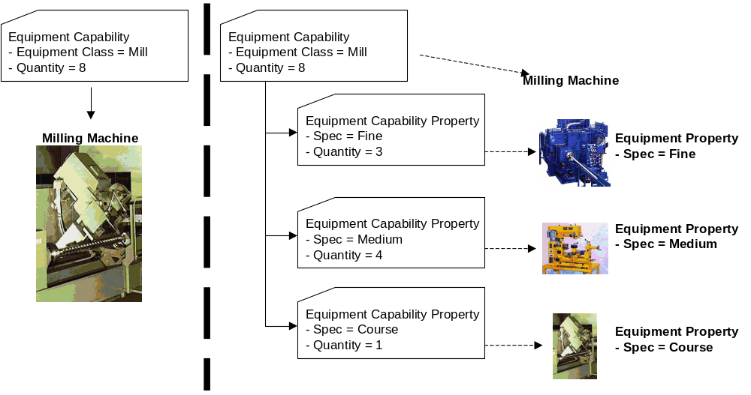

Element Definitions

Element/Type | Description
OperationsDefinitionInformation  OperationsDefinitionInformationType | Contains a list of operation definitions. Includes the hierarchy scope of the information, and the date of publication of the information.  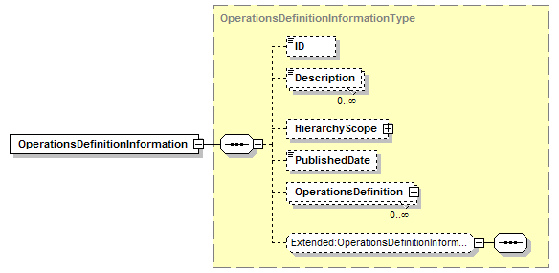
OperationsDefinition  OperationsDefinitionType | Contains an operations definition. Includes the hierarchy scope of the information, the date of publication of the information, the list of materials in the manufacturing bill, the identification of the bill material, the identification of the bill of resources, and the definition of operations segments.  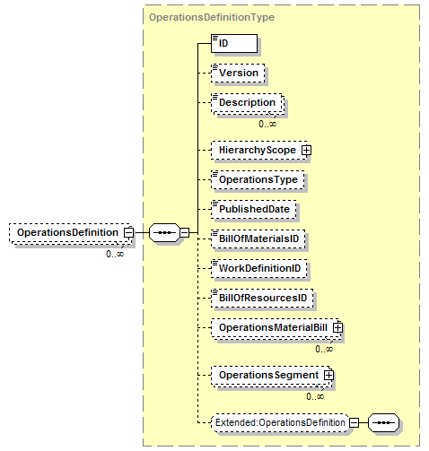
OperationsMaterialBill  OperationsMaterialBillType | Contains the list of operations material bill items.  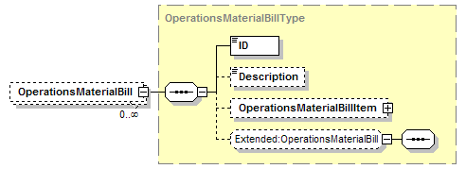
OperationsMaterialBillItem  OperationsMaterialBillItemType | Contains a definition of a material bill item, including the quantity of the material needed, an identification of the material class or definition, any assembly bil of material items, and the corresponding bill of material ID.  A OperationsMaterialBillItem element may have a set of contained AssemblyBillOfMaterialItem elements to support hierarchical material bills.  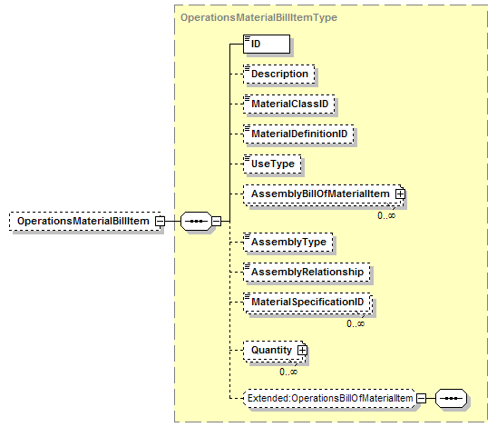
EquipmentSpecification  OpEquipmentSpecificationType | Contains a definition of the equipment resources required for the operations segment. Includes the identification of the class or instance of the resources, the quantity of the resource, and the property specification if required to identify the resource.  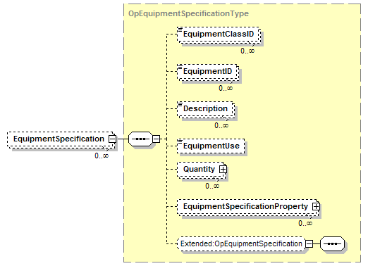
EquipmentSpecificationProperty  OpEquipmentSpecificationPropertyType | Contains a definition of a equipment property required for the operations segment, including the quantity of the resource, and a value used to identify the subset of the class.  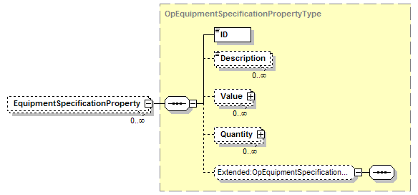
MaterialSpecification  OpMaterialSpecificationType | Contains a definition of the material resources required for the operations segment. Includes the identification of the class or instance of the resources, the quantity of the resource, the use (consumed, produced), any specification assemblies, and the property specification if required to identify the resource.  A ManufacturingSpecification element may have a set of contained AssemblySpecification elements to support hierarchical manufacturing bills.  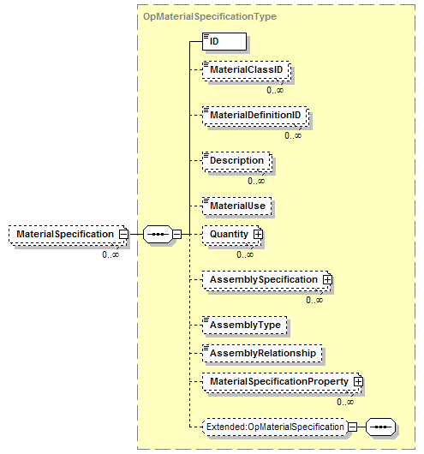
MaterialSpecificationProperty  OpMaterialSpecificationPropertyType | Contains a definition of a material property required for the operations segment, including the quantity of the resource, and a value used to identify the subset of the class.  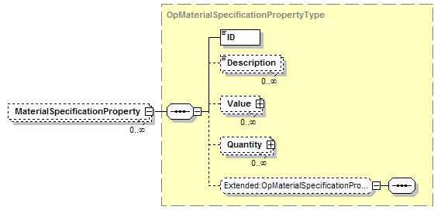
PersonnelSpecification  OpPersonnelSpecificationType | Contains a definition of the personnel resources required for the operations segment. Includes the identification of the class or instance of the resources, the quantity of the resource, and the property specification if required to identify the resource.  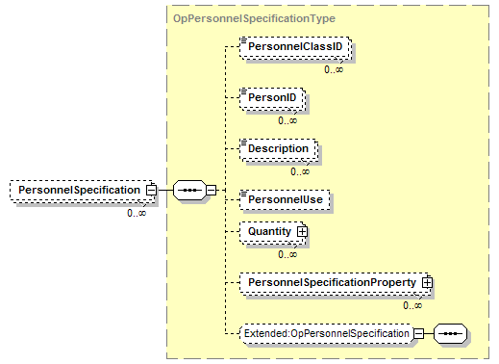
PersonnelSpecificationProperty  OpPersonnelSpecificationPropertyType | Contains a definition of a personnel property required for the operations segment, including the quantity of the resource, and a value used to identify the subset of the class.  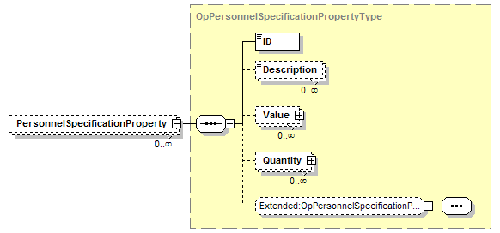
PhysicalAssetSpecification  OpPhysicalAssetSpecificationType | Contains a definition of the physical asset resources required for the operations segment. Includes the identification of the class or instance of the resources, the quantity of the resource, and the property specification if required to identify the resource.  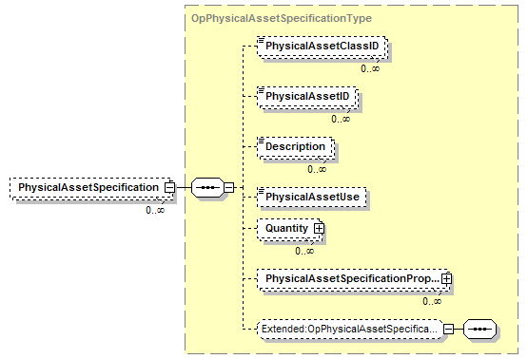
PhysicalAssetSpecificationProperty  OpPhysicalAssetSpecificationPropertyType | Contains a definition of a physical asset property required for the operations segment, including the quantity of the resource, and a value used to identify the subset of the class.  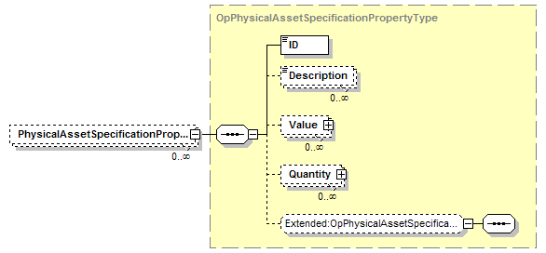
OperationsSegment  OperationsSegmentType | Contains a definition of an operations segment, including the quantity of resources required for the segment (per unit of production), an estimated duration of the segment, an identification of the corresponding process segment, parameters associated with the segment, the segment dependencies, and any encapsulated segments. May also contain application specific elements.  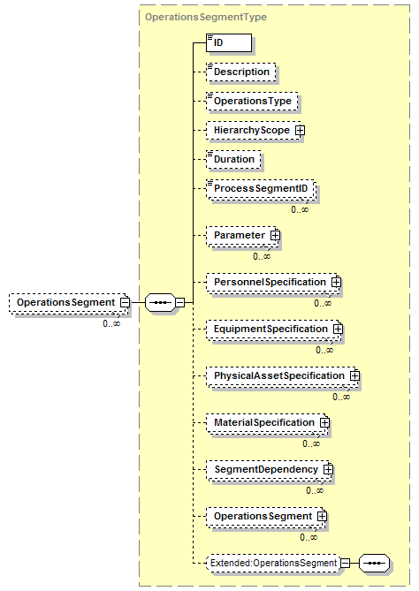

Transaction Elements
The following elements are defined to support the ISA 95 Part 5 transactions, using the transaction data types defined in the B2MML-Common.xsd schema.

Operations Definition Information Elements | Description
GetOperationsDefinitionInformation | Get OperationsDefinitionInformation definitions.
ShowOperationsDefinitionInformation | Returned information from the GetOperationsDefinitionInformation message.
ProcessOperationsDefinitionInformation | Process OperationsDefinitionInformation definitions.
AcknowledgeOperationsDefinitionInformation | Returned status from the ProcessOperationsDefinitionInformation message.
ChangeOperationsDefinitionInformation | Change OperationsDefinitionInformation definitions.
RespondOperationsDefinitionInformation | Returned status from the ChangeOperationsDefinitionInformation message.
CancelOperationsDefinitionInformation | Cancel OperationsDefinitionInformation definitions.
SyncOperationsDefinitionInformation | Published OperationsDefinitionInformation definitions.

Operations Definition Elements | Description
GetOperationsDefinition | Get a OperationsDefinition definition.
ShowOperationsDefinition | Returned information from the GetOperationsDefinition message.
ProcessOperationsDefinition | Process a OperationsDefinition definition.
AcknowledgeOperationsDefinition | Returned status from the ProcessOperationsDefinition message.
ChangeOperationsDefinition | Change a OperationsDefinition definition.
RespondOperationsDefinition | Returned status from the ChangeOperationsDefinition message.
CancelOperationsDefinitionI | Cancel a OperationsDefinition definition.
SyncOperationsDefinition | Published OperationsDefinition definition.

Diagram Convention
The schema diagrams using the following convention to illustrate the structure of the schema elements, the type of the elements and attributes, and the rules for optional elements and repetition.

