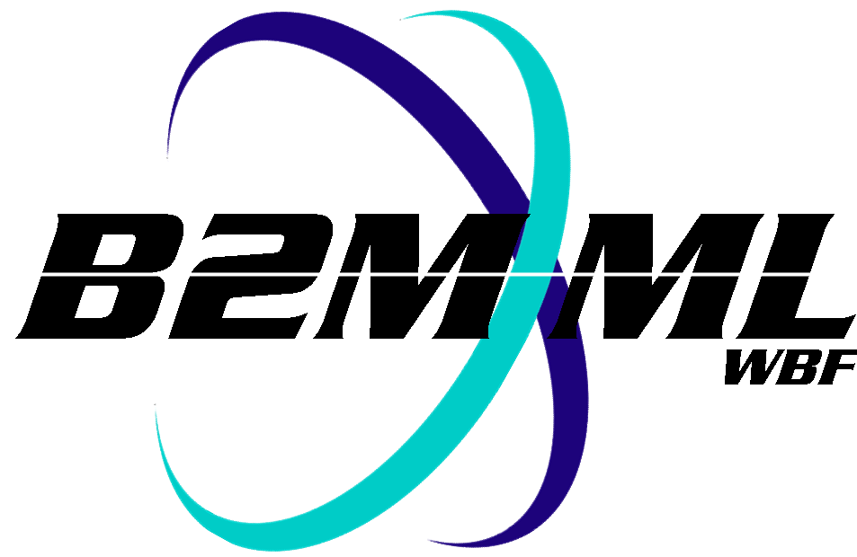
Business To Manufacturing
Markup Language
B2MML – Operations Performance
Version 0500 – March 2011
Operations Performance Schema
Documentation



IMPORTANT: While the information, data, and standards provided in this publication were developed and are presented in good faith in accordance with a reasonable process that was subject to intellectual property and antitrust policies to benefit the industry as a whole, the publication is provided “as is” for information and guidance only, and there is no representation or warranty of any type or kind, including but not limited to warranties of merchantability or fitness for a particular purpose, and no warranty that use of the information, data, or standards will not infringe patent, copyright, trademark, trade secret, or other intellectual property rights of any party.
Table of Contents

1 Schema Scope 4
1.1 Key Information Assumptions 4
1.2 Key Use Assumptions 5
1.3 Type Definitions 5
1.4 OperationsPerformance 5
1.5 OperationsResponse 5
1.6 SegmentResponse 5
1.7 PersonnelActual 6
1.8 EquipmentActual 6
1.9 PhusicalAssetActual 6
1.10 MaterialActual 6
1.11 Identifying Resources 6
1.12 Use within An operations schedule 7
2 Element Definitions 8
3 Transaction Elements 16
4 Diagram Convention 17

Change History:
Change | Date | Person | Description
V0500 | Mar 2011 | Dennis Brandl | Initial version

Copyright © 2011 WBF The Organization for Operations Technology
All Rights Reserved. http://www.wbf.org

This WBF Work (including specifications, documents, software, and related items) referred to as the Business To Manufacturing Markup Language (B2MML) is provided by the copyright holders under the following license.

Permission to use, copy, modify, or redistribute this Work and its documentation, with or without modification, for any purpose and without fee or royalty is hereby granted provided the WBF is acknowledged as the originator of this Work using the following statement:

"The Business To Manufacturing Markup Language (B2MML) is used courtesy of the WBF."

In no event shall the WBF, its members, or any third party be liable for any costs, expenses, losses, damages or injuries incurred by use of the Work or as a result of this agreement.

Material from ANSI/ISA-88 and ANSI/ISA-95 series of standards used with permission of ISA - The Instrumentation, Systems, and Automation Society, www.isa.org

Schema Scope
This document defines the information about Operations Performance information that may be passed from manufacturing operations systems to business systems. This information is based on the data models and attributes defined in the ANSI/ISA 95.00.02 Enterprise/Control System Integration standard. Contact ISA (The Instrumentation, System, and Automation Society) for copies of the standard. Additional information on the standard is available at www.isa.org.

Key Information Assumptions
The data represented in these schemas is derived from the UML model below. This model is defined in the ANSI/ISA 95.00.02-2010 standard. The information model in the figure below is hierarchical, and the assumption is that any operations response information will always be within a contained Operations Performance object.

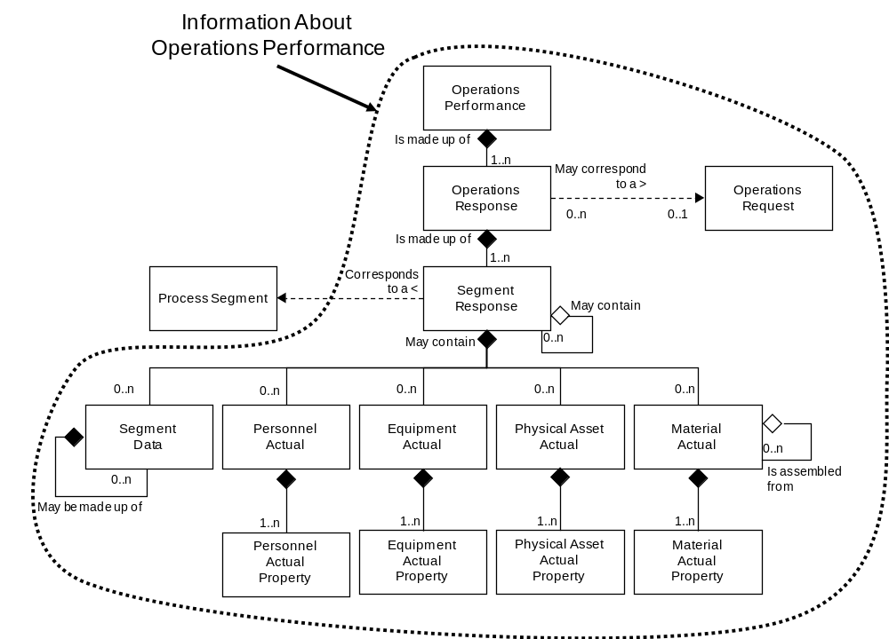
Model of Exchanged Operations Performance Information

This schema uses a common schema for definition of elements that are used in multiple schemas, such as ID, Description, and Value. See the document defining the Common schema for definition of the common elements.

Key Use Assumptions
The model only defines the exchanged information and does not define the use of the information or encapsulation of the information in any defining transactions.

Type Definitions
The XML schema uses a model that defines simple and complex data types for each element. The data types all follow the convention of a suffix of “Type” added to the element name. Elements that have the same name in other B2MML schemas are also prefixed with “Op” to uniquely identify the extension group.

Schema definition:

<xsd:element name = "OpPersonnelActual" type = " OpPersonnelActualType"/>

<xsd:complexType name = "OpPersonnelActualType">
<xsd:sequence>
<xsd:element name = "PersonnelClassID" type = "PersonnelClassIDType"
minOccurs = "0" />
…
</xsd:complexType>

The method is a modification of the “Venetian Blind Model”, defined in the book Professional XML Schemas, 2001, published by WROX (ISBN 1-861005-47-4). It makes all of the type names global and usable in user derived works, without a loss of context or additional information required to identify the element as of being of the same type as related B2MML elements

OperationsPerformance
An Operations Performance report is made up of a set of 1 or more operation responses. The Operations Performance also contains the information that defines the context of the report, such as start time, end time, location, and published date.

OperationsResponse
Operation responses are the response from operations that is associated with an Operations Request. There may be one or more operation responses for a single operation request if the facility needs to split the request into smaller elements of work. For example a single request for the operations of “200 gears” may be reported on by 10 response objects of “20 gears” each because of manufacturing restrictions.

A result may include the status of the request, such as the percentage complete, a finished status, or an aborted status.

SegmentResponse
The operations response for a specific segment of operations is defined as a segment response. A segment response may be made up of zero or more sets of information on operations data, personnel actual, equipment actual, materials consumed actual, materials produced actual, and consumables actual. A segment response may include an identification of the associated process segment. the actual starting and stopping time of the segment, and the duration of the segment.

A SegmentResponse is also included as an optional element in a OperationsRequest. In those cases the SegmentResponse defines elements that are to be returned with a OperationsResponse. In this use it basically defines a template of information to be filled in and returned. A segment response contains an element (RequiredByRequestedSegmentresponse) that is used in a OperationsSchedule to indicate if the including element is required or optional in a response from a request. The value of the RequiredByRequestedSegmentResponse element may be extended on an application specific basis.

NOTE: The SegmentResponse element (OpSegmentResponseType) is defined in the file:
B2MML-V0500-OperationsPerformanceTypes.xsd

PersonnelActual
A personnel actual in an operations response identifies a personnel resource by class ID or by instance ID used during the specified segment of operations.

EquipmentActual
An equipment actual in an operations response identifies an equipment resource by class ID or instance ID used during the specifiend segment of operations.

PhusicalAssetActual
A physical asset actual in an operations response identifies a physical asset resource by class ID or instance ID used during the specified segment of operations.

MaterialActual
A material produced, material consumed, or consumable material actually used are identified in a MaterialActual. This identifies a material resource by class ID, definition ID, Lot ID, and/or Sublot ID produced or consumed during the specified segment of operations.

Identifying Resources
The schemas follow the ANSI/ISA-95 standard by defining resources by class ID or instance ID, or by defining them by class ID and a property value that is used to define a subset of the resource. For example, the figure below illustrates that a segment may require a certain number of milling machine, an equipment class. Other segments may require a subset of milling machine, such as “Fine” milling machines only. In the first case the class name, “Mill”, is sufficient to identify the resource required. In the second case the class name, “Mill”, and property name and value, “Spec” and “Fine”, define the required resource. Alternately a specific resource may be identified in a Operations Performance report, such as specifying an actual milling machine with ID=”Miller#1”.

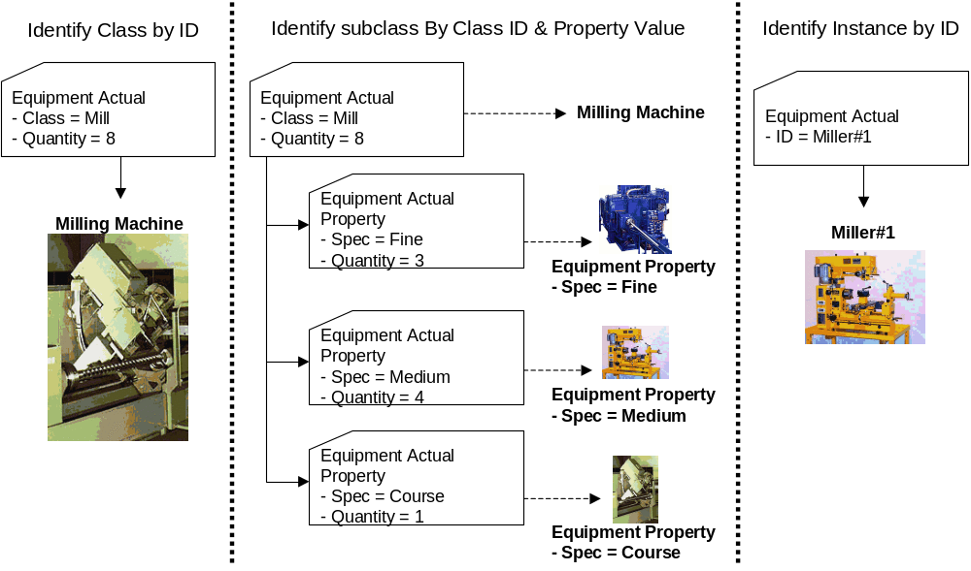

Use within An operations schedule
The SegmentResponseType is also used in an operations schedule to define the requested segment response for a segment of operations. This defines the structure and elements to be returned as a response for the operations schedule. The RequestedBySegmentResponse attribute is used to indicate if the element is a required or optional element in a response.

Element Definitions

Element/Type | Description
OperationsPerformance  OperationsPerformanceType | The top level element. Contains a definition of a report on Operations Performance, including the hierarchy scope of the information, the operations type, the publication data of the performance report, the ID of the associated operations schedule, the duration of the Operations Performance, and the list of operations responses making up the Operations Performance report. May include application specific defined elements.  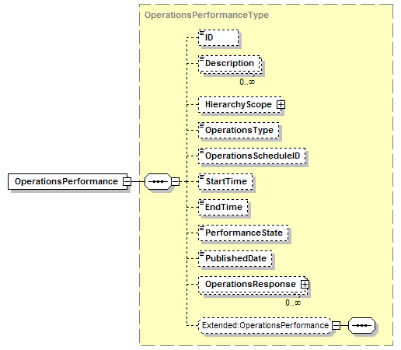
OperationsResponse  OperationsResponseType | Contains a definition of an operations response report, including the identification of an associated operations request, the product produced, the operations type, the duration of the report, and the segments making up the operations response. May include application specific defined elements. May be a top level element for defined scopes.  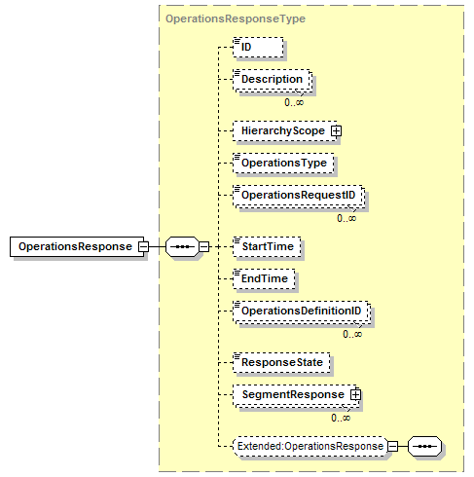
SegmentResponse  OpSegmentResponseType | Contains a definition of a report on a segment. Includes the duration, operations segment type, operations data, personnel, equipment, physical assets, and material.  [Note: The RequiredByRequestedSegmentResponse element is only used when this is included as part of an operations schedule schema.]  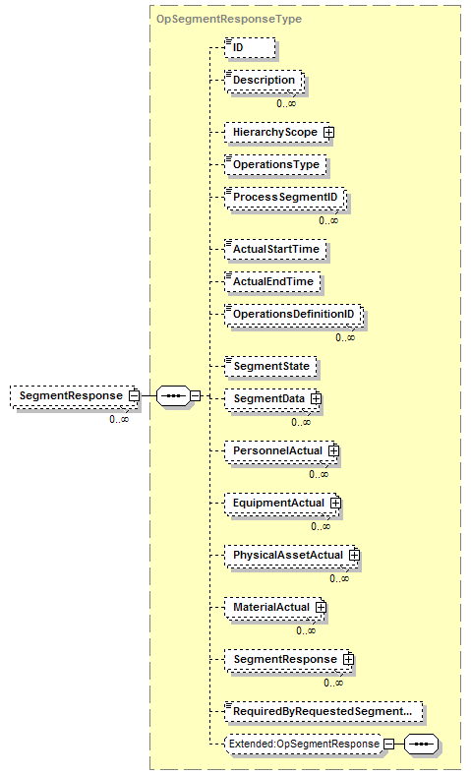
EquipmentlActual  OpEquipmentlActualType | Contains a report on actual equipment resources used and use of the equipment. May define the quantity of the resource used, or may contain a list of property definitions and quantities for each property subset.  [Note: The RequiredByRequestedSegmentResponse element is only used when this is part of an operations schedule schema.]  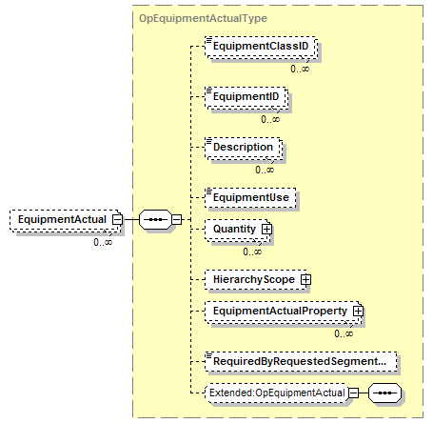
EquipmentlActualProperty  OpEquipmentlActualPropertyType | Contains a definition of actual equipment resources used, for a subset of the resource identified by a property value. Includes the quantity of the resources used.  [Note: The RequiredByRequestedSegmentResponse element is only used when this is part of an operations schedule schema.]  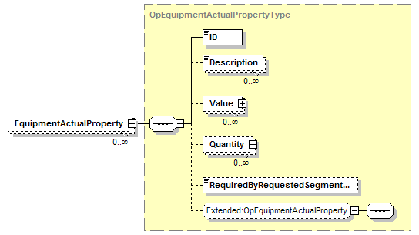
MaterialActual  OpMaterialActualType | Contains a report on actual material resources used and use of the material. May define the quantity of the material, or may contain a list of property definitions and quantities for each property subset.  A MaterialActual element may have a set of contained AssemblyActual elements to support hierarchical manufacturing bills.  [Note: The RequiredByRequestedSegmentResponse element is only used when this is part of an operations schedule schema.]  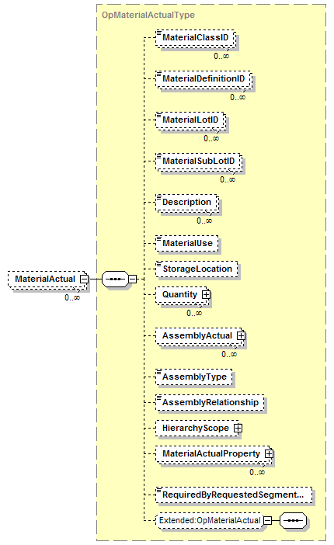
MaterialActualProperty  OpMaterialActualPropertyType | Contains a definition of actual material resources used, for a subset of the resource identified by a property value. Includes the quantity of the resource used.  [Note: The RequiredByRequestedSegmentResponse element is only used when this is part of an operations schedule schema.]  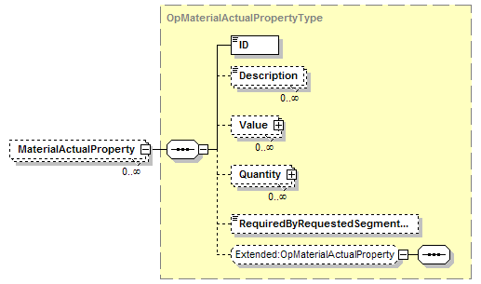
PersonnelActual  OpPersonnelActualType | Contains a report on actual personnel resources used and use. May define the quantity of the resource used, or may contain a list of property definitions and quantities for each property subset.  [Note: The RequiredByRequestedSegmentResponse element is only used when this is part of an operations schedule schema.]  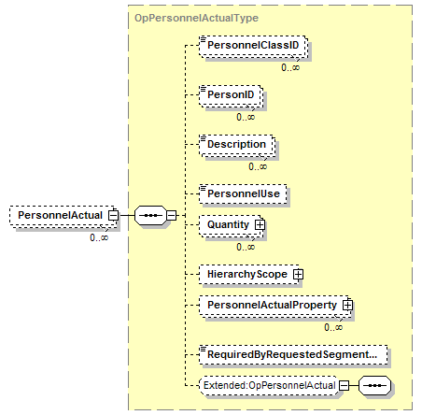
PersonnelActualProperty  OpPersonnelActualPropertyType | Contains a definition of actual personnel resources used, for a subset of the resource identified by a property value. Includes the quantity of the resources used.  [Note: The RequiredByRequestedSegmentResponse element is only used when this is part of an operations schedule schema.]  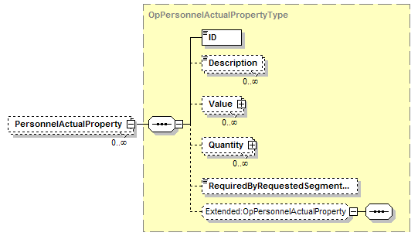
PhysicalAssetActual  OpPhysicalAssetActualType | Contains a report on actual physical asset resources used and use. May define the quantity of the resource used, or may contain a list of property definitions and quantities for each property subset.  [Note: The RequiredByRequestedSegmentResponse element is only used when this is part of an operations schedule schema.]  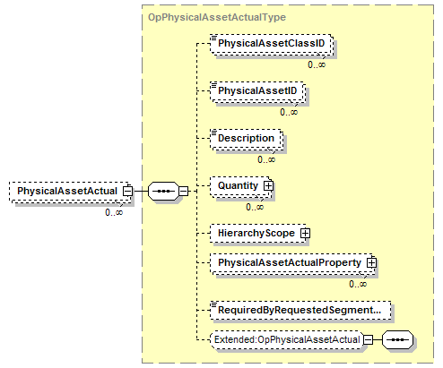
PhysicalAssetActualProperty  OpPhysicalAssetActualPropertyType | Contains a definition of actual physical asset resources used, for a subset of the resource identified by a property value. Includes the quantity of the resources used.  [Note: The RequiredByRequestedSegmentResponse element is only used when this is part of an operations schedule schema.]  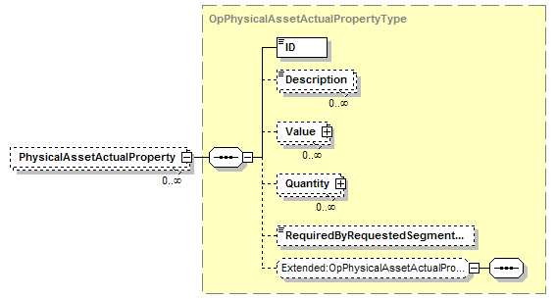
SegmentData  OpSegmentDataType | Contains a definition of an operations data element, Includes the ID of the information and the value for the date, and nested segment data elements..  [Note: The RequiredByRequestedSegmentResponse element is only used when this is part of an operations schedule schema.]  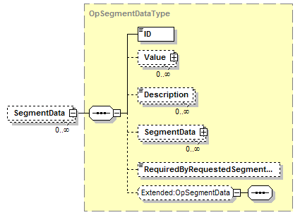

Transaction Elements
The following elements are defined to support the ISA 95 Part 5 transactions, using the transaction data types defined in the B2MML-Common.xsd schema.

Operations Performance Elements | Description
GetOperationsPerformance | Get OperationsPerformance definition.
ShowOperationsPerformance | Returned information from the GetOperationsPerformance message.
ProcessOperationsPerformance | Process OperationsPerformance definition.
AcknowledgeOperationsPerformance | Returned status from the ProcessOperationsPerformance message.
ChangeOperationsPerformance | Change OperationsPerformance definition.
RespondOperationsPerformance | Returned status from the ChangeOperationsPerformance message.
CancelOperationsPerformance | Cancel OperationsPerformance definition.
SyncOperationsPerformance | Published OperationsPerformance definition.

Diagram Convention
The schema diagrams using the following convention to illustrate the structure of the schema elements, the type of the elements and attributes, and the rules for optional elements and repetition.

