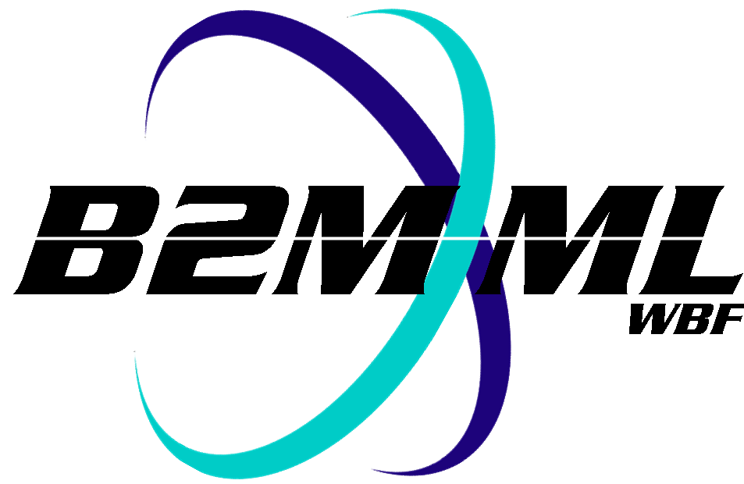
Business To Manufacturing
Markup Language
B2MML – Operations Schedule
Version 0500 – March 2011
Operations Schedule Schema
Documentation



IMPORTANT: While the information, data, and standards provided in this publication were developed and are presented in good faith in accordance with a reasonable process that was subject to intellectual property and antitrust policies to benefit the industry as a whole, the publication is provided “as is” for information and guidance only, and there is no representation or warranty of any type or kind, including but not limited to warranties of merchantability or fitness for a particular purpose, and no warranty that use of the information, data, or standards will not infringe patent, copyright, trademark, trade secret, or other intellectual property rights of any party.
Table of Contents

1 Schema Scope 4
1.1 Key Information Assumptions 4
1.2 Key Use Assumptions 5
1.3 Type Definitions 5
1.4 OperationsSchedule 5
1.5 OperationsRequest 5
1.6 SegmentRequirement 5
1.7 SegmentResponse 5
1.8 PersonnelRequirement 6
1.9 EquipmentRequirement 6
1.10 PhysicalAssetRequirement 6
1.11 MaterialRequirement 6
1.12 Resource Identification 6
2 Element Definitions 8
3 Transaction Elements 16
4 Diagram Convention 17

Change History:
Change | Date | Person | Description
V0500 | Mar 2011 | Dennis Brandl | - Initial version for ISA 95.02-2010

Copyright © 2011 WBF The Organization for Operations Technology
All Rights Reserved. http://www.wbf.org

This WBF Work (including specifications, documents, software, and related items) referred to as the Business To Manufacturing Markup Language (B2MML) is provided by the copyright holders under the following license.

Permission to use, copy, modify, or redistribute this Work and its documentation, with or without modification, for any purpose and without fee or royalty is hereby granted provided the WBF is acknowledged as the originator of this Work using the following statement:

"The Business To Manufacturing Markup Language (B2MML) is used courtesy of the WBF."

In no event shall the WBF, its members, or any third party be liable for any costs, expenses, losses, damages or injuries incurred by use of the Work or as a result of this agreement.

Material from ANSI/ISA-88 and ANSI/ISA-95 series of standards used with permission of ISA - The Instrumentation, Systems, and Automation Society, www.isa.org

Schema Scope
This document defines the information about Operations schedules sent from business systems to manufacturing operations systems. This information is based on the data models and attributes defined in the ANSI/ISA 95.00.02 Enterprise/Control System Integration standard. Contact ISA (The Instrumentation, System, and Automation Society) for copies of the standard. Additional information on the standard is available at www.isa.org.

Key Information Assumptions
The data represented in these schemas is derived from the UML model below. This model is defined in the ANSI/ISA 95.00.02 standard. The information model in the figure below is hierarchical, and the assumption is that any Operations request information will always be within a contained Operations schedule object.

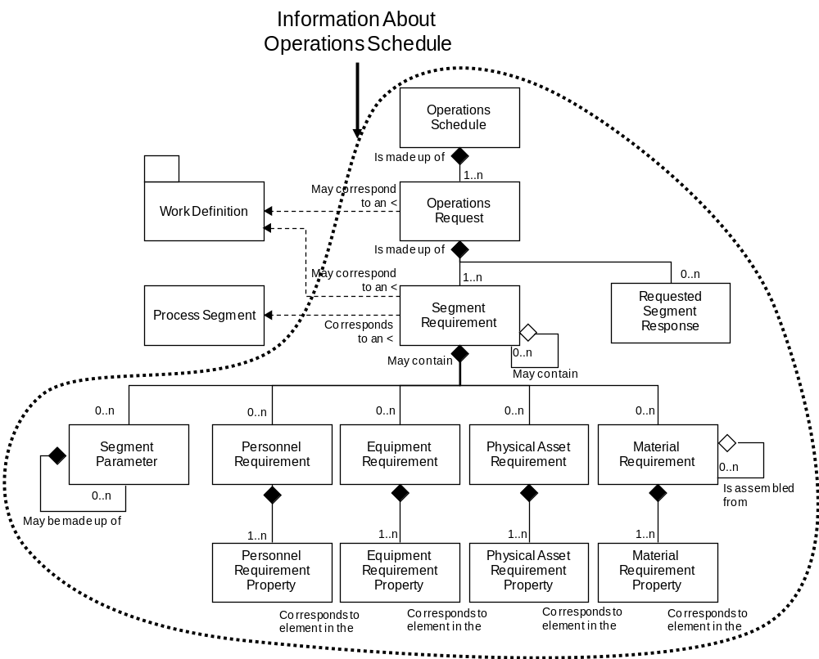
Model of Exchanged Operations Schedule Information

This schema uses a common schema for definition of elements that are used in multiple schemas, such as ID, Description, and Value. This schema also includes the Operations Performance schema definition for the requested segment response structure. See the document defining the Common schema for definition of the common elements. See the document defining the Operations Performance schema for the definition of the requested segment response.

Key Use Assumptions
The model only defines the exchanged information and does not define the use of the information or encapsulation of the information in any defining transactions.

Type Definitions
The XML schema uses a model that defines simple and complex data types for each element. The data types all follow the convention of a suffix of “Type” added to the element name. Elements that have the same name in other B2MML schemas are also prefixed with “Op” to uniquely identify the extension group.

Schema definition:

<xsd:element name = "OpPersonnelRequirement" type = " OpPersonnelRequirementType"/>

<xsd:complexType name = " OpPersonnelRequirementType">
<xsd:sequence>
<xsd:element name = "PersonnelClassID" type = "PersonnelClassIDType"
minOccurs = "0" />
…
</xsd:complexType>

The method is a modification of the “Venetian Blind Model”, defined in the book Professional XML Schemas, 2001, published by WROX (ISBN 1-861005-47-4). It makes all of the type names global and usable in user derived works, without a loss of context or additional information required to identify the element as of being of the same type as related B2MML elements

OperationsSchedule
An operations schedule is made up of a set of 1 or more Operations requests. The Operations schedule also contains the information that defines the context of the schedule, such as start time, end time, location, and published date. The main structuring element of the schema definition is OperationsSchedule.

OperationsRequest
An operations request defines a request for Operations.

An operations request identifies the associated Work Definition. An operations request must contain at least one segment requirement, even it spans all required operations..

SegmentRequirement
An operations request is made up of one or more segment requirements. Each segment requirement may correspond to, or reference, an identified process segment. The segment requirement references the segment capability to which the associated personnel, equipment, physical assets materials, and segment parameters

SegmentResponse
An operations request may include a SegmentResponse element that defines the data to be returned after the execution of the segment.

NOTE: The SegmentResponse element (OpSegmentResponseType) is defined in the file:
B2MML-V0500-OperationsPerformanceTypes.xsd
.

PersonnelRequirement
A personnel requirement and the associated personnel requirement property elements define to the number, type, duration, and scheduling of specific certifications and job classifications needed to support the current Operations request.

EquipmentRequirement
The Operations request may include one or more requirements for, or constraints upon, the equipment that the facility shall use in the Operations process for the scheduled item. Requirements can be as generic as materials of construction, or it can as specific as a particular piece of equipment. Each of these requirements is defined in an EquipmentRequirement element and property.

PhysicalAssetRequirement
The Operations request may include one or more requirements for, or constraints upon, the physical assets that the facility shall use in the Operations process for the scheduled item.

MaterialRequirement
A MaterialRequirement defines a requirement for a material to be produced or used. A material requirement may include the total quantity of the material to be produced or consumed and unit of measure, such as 5000 Lbs, and an acceptable range for the quantity of material. Material may be defined by Material Class ID, Material Definition ID, Material Lot ID, and/or Material Sublot ID. A MaterialRequirement element includes an element that specifies if the material is to be consumed, produced, or is a consumable material

Resource Identification
The schemas follow the ANSI/ISA-95 standard by defining resources by class ID or instance ID, or by defining them by class ID and a property value that is used to define a subset of the resource. For example, the figure below illustrates that a segment may require a certain number of milling machine, an equipment class. Other segments may require a subset of milling machine, such as “Fine” milling machines only. In the first case the class name, “Mill”, is sufficient to identify the resource required. In the second case the class name, “Mill”, and property name and value, “Spec” and “Fine”, define the required resource. Alternately a specific resource may be specified for an Operations schedule, such as requiring milling machine with ID=”Miller#1”.

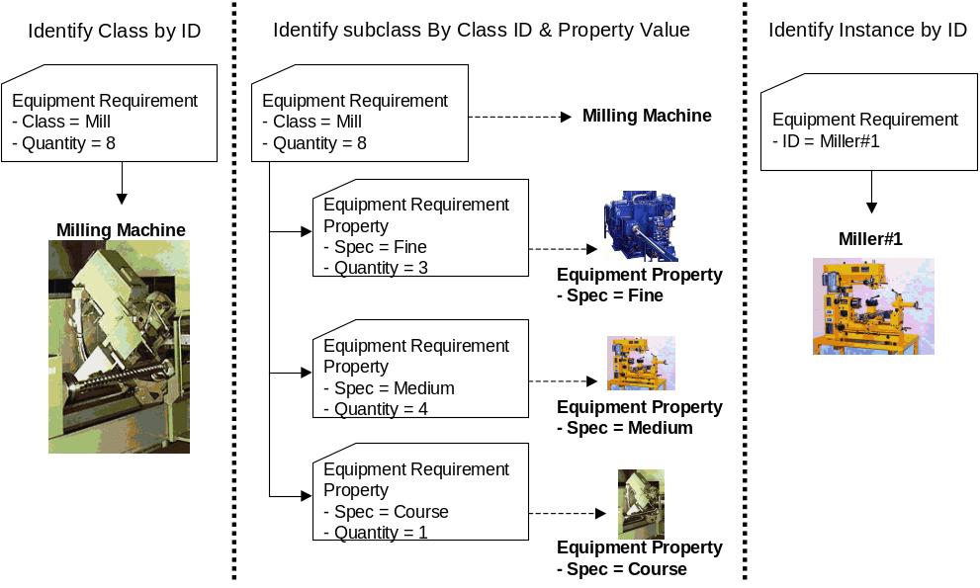

Element Definitions

Element/Type | Description
OperationsSchedule  OperationsScheduleType | Contains a definition of an Operations schedule, including the hierarchy scope of the scheduled elements, the publication date of the schedule, the time range of the schedule, and the list of Operations requests that make up the schedule.  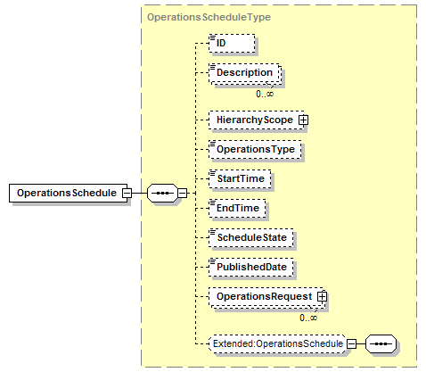
OperationsRequest  OperationsRequestType | Contains a definition of an Operations Request element of an Operations Schedule, including the associated operation to be performed, the time range of the request, the priority of the request, the segment requirements of the request, and the definition of the expected segment response. 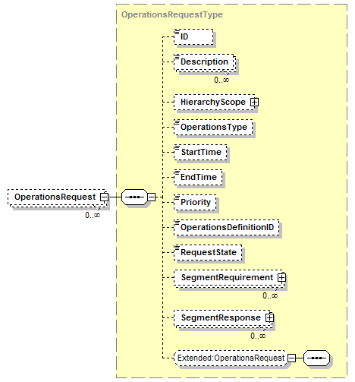
SegmentRequirement  OpSegmentRequirementType | Contains a definition of the schedule for a specific segment of Operations, including an identification of the associated process segment, the time range of the request, the expected duration of the request, Operations parameters for the segment, and the definition of the personnel, equipment, physical assets, material produced, material consumed, and consumables to be used in Operations.  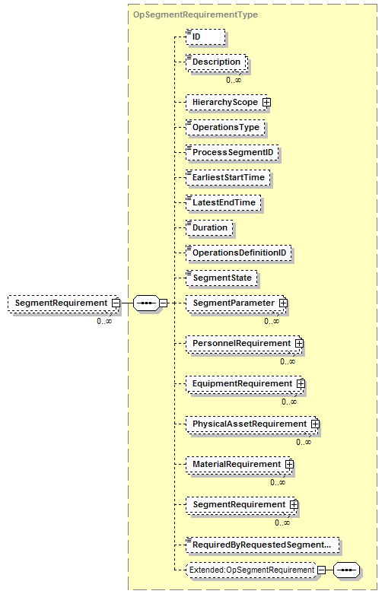
MaterialRequirement  OpMaterialRequirementType | Contains a definition of a material, including an identification of the use of the material, the quantity of the material or a definition of required subsets identified by resource properties.  A MaterialRequirement element may have a set of contained AsemblyRequirement elements to support hierarchical manufacturing bills.  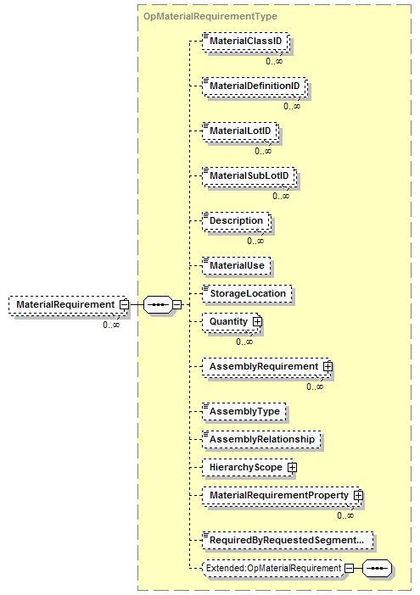
MaterialRequirementProperty  OpMaterialRequirementPropertyType | Contains a definition of a subset of a material used in a segment requirement, including the value used to identify the subset and the quantity of the material used.  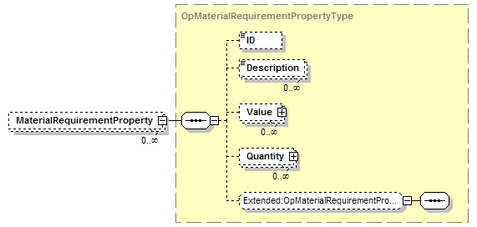
EquipmentlRequirement  OpEquipmentlRequirementType | Contains a definition of an equipment requirement for a segment requirement, including an identification of the quantity of the resource used, or a definition of required subsets identified by resource properties.  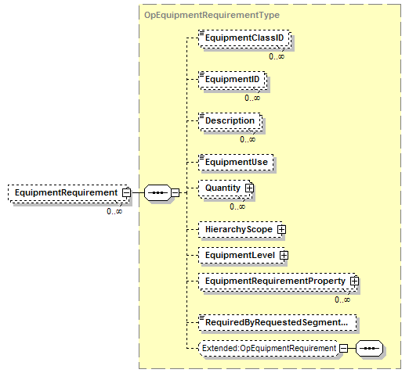
EquipmentRequirementProperty  OpEquipmentRequirementPropertyType | Contains a definition of a subset of an equipment resource used in a segment requirement, including the value used to identify the subset and the quantity of the resource used.  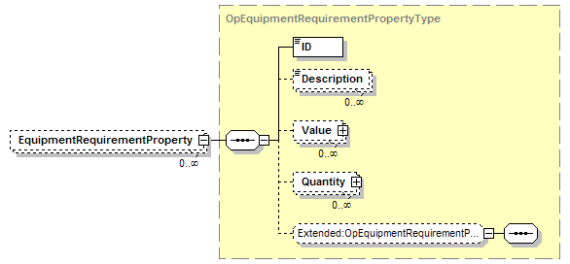
PersonnelRequirement  OpPersonnelRequirementType | Contains a definition of a personnel requirement for a segment requirement, including an identification of the quantity of the resource used, or a definition of required subsets identified by resource properties.  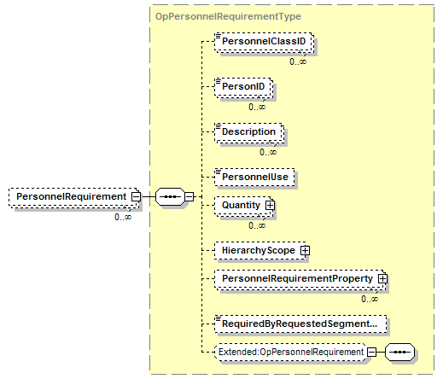
PersonnelRequirementProperty  OpPersonnelRequirementPropertyType | Contains a definition of a subset of a personnel resource used in a segment requirement, including the value used to identify the subset and the quantity of the resource used.  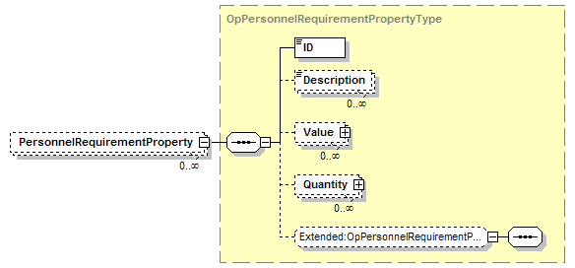
PhysicalAssetRequirement  OpPhysicalAssetRequirementType | Contains a definition of a physical asset requirement for a segment requirement, including an identification of the quantity of the resource used, or a definition of required subsets identified by resource properties.  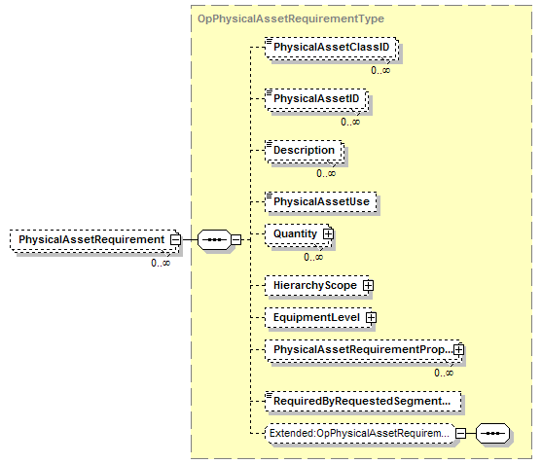
PhysicalAssetRequirementProperty  OpPhysicalAssetRequirementPropertyType | Contains a definition of a subset of a physical asset resource used in a segment requirement, including the value used to identify the subset and the quantity of the resource used.  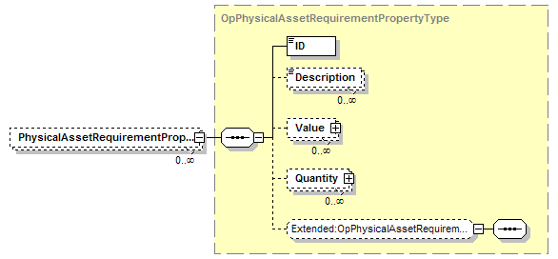
SegmentParameter  ParameterType | Contains a definition of a segment parameter, as a ParameterType, including the value for the parameter.  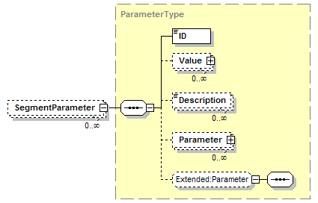

Transaction Elements
The following elements are defined to support the ISA 95 Part 5 transactions, using the transaction data types defined in the B2MML-Common.xsd schema.

Operations Schedule Elements | Description
GetOperationsSchedule | Get OperationsSchedule definition.
ShowOperationsSchedule | Returned information from the GetOperationsSchedule message.
ProcessOperationsSchedule | Process OperationsSchedule definition.
AcknowledgeOperationsSchedule | Returned status from the ProcessOperationsSchedule message.
ChangeOperationsSchedule | Change OperationsSchedule definition.
RespondOperationsSchedule | Returned status from the ChangeOperationsSchedule message.
CancelOperationsSchedule | Cancel OperationsSchedule definition.
SyncOperationsSchedule | Published OperationsSchedule definition.

Diagram Convention
The schema diagrams using the following convention to illustrate the structure of the schema elements, the type of the elements and attributes, and the rules for optional elements and repetition.

