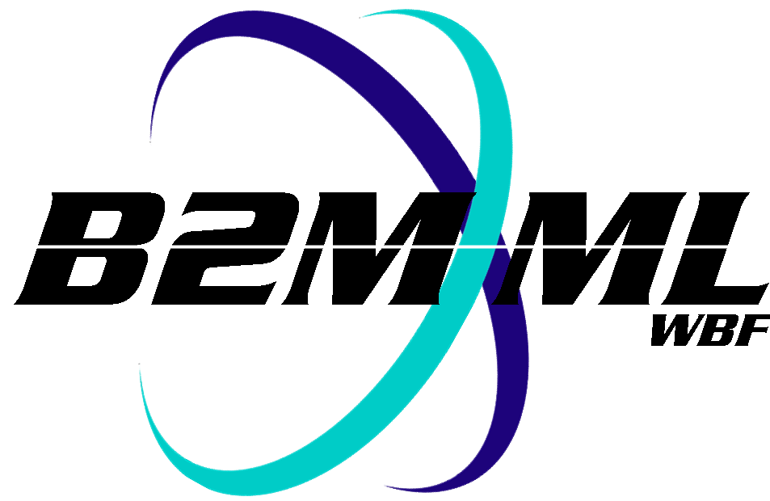
Business To Manufacturing
Markup Language
B2MML - Personnel
Version 0500 – March 2011
Personnel Schema
Documentation


IMPORTANT: While the information, data, and standards provided in this publication were developed and are presented in good faith in accordance with a reasonable process that was subject to intellectual property and antitrust policies to benefit the industry as a whole, the publication is provided “as is” for information and guidance only, and there is no representation or warranty of any type or kind, including but not limited to warranties of merchantability or fitness for a particular purpose, and no warranty that use of the information, data, or standards will not infringe patent, copyright, trademark, trade secret, or other intellectual property rights of any party.
Table of Contents

1 Schema Scope 3
1.1 Key Information Assumptions 3
1.2 Key Use Assumptions 4
1.3 PersonnelInformation 4
1.4 Person 4
1.5 PersonnelClass 4
1.6 QualificationTestSpecification 4
2 Element Definitions 5
3 Transaction Elements 9
4 Diagram Convention 11

Change History:
Change | Date | Person | Description
V01 | 7 April 2002 | Dennis Brandl  Dave Emerson | Initial release
V02 | 23 Sept 2003 | Dennis Brandl  Dave Emerson | - Added Location to person, Changed ##any to "Any" element of type "AnyType"
V03 | 26 Aug 2005 | Dennis Brandl  Dave Emerson | - Added substitution groups. One group added just before each Any element.
V0301 | 29 Dec 2005 | Dennis Brandl | - Only changed version to v0301
V04 | 04 June 2007 | Dennis Brandl | - Added transaction elements
V0401 | Oct 2008 | Dennis Brandl | - Changed Version number
V0500 | Mar 2011 | Dennis Brandl | - Updated for ISA 95.02-2010  - Removed ##any elements

Copyright © 2011 WBF The Organization for Production Technology
All Rights Reserved. http://www.wbf.org

This WBF Work (including specifications, documents, software, and related items) referred to as the Business To Manufacturing Markup Language (B2MML) is provided by the copyright holders under the following license.

Permission to use, copy, modify, or redistribute this Work and its documentation, with or without modification, for any purpose and without fee or royalty is hereby granted provided the WBF is acknowledged as the originator of this Work using the following statement:

"The Business To Manufacturing Markup Language (B2MML) is used courtesy of the WBF."

In no event shall the WBF, its members, or any third party be liable for any costs, expenses, losses, damages or injuries incurred by use of the Work or as a result of this agreement.

Material from ANSI/ISA-88 and ANSI/ISA-95 series of standards used with permission of ISA - The Instrumentation, Systems, and Automation Society, www.isa.org

Schema Scope
This document defines the information about persons, personnel class, and qualification tests that may be exchanged between business systems and manufacturing operations systems. This information is based on the data models and attributes defined in the ANSI/ISA 95.00.02 Enterprise/Control System Integration standard. Contact ISA (The Instrumentation, System, and Automation Society) for copies of the standard. Additional information on the standard is available at www.isa.org.

Key Information Assumptions
The data represented in these schemas is derived from the UML model below. This model is defined in the ANSI/ISA 95.00.02 standard. The information model in the model below is not hierarchical, so the key assumption is that the information may be accessed from any of three starting points: personnel class, person, or qualification test, as identified by the dotted collections in the figure.

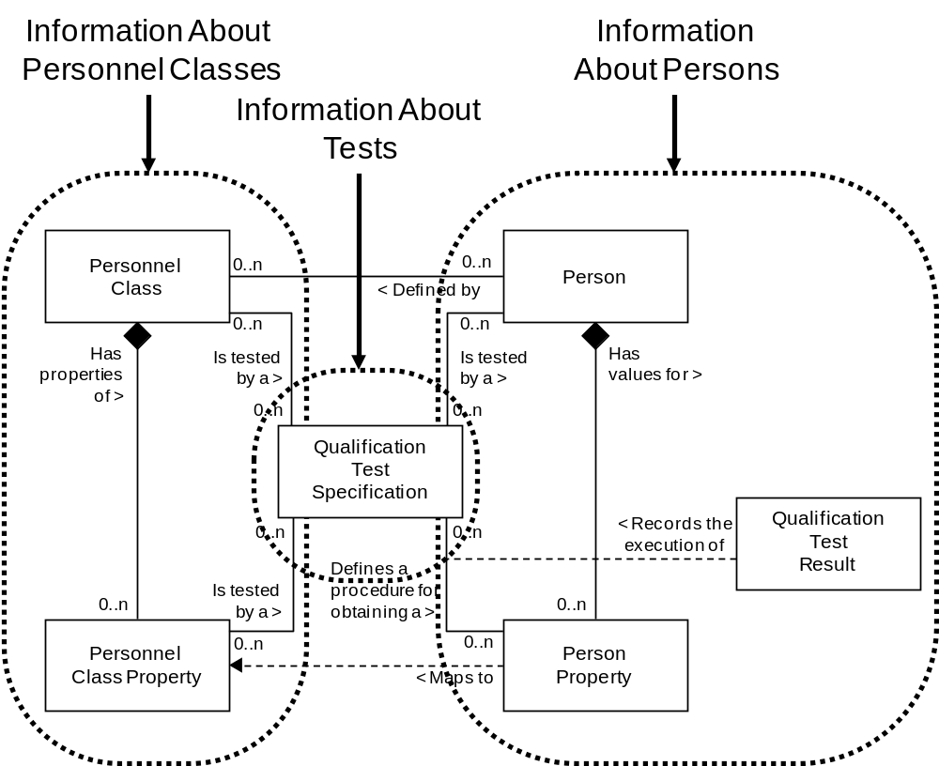
Model of Exchanged Personnel Information

This schema uses a common schema for definition of elements that are used in multiple schemas, such as ID, Description, and Value. See the document defining the Common schema for definition of the common elements.

Key Use Assumptions
The model only defines the exchanged information and does not define the use of the information or encapsulation of the information in any defining transactions.

PersonnelInformation
The main structuring element of the schema definition is PersonnelInformation. PersonnelInformation contains definitions of personnel classes, persons, and qualification test specifications.

Person
A person represents a specifically identified individual. A person may be a member of zero or more personnel classes. Person elements may be used to contain information about specific personnel. It may also include the definition of qualification test results. It may include the list of personnel classes the person belongs to and the list of qualification test specifications associated with properties.

PersonnelClass
A personnel class is a means to describe a grouping of persons with similar characteristics for purposes of scheduling and planning. Any person may be a member of zero or more personnel classes. Examples of personnel classes are “Cook Machine Mechanics”, “Slicing Machine Operators”, “Cat-Cracker Operator”, and “Zipper Line Inspectors”.

PersonnelClass information may be used to contain information about personnel classes. It may contain the list of persons belonging to a class and the list of qualification test specifications associated with personnel class properties.

QualificationTestSpecification
A qualification test specification may be associated with a personnel class property or person property. This is typically used where a qualification test is required to ensure that a person has the correct training and/or experience for specific operations. A qualification test specification may test for one or more properties.

QualificationTestSpecification information may be used to contain information about qualification tests. It may contain identifications of the tested person properties and the tested personnel class properties.

Element Definitions

Element/Type | Description
PersonnelInformation  PersonnelInformationType | Contains the top level definition of persons, personnel classes, and qualification test specifications.  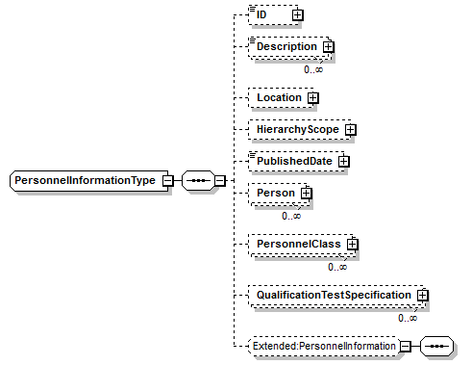
Person  PersonType | Contains a definition of a person resource, including the ID, name, properties of persons, and the list of personnel classes the person is a member of.  May be a top level object.  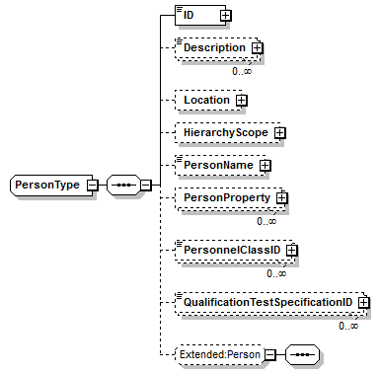
PersonProperty  PersonPropertyType | Contains a definition of a property for a person, including the value for the property, the list of qualification test specifications for the property, and test results for tests of the property.  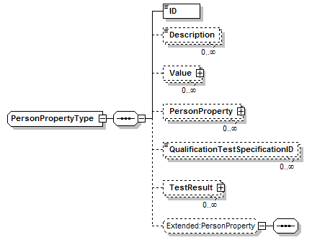
PersonnelClass  PersonnelClassType | Contains a definition of a personnel class resource, including the ID of the class, properties of the personnel class, and the list of persons belonging to the class. May also be a top level object.  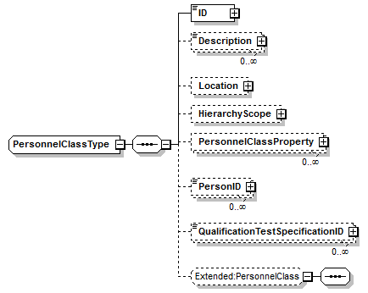
PersonnelClassProperty  PersonnelClassPropertyType | Contains a definition of a property for a personnel class, including a nominal value for the property, and the list of qualification test specifications for the property.  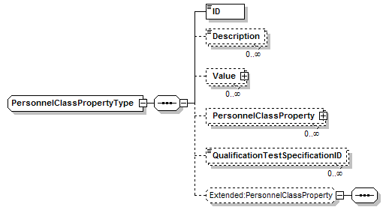
QualificationTestSpecification  QualificationTestSpecificationType | Contains a definition of a qualification test specification, including the ID of the test, the version of the test, the list of person properties tested, the list of personnel properties tested, and application specific extensions. May also be a top level object.  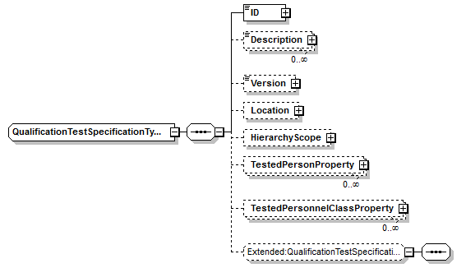
TestedPersonProperty  TestedPersonPropertyType | Contains an identification of person property tested, containing the ID of the person and the ID of the property.  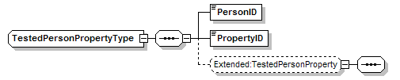
TestedPersonnelClassProperty  TestedPersonnelClassPropertyType | Contains an identification of personnel property tested, containing the ID of the personnel and the ID of the property.  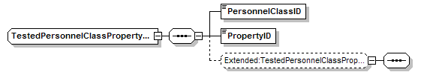

Transaction Elements
The following elements are defined to support the ISA 95 Part 5 transactions, using the transaction data types defined in the B2MML-Common.xsd schema.

Personnel Information Elements | Description
GetPersonnelInformation | Get PersonnelClass, Person, and QualificationTestSpecificationdefinitions.
ShowPersonnelInformation | Returned information from the GetPersonnelInformation message.
ProcessPersonnelInformation | Process PersonnelClass, Person, and QualificationTestSpecificationdefinitions.
AcknowledgePersonnelInformation | Returned status from the ProcessPersonnelInformation message.
ChangePersonnelInformation | Change PersonnelClass, Person, and QualificationTestSpecificationdefinitions.
RespondPersonnelInformation | Returned status from the ChangePersonnelInformation message.
CancelPersonnelInformation | Cancel PersonnelClass, Person, and QualificationTestSpecificationdefinitions.
SyncPersonnelInformation | Published PersonnelClass, Person, and QualificationTestSpecificationdefinitions.

Personnel Class Elements | Description
GetPersonnelClass | Get PersonnelClass definitions.
ShowPersonnelClass | Returned information from the GetPersonnelClass message.
ProcessPersonnelClass | Process PersonnelClass definitions.
AcknowledgePersonnelClass | Returned status from the ProcessPersonnelClass message.
ChangePersonnelClass | Change PersonnelClass definitions.
RespondPersonnelClass | Returned status from the ChangePersonnelClass message.
CancelPersonnelIClass | Cancel PersonnelClass definitions.
SyncPersonnelClass | Published PersonnelClass definitions.

Person Elements | Description
GetPerson | Get Person definitions.
ShowPerson | Returned information from the GetPerson message.
ProcessPerson | Process Person definitions.
AcknowledgePerson | Returned status from the ProcessPersonn message.
ChangePerson | Change Person definitions.
RespondPerson | Returned status from the ChangePerson message.
CancelPerson | Cancel Person definitions.
SyncPerson | Published Person definitions.

QualificationTestSpecification Elements | Description
GetQualificationCapabilityTestSpecification | Get QualificationTestSpecification definitions.
ShowQualificationCapabilityTestSpecification | Returned information from the GetQualificationCapabilityTestSpecification message.
ProcessQualificationCapabilityTestSpecification | Process QualificationTestSpecification definitions.
AcknowledgeQualificationCapabilityTestSpecification | Returned status from the ProcessQualificationCapabilityTestSpecification message.
ChangeQualificationCapabilityTestSpecification | Change QualificationTestSpecification definitions.
RespondQualificationCapabilityTestSpecification | Returned status from the ChangeQualificationCapabilityTestSpecification message.
CancelQualificationCapabilityTestSpecification | Cancel QualificationTestSpecificationdefinitions.
SyncQualificationCapabilityTestSpecification | Published QualificationTestSpecificationdefinitions.

Diagram Convention
The schema diagrams using the following convention to illustrate the structure of the schema elements, the type of the elements and attributes, and the rules for optional elements and repetition.

