
Business To Manufacturing
Markup Language
B2MML - PhysicalAsset
Version 0500 – March 2011
PhysicalAsset Schema
Documentation



IMPORTANT: While the information, data, and standards provided in this publication were developed and are presented in good faith in accordance with a reasonable process that was subject to intellectual property and antitrust policies to benefit the industry as a whole, the publication is provided “as is” for information and guidance only, and there is no representation or warranty of any type or kind, including but not limited to warranties of merchantability or fitness for a particular purpose, and no warranty that use of the information, data, or standards will not infringe patent, copyright, trademark, trade secret, or other intellectual property rights of any party.
Table of Contents

1 Schema Scope 3
1.1 Key Information Assumptions 3
1.2 Key Use Assumptions 4
1.3 PhysicalAssetInformation 4
1.4 PhysicalAsset 4
1.5 PhysicalAssetClass 4
1.6 PhysicalAssetCapabilityTestSpecification 4
2 Element Definitions 5
3 Transaction Elements 9
4 Diagram Convention 11

Change History:
Change | Date | Person | Description
V0500 | Mar 2011 | Dennis Brandl | - Initial version to match ANSI/ISA 95.02-2010

Copyright © 2010 WBF The Organization for Production Technology
All Rights Reserved. http://www.wbf.org

This WBF Work (including specifications, documents, software, and related items) referred to as the Business To Manufacturing Markup Language (B2MML) is provided by the copyright holders under the following license.

Permission to use, copy, modify, or redistribute this Work and its documentation, with or without modification, for any purpose and without fee or royalty is hereby granted provided the World Batch Forum is acknowledged as the originator of this Work using the following statement:

"The Business To Manufacturing Markup Language (B2MML) is used courtesy of WBF."

In no event shall the WBF, its members, or any third party be liable for any costs, expenses, losses, damages or injuries incurred by use of the Work or as a result of this agreement.

Material from ANSI/ISA-88 and ANSI/ISA-95 series of standards used with permission of ISA - The Instrumentation, Systems, and Automation Society, www.isa.org

Schema Scope
This document defines the information about Physical asset classes, physical assets, and physical asset capability tests that may be exchanged between business systems and manufacturing operations systems. This information is based on the data models and attributes defined in the ANSI/ISA 95.00.02 Enterprise/Control System Integration standard. Contact ISA (The Instrumentation, System, and Automation Society) for copies of the standard. Additional information on the standard is available at www.isa.org.

Key Information Assumptions
The data represented in these schemas is derived from the UML model below. This model is defined in the ANSI/ISA 95.00.02 standard. The information model in the model below is not hierarchical, so the key assumption is that the information may be accessed from any of three starting points: Physical Asset class, Physica lAsset, or capability test, as identified by the dotted collections in the figure.

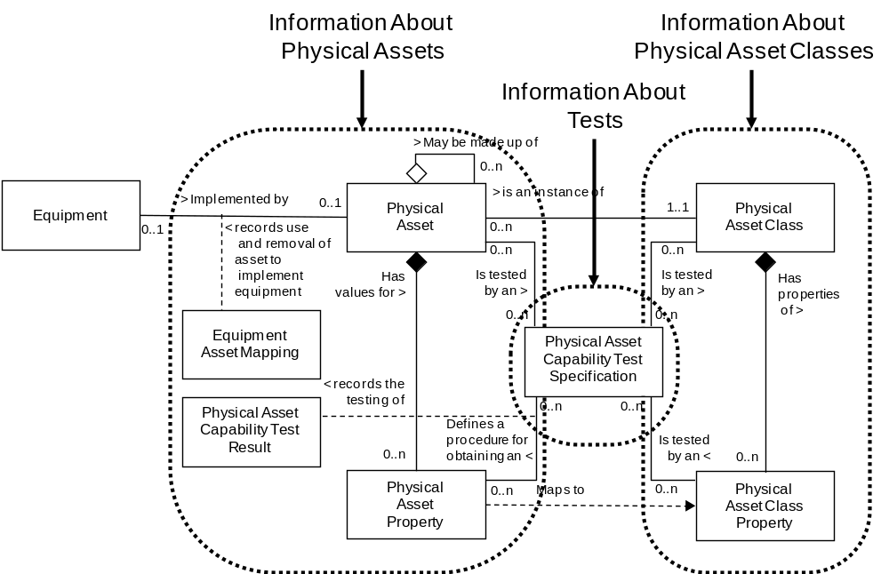
Model of Exchanged Physical Asset Information

This schema uses a common schema for definition of elements that are used in multiple schemas, such as ID, Description, and Value. See the documentation of the common schema for definition of the common elements.

Key Use Assumptions
The model only defines the exchanged information and does not define the use of the information or encapsulation of the information in any defining transactions.

PhysicalAssetInformation
The main structuring element of the schema definition is PhysicalAssetInformation. Alternately, schemas may be made up an Physical Asset, Physical Asset class, or Physical Asset capability test specification document.

PhysicalAssetInformation elements define Physical Asset, Physical Asset classes, and/or Physical Asset capability test specifications.

PhysicalAsset
Physical Asset represents the elements of a Physica lAsset hierarchy model defined in ANSI/ISA-95.00.01.

Physical Asset may be made up of other Physical Asset, as defined in Physical Asset hierarchy model.

PhysicalAsset elements may be used to contain information about specific PhysicalAsset. PhysicalAsset elements may also include the definition of capability test results.

PhysicalAssetClass
An PhysicalAsset class is a means to describe a grouping of PhysicalAsset with similar characteristics for purposes of scheduling and planning. Any piece of PhysicalAsset may be a member of zero or more PhysicalAsset classes.

PhysicalAssetClass information may be used to contain information about classes of PhysicalAssets. It may contain the list of PhysicalAsset belonging to the class and the list of capability test specifications associated with PhysicalAsset class properties.

PhysicalAssetCapabilityTestSpecification
A Physica lAsset capability test specification may be associated with an Physical Asset property. This is typically used where a test is required to ensure that the Physical Asset has the rated capability. An Physical Asset capability test specification may test for one or more Physical Asset properties.

PhysicalAssetCapabilityTestSpecification information may be used to contain information about Physical Asset capability tests. It may contain identifications of the tested Physical Asset properties and the tested Physical Asset class properties.

Element Definitions

Element/Type | Description
PhysicalAsset  PhysicalAssetType | A top-level object that may contain a definition of PhysicalAsset, containing PhysicalAsset, PhysicalAsset properties, the ID’s of PhysicalAsset classes the PhysicalAsset belongs to, and the PhysicalAsset to physical asset mapping. May also contain application specific elements.  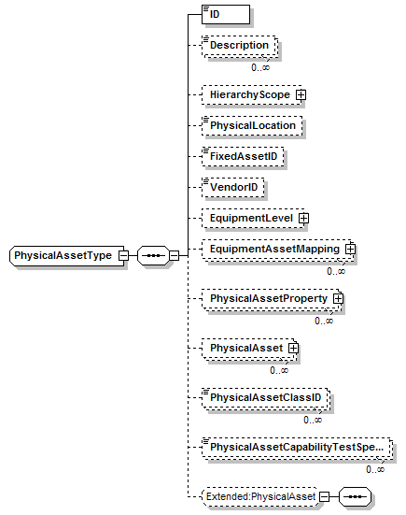
PhysicalAssetCapabilityTestSpecification  PhysicalAssetCapabilityTestSpecificationType | A top level object that contains the description of an PhysicalAsset capability test specification. Containing the name of the test, version of the test, description of the test, the list of class properties tested by the test, the list of specific PhysicalAsset properties tested by the test, and additional application specific information. May also contain application specific elements.  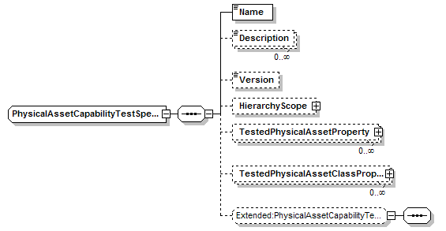
PhysicalAssetClass  PhysicalAssetClassType | A top-level object that may contain a definition of an PhysicalAsset class, containing PhysicalAsset properties, and the ID’s of PhysicalAsset the belonging to the class. May also contain application specific elements.  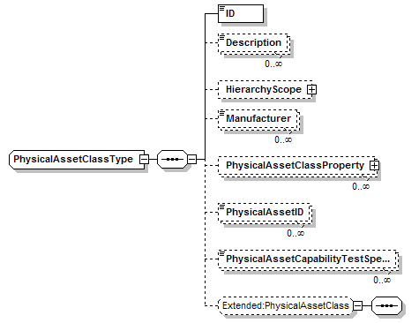
PhysicalAssetClassPropertyType | Contains a definition of an PhysicalAsset class property, consisting of an ID and a description. May include the capability test specification.  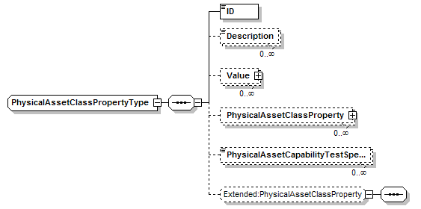
PhysicalAssetInformation  PhysicalAssetInformationType | A top-level object that may contain a list of PhysicalAsset, PhysicalAsset class, and/or PhysicalAsset capability test specifications. May also contain application specific elements.  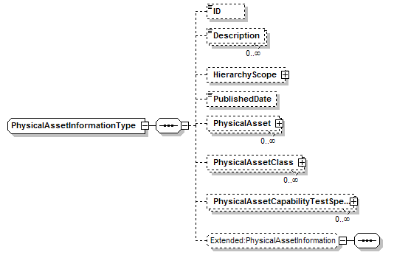
PhysicalAssetProperty  PhysicalAssetPropertyType | Contains a definition of a PhysicalAsset property, consisting of an ID and a description. May include the capability test specification and test result.  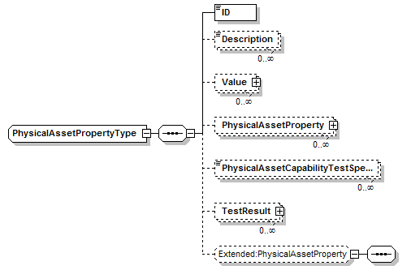
TestedPhysicalAssetClassProperty  TestedPhysicalAssetClassPropertyType | Contains a definition of a class property type tested by a qualification test specification. The ID defines the property.  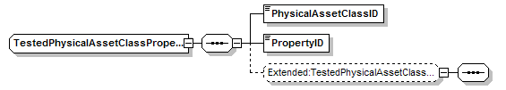
TestedPhysicalAssetProperty  TestedPhysicalAssetPropertyType | Contains a definition of a property type tested by a qualification test specification. The ID defines the property.  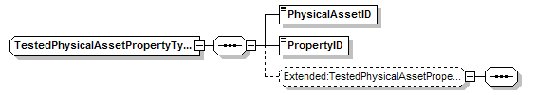
EquipmenttAssetMapping  EquipmentAssetMappingType | Defines the mapping of PhysicalAsset to a physical asset.  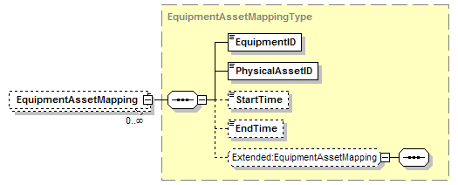

Transaction Elements
The following elements are defined to support the ISA 95 Part 5 transactions, using the transaction data types defined in the B2MML-Common.xsd schema.

PhysicalAsset Information Elements | Description
GetPhysicalAssetInformation | Get PhysicalAssetClass, PhysicalAsset, and PhysicalAssetCapabilityTestSpecification definitions.
ShowPhysicalAssetInformation | Returned information from the GetPhysicalAssetInformation message.
ProcessPhysicalAssetInformation | Process PhysicalAssetClass, PhysicalAsset, and PhysicalAssetCapabilityTestSpecification definitions.
AcknowledgePhysicalAssetInformation | Returned status from the ProcessPhysicalAssetInformation message.
ChangePhysicalAssetInformation | Change PhysicalAssetClass, PhysicalAsset, and PhysicalAssetCapabilityTestSpecification definitions.
RespondPhysicalAssetInformation | Returned status from the ChangePhysicalAssetInformation message.
CancelPhysicalAssetInformation | Cancel PhysicalAssetClass, PhysicalAsset, and PhysicalAssetCapabilityTestSpecification definitions.
SyncPhysicalAssetInformation | Published PhysicalAssetClass, PhysicalAsset, and PhysicalAssetCapabilityTestSpecification definitions.

PhysicalAsset Class Elements | Description
GetPhysicalAssetClass | Get PhysicalAssetClass definitions.
ShowPhysicalAssetClass | Returned information from the GetPhysicalAssetClass message.
ProcessPhysicalAssetClass | Process PhysicalAssetClass definitions.
AcknowledgePhysicalAssetClass | Returned status from the ProcessPhysicalAssetClass message.
ChangePhysicalAssetClass | Change PhysicalAssetClass definitions.
RespondPhysicalAssetClass | Returned status from the ChangePhysicalAssetClass message.
CancelPhysicalAssetClass | Cancel PhysicalAssetClass definitions.
SyncPhysicalAssetClass | Published PhysicalAssetClass definitions.

PhysicalAsset Elements | Description
GetPhysicalAsset | Get PhysicalAsset definitions.
ShowPhysicalAsset | Returned information from the GetPhysicalAsset message.
ProcessPhysicalAsset | Process PhysicalAsset definitions.
AcknowledgePhysicalAsset | Returned status from the ProcessPhysicalAsset message.
ChangePhysicalAsset | Change PhysicalAsset definitions.
RespondPhysicalAsset | Returned status from the ChangePhysicalAsset message.
CancelPhysicalAsset | Cancel PhysicalAsset definitions.
SyncPhysicalAsset | Published PhysicalAsset definitions.

PhysicalAssetCapabilityTestSpec Elements | Description
GetPhysicalAssetCapabilityTestSpec | Get PhysicalAssetCapabilityTestSpecification definitions.
ShowPhysicalAssetCapabilityTestSpec | Returned information from the GetPhysicalAssetCapabilityTestSpec message.
ProcessPhysicalAssetCapabilityTestSpec | Process PhysicalAssetCapabilityTestSpecification definitions.
AcknowledgePhysicalAssetCapabilityTestSpec | Returned status from the ProcessPhysicalAssetCapabilityTestSpec message.
ChangePhysicalAssetCapabilityTestSpec | Change PhysicalAssetCapabilityTestSpecification definitions.
RespondPhysicalAssetCapabilityTestSpec | Returned status from the ChangePhysicalAssetCapabilityTestSpec message.
CancelPhysicalAssetICapabilityTestSpec | Cancel PhysicalAssetCapabilityTestSpecification definitions.
SyncPhysicalAssetCapabilityTestSpec | Published PhysicalAssetCapabilityTestSpecification definitions.

Diagram Convention
The schema diagrams using the following convention to illustrate the structure of the schema elements, the type of the elements and attributes, and the rules for optional elements and repetition.

