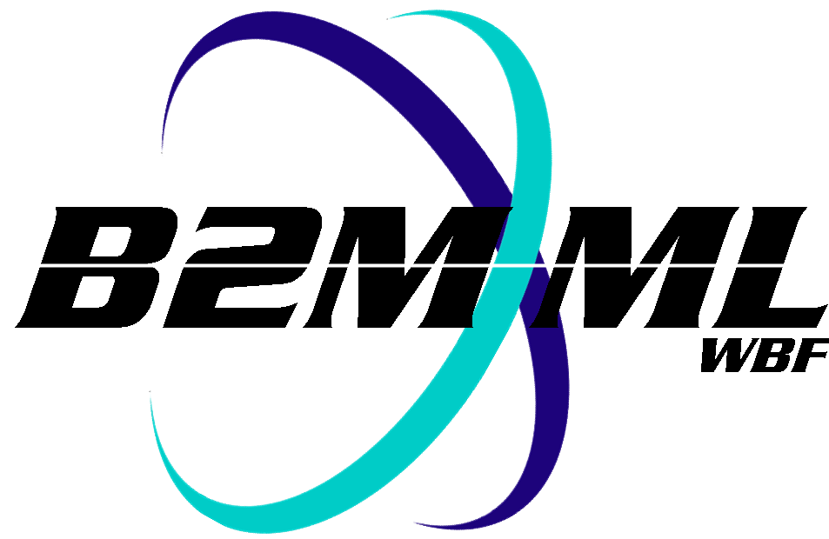
Business To Manufacturing
Markup Language
B2MML –Process Segment
Version 0500 – March 2011
Process Segment Schema
Documentation



IMPORTANT: While the information, data, and standards provided in this publication were developed and are presented in good faith in accordance with a reasonable process that was subject to intellectual property and antitrust policies to benefit the industry as a whole, the publication is provided “as is” for information and guidance only, and there is no representation or warranty of any type or kind, including but not limited to warranties of merchantability or fitness for a particular purpose, and no warranty that use of the information, data, or standards will not infringe patent, copyright, trademark, trade secret, or other intellectual property rights of any party.
Table of Contents

1 Schema Scope 4
1.1 Key Information Assumptions 4
1.2 Key Use Assumptions 4
1.3 ProcessSegmentInformation 5
1.4 ProcessSegment 5
1.4.1 PersonnelSegmentSpecification 6
1.4.2 EquipmentSegmentSpecification 6
1.4.3 PhysicalAssetSegmentSpecification 6
1.4.4 MaterialSegmentSpecification 7
1.5 Resource Identification 7
2 Element Definitions 8
3 Transaction Elements 13
4 Diagram Convention 14

Change History:
Change | Date | Person | Description
V01 | 7 April 2002 | Dennis Brandl  Dave Emerson | Initial release
V02 | 23 Sept 2003 | Dennis Brandl  Dave Emerson | - Changed ##any to "Any" element of type "AnyType"
V03 | 26 Aug 2005 | Dennis Brandl  Dave Emerson | - Added substitution groups. One group added just before each Any element.
V0301 | 29 Dec 2005 | Dennis Brandl | - Made “Value” elements 0..unbounded
V04 | 04 June 2007 | Dennis Brandl | - Added transaction elements  - Removed choice elements in Equipment, Material, and Personnel segment specification types.
V0401 | Oct 2008 | Dennis Brandl | - Changed version number
V0500 | Mar 2011 | Dennis Brandl | - Updated for ISA 95.02-2010  - Added Physical Asset elements  - Added material assembly elements  - Removed ##any elements

Copyright © 2011 WBF The Organization for Production Technology
All Rights Reserved. http://www.wbf.org

This WBF Work (including specifications, documents, software, and related items) referred to as the Business To Manufacturing Markup Language (B2MML) is provided by the copyright holders under the following license.

Permission to use, copy, modify, or redistribute this Work and its documentation, with or without modification, for any purpose and without fee or royalty is hereby granted provided the WBF is acknowledged as the originator of this Work using the following statement:

"The Business To Manufacturing Markup Language (B2MML) is used courtesy of the WBF."

In no event shall the WBF, its members, or any third party be liable for any costs, expenses, losses, damages or injuries incurred by use of the Work or as a result of this agreement.

Material from ANSI/ISA-88 and ANSI/ISA-95 series of standards used with permission of ISA - The Instrumentation, Systems, and Automation Society, www.isa.org

Schema Scope
This document defines the information about process segment definitions that may be exchanged between business systems and manufacturing operations systems. This information is based on the data models and attributes defined in the ANSI/ISA 95.00.02 Enterprise/Control System Integration standard. Contact ISA (The Instrumentation, System, and Automation Society) for copies of the standard. Additional information on the standard is available at www.isa.org.

Key Information Assumptions
The data represented in these schemas is derived from the UML model below. This model is defined in the ANSI/ISA 95.00.02 standard. The information model in the model below is hierarchical with process segments containing process segments and personnel, equipment, and material specification information. The key assumption is that the information will be accessed by process segment.

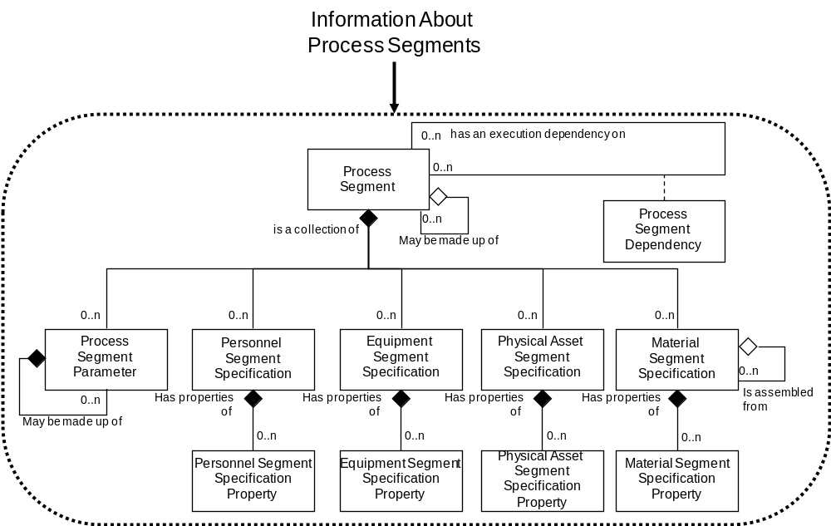

Model of Exchanged Process Segment Information

This schema uses a common schema for definition of elements that are used in multiple schemas, such as ID, Description, and Value. See the document defining the Common schema for definition of the common elements.

Key Use Assumptions
The model only defines the exchanged information and does not define the use of the information or encapsulation of the information in any defining transactions.

ProcessSegmentInformation
The main structuring element of the schema definition is ProcessSegmentInformation.

ProcessSegment
A process segment is a logical grouping of personnel resources, equipment resources, and material required to carry out a production step. Process segment usually define the needed classes of personnel, equipment, and material, but it may define specific resources, such as specific equipment needed. Process segment usually define the quantity of the resource needed.

Identifying process segments requires an understanding of the business processes within the company and the general structure of the manufacturing processes. Not all process segments need to relate to production, there are at least three general types of process segments:

- Production segments – those relating to conversion of raw or intermediate materials into intermediate materials or final products.
- Movement segments – those relating to movement of materials and keeping track of material and product locations.
- Inspection segments – those relating to confirming or testing quality and suitability of materials and products.

ProcessSegment elements may be used to contain information about defined process segments, and the personnel, equipment, and materials required for the segment.

Process segments may also contain process segments, for example a product assembly segment may be made up of assembly, test, and packaging segments. Each segment may be defined as a separate element with separate specifications

Routing may be dependent on the processes. In the figure below the routing contains material dependencies information. The routing information is then used for scheduling. The route in the left side of the figure can be represented in a set of process segment definitions (center table in figure) and process segment dependency definitions (right table in figure). The process segment definitions contain the material production and consumption information. The consumption and production information within the process segments define additional constraints and dependencies required for scheduling of material B1, C1, and F1.

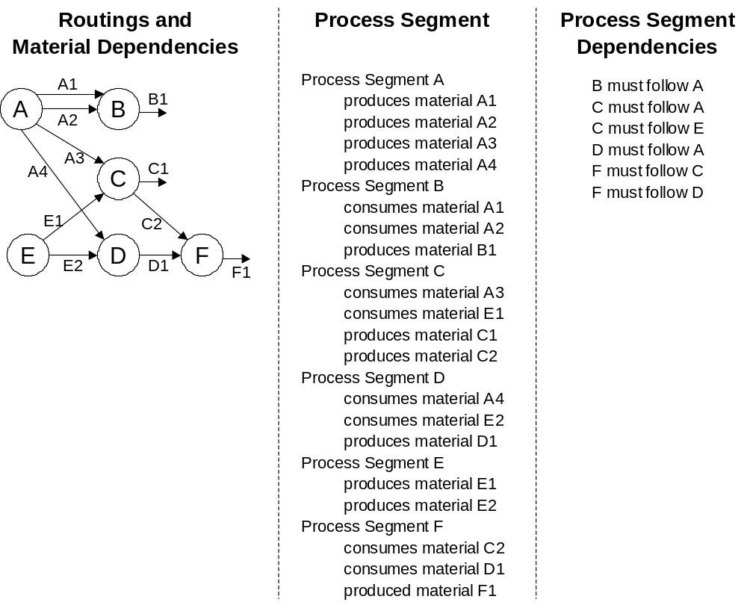
Routing with co-products and material dependencies
.

PersonnelSegmentSpecification
PersonnelSegmentSpecification information may be used to contain information about personnel resources required for execution of the process segment. An element defines the quantity of the personnel class or person required, or a list of properties that identify the subset of the class and quantity of the subset required.

EquipmentSegmentSpecification
EquipmentSegmentSpecification information may be used to contain information about equipment resources required for execution of the process segment. An element defines the quantity of the equipment class or equipment required, or a list of properties that identify the subset of the class and quantity of the subset required.

PhysicalAssetSegmentSpecification
PhysicalAssetSegmentSpecification information may be used to contain information about physical asset resources required for execution of the process segment. An element defines the quantity of the physical asset class or physical asset required, or a list of properties that identify the subset of the class and quantity of the subset required.

MaterialSegmentSpecification
MaterialSegmentSpecification information may be used to contain information about material resources required for execution of the process segment. An element defines the quantity of the material class or material definition required, or a list of properties that identify the subset of the class and quantity of the subset required.

Resource Identification
The process segment information defines what resources are required for execution of the process segment. It does this by defining the classes of resources, or in some cases the exact instance of a resource required. For example, an inspection segment may require 1 inspector for 2 hours, and 1 inspection machine for 2 hours. In some industries the exact inspection machine may have to be specified, such as “ElectonMicroprobe#1”.

The schemas follow the ANSI/ISA-95 standard by defining resources by class or instance ID, or by defining them by class ID and a property value that is used to define a subset of the resource. For example, the figure below illustrates that a segment may require a certain number of “operators”, a personnel class. Other segments may require a subset of operators, such as “Master” operators only. In the first case the class name, “Operator”, is sufficient to identify the resource required. In the second case the class name, “Operator”, and property name and value, “Ranking” and “Master”, define the required resource.

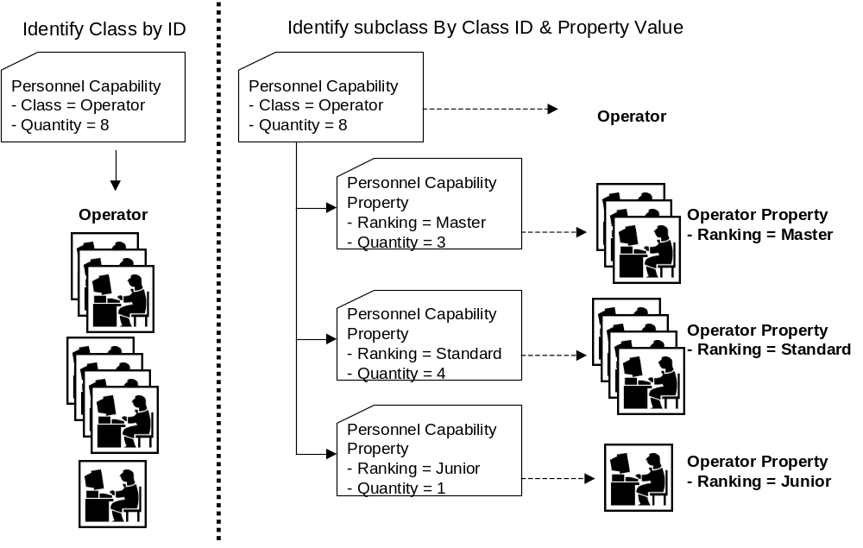

Element Definitions

Element/Type | Description
ProcessSegmentInformation  ProcessSegmentInformationType | Contains a list of process segments, includes the location of the scope of the information, and the date of publication of the information.  May also contain application specific extended elements.  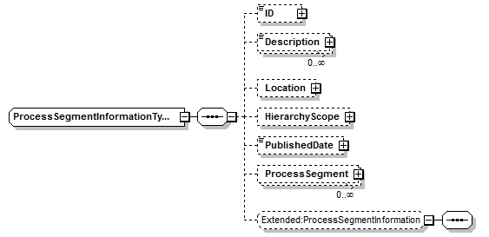
ProcessSegment  ProcessSegmentType | Contains a definition of a process segment, including the location of the scope the definition, the date of publication, the segment dependencies, encapsulated segments, parameters associated with the segment, and the material, personnel, and equipment resources required for the segment. May also be a top level element. This may also contain application specific extended elements.  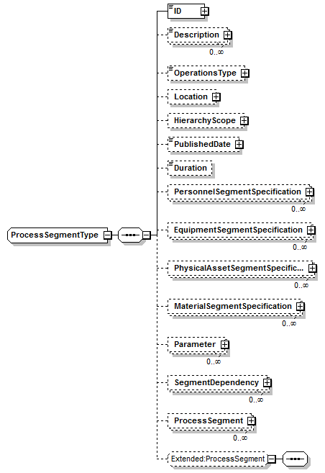
EquipmentSegmentSpecification  EquipmentSegmentSpecificationType | Contains a specification of an equipment resource required for a process segment, the quantity of the resource, and a definition of the class or equipment and property.  May also contain application specific extension elements.  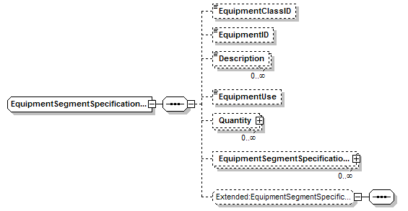
EquipmentSegmentSpecificationProperty  EquipmentSegmentSpecificationPropertyType | Contains a specification of a quantity required for an equipment property that is identified by value.  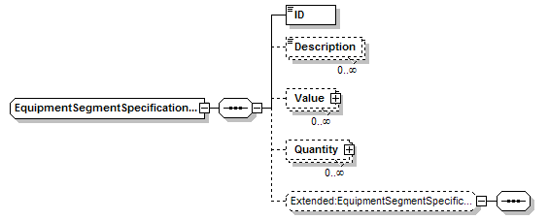
MaterialSegmentSpecification  MaterialSegmentSpecificationType | Contains a specification of a material resource required for a process segment, the quantity of the resource, and a definition of the class or definition and property.  May also contain application specific extension elements.  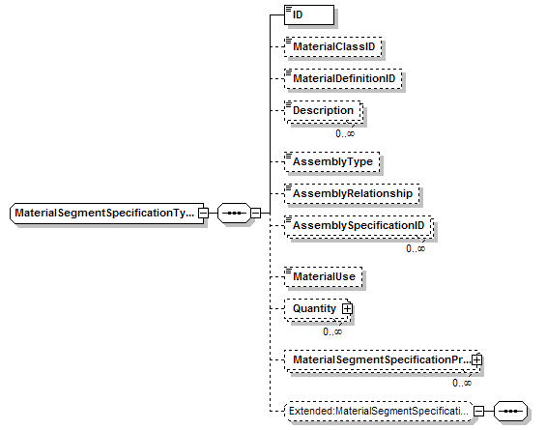
MaterialSegmentSpecificationProperty  MaterialSegmentSpecificationPropertyType | Contains a specification of a quantity required for a material property that is identified by value.  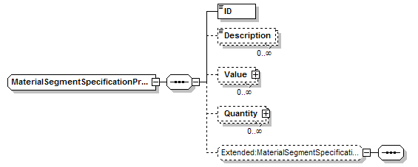
PersonnelSegmentSpecification  PersonnelSegmentSpecificationType | Contains a specification of a personnel resource required for a process segment, the quantity of the resource, and a definition of the class or person and property.  May also contain application specific extension elements.  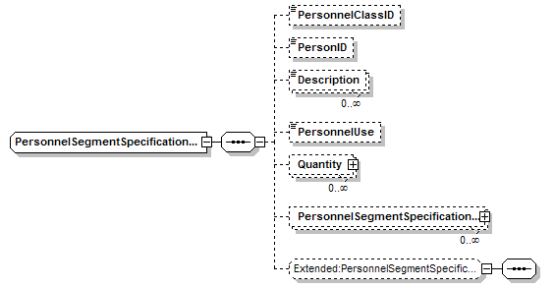
PersonnelSegmentSpecificationProperty  PersonnelSegmentSpecificationPropertyType | Contains a specification of a quantity required for a personnel property that is identified by value.  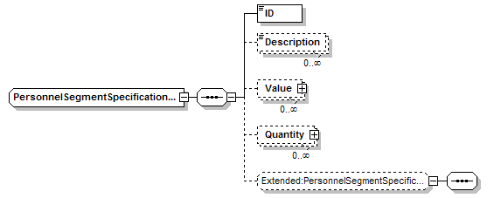
PhysicalAssetSegmentSpecification  PhysicalAssetSegmentSpecificationType | process segment, the quantity of the resource, and a definition of the class or person and property.  May also contain application specific extension elements.  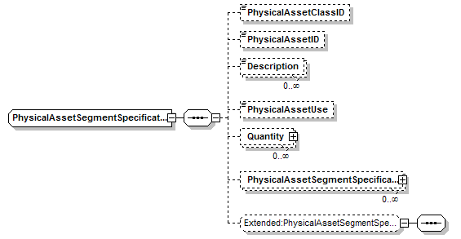
PhysicalAssetSegmentSpecificationProperty  PhysicalAssetSegmentSpecificationPropertyType | Contains a specification of a quantity required for a personnel property that is identified by value.  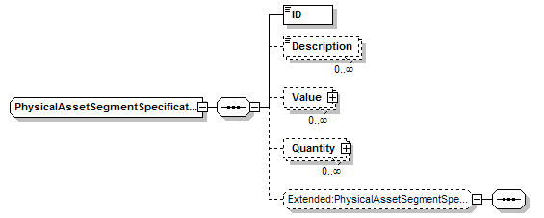

Transaction Elements
The following elements are defined to support the ISA 95 Part 5 transactions, using the transaction data types defined in the B2MML-Common.xsd schema.

Process Segment Information Elements | Description
GetProcessSegmentInformation | Get ProcessSegment definitions.
ShowProcessSegmentInformation | Returned information from the GetProcessSegmentInformation message.
ProcessProcessSegmentInformation | Process ProcessSegment definitions.
AcknowledgeProcessSegmentInformation | Returned status from the ProcessProcessSegmentInformation message.
ChangeProcessSegmentInformation | Change ProcessSegment definitions.
RespondProcessSegmentInformation | Returned status from the ChangeProcessSegmentInformation message.
CancelProcessSegmentInformation | Cancel ProcessSegment definitions.
SyncProcessSegmentInformation | Published ProcessSegment definitions.

Process Segment Elements | Description
GetProcessSegment | Get a ProcessSegment definition.
ShowProcessSegment | Returned information from the GetProcessSegment message.
ProcessProcessSegment | Process a ProcessSegment definition.
AcknowledgeProcessSegment | Returned status from the ProcessProcessSegment message.
ChangeProcessSegment | Change a ProcessSegment definition.
RespondProcessSegment | Returned status from the ChangeProcessSegment message.
CancelProcessSegmentI | Cancel a ProcessSegment definition.
SyncProcessSegment | Published ProcessSegment definition.

Diagram Convention
The schema diagrams using the following convention to illustrate the structure of the schema elements, the type of the elements and attributes, and the rules for optional elements and repetition.

