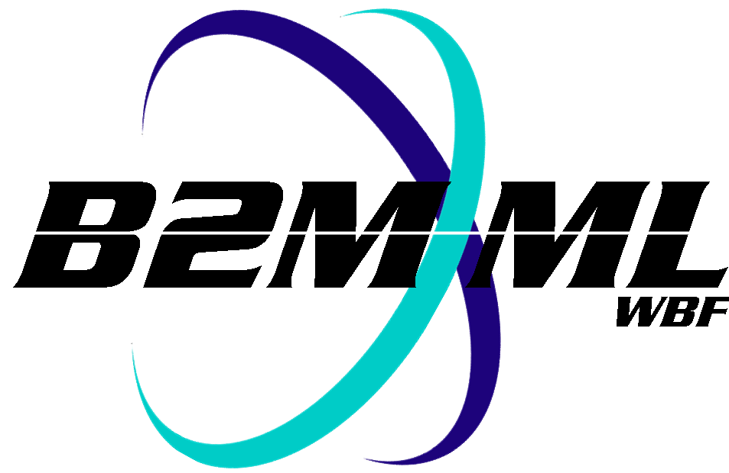
Business To Manufacturing
Markup Language
B2MML – Product Definition
Version 0500 – March 2011
Product Definition Schema
Documentation



IMPORTANT: While the information, data, and standards provided in this publication were developed and are presented in good faith in accordance with a reasonable process that was subject to intellectual property and antitrust policies to benefit the industry as a whole, the publication is provided “as is” for information and guidance only, and there is no representation or warranty of any type or kind, including but not limited to warranties of merchantability or fitness for a particular purpose, and no warranty that use of the information, data, or standards will not infringe patent, copyright, trademark, trade secret, or other intellectual property rights of any party.
Table of Contents

1 Schema Scope 3
1.1 Key Information Assumptions 3
1.2 Key Use Assumptions 4
1.3 ProductDefinition 4
1.4 ManufacturingBill 4
1.5 ProductSegment 4
1.5.1 PersonnelSpecification 4
1.5.2 EquipmentSpecification 4
1.5.3 PhysicalAssetSpecification 4
1.5.4 MaterialSpecification 5
1.6 Resource Identification 5
2 Element Definitions 6
3 Transaction Elements 13
4 Diagram Convention 14

Change History:
Change | Date | Person | Description
V01 | 7 April 2002 | Dennis Brandl  Dave Emerson | Initial release
V02 | 23 Sept 2003 | Dennis Brandl  Dave Emerson | - Changed ##any to "Any" element of type "AnyType"
V03 | 26 Aug 2005 | Dennis Brandl  Dave Emerson | - Added substitution groups. One group added just before each Any element.
V0301 | 29 Dec 2005 | Dennis Brandl | - Changed “Value” elements to be 0..unbounded
V04 | 04 June 2007 | Dennis Brandl | - Added transaction elements  - Removed choice options in Manufacturing Bill, material, personnel, and equipment specifications.
V0401 | Oct 2008 | Dennis Brandl | - Changed version number
V0500 | Mar 2011 | Dennis Brandl | - Updated to match ISA 95.02-2010  - Added Physical Asset elements  - Added material assembly elements  - Removed AnyType

Copyright © 2011 WBF The Organization for Production Technology
All Rights Reserved. http://www.wbf.org

This WBF Work (including specifications, documents, software, and related items) referred to as the Business To Manufacturing Markup Language (B2MML) is provided by the copyright holders under the following license.

Permission to use, copy, modify, or redistribute this Work and its documentation, with or without modification, for any purpose and without fee or royalty is hereby granted provided the WBF is acknowledged as the originator of this Work using the following statement:

"The Business To Manufacturing Markup Language (B2MML) is used courtesy of the WBF."

In no event shall the WBF, its members, or any third party be liable for any costs, expenses, losses, damages or injuries incurred by use of the Work or as a result of this agreement.

Material from ANSI/ISA-88 and ANSI/ISA-95 series of standards used with permission of ISA - The Instrumentation, Systems, and Automation Society, www.isa.org

Schema Scope
This document defines the information about the definition of product information that may be exchanged between business systems and manufacturing operations systems. This information is based on the data models and attributes defined in the ANSI/ISA 95.00.02 Enterprise/Control System Integration standard. Contact ISA (The Instrumentation, System, and Automation Society) for copies of the standard. Additional information on the standard is available at www.isa.org.

Key Information Assumptions
The data represented in these schemas is derived from the UML model below. This model is defined in the ANSI/ISA 95.00.02 standard. The information model in the figure below is hierarchical with references to, but does not include, the bill of materials and the bill of resources. The key assumption is that the information will be accessed by a Product Definition.

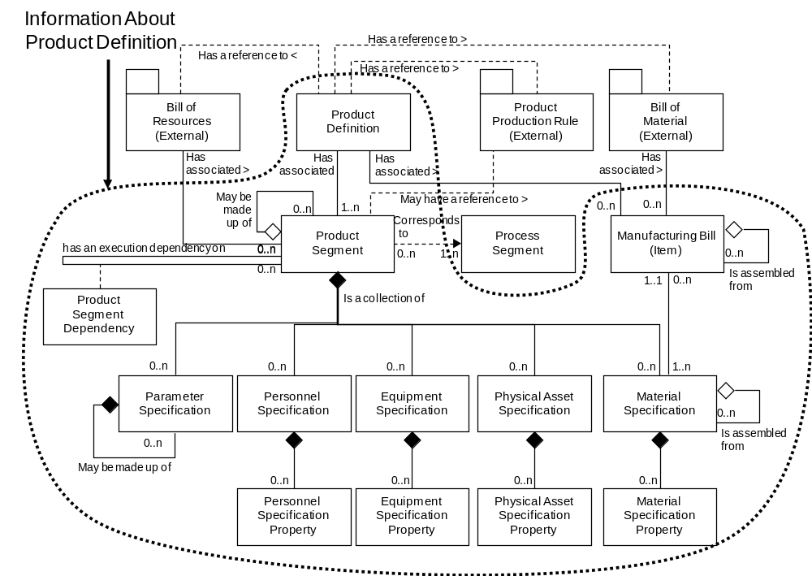
Model of Exchanged Product Definition Information

This schema uses a common schema for definition of elements that are used in multiple schemas, such as ID, Description, and Value. See the document defining the Common schema for definition of the common elements.

Key Use Assumptions
The model only defines the exchanged information and does not define the use of the information or encapsulation of the information in any defining transactions.

ProductDefinition
The main structuring element of the schema definition is ProductDefinition. ProductDefinition is the container object for exchanged information and includes references to the Product Production Rules, Bill Of Materials, and Bill Of Resources. The term Product Production Rule is used in ANSI/ISA-95.00.01 to indicate the information that used within manufacturing to manufacture the product, such as assembly instructions, flow sheets, or recipes. Additional information exists in the bill of materials, bill of resources, and manufacturing operations systems, but is not defined in the exchange schemas.

ManufacturingBill
A manufacturing bill identifies a material or material class that is needed for production of the product.
The manufacturing bill includes all uses of the material in production of the product, while the product segment’s material specification defines just the amount used in a segment of production.

For example: a manufacturing bill may identify 55 Type C left threaded screws, where 20 are used in one product segment, 20 in another product segment, and 15 used in a third product segment.

ManufacturingBill elements define materials that make up the manufacturing bill. These materials may be identified by material class or by material definition.

ProductSegment
The product segment information defines what manufacturing personnel, equipment, or material resources are required for execution of the product segment for a specified quantity of product (eg: a standard batch or lot size). It does this by defining the classes of resources, or in some cases the exact instance of a resource required. For example, an assembly segment may require 1 assembler for 2 hours, and 1 assembly machine for 2 hours. In some industries the exact assembly machine may have to be specified, such as “AssemblyMachine#1”.

A product segment also defines parameters that may be specified when the segment is executed, such as production specification as color or manufacturing options.

PersonnelSpecification
PersonnelSpecification elements define the personnel resources, by class or instance, required for production of the product within a product segment. Such as 2 hours of a painter for a paint segment for a lot size of one widget.

EquipmentSpecification
EquipmentSpecification elements define the equipment resources, by class or instance, required for production of the product within a product segment. Such as 2 hours for a paint station for a lot size of one widget.

PhysicalAssetSpecification
PhysicalAssetSpecification elements define the equipment resources, by class or instance, required for production of the product within a product segment.

MaterialSpecification
MaterialSpecification elements define the material resources, by material class or material definition, required for production of the product within a product segment. Such as 30 Kg of cooking oil (material class) required for the cooking segment for a lot size of 50 Kg.

Resource Identification
The schemas follow the ANSI/ISA-95 standard by defining resources by class ID or instance ID, or by defining them by class ID and a property value that is used to define a subset of the resource. For example, the figure below illustrates that a segment may require a certain number of milling machine, an equipment class. Other segments may require a subset of milling machine, such as “Fine” milling machines only. In the first case the class name, “Mill”, is sufficient to identify the resource required. In the second case the class name, “Mill”, and property name and value, “Spec” and “Fine”, define the required resource.

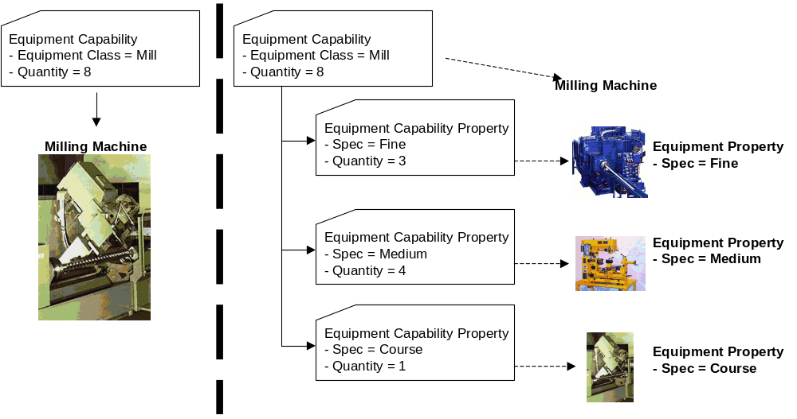

Element Definitions

Element/Type | Description
ProductInformation  ProductInformationType | Contains a list of product definitions. Includes the location of the scope of the information, and the date of publication of the information.  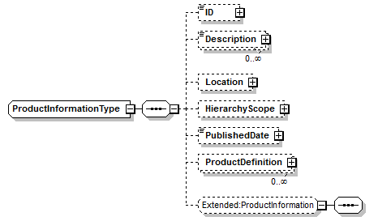
ProductDefinition  ProductDefinitionType | Contains a product production rule. Includes the location of the scope of the information, the date of publication of the information, the list of materials in the manufacturing bill, the identification of the bill material, the identification of the bill of resources, and the definition of product segments.  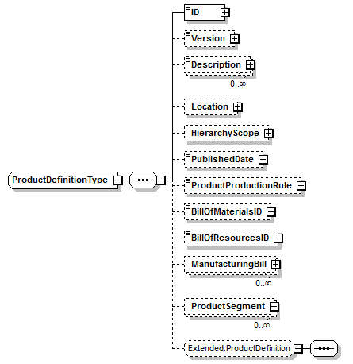  The BillOfMaterialsID in a ProductDefinitionType should contain the ID of the complete bill of materials in the ERP system. This is usually the same as the ID of the material, but there are cases where the bill of material ID can be different. (For example several co-branded products may have different product IDs but the same bill of materials. There is either zero or one BillOfMaterialsID  The BillOfMaterialsID identifies the list.
EquipmentSpecification  EquipmentSpecificationType | Contains a definition of the equipment resources required for the product segment. Includes the identification of the class or instance of the resources, the quantity of the resource, and the property specification if required to identify the resource.  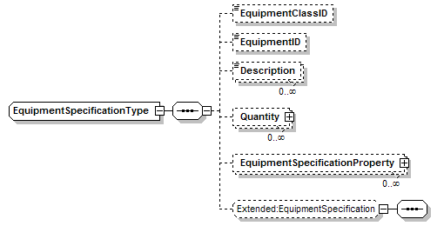
EquipmentSpecificationProperty  EquipmentSpecificationPropertyType | Contains a definition of a equipment property required for the product segment, including the quantity of the resource, and a value used to identify the subset of the class.  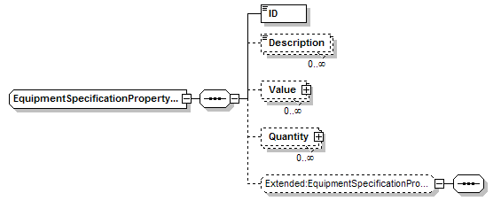
ManufacturingBill  ManufacturingBillType | Contains a definition of a material in the manufacturing bill, including the quantity of the material needed, an identification of the material class or definition, any manufacturing bill item assemblies, and the corresponding bill of material ID.  A ManuacturingBill element may have a set of contained ManufacturingBill elements to support hierarchical manufacturing bills.  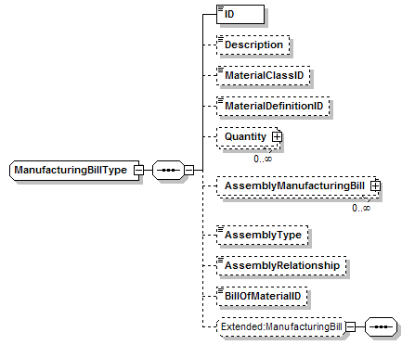  There is one ManufacturingBill element for each material in the BOM. The ID is the local ID of the bill element. The BillOfMaterialID contains the ID of the BOM item in the BillOfMaterials. There is one BillOfMaterialID for each material in the manufacturing bill.  The BillOfMaterialID identifies each item in the BillOfMaterialsID list.
MaterialSpecification  MaterialSpecificationType | Contains a definition of the material resources required for the product segment. Includes the identification of the class or instance of the resources, the quantity of the resource, the use (consumed, produced), any specification assemblies, and the property specification if required to identify the resource.  A ManufacturingSpecification element may have a set of contained ManufacturingSpecification elements to support hierarchical manufacturing bills.  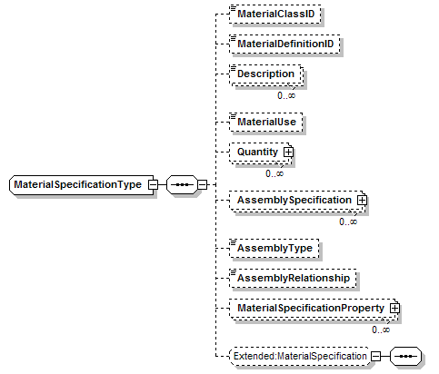
MaterialSpecificationProperty  MaterialSpecificationPropertyType | Contains a definition of a material property required for the product segment, including the quantity of the resource, and a value used to identify the subset of the class.  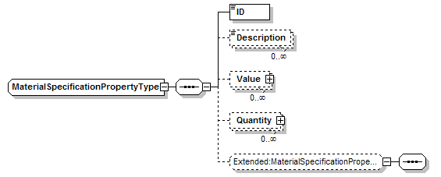
PersonnelSpecification  PersonnelSpecificationType | Contains a definition of the personnel resources required for the product segment. Includes the identification of the class or instance of the resources, the quantity of the resource, and the property specification if required to identify the resource.  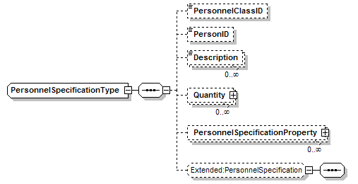
PersonnelSpecificationProperty  PersonnelSpecificationPropertyType | Contains a definition of the personnel resources required for the product segment. Includes the identification of the class or instance of the resources, the quantity of the resource, and the property specification if required to identify the resource.  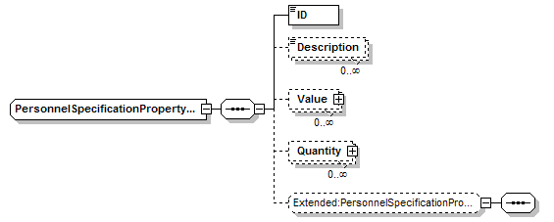
PhysicalAssetSpecification  PhysicalAssetSpecificationType | Contains a definition of the physical asset resources required for the product segment. Includes the identification of the class or instance of the resources, the quantity of the resource, and the property specification if required to identify the resource.  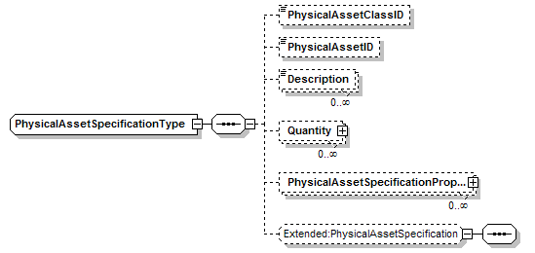
PhysicalAssetSpecificationProperty  PhysicalAssetSpecificationPropertyType | Contains a definition of the physical asset resources required for the product segment. Includes the identification of the class or instance of the resources, the quantity of the resource, and the property specification if required to identify the resource.  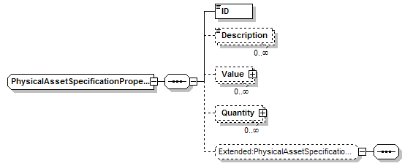
ProductSegment  ProductSegmentType | Contains a definition of a product segment, including the quantity of resources required for the segment (per unit of production), an estimated duration of the segment, an identification of the corresponding process segment, parameters associated with the segment, the segment dependencies, and any encapsulated segments. May also contain application specific elements.  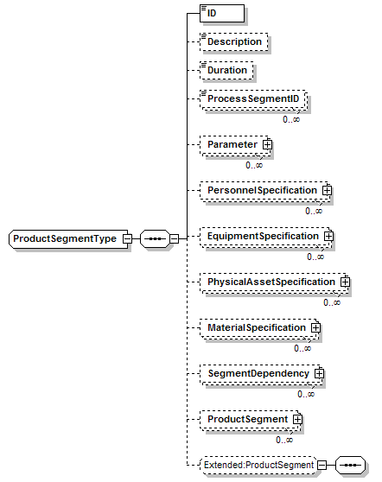

Transaction Elements
The following elements are defined to support the ISA 95 Part 5 transactions, using the transaction data types defined in the B2MML-Common.xsd schema.

Product Definition Information Elements | Description
GetProductDefinitionInformation | Get ProductDefinition definitions.
ShowProductDefinitionInformation | Returned information from the GetProductDefinitionInformation message.
ProcessProductDefinitionInformation | Process ProductDefinition definitions.
AcknowledgeProductDefinitionInformation | Returned status from the ProcessProductDefinitionInformation message.
ChangeProductDefinitionInformation | Change ProductDefinition definitions.
RespondProductDefinitionInformation | Returned status from the ChangeProductDefinitionInformation message.
CancelProductDefinitionInformation | Cancel ProductDefinition definitions.
SyncProductDefinitionInformation | Published ProductDefinition definitions.

Product Definition Elements | Description
GetProductDefinition | Get a ProductDefinition definition.
ShowProductDefinition | Returned information from the GetProductDefinition message.
ProcessProductDefinition | Process a ProductDefinition definition.
AcknowledgeProductDefinition | Returned status from the ProcessProductDefinition message.
ChangeProductDefinition | Change a ProductDefinition definition.
RespondProductDefinition | Returned status from the ChangeProductDefinition message.
CancelProductDefinitionI | Cancel a ProductDefinition definition.
SyncProductDefinition | Published ProductDefinition definition.

Diagram Convention
The schema diagrams using the following convention to illustrate the structure of the schema elements, the type of the elements and attributes, and the rules for optional elements and repetition.

