
Business To Manufacturing
Markup Language
B2MML – Production Schedule
Version 0500 – March 2011
Production Schedule Schema
Documentation



IMPORTANT: While the information, data, and standards provided in this publication were developed and are presented in good faith in accordance with a reasonable process that was subject to intellectual property and antitrust policies to benefit the industry as a whole, the publication is provided “as is” for information and guidance only, and there is no representation or warranty of any type or kind, including but not limited to warranties of merchantability or fitness for a particular purpose, and no warranty that use of the information, data, or standards will not infringe patent, copyright, trademark, trade secret, or other intellectual property rights of any party.
Table of Contents

1 Schema Scope 4
1.1 Key Information Assumptions 4
1.2 Key Use Assumptions 5
1.3 ProductionSchedule 5
1.4 ProductionRequest 5
1.5 SegmentRequirement 5
1.6 SegmentResponse 5
1.7 PersonnelRequirement 6
1.8 EquipmentRequirement 6
1.9 PhysicalAssetRequirement 6
1.10 MaterialRequirement 6
1.11 MaterialProducedRequirement 6
1.12 MaterialsConsumedRequirement 6
1.13 ConsumableExpectedRequirement 7
1.14 Resource Identification 7
2 Element Definitions 8
3 Transaction Elements 17
4 Diagram Convention 18

Change History:
Change | Date | Person | Description
V01 | 7 April 2002 | Dennis Brandl  Dave Emerson | Initial release
V02 | 23 Sept 2003 | Dennis Brandl  Dave Emerson | - Fixed the missing unbounded on the description in MaterialConsumedRequirementType  - Added RequiredByRequestedSegmentResponse to  - SegmentRequirementType and sub elements  - Changed ##any to "Any" element of type "AnyType"  - Removed include of Common schema since it is included when ProductionPerformance schema is included
V03 | 26 Aug 2005 | Dennis Brandl  Dave Emerson | - Added substitution groups. One group added just before each Any element.
V0301 | 29 Dec 2005 | Dennis Brandl | - Changed “Value” elements to 0..unbounded
V04 | 04 June 2007 | Dennis Brandl | - Added transaction elements and MaterialRequirement as replacement for produced, consumed, and consumable materials.
V0401 | Oct 2008 | Dennis Brandl | - Changed maxOccurs for resource elements in Segment Requirements
V0500 | Mar 2011 | Dennis Brandl | - Updated for ISA 95.02-2010 changes  - Added physical asset elements  - Added material assembly elements  - Removed AnyType

Copyright © 2011 WBF The Organization for Production Technology
All Rights Reserved. http://www.wbf.org

This WBF Work (including specifications, documents, software, and related items) referred to as the Business To Manufacturing Markup Language (B2MML) is provided by the copyright holders under the following license.

Permission to use, copy, modify, or redistribute this Work and its documentation, with or without modification, for any purpose and without fee or royalty is hereby granted provided the WBF is acknowledged as the originator of this Work using the following statement:

"The Business To Manufacturing Markup Language (B2MML) is used courtesy of the WBF."

In no event shall the WBF, its members, or any third party be liable for any costs, expenses, losses, damages or injuries incurred by use of the Work or as a result of this agreement.

Material from ANSI/ISA-88 and ANSI/ISA-95 series of standards used with permission of ISA - The Instrumentation, Systems, and Automation Society, www.isa.org

Schema Scope
This document defines the information about production schedules sent from business systems to manufacturing operations systems. This information is based on the data models and attributes defined in the ANSI/ISA 95.00.02 Enterprise/Control System Integration standard. Contact ISA (The Instrumentation, System, and Automation Society) for copies of the standard. Additional information on the standard is available at www.isa.org.

Key Information Assumptions
The data represented in these schemas is derived from the UML model below. This model is an extension of the model defined in the ANSI/ISA 95.00.02 standard, and is based on the planned update of the ANSI/ISA standard. The information model in the figure below is hierarchical, and the assumption is that any production request information will always be within a contained production schedule object.

The Material Requirement object is a replacement for the Material Produced Requirement, Material Consumed Requirement, and Consumable Expected objects.

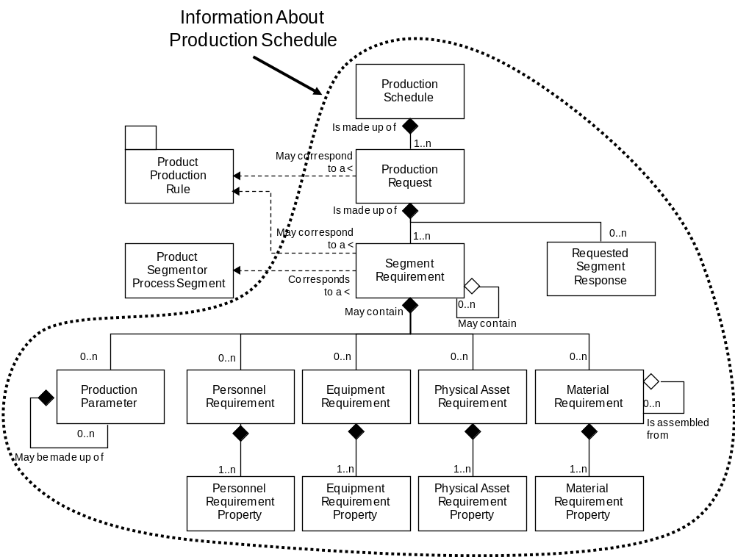
Model of Exchanged Production Schedule Information

This schema uses a common schema for definition of elements that are used in multiple schemas, such as ID, Description, and Value. This schema also includes the Production Performance schema definition for the requested segment response structure. See the document defining the Common schema for definition of the common elements. See the document defining the Production Performance schema for the definition of the requested segment response.

Key Use Assumptions
The model only defines the exchanged information and does not define the use of the information or encapsulation of the information in any defining transactions.

ProductionSchedule
A production schedule is made up of a set of 1 or more production requests. The production schedule also contains the information that defines the context of the schedule, such as start time, end time, location, and published date. The main structuring element of the schema definition is ProductionSchedule.

ProductionRequest
A production request defines a request for production for a single product identified by a production rule. A production request contains the information required by manufacturing to fulfill scheduled production. This may be a subset of the business production order information, or it may contain additional information not normally used by the business system.

A production request identifies the associated production rule. A production request must contain at least one segment requirement, even it spans all production of the product. If not uniquely defined by the production rule, then a segment requirement will contain at least one material produced requirement with the identification, quantity, and units of measure of the material to be produced.

SegmentRequirement
A production request is made up of one or more segment requirements. Each segment requirement may correspond to, or reference, an identified process or product segment. The segment requirement references the segment capability to which the associated personnel, equipment, materials, and production parameters correspond.

A SegmentRequirment reflects the ISA-95 standard where it says that a segment requirement corresponds to either a product segment or a process segment. It many cases it may not matter. A segment request should define resources and parameters already defined in process segments or product segments. However, in general in order to match the spirit of the ANSI/ISA-95 standard, this should always be a product segment ID in the SegmentRequirement, and the product segment should refer to a process segment through the ProductDefinition.

The production parameter in a SegmentRequirement can be a Process Segment parameter, or a Product Segment parameter. This means the production parameter could have been defined in the process segment, because it is product independent (like the color in a "PAINT" segment), or defined in a product segment when it is product dependent (such as a component’s color to be applied to only specific products). So, the SegmentRequirment could point to the product segment, but there could possible be duplicated parameters for the product segment and the process segment, and this allows them to be differentiated.

SegmentResponse
An production request may include a SegmentResponse element that defines the data to be returned after the execution of the segment.

NOTE: The SegmentResponse element (SegmentResponseType) is defined in the file:
B2MML-V0500-ProductionPerformanceTypes.xsd

PersonnelRequirement
A personnel requirement and the associated personnel requirement property elements define to the number, type, duration, and scheduling of specific certifications and job classifications needed to support the current production request.

EquipmentRequirement
The production request may include one or more requirements for, or constraints upon, the equipment that the facility shall use in the production process for the scheduled item. Requirements can be as generic as materials of construction, or it can as specific as a particular piece of equipment. Each of these requirements is defined in an EquipmentRequirement element and property.

PhysicalAssetRequirement
The production request may include one or more requirements for, or constraints upon, the physical assets that the facility shall use in the production process for the scheduled item. Requirements can be as generic as materials of construction, or it can as specific as a particular physical asset. Each of these requirements is defined in an PhysicalAssetRequirement element and property.

MaterialRequirement
A MaterialRequirement defines a requirement for a material to be produced, a material that will be consumed, or the expected amount of a consumable material. A material requirement may include the total quantity of the material to be produced or consumed and unit of measure, such as 5000 Lbs, and an acceptable range for the quantity of material. Material may be defined by Material Class ID, Material Definition ID, Material Lot ID, and/or Material Sublot ID. A MaterialRequirement element includes an element that specifies if the material is to be consumed, produced, or is a consumable material

MaterialProducedRequirement
A material produced requirement is an identification of a material to be produced from the production request. A material produced requirement may include the total quantity of the material to be produced and unit of measure, such as 5000 Lbs, and an acceptable range for the quantity of material. Material may be defined by Material Class ID, Material Definition ID, Material Lot ID, and/or Material Sublot ID.

Specific elements associated with each material produced requirement may be included in one or more material produced requirement properties.

Note: This element is included for backward compatibility. The MaterialRequirement should be used to specify material requirements.

MaterialsConsumedRequirement
A material consumed requirement is an identification of a material to be used in the production request. A material consumed requirement may include the total quantity of the material to be used and unit of measure, such as 5000 Lbs, and an acceptable range for the quantity of material. Material may be defined by Material Class ID, Material Definition ID, Material Lot ID, and/or Material Sublot ID.

Specific elements associated with each material consumed requirement may be included in one or more material consumed requirement properties.

Note: This element is included for backward compatibility. The MaterialRequirement should be used to specify material requirements.

ConsumableExpectedRequirement
Consumable expected include resources that are not normally included in bills of materials or are not individually accounted for in specific production requests. Depending on the industry these may include water, catalysts, common chemicals, and utilities, such as electricity and steam. These items will often result in direct charges that will usually be considered in costing the product segment. Consumables are often materials that do have an inventory balance.

Consumables do not have lot identifications. Consumables with lot identifications are typically treated as material consumed requirements.

Note: This element is included for backward compatibility. The MaterialRequirement should be used to specify material requirements.

Resource Identification
The schemas follow the ANSI/ISA-95 standard by defining resources by class ID or instance ID, or by defining them by class ID and a property value that is used to define a subset of the resource. For example, the figure below illustrates that a segment may require a certain number of milling machine, an equipment class. Other segments may require a subset of milling machine, such as “Fine” milling machines only. In the first case the class name, “Mill”, is sufficient to identify the resource required. In the second case the class name, “Mill”, and property name and value, “Spec” and “Fine”, define the required resource. Alternately a specific resource may be specified for a production schedule, such as requiring milling machine with ID=”Miller#1”.

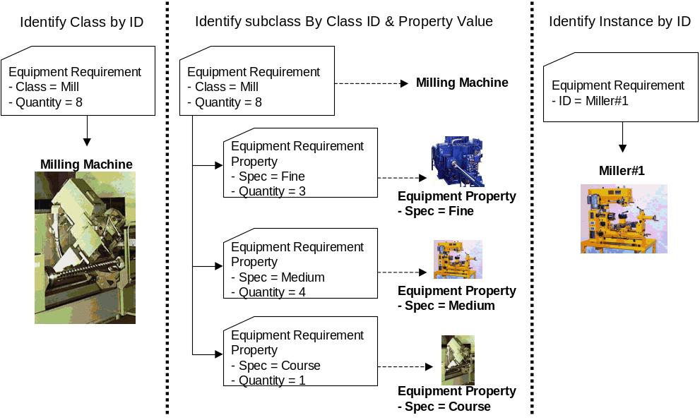

Element Definitions

Element/Type | Description
ProductionSchedule  ProductionScheduleType | Contains a definition of a production schedule, including the location of the scheduled elements, the publication date of the schedule, the time range of the schedule, and the list of production requests that make up the schedule.  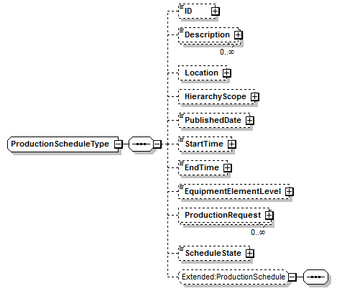
ProductionRequest  ProductionRequestType | Contains a definition of a production request element of a production schedule, including the associated product to be produced, the time range of the request, the priority of the request, the segment requirements of the request, and the definition of the expected segment response. 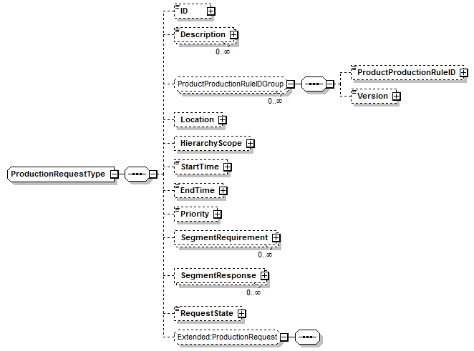
SegmentRequirement  SegmentRequirementType | Contains a definition of the schedule for a specific segment of production, including an identification of the associated product or process segment, the time range of the request, the expected duration of the request, production parameters for the segment, and the definition of the personnel, equipment, material produced, material consumed, and consumables to be used in production.  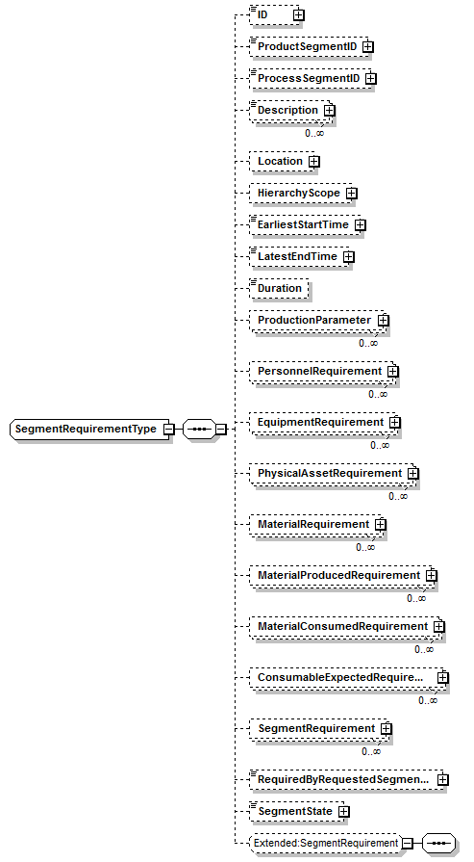
MaterialRequirement  MaterialRequirementType | Contains a definition of a material to be produced, consumed, or consumable material (non lot tracked material), including an identification of the use of the material, the quantity of the material or a definition of required subsets identified by resource properties.  A MaterialRequirement element may have a set of contained AssemblyRequirement elements to support hierarchical manufacturing bills.  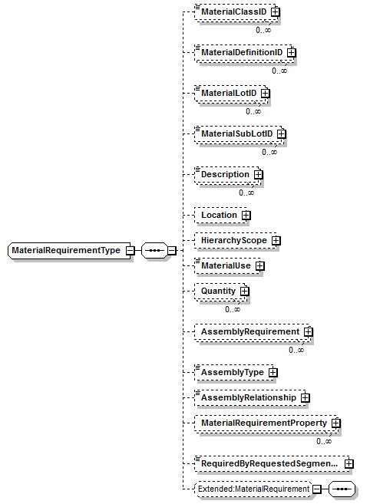
MaterialRequirementProperty  MaterialRequirementPropertyType | Contains a definition of a subset of a material used in a segment requirement, including the value used to identify the subset and the quantity of the material used.  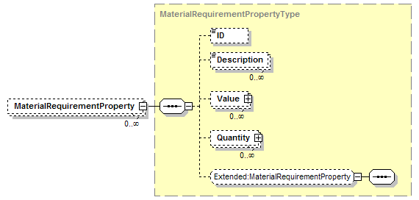
ConsumableExpectedRequirement  ConsumableExpectedRequirementType | Contains a definition of a consumable material used for a segment requirement, including an identification of the quantity of the resource consumed, or a definition of required subsets identified by resource properties.  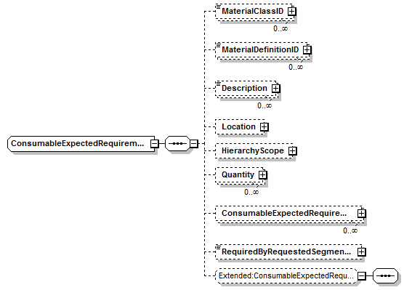  Note: This element is included for backward compatibility. The MaterialRequirement should be used to specify material requirements.
ConsumableExpectedRequirementProperty  ConsumableExpectedRequirementPropertyType | Contains a definition of a subset of a consumable material used in a segment requirement, including the value used to identify the subset and the quantity of the consumable used.  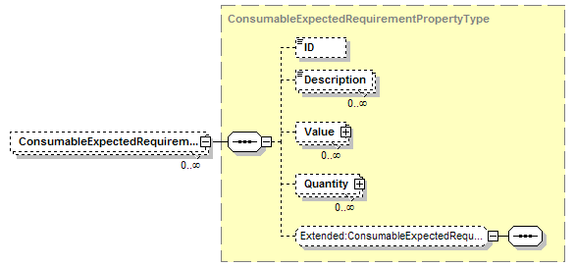  Note: This element is included for backward compatibility.
EquipmentlRequirement  EquipmentlRequirementType | Contains a definition of an equipment requirement for a segment requirement, including an identification of the quantity of the resource used, or a definition of required subsets identified by resource properties.  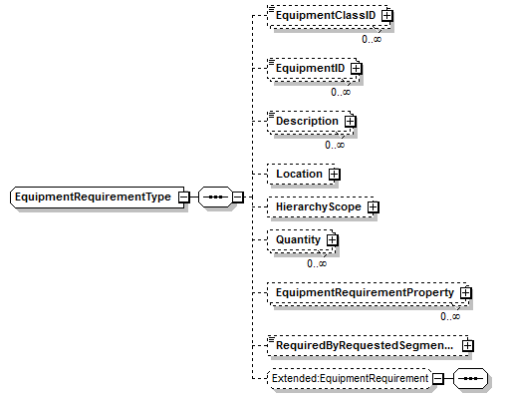
EquipmentRequirementProperty  EquipmentRequirementPropertyType | Contains a definition of a subset of an equipment resource used in a segment requirement, including the value used to identify the subset and the quantity of the resource used.  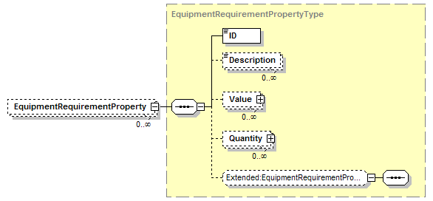
MaterialConsumedRequirement  MaterialConsumedRequirementType | Contains a definition of a material to be consumed for a segment requirement, including an identification of the quantity of the resource consumed, or a definition of required subsets identified by resource properties.  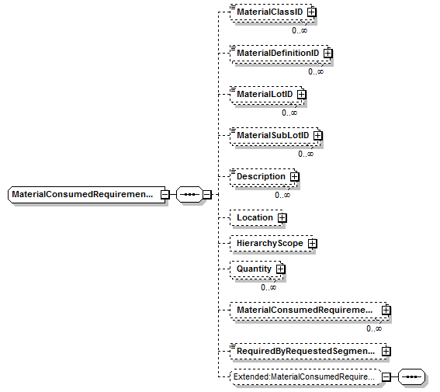  Note: This element is included for backward compatibility. The MaterialRequirement should be used to specify material requirements.
MaterialConsumedRequirementProperty  MaterialConsumedRequirementPropertyType | Contains a definition of a subset of a material consumed in a segment requirement, including the value used to identify the subset and the quantity of the material consumed.  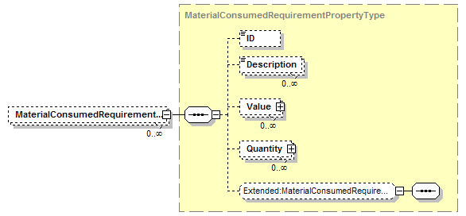  Note: This element is included for backward compatibility.
MaterialProducedRequirement  MaterialProducedRequirementType | Contains a definition of a material to be produced for a segment requirement, including an identification of the quantity of the resource produced, or a definition of required subsets identified by resource properties.  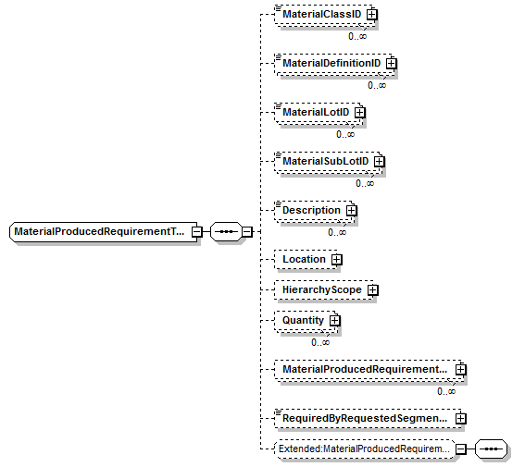  Note: This element is included for backward compatibility. The MaterialRequirement should be used to specify material requirements.
MaterialProducedRequirementProperty  MaterialProducedRequirementPropertyType | Contains a definition of a subset of a material produced in a segment requirement, including the value used to identify the subset and the quantity of the material produced.  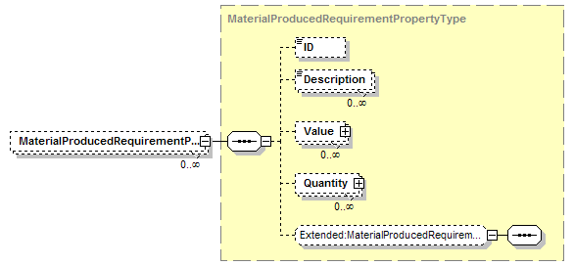  Note: This element is included for backward compatibility.
PersonnelRequirement  PersonnelRequirementType | Contains a definition of a personnel requirement for a segment requirement, including an identification of the quantity of the resource used, or a definition of required subsets identified by resource properties.  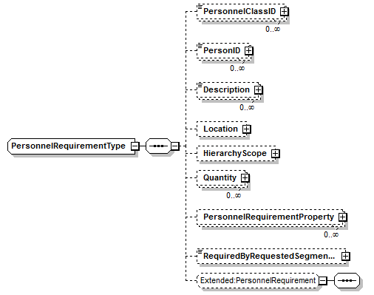
PersonnelRequirementProperty  PersonnelRequirementPropertyType | Contains a definition of a subset of a personnel resource used in a segment requirement, including the value used to identify the subset and the quantity of the resource used.  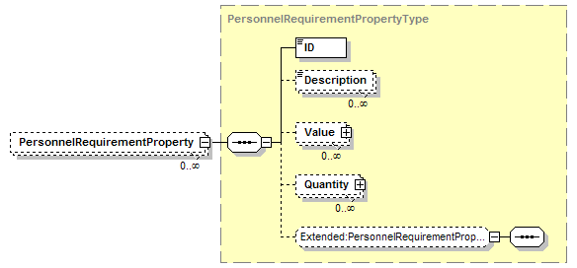
PhysicalAssetRequirement  PhysicalAssetRequirementType | Contains a definition of a physical asset requirement for a segment requirement, including an identification of the quantity of the resource used, or a definition of required subsets identified by resource properties.  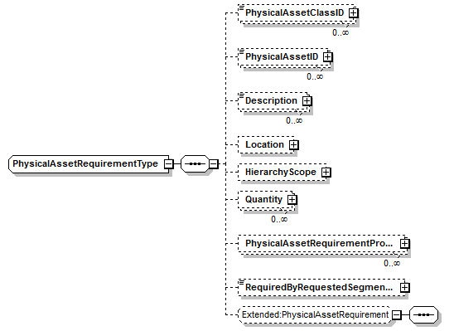
PhysicalAssetRequirementProperty  PhysicalAssetRequirementPropertyType | Contains a definition of a subset of a physical asset resource used in a segment requirement, including the value used to identify the subset and the quantity of the resource used.  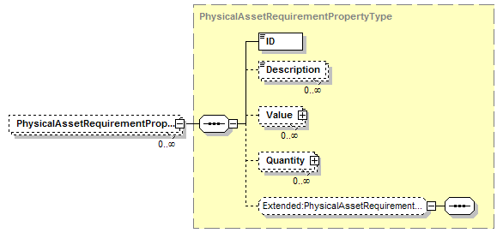
ProductionParameter  ProductionParameterType | Contains a definition of a production parameter, which may correspond to a product segment parameter or a process segment parameter, including the value for the parameter.  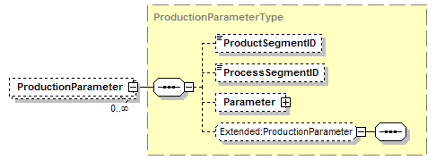

Transaction Elements
The following elements are defined to support the ISA 95 Part 5 transactions, using the transaction data types defined in the B2MML-Common.xsd schema.

Production Schedule Elements | Description
GetProductionSchedule | Get ProductionSchedule definition.
ShowProductionSchedule | Returned information from the GetProductionSchedule message.
ProcessProductionSchedule | Process ProductionSchedule definition.
AcknowledgeProductionSchedule | Returned status from the ProcessProductionSchedule message.
ChangeProductionSchedule | Change ProductionSchedule definition.
RespondProductionSchedule | Returned status from the ChangeProductionSchedule message.
CancelProductionSchedule | Cancel ProductionSchedule definition.
SyncProductionSchedule | Published ProductionSchedule definition.

Diagram Convention
The schema diagrams using the following convention to illustrate the structure of the schema elements, the type of the elements and attributes, and the rules for optional elements and repetition.

