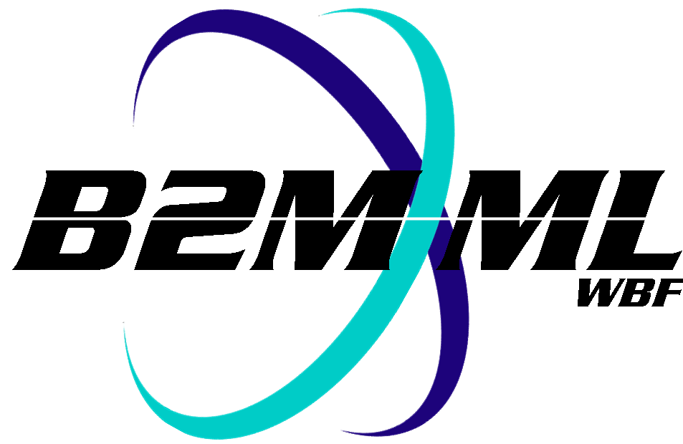
Business To Manufacturing
Markup Language
B2MML – Transaction Profile
Version 0500 – March 2011
Transaction Profile Schema
Documentation



IMPORTANT: While the information, data, and standards provided in this publication were developed and are presented in good faith in accordance with a reasonable process that was subject to intellectual property and antitrust policies to benefit the industry as a whole, the publication is provided “as is” for information and guidance only, and there is no representation or warranty of any type or kind, including but not limited to warranties of merchantability or fitness for a particular purpose, and no warranty that use of the information, data, or standards will not infringe patent, copyright, trademark, trade secret, or other intellectual property rights of any party.
Table of Contents

1 Schema Scope 3
1.1 Key Information Assumptions 3
1.2 Transaction Profile 3
1.3 Supported Action 3
2 Element Definitions 4
3 Transaction Elements 6
4 Diagram Convention 7

Change History:
Change | Date | Person | Description
V04 | 04 June 2007 | Dennis Brandl | - Initial version with transaction elements
V0401 | Oct 2008 | Dennis Brandl | - Updated version number
V0500 | Mar 2011 | Dennis Brandl | Updated version documentation and WBF name in copyright. Updated list of objects types.

Copyright © 2011 WBF The Organization for Production Technology
All Rights Reserved. http://www.wbf.org

This WBF Work (including specifications, documents, software, and related items) referred to as the Business To Manufacturing Markup Language (B2MML) is provided by the copyright holders under the following license.

Permission to use, copy, modify, or redistribute this Work and its documentation, with or without modification, for any purpose and without fee or royalty is hereby granted provided the WBF is acknowledged as the originator of this Work using the following statement:

"The Business To Manufacturing Markup Language (B2MML) is used courtesy of the WBF."

In no event shall the WBF, its members, or any third party be liable for any costs, expenses, losses, damages or injuries incurred by use of the Work or as a result of this agreement.

Material from ANSI/ISA-88 and ANSI/ISA-95 series of standards used with permission of ISA - The Instrumentation, Systems, and Automation Society, www.isa.org

Schema Scope
This document defines the information about transaction profile definitions that may be exchanged between business systems and manufacturing operations systems. This information is based on the data models and attributes defined in the ANSI/ISA 95.00.02 Enterprise/Control System Integration standard. Contact ISA (The Instrumentation, System, and Automation Society) for copies of the standard. Additional information on the standard is available at www.isa.org.

Key Information Assumptions
The data represented in these schemas is derived from the UML model below. This model is defined in the ANSI/ISA 95.00.05 standard. The information model defines a transaction profile as a collection of supported action definitions.

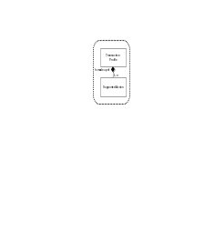

Model of Transaction Profile Information

This schema uses a common schema for definition of elements that are used in multiple schemas. See the document defining the WBF95Common schema for definition of the common elements.

Transaction Profile
A TransactionProfile contains a set of supported transaction actions. There is only one transaction defined for a TransactionProfile, a GET transaction. This allows an application to query another application to obtain what B2MML transaction services the server provides.

Supported Action
A SupportedAction contains a definition of a single transaction that is supported by an application. This includes the verb that is supported (GET, PROCESS, CHANGE, CANCEL, CONFIRM, SYNC ADD, SYNC CHANGE, and SYNC DELETE) and the noun (object type) that is supported.

Element Definitions

Element/Type | Description
TransactionProfile | A complex type that includes an identification of the transaction profile, a location (scope) of the profile, the published date of the profile, and any supported actions.  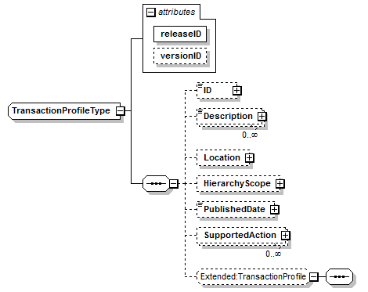

SupportedAction | A complex type that contains:  - An identification of the supported action.  - An optional description of the supported action.  - The verb that is defined for the supported action.  - The noun that is defined for the supported action.  - An indication (True or False) that the responder can act as an information user.  - An indication (True or False) that the responder can act as an information provider.  - An indication (True or False) that the responder can act as an information Sender.  - An indication (True or False) that the responder can act as an information Receiver.  - An indication (True or False) that the responder supports wildcard specifications in object identifications.  - An indication (True or False) that the responder supports wildcard specifications in property identifications.  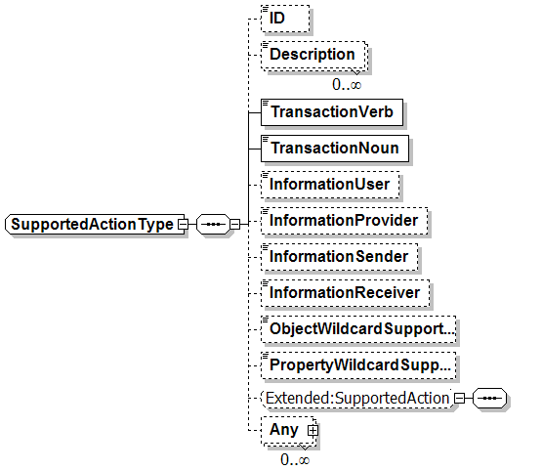
TransactionNounType | A string used to indicate the noun supported by a transaction that is defined in a TransactionProfile. The value must be one of the following standard enumerations:  “PERSONNEL CLASS", “PERSON", “QUALIFICATION TEST", “EQUIPMENT CLASS", “EQUIPMENT", “CAPABILITY TEST", “MAINTENANCE REQUEST", “MAINTENANCE WORK ORDER", “MAINTENANCE RESPONSE", “MATERIAL CLASS", "MATERIAL DEFINITION", “MATERIAL LOT", “MATERIAL SUBLOT", "MATERIAL TEST", "PROCESS SEGMENT", "OPERATIONS CAPABILITY", “OPERATIONS DEFINITION", “OPERATIONS SCHEDULE", “OPERATIONS PERFORMANCE", "PRODUCTION CAPABILITY", “PRODUCT DEFINITION", “PRODUCTION SCHEDULE", “PRODUCTION PERFORMANCE", “TRANSACTION PROFILE", “CONFIRM BOD”, or “Other”  If “Other” then the type is an application specific extension and the value is defined in the attribute “OtherValue”.
TransactionVerbType | A string used to indicate a verb transaction set that is defined in a TransactionProfile. The value must be one of the following standard enumerations:  “GET”, “PROCESS”, “CHANGE”, “CANCEL”, “CONFIRM”, “SYNC ADD”, “SYNC CHANGE”, “SYNC DELETE”, or “Other”.  - GET → Supports the GET/SHOW transaction  - PROCESS → Supports the PROCESS/ACKNOWLEDGE transaction  - CHANGE → Supports the CHANGE/RESPOND transaction  - CANCEL → Supports the CANCEL transaction  - CONFIRM → Supports a CONFIRM response  - SYNC ADD → Supports the SYNC ADD transaction  - SYNC CHANGE → Supports the SYNC CHANGE transaction  - SYNC DELETE → Supports the SYNC DELETE transaction  If “Other” then the type is an application specific extension and the value is defined in the attribute “OtherValue”.

Transaction Elements
The following elements are defined to support the ISA 95 Part 5 transactions, using the transaction data types defined in the B2MML-Common.xsd schema.

Transaction Profile Information Elements | Description
GetTransactionProfile | Get TransactionProfile definitions.
ShowTransactionProfile | Response from a GetTransactionProfile message.

Diagram Convention
The schema diagrams using the following convention to illustrate the structure of the schema elements, the type of the elements and attributes, and the rules for optional elements and repetition.

