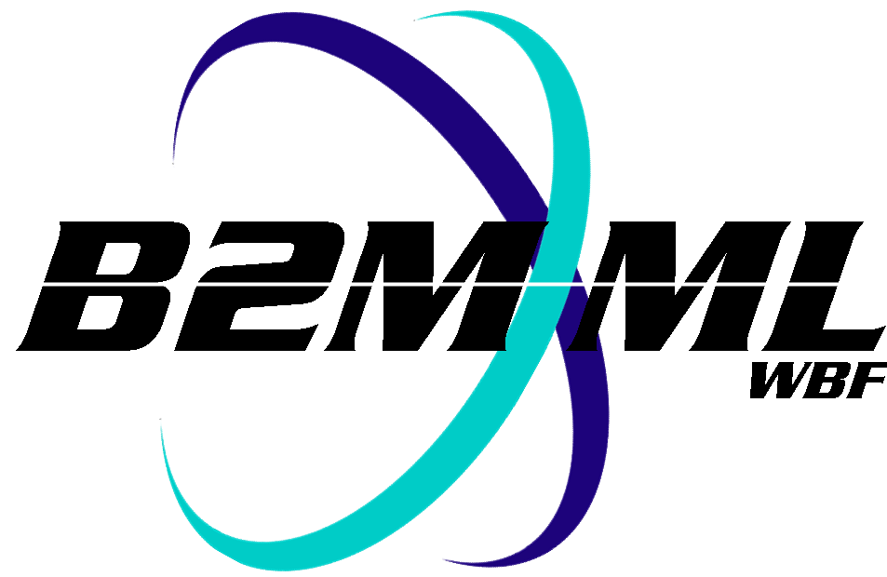
Business To Manufacturing
Markup Language
B2MML - Maintenance
Version 0401 – October 2008
Maintenance Schema
Documentation



IMPORTANT: While the information, data, and standards provided in this publication were developed and are presented in good faith in accordance with a reasonable process that was subject to intellectual property and antitrust policies to benefit the industry as a whole, the publication is provided “as is” for information and guidance only, and there is no representation or warranty of any type or kind, including but not limited to warranties of merchantability or fitness for a particular purpose, and no warranty that use of the information, data, or standards will not infringe patent, copyright, trademark, trade secret, or other intellectual property rights of any party.
Table of Contents

1 Schema Scope 3
1.1 Key Information Assumptions 3
1.2 Key Use Assumptions 3
1.3 MaintenanceInformation 3
1.4 MaintenanceRequest 4
1.5 MaintenanceResponse 4
1.6 MaintenanceWorkOrder 4
2 Element Definitions 5
3 Transaction Elements 9
4 Diagram Convention 11

Change History:
Change | Date | Person | Description
V01 | 7 April 2002 | Dennis Brandl  Dave Emerson | Initial release
V02 | 23 Sept 2003 | Dennis Brandl  Dave Emerson | - Changed ##any to "Any" element of type "AnyType"
V03 | 26 Aug 2005 | Dennis Brandl  Dave Emerson | - Added substitution groups. One group added just before each Any element.
V0301 | 29 Dec 2005 | Dennis Brandl | - Only changed version to v0301
V04 | 04 June 2007 | Dennis Brandl | - Added transaction elements
V0401 | Oct 2008 | Dennis Brandl | - Changed version number

Copyright © 2008 WBF. All Rights Reserved. http://www.wbf.org

This WBF Work (including specifications, documents, software, and related items) referred to as the Business To Manufacturing Markup Language (B2MML) is provided by the copyright holders under the following license.

Permission to use, copy, modify, or redistribute this Work and its documentation, with or without modification, for any purpose and without fee or royalty is hereby granted provided the WBF is acknowledged as the originator of this Work using the following statement:

"The Business To Manufacturing Markup Language (B2MML) is used courtesy of WBF."

In no event shall the WBF, its members, or any third party be liable for any costs, expenses, losses, damages or injuries incurred by use of the Work or as a result of this agreement.

Material from ANSI/ISA-88 and ANSI/ISA-95 series of standards used with permission of ISA - The Instrumentation, Systems, and Automation Society, www.isa.org

Schema Scope
This document defines the information about process segment definitions that may be exchanged between business systems and manufacturing operations systems. This information is based on the data models and attributes defined in the ANSI/ISA 95.00.02 Enterprise/Control System Integration standard. Contact ISA (The Instrumentation, System, and Automation Society) for copies of the standard. Additional information on the standard is available at www.isa.org.

Key Information Assumptions
The data represented in these schemas is derived from the UML model below. This model is defined in the ANSI/ISA 95.00.02 standard. . The information model in the model below is not hierarchical, so the key assumption is that the information may be accessed from any of the three starting points: maintenance requests, maintenance work orders, or maintenance responses.

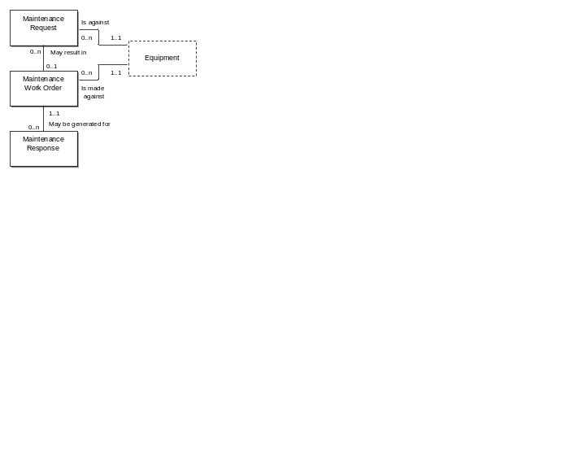
Model of Exchanged Maintenance Information

The maintenance model follows the simplified structure of ANSI/ISA-95.00.01, and will only be a subset of the full maintenance information.

This schema uses a common schema for definition of elements that are used in multiple schemas, such as ID, Description, and Value. See the document defining the WBF95Common schema for definition of the common elements.

Key Use Assumptions
The model only defines the exchanged information and does not define the use of the information or encapsulation of the information in any defining transactions.

MaintenanceInformation
The main structuring element of the schema definition is MaintenanceInformation. Maintenance Information includes zero or more maintenance requests, maintenance work orders, and maintenance responses.

MaintenanceRequest
A maintenance request is made against specific equipment. There may be many outstanding maintenance requests against a piece of equipment. A maintenance request may result in a maintenance work order against the equipment. Zero or more maintenance work orders may be generated from a maintenance request. A maintenance response is made against a maintenance work order.

Maintenance requests will usually include:
- Who made the request
- The date and time of the request
- The needed data and time of resolution
- The equipment associated with the request
- A description of the request
- A priority

MaintenanceResponse
Maintenance responses will usually include:
- The date and time of the response
- Who responded to the work order
- A description of the response
- The result of the work order

MaintenanceWorkOrder
Maintenance work order will usually include:
- The associated person or personnel class assigned
- The assigned priority of the work order
- The status of the work order (e.g. pending, in process)

Element Definitions

Element/Type | Description
MaintenanceInformation  MaintenanceInformationType | Maintenance information is a top level object that contains the definition of maintenance requests, maintenance work orders, and maintenance response. This element type may be extended with application specific elements.  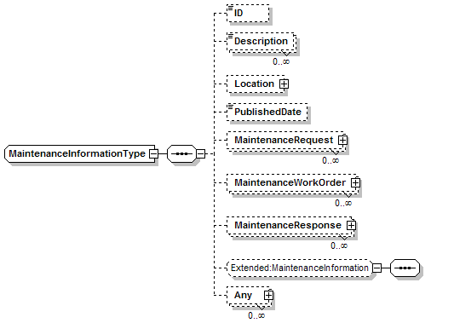
MaintenanceRequest  MaintenanceRequestType | A top level object that contains the definition of a maintenance request. This element type may be extended with application specific elements.  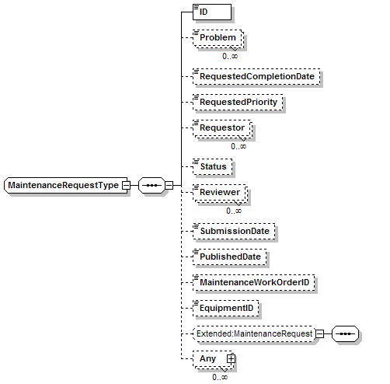
MaintenanceWorkOrder  MaintenanceWorkOrderType | A top level object that contains the definition of a maintenance work order. This element type may be extended with application specific elements.  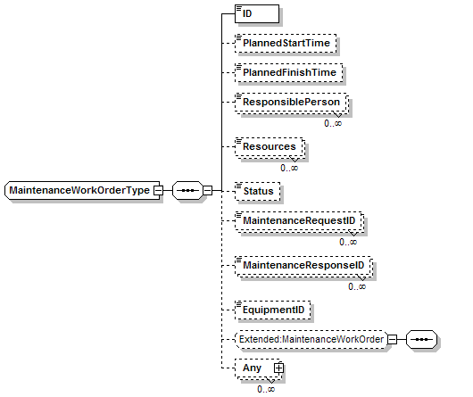
MaintenanceResponse  MaintenanceResponseType | A top level object that contains the definition of a maintenance response. This document may be defined by application specific elements.

Transaction Elements
The following elements are defined to support the ISA 95 Part 5 transactions, using the transaction data types defined in the B2MML-Common.xsd schema.

Maintenance Information Elements | Description
GetMaintenanceInformation | Get MaintenanceRequest, MaintenanceResponse, and MaintenanceWorkOrder definitions.
ShowMaintenanceInformation | Returned information from the GetMaintenanceInformation message.
ProcessMaintenanceInformation | Process MaintenanceRequest, MaintenanceResponse, and MaintenanceWorkOrder definitions.
AcknowledgeMaintenanceInformation | Returned status from the ProcessMaintenanceInformation message.
ChangeMaintenanceInformation | Change MaintenanceRequest, MaintenanceResponse, and MaintenanceWorkOrder definitions.
RespondMaintenanceInformation | Returned status from the ChangeMaintenanceInformation message.
CancelMaintenanceInformation | Cancel MaintenanceRequest, MaintenanceResponse, and MaintenanceWorkOrder definitions.
SyncMaintenanceInformation | Published MaintenanceRequest, MaintenanceResponse, and MaintenanceWorkOrder definitions.

Maintenance Request Elements | Description
GetMaintenanceRequest | Get MaintenanceRequest definitions.
ShowMaintenanceRequest | Returned information from the GetMaintenanceRequest message.
ProcessMaintenanceRequest | Process MaintenanceRequest definitions.
AcknowledgeMaintenanceRequest | Returned status from the ProcessMaintenanceRequest message.
ChangeMaintenanceRequest | Change MaintenanceRequest definitions.
RespondMaintenanceRequest | Returned status from the ChangeMaintenanceRequest message.
CancelMaintenanceRequest | Cancel MaintenanceRequest definitions.
SyncMaintenanceRequest | Published MaintenanceRequest definitions.

Maintenance Response Elements | Description
GetMaintenanceResponse | Get MaintenanceResponse definitions.
ShowMaintenanceResponse | Returned information from the GetMaintenanceResponse message.
ProcessMaintenanceResponse | Process MaintenanceResponse definitions.
AcknowledgeMaintenanceResponse | Returned status from the ProcessMaintenanceResponse message.
ChangeMaintenanceResponse | Change MaintenanceResponse definitions.
RespondMaintenanceResponse | Returned status from the ChangeMaintenanceResponse message.
CancelMaintenanceResponse | Cancel MaintenanceResponse definitions.
SyncMaintenanceResponse | Published MaintenanceRequest definitions.

Maintenance Work Order Elements | Description
GetMaintenanceWorkOrder | Get MaintenanceWorkOrder definitions.
ShowMaintenanceWorkOrder | Returned information from the GetMaintenanceWorkOrder message.
ProcessMaintenanceWorkOrder | Process MaintenanceWorkOrder definitions.
AcknowledgeMaintenanceWorkOrder | Returned status from the ProcessMaintenanceWorkOrder message.
ChangeMaintenanceWorkOrder | Change MaintenanceWorkOrder definitions.
RespondMaintenanceWorkOrder | Returned status from the ChangeMaintenanceWorkOrder message.
CancelMaintenanceWorkOrder | Cancel MaintenanceWorkOrder definitions.
SyncMaintenanceWorkOrder | Published MaintenanceRequest definitions.

Diagram Convention
The schema diagrams using the following convention to illustrate the structure of the schema elements, the type of the elements and attributes, and the rules for optional elements and repetition.

