
Business To Manufacturing
Markup Language
B2MML - Material
Version 0401 – October 2008
Material Schema
Documentation

IMPORTANT: While the information, data, and standards provided in this publication were developed and are presented in good faith in accordance with a reasonable process that was subject to intellectual property and antitrust policies to benefit the industry as a whole, the publication is provided “as is” for information and guidance only, and there is no representation or warranty of any type or kind, including but not limited to warranties of merchantability or fitness for a particular purpose, and no warranty that use of the information, data, or standards will not infringe patent, copyright, trademark, trade secret, or other intellectual property rights of any party.
Table of Contents

1 Schema Scope 3
1.1 Key Information Assumptions 3
1.2 Key Use Assumptions 3
1.3 MaterialInformation 4
1.4 MaterialLot 4
1.5 MaterialSublot 4
1.6 MaterialDefinition 4
1.7 MaterialClass 4
1.8 QATestSpecification 4
2 Element Definitions 6
3 Transaction Elements 12
4 Diagram Convention 14

Change History:
Change | Date | Person | Description
V01 | 7 April 2002 | Dennis Brandl  Dave Emerson | Initial release
V02 | 23 Sept 2003 | Dennis Brandl  Dave Emerson | - Added Location information to lot type  - Changed ##any to "Any" element of type "AnyType"  - Move StorageLocation and Quantity to MaterialLotType
V03 | 26 Aug 2005 | Dennis Brandl  Dave Emerson | - Added substitution groups. One group added just before each Any element.  - Added MaterialLotID to MaterialSubLot so a stand alone MaterialSubLot element can be identified with a Lot ID.
V0301 | 29 Dec 2005 | Dennis Brandl | - Added properties to sublots
V04 | 04 June 2007 | Dennis Brandl | - Added transaction elements
V0401 | Oct 2008 | Dennis Brandl | - Changed version number

Copyright © 2008 WBF. All Rights Reserved. http://www.wbf.org

This WBF Work (including specifications, documents, software, and related items) referred to as the Business To Manufacturing Markup Language (B2MML) is provided by the copyright holders under the following license.

Permission to use, copy, modify, or redistribute this Work and its documentation, with or without modification, for any purpose and without fee or royalty is hereby granted provided the WBF is acknowledged as the originator of this Work using the following statement:

"The Business To Manufacturing Markup Language (B2MML) is used courtesy of the WBF."

In no event shall the WBF, its members, or any third party be liable for any costs, expenses, losses, damages or injuries incurred by use of the Work or as a result of this agreement.

Material from ANSI/ISA-88 and ANSI/ISA-95 series of standards used with permission of ISA - The Instrumentation, Systems, and Automation Society, www.isa.org

Schema Scope
This document defines the information about material definitions, material classes, material lots, material sublots, and QA (Quality Assurance) tests that may be exchanged between business systems and manufacturing operations systems. This information is based on the data models and attributes defined in the ANSI/ISA 95.00.02 Enterprise/Control System Integration standard. Contact ISA (The Instrumentation, System, and Automation Society) for copies of the standard. Additional information on the standard is available at www.isa.org.

Key Information Assumptions
The data represented in these schemas is derived from the UML model below. This model is defined in the ANSI/ISA 95.00.02 standard. The information model in the model below is not hierarchical, so the key assumption is that the information may be accessed from any of four starting points: material class, material definition, lot, or QA test, as identified by the dotted collections in the figure.

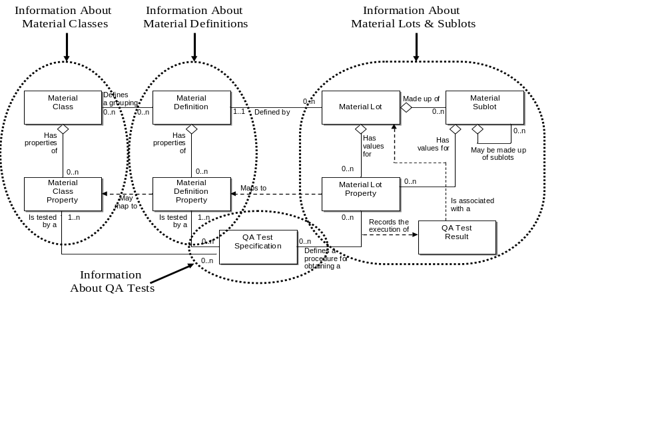
Model of Exchanged Material Information

This schema uses a common schema for definition of elements that are used in multiple schemas, such as ID, Description, and Value. See the document defining the WBF95Common schema for definition of the common elements.

Key Use Assumptions
The model only defines the exchanged information and does not define the use of the information or encapsulation of the information in any defining transactions.

MaterialInformation
The main structuring element of the schema definition is MaterialInformation.

MaterialLot
A material lot object uniquely identifies a specific amount of material, countable or weighable. This describes the actual total quantity or amount of material available, its current state, and its specific property values.

MaterialLot elements may be used to contain information about specific material and subsets of the material stored as sublots. It may also include the definition of QA test results. It may include the list of material definitions the material belongs to and the list of QA test specifications associated with properties.

MaterialSublot
A material lot may be stored as separately identifiable quantities. Each separate identifiable quantity of the material is identified in a material sublot. All material sublots must contain the same material lot, so they use the material lot element’s property values. A material sublot may be just a single item. Material sublots may have sublot specific properties, such as RFID tag IDs or other identification properties, maintained in a MaterialSublotProperty element.

Each material sublot also contains the location of the sublot, the quantity or amount of material available in the sublot, and a reference to the material lot. Material sublots may contain other sublots. For example, a sublot may be a pallet, each box on the pallet may also be a sublot, and each material blister pack in the box may also be a sublot.

MaterialDefinition
A material definition is a means to describe goods with similar characteristics for purposes of scheduling and planning. Examples of these may be “City Water”, “HCl”, and “Grade B Aluminum”. The materials may be identified as raw, intermediate, or final and may have other state information, such as availability of safety information.

MaterialDefinition information may be used to contain information about material definitions. It may contain the list of material lots belonging to the definition and the list of QA test specifications associated with material definition properties.

MaterialClass
A material class is means of defining groupings material definitions for use in production scheduling or processing. An example of a material class is "Sweetener", with members of "Fructose", "Corn Syrup", and "Sugar Cane Syrup". Another example of a material class is "Water", with members of "City Water", "Recycled Water", and "Spring Water". A material definition may belong to zero or more material classes.

MaterialClass information may be used to contain information about material classes. It may contain the list of material definitions belonging to the class and the list of QA test specifications associated with material class properties.

QATestSpecification
A QA test specification may be associated with a material class property. This is typically used where a test is required to ensure that the material has the required property value. A QA test specification may identify a test for one or more material class properties. Not all properties need to have a defined QA test specification.

QATestSpecification information may be used to contain information about QA (Quality Assurance) tests. It may contain identifications of the tested material properties and the tested material class properties.

Element Definitions

Element/Type | Description
MaterialClass  MaterialClassType | Contains a definition of a material class, the properties associated with the class, and the list of material definitions associated with the class.  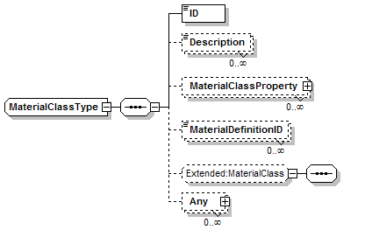
MaterialClassProperty  MaterialClassPropertyType | Contains a definition of a property for a material class, the nominal value of the property and the ID of a QA test specification for the property.  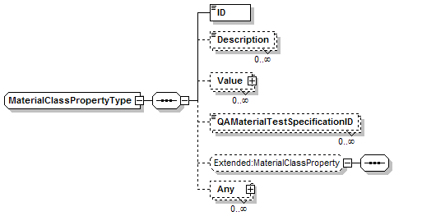
MaterialDefinition  MaterialDefinitionType | Contains a definition of a material definition, the properties associated with the definition, the list of material class the definition belongs to, and the list of material lots belonging to the definition.  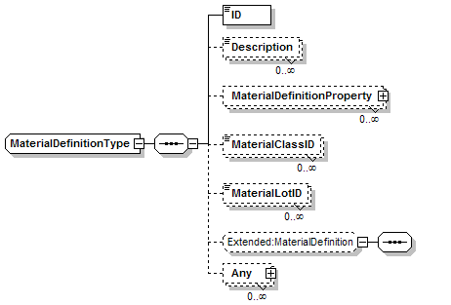
MaterialDefinitionProperty  MaterialDefinitionPropertyType | Contains a definition of a property for a material definition, the nominal value of the property and the ID of a QA test specification for the property.  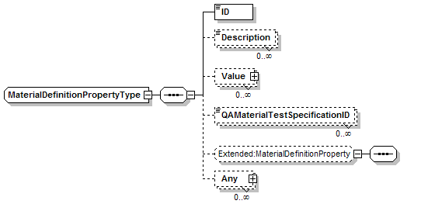
MaterialInformation  MaterialInformationType | Contains material information, may include a list of material classes, material definitions, material lots, material sublots, and QA test specifications.  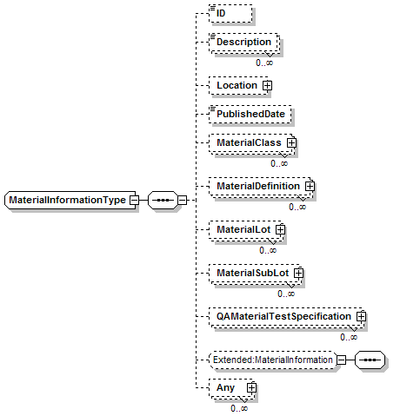
MaterialLot  MaterialLotType | Contains a definition of a material lot, the properties associated with the lot, the material definition of the lot, a status of the lot, the list of material sub lots associated with the lot, an optional storage location and quantity.  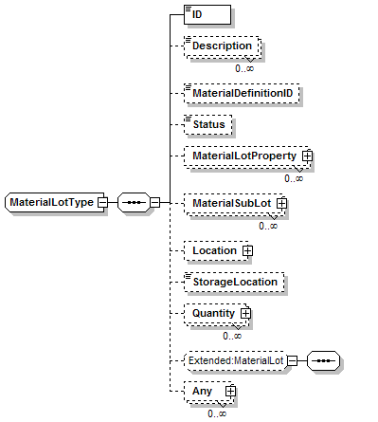
MaterialLotProperty  MaterialLotPropertyType | Contains a definition of a property for a material lot, the nominal value of the property and the ID of a QA test specification for the property. It may contain a storage location and quantity, and test results from QA material tests.  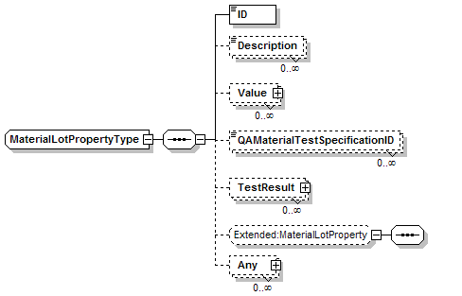
MaterialSublot  MaterialSublotType | Contains a definition of a material sublot, a status of the sublot, the storage location of the sublot, the quantity of the sublot, any sublots that make up the sublot, and the ID of the associated material lot.  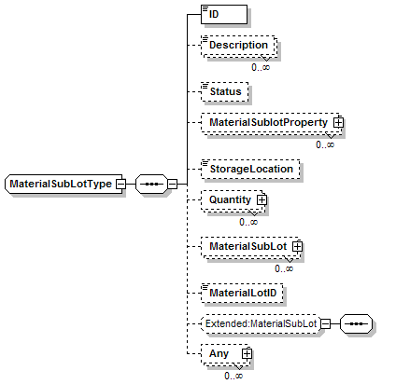
QAMaterialTestSpecification  QAMaterialTestSpecificationType | Contains a definition of a QA (Quality Assurance) test specification, including the ID and version of the test, the list of tested material class properties, the list of tested material definition properties, the list of tested material lot properties, and application defined elements.  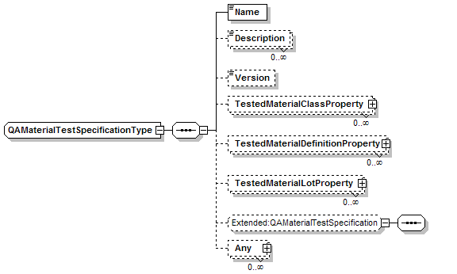
TestedMaterialClassProperty  TestedMaterialClassPropertyType | Contains an identification of a tested material class and a property ID.  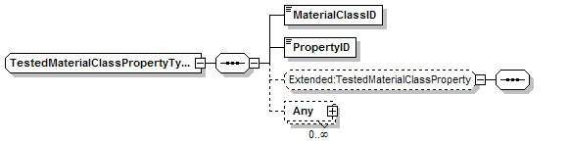
TestedMaterialDefinitionProperty  TestedMaterialDefinitionPropertyType | Contains an identification of a tested material definition and a property ID.  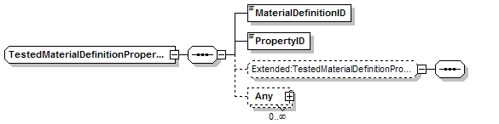
TestedMaterialLotProperty  TestedMaterialLotPropertyType | Contains an identification of a tested material lot and a property ID.  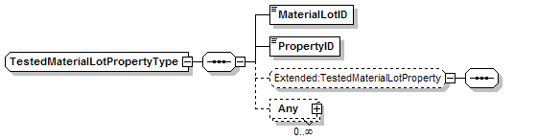

Transaction Elements
The following elements are defined to support the ISA 95 Part 5 transactions, using the transaction data types defined in the B2MML-Common.xsd schema.

Material Information Elements | Description
GetMaterialInformation | Get MaterialClass, MaterialDefinition, MaterialLot, MaterialSublot, and QAMaterialTestSpecification definitions.
ShowMaterialInformation | Returned information from the GetMaterialInformation message.
ProcessMaterialInformation | Process MaterialClass, MaterialDefinition, MaterialLot, MaterialSublot, and QAMaterialTestSpecification definitions.
AcknowledgeMaterialInformation | Returned status from the ProcessMaterialInformation message.
ChangeMaterialInformation | Change MaterialClass, MaterialDefinition, MaterialLot, MaterialSublot, and QAMaterialTestSpecification definitions.
RespondMaterialInformation | Returned status from the ChangeMaterialInformation message.
CancelMaterialInformation | Cancel MaterialClass, MaterialDefinition, MaterialLot, MaterialSublot, and QAMaterialTestSpecification definitions.
SyncMaterialInformation | Published MaterialClass, MaterialDefinition, MaterialLot, MaterialSublot, and QAMaterialTestSpecification definitions.

Material Class Elements | Description
GetMaterialClass | Get MaterialClass definitions.
ShowMaterialClass | Returned information from the GetMaterialClass message.
ProcessMaterialClass | Process MaterialClass definitions.
AcknowledgeMaterialClass | Returned status from the ProcessMaterialClass message.
ChangeMaterialClass | Change MaterialClass definitions.
RespondMaterialClass | Returned status from the ChangeMaterialClass message.
CancelMaterialClass | Cancel MaterialClass definitions.
SyncMaterialClass | Published MaterialClass definitions.

Material Definition Elements | Description
GetMaterialDefinition | Get MaterialDefinition definitions.
ShowMaterialDefinition | Returned information from the GetMaterialDefinition message.
ProcessMaterialDefinition | Process MaterialDefinition definitions.
AcknowledgeMaterialDefinition | Returned status from the ProcessMaterialDefinition message.
ChangeMaterialDefinition | Change MaterialDefinition definitions.
RespondMaterialDefinition | Returned status from the ChangeMaterialDefinition message.
CancelMaterialClass | Cancel MaterialDefinition definitions.
SyncMaterialDefinition | Published MaterialClass definitions.

Material Lot Elements | Description
GetMaterialLot | Get MaterialLot definitions.
ShowMaterialLot | Returned information from the GetMaterialLot message.
ProcessMaterialLot | Process MaterialLot definitions.
AcknowledgeMaterialLot | Returned status from the ProcessMaterialLot message.
ChangeMaterialLot | Change MaterialLot definitions.
RespondMaterialLot | Returned status from the ChangeMaterialLot message.
CancelMaterialLot | Cancel MaterialLot definitions.
SyncMaterialLot | Published MaterialLot definitions.

Material Sublot Elements | Description
GetMaterialSublot | Get MaterialSublot definitions.
ShowMaterialSublot | Returned information from the GetMaterialSublot message.
ProcessMaterialSublot | Process MaterialSublot definitions.
AcknowledgeMaterialSublot | Returned status from the ProcessMaterialSublot message.
ChangeMaterialSublot | Change MaterialSublot definitions.
RespondMaterialSublot | Returned status from the ChangeMaterialSublot message.
CancelMaterialSublot | Cancel MaterialSublot definitions.
SyncMaterialSublot | Published MaterialSublot definitions.

QA Material Test Specification Elements | Description
GetQAMaterialTestSpec | Get QAMaterialTestSpecification definitions.
ShowQAMaterialTestSpec | Returned information from the GetQAMaterialTestSpec message.
ProcessQAMaterialTestSpec | Process QAMaterialTestSpecification definitions.
AcknowledgeQAMaterialTestSpec | Returned status from the ProcessQAMaterialTestSpec message.
ChangeQAMaterialTestSpec | Change QAMaterialTestSpecification definitions.
RespondQAMaterialTestSpec | Returned status from the ChangeQAMaterialTestSpec message.
CancelQAMaterialTestSpec | Cancel QAMaterialTestSpecification definitions.
SyncQAMaterialTestSpec | Published QAMaterialTestSpecification definitions.

Diagram Convention
The schema diagrams using the following convention to illustrate the structure of the schema elements, the type of the elements and attributes, and the rules for optional elements and repetition.

