
Business To Manufacturing
Markup Language
B2MML – Production Capability
Version 0401 – October 2008
Production Capability Schema
Documentation



IMPORTANT: While the information, data, and standards provided in this publication were developed and are presented in good faith in accordance with a reasonable process that was subject to intellectual property and antitrust policies to benefit the industry as a whole, the publication is provided “as is” for information and guidance only, and there is no representation or warranty of any type or kind, including but not limited to warranties of merchantability or fitness for a particular purpose, and no warranty that use of the information, data, or standards will not infringe patent, copyright, trademark, trade secret, or other intellectual property rights of any party.
Table of Contents

1 Schema Scope 3
1.1 Key Information Assumptions 3
1.2 Key Use Assumptions 3
1.3 ProductionCapability 3
1.4 Personnel Capability 4
1.5 EquipmentCapability 4
1.6 MaterialCapability 4
1.7 ProcessSegmentCapability 4
1.8 Resource Identification 4
2 Element Definitions 6
3 Transaction Elements 11
4 Diagram Convention 12

Change History:
Change | Date | Person | Description
V01 | 7 April 2002 | Dennis Brandl  Dave Emerson | Initial release
V02 | 23 Sept 2003 | Dennis Brandl  Dave Emerson | - Added Location to production capability definitions  - Changed ##any to "Any" element of type "AnyType"
V03 | 26 Aug 2005 | Dennis Brandl  Dave Emerson | - Added substitution groups. One group added just before each Any element.
V0301 | 29 Dec 2005 | Dennis Brandl | - Changed “Value” elements to 0..unbounded
V04 | 04 June 2007 | Dennis Brandl | - Added transaction elements, removed choice elements in material, equipment, and personnel elements.
V0401 | Oct 2008 | Dennis Brandl | - Revised version number

Copyright © 2008 WBF. All Rights Reserved. http://www.wbf.org

This WBF Work (including specifications, documents, software, and related items) referred to as the Business To Manufacturing Markup Language (B2MML) is provided by the copyright holders under the following license.

Permission to use, copy, modify, or redistribute this Work and its documentation, with or without modification, for any purpose and without fee or royalty is hereby granted provided the WBF is acknowledged as the originator of this Work using the following statement:

"The Business To Manufacturing Markup Language (B2MML) is used courtesy of the WBF."

In no event shall the WBF, its members, or any third party be liable for any costs, expenses, losses, damages or injuries incurred by use of the Work or as a result of this agreement.

Material from ANSI/ISA-88 and ANSI/ISA-95 series of standards used with permission of ISA - The Instrumentation, Systems, and Automation Society, www.isa.org

Schema Scope
This document defines the information about capability by resource, and by process segment, that may be exchanged between business systems and manufacturing operations systems. This information is based on the data models and attributes defined in the ANSI/ISA 95.00.02 Enterprise/Control System Integration standard. Contact ISA (The Instrumentation, System, and Automation Society) for copies of the standard. Additional information on the standard is available at www.isa.org.

Key Information Assumptions
The data represented in these schemas is derived from the UML model below. This model is defined in the ANSI/ISA 95.00.02 standard. The information model in the figure below is hierarchical, and the assumption is that any production capability information will always be within a contained production capability object.

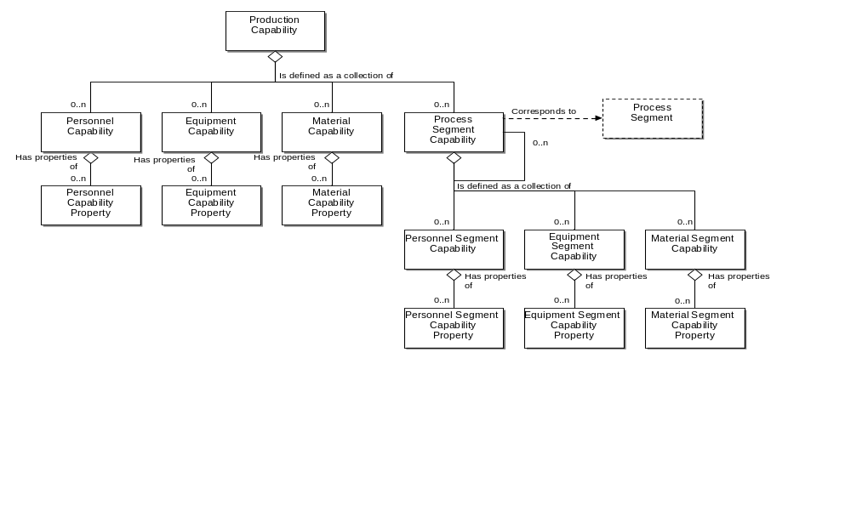
Model of Exchanged Production Capability Information

This schema uses a common schema for definition of elements that are used in multiple schemas, such as ID, Description, and Value. See the document defining the WBF95Common schema for definition of the common elements.

Key Use Assumptions
The model only defines the exchanged information and does not define the use of the information or encapsulation of the information in any defining transactions.

ProductionCapability
The production capability information is the collection of information about all resources for production for selected times and within a selected site, area, process cell, production unit, or production line. This is made up of capability information about equipment, material, personnel, and process segments. It describes the names, terms, status, and quantities of which the manufacturing control system has knowledge. Production capability also defines the available capability, committed capability, and unattainable capability of each resource, and each resource within a process segment.

Personnel Capability
Personnel capability is defined as a set of references to persons or personnel classes committed, available, or unattainable for a defined time. Personnel capability contains references to persons or personnel classes. Personnel capability identifies the capability type (available, unattainable, committed), and the time associated with the capability (e.g. third shift on a specific date).

Specific personnel capabilities are defined in personnel capability properties. The personnel capability property may include the quantity of the resource referenced, such as 3 horizontal drill press operators available for the third shift on February 29, 2000.

EquipmentCapability
Equipment capability is defined as a set of references to equipment or equipment classes committed, available, or unavailable for a defined time. Equipment capability contains references to equipment or equipment classes. Equipment capability will usually identify the capability type (available, unattainable, committed) and the time associated with the capability (e.g. third shift on a specific date).

Specific equipment capabilities are defined in equipment capability properties. The equipment capability properties may include the quantity of the resource referenced, such as 3 horizontal drill presses currently available.

MaterialCapability
Material capability is defined as a set of references to material lots or sublots committed, available, or unavailable for a defined time. Material capability identifies the capability type (available, unattainable, committed) and the time associated with the capability (e.g. third shift on a specific date).

Specific material capabilities are defined in material capability properties. The material capability properties may include the quantity of the material referenced, such as 3 sublots in Building 3 of material Starch Lot #12345 committed to production for February 29, 2000.

ProcessSegmentCapability
A process segment capability is defined as a logical grouping of personnel resources, equipment resources, and material that is committed, available, or unavailable for a defined process segment for a specific time. A process segment capability is related to a product segment that can occur during production. A process segment capability may relate to one or more products.

Process segment capability identifies the capability type (available, unattainable, committed), the time associated with the capability (e.g. third shift on a specific date).

Resource Identification
The schemas follow the ANSI/ISA-95 standard by defining resources by class ID or instance ID, or by defining them by class ID and a property value that is used to define a subset of the resource. For example, the figure below illustrates that a segment may require a certain number of milling machine, an equipment class. Other segments may require a subset of milling machine, such as “Fine” milling machines only. In the first case the class name, “Mill”, is sufficient to identify the resource required. In the second case the class name, “Mill”, and property name and value, “Spec” and “Fine”, define the required resource. Alternately a specific resource may be specified for a production capability, such as specifying milling machine with ID=”Miller#1”.

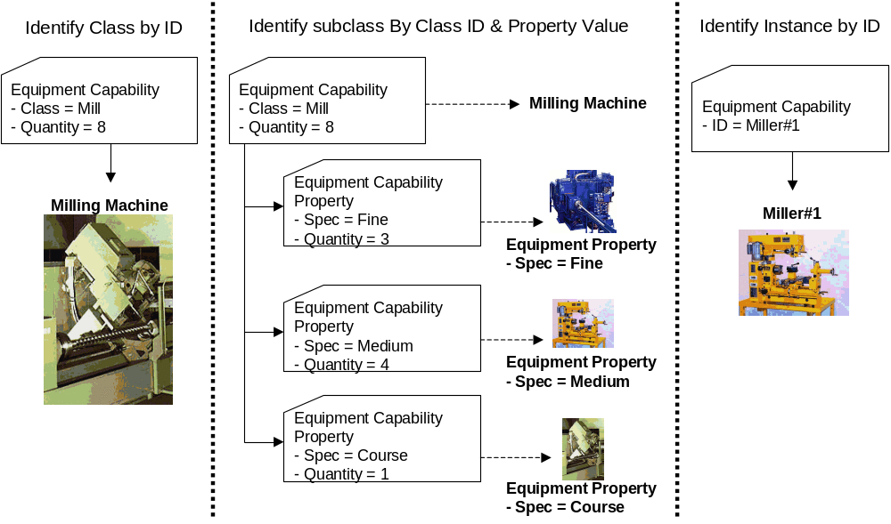

Element Definitions

Element/Type | Description
ProductionCapability  ProductionCapabilityType | Contains a description of a production capability, including the location of the capability, the published date of the capability, the reason for the capability, the time range of the capability, the equipment, material, and personnel resources for the capability, and process segment capabilities within the production capability report.  May also include application defined extension elements.  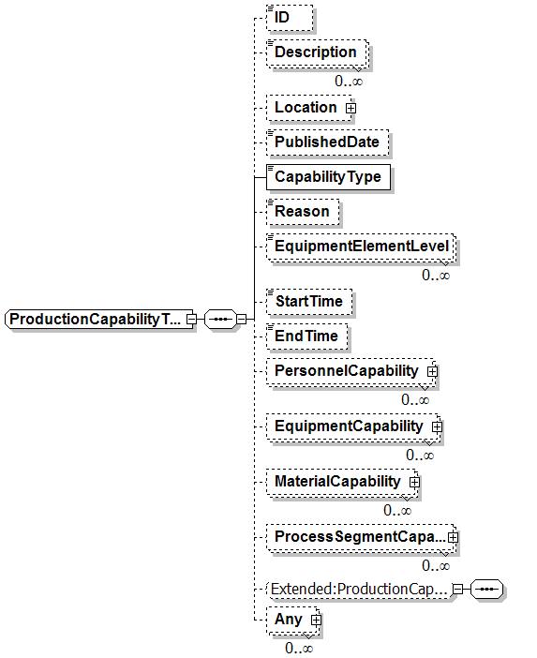
EquipmentCapability  EquipmentCapabilityType | Contains a definition of an equipment capability. Including the type of the capability, the scoped location of the capability, the time duration of the capability, the quantity of the capability, and the properties that may be required to identify capabilities of subsets of the class.  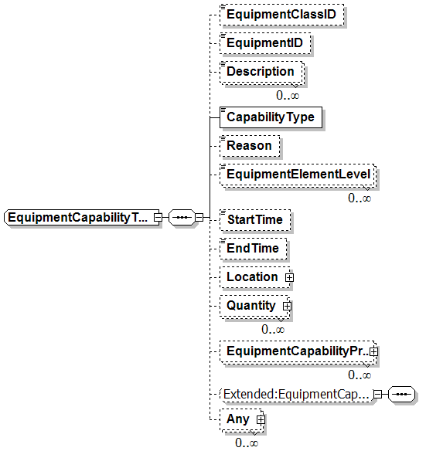
EquipmentCapabilityProperty  EquipmentCapabilityPropertyType | Contains a definition of the quantity of an equipment property, including the value used to identify the class subset of the capability, and the quantity of the capability.  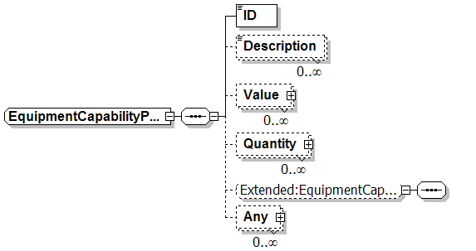
MaterialCapability  MaterialCapabilityType | Contains a definition of a material capability. Including the type of the capability, the scoped location of the capability, the time duration of the capability, the quantity of the capability, the use of the material (consumed or produced), and the properties that may be required to identify capabilities of subsets of the class.  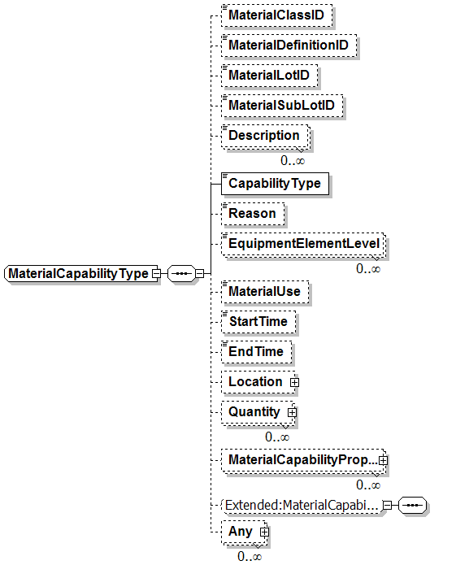
MaterialCapabilityProperty  MaterialCapabilityPropertyType | Contains a definition of the quantity of a material property, including the value used to identify the class subset of the capability, the use of the material in the capability, and the quantity of the capability.  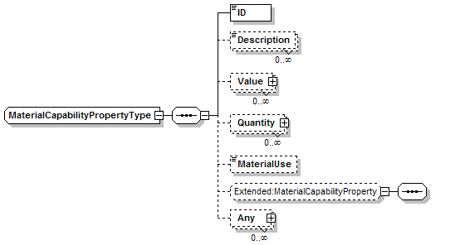
PersonnelCapability  PersonnelCapabilityType | Contains a definition of a personnel capability. Including the type of the capability, the scoped location of the capability, the time duration of the capability, the quantity of the capability, and the properties that may be required to identify capabilities of subsets of the class.  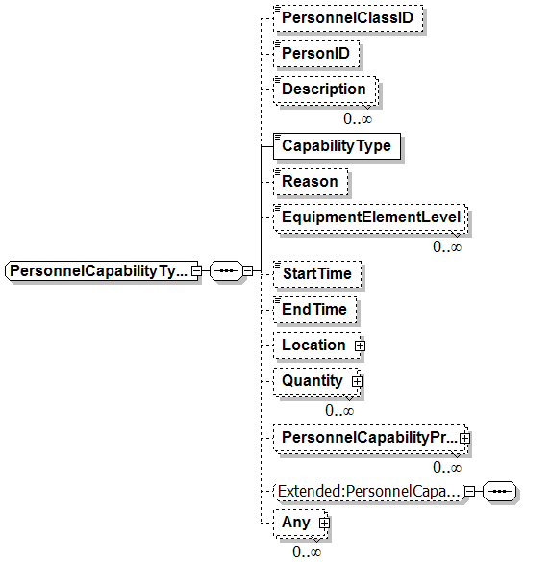
PersonnelCapabilityProperty  PersonnelCapabilityPropertyType | Contains a definition of the quantity of a personnel property, including the value used to identify the class subset of the capability, and the quantity of the capability.  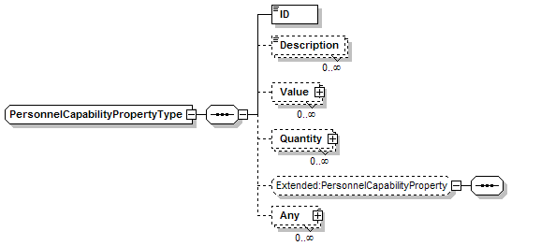
ProcessSegmentCapability  ProcessSegmentCapabilityType | Contains a definition of a capability for a process segment, includes the identification of the associated process segment, the capability type, the reason for the capability, the location of the capability, the duration of the capability, the personnel, equipment, and material capability definitions, and any encapsulated process segment capabilities.  May also include application defined elements.  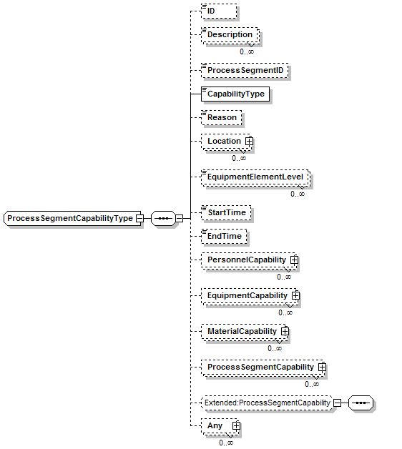

Transaction Elements
The following elements are defined to support the ISA 95 Part 5 transactions, using the transaction data types defined in the B2MML-Common.xsd schema.

Production Capability Elements | Description
GetProductionCapabilityInformation | Get a ProductionCapability definition.
ShowProductionCapabilityInformation | Returned information from the GetProductionCapabilityInformation message.
ProcessProductionCapabilityInformation | Process a ProductionCapability definition.
AcknowledgeProductionCapabilityInformation | Returned status from the ProcessProductionCapabilityInformation message.
ChangeProductionCapabilityInformation | Change a ProductionCapability definition.
RespondProductionCapabilityInformation | Returned status from the ChangeProductionCapabilityInformation message.
CancelProductionCapabilityInformation | Cancel a ProductionCapability definition.
SyncProductionCapabilityInformation | Published ProductionCapability definition.

Diagram Convention
The schema diagrams using the following convention to illustrate the structure of the schema elements, the type of the elements and attributes, and the rules for optional elements and repetition.

