
Business To Manufacturing
Markup Language
B2MML – Production Performance
Version 0401 – October 2008
Production Performance Schema
Documentation



IMPORTANT: While the information, data, and standards provided in this publication were developed and are presented in good faith in accordance with a reasonable process that was subject to intellectual property and antitrust policies to benefit the industry as a whole, the publication is provided “as is” for information and guidance only, and there is no representation or warranty of any type or kind, including but not limited to warranties of merchantability or fitness for a particular purpose, and no warranty that use of the information, data, or standards will not infringe patent, copyright, trademark, trade secret, or other intellectual property rights of any party.
Table of Contents

1 Schema Scope 4
1.1 Key Information Assumptions 4
1.2 Key Use Assumptions 4
1.3 ProductionPerformance 5
1.4 ProductionResponse 5
1.5 SegmentResponse 5
1.6 PersonnelActual 5
1.7 EquipmentActual 5
1.8 MaterialActual 5
1.9 MaterialProducedActual 5
1.10 MaterialsConsumedActual 6
1.11 ConsumableActual 6
1.12 Identifying Resources 6
1.13 Use Within A Production Schedule 7
2 Element Definitions 8
3 Transaction Elements 18
4 Diagram Convention 19

Change History:
Change | Date | Person | Description
V01 | 7 April 2002 | Dennis Brandl  Dave Emerson | Initial release
V02 | 23 Sept 2003 | Dennis Brandl  Dave Emerson | - Added Location to resource actual types  - Added SegmentState to SegmentResponseType  - Changed ##any to "Any" element of type "AnyType"  - Added ProductSegmentID to SegmentResponseType so it may be associated with process or product segments.
V03 | 26 Aug 2005 | Dennis Brandl  Dave Emerson | - Added substitution groups. One group added just before each Any element.
V0301 | 29 Dec 2005 | Dennis Brandl | - Changed “Value” elements to 0..unbounded
V04 | 04 June 2007 | Dennis Brandl | - Added transaction elements  - Added MaterialActual to replace MaterialProducedActual, MaterialProducedActual, and ConsumableActual.
V0401 | Oct 2008 | Dennis Brandl | - Added maxOccurs to resources in segment responses.

Copyright © 2008 WBF. All Rights Reserved. http://www.wbf.org

This WBF Work (including specifications, documents, software, and related items) referred to as the Business To Manufacturing Markup Language (B2MML) is provided by the copyright holders under the following license.

Permission to use, copy, modify, or redistribute this Work and its documentation, with or without modification, for any purpose and without fee or royalty is hereby granted provided the WBF is acknowledged as the originator of this Work using the following statement:

"The Business To Manufacturing Markup Language (B2MML) is used courtesy of the WBF."

In no event shall the WBF, its members, or any third party be liable for any costs, expenses, losses, damages or injuries incurred by use of the Work or as a result of this agreement.

Material from ANSI/ISA-88 and ANSI/ISA-95 series of standards used with permission of ISA - The Instrumentation, Systems, and Automation Society, www.isa.org

Schema Scope
This document defines the information about production performance information that may be passed from manufacturing operations systems to business systems. This information is based on the data models and attributes defined in the ANSI/ISA 95.00.02 Enterprise/Control System Integration standard. Contact ISA (The Instrumentation, System, and Automation Society) for copies of the standard. Additional information on the standard is available at www.isa.org.

Key Information Assumptions
The data represented in these schemas is derived from the UML model below. This model is an extension of the model defined in the ANSI/ISA 95.00.02 standard, and is based on the planned update of the ANSI/ISA standard. The information model in the figure below is hierarchical, and the assumption is that any production response information will always be within a contained production performance object. The Material Actual object is a replacement for the Material Produced Actual, Material Consumed Actual, and Consumable Actual objects.

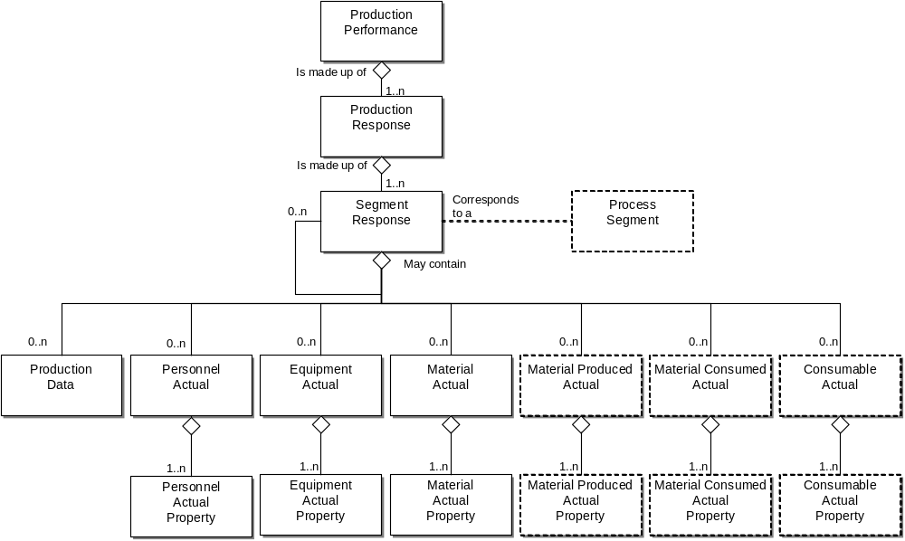
Model of Exchanged Production Capability Information

This schema uses a common schema for definition of elements that are used in multiple schemas, such as ID, Description, and Value. See the document defining the WBF95Common schema for definition of the common elements.

Key Use Assumptions
The model only defines the exchanged information and does not define the use of the information or encapsulation of the information in any defining transactions.

ProductionPerformance
A production performance report is made up of a set of 1 or more production responses. The production performance also contains the information that defines the context of the report, such as start time, end time, location, and published date.

ProductionResponse
Production responses are the response from manufacturing that is associated with a production Request. There may be one or more production responses for a single production request if the production facility needs to split the production request into smaller elements of work. For example a single production request for the production of “200 gears” may be reported on by 10 production response objects of “20 gears” each because of manufacturing restrictions.

A production result may include the status of the request, such as the percentage complete, a finished status, or an aborted status.

SegmentResponse
The production response for a specific segment of production is defined as a segment response. A segment response may be made up of zero or more sets of information on production data, personnel actual, equipment actual, materials consumed actual, materials produced actual, and consumables actual. A segment response may include an identification of the associated process segment. the actual starting and stopping time of the segment. and the duration of the segment.

A SegmentResponse is also included as an optional element in a ProductionRequest. In those cases the SegmentResponse defines elements that are to be returned with a ProductionResponse. In this use it basically defines a template of information to be filled in and returned. A segment response contains an element (RequiredByRequestedSegmentresponse) that is used in a ProductionSchedule to indicate if the including element is required or optional in a response from a request. The value of the RequiredByRequestedSegmentResponse element may be extended on an application specific basis.

PersonnelActual
A personnel actual in a production response identifies a personnel resource by class ID or by instance ID used during the specified segment of production.

EquipmentActual
A equipment actual in a production response identifies a equipment resource by class ID or instance ID used during the specified segment of production.

MaterialActual
A material produced, material consumed, or consumable material consumed are identified in a MaterialActual. This identifies a material resource by class ID, definition ID, Lot ID, and/or Sublot ID produced or consumed during the specified segment of production.

MaterialProducedActual
A material produced actual in a production response identifies a material resource by class ID, definition ID, Lot ID, and/or Sublot ID produced during the specified segment of production.

Note: This element is included for backward compatibility. The MaterialActual should be used to specify material produced actuals.

MaterialsConsumedActual
A material consumed actual in a production response identifies a material resource by class ID, definition ID, Lot ID, and/or Sublot ID consumed during the specified segment of production.

Note: This element is included for backward compatibility. The MaterialActual should be used to specify material consumed actuals.

ConsumableActual
Consumable include resources that are not normally included in bills of materials or are not individually accounted for in specific production requests. Depending on the industry these may include water, catalysts, common chemicals, and utilities, such as electricity and steam. These items will often result in direct charges that will usually be considered in costing the product segment. Consumables are often materials that do have an inventory balance.

A consumables actual in a production response identifies a consumable material by class ID and/or definition ID consumed during the specified segment of production.

Note: This element is included for backward compatibility. The MaterialActual should be used to specify consumable actuals.

Identifying Resources
The schemas follow the ANSI/ISA-95 standard by defining resources by class ID or instance ID, or by defining them by class ID and a property value that is used to define a subset of the resource. For example, the figure below illustrates that a segment may require a certain number of milling machine, an equipment class. Other segments may require a subset of milling machine, such as “Fine” milling machines only. In the first case the class name, “Mill”, is sufficient to identify the resource required. In the second case the class name, “Mill”, and property name and value, “Spec” and “Fine”, define the required resource. Alternately a specific resource may be identified in a production performance report, such as specifying an actual milling machine with ID=”Miller#1”.

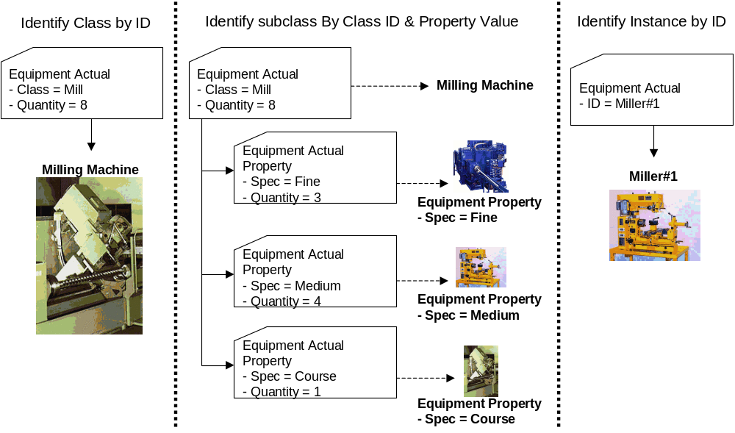

Use Within A Production Schedule
The SegmentResponseType is also used in a production schedule to define the requested segment response for a segment of production. This defines the structure and elements to be returned as a response for the production schedule. The RequestedBySegmentResponse attribute is used to indicate if the element is a required or optional element in a response.

Element Definitions

Element/Type | Description
ProductionPerformance  ProductionPerformanceType | The top level element. Contains a definition of a report on production performance, including the location of the performance, the publication data of the performance report, the ID of the associated production schedule, the duration of the production performance, and the list of production responses making up the production performance report. May include application specific defined elements.  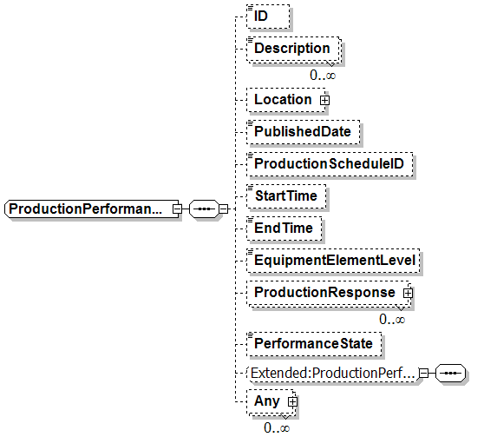
ProductionResponse  ProductionResponseType | Contains a definition of a production response report, including the identification of an associated production request, the product produced, the duration of the report, and the segments making up the production response. May include application specific defined elements. May be a top level element for defined locations.  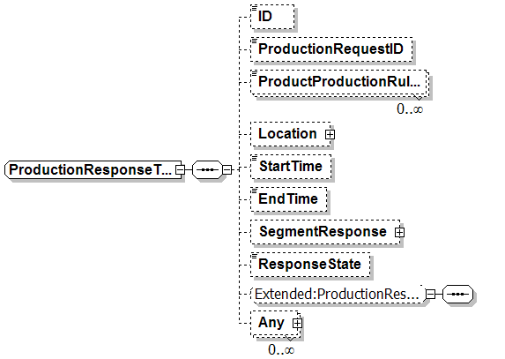
SegmentResponse  SegmentResponseType | Contains a definition of a report on a segment. Includes the duration, production data, personnel, equipment, material produced, material consumed, and consumables used.  [Note: The RequiredByRequestedSegmentResponse element is only used when this is included as part of a production schedule schema.]  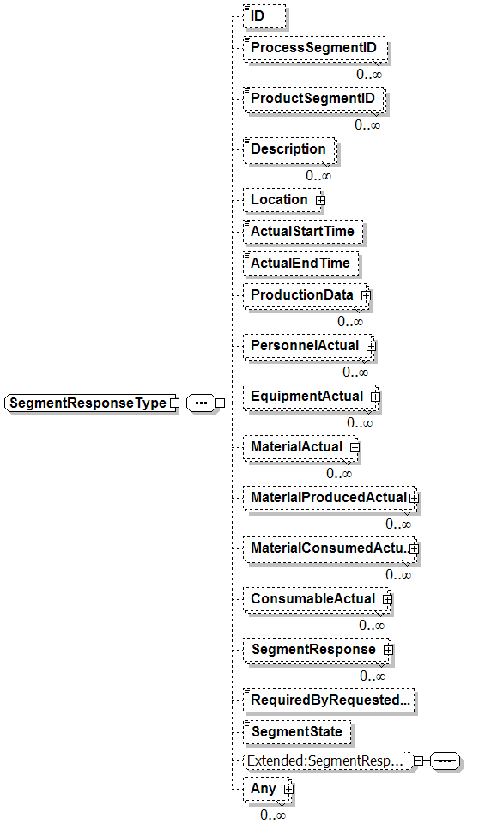
ConsumableActual  ConsumableActualType | Contains a report on actual consumable materials used. May define the quantity of the consumable used, the location the consumable was obtained from, or may contain a list of property definitions and quantities for each property subset.  [Note: The RequiredByRequestedSegmentResponse element is only used when this is included as part of a production schedule schema.]  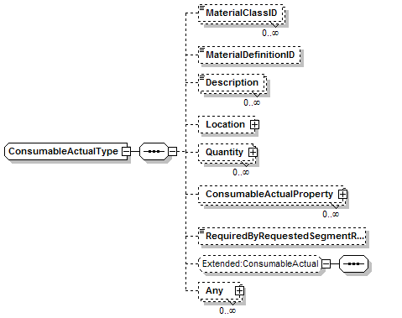  Note: This element is included for backward compatibility. The MaterialActual should be used to specify material requirements.
ConsumableActualProperty  ConsumableActualPropertyType | Contains a definition of actual consumable materials used, for a subset of the resource identified by a property value. Includes the quantity of the consumable used.  [Note: The RequiredByRequestedSegmentResponse element is only used when this is included as part of a production schedule schema.]  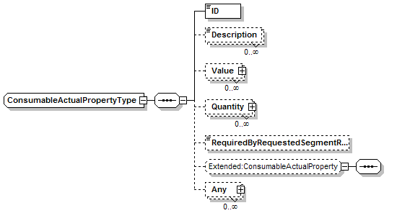  Note: This element is included for backward compatibility.
EquipmentlActual  EquipmentlActualType | Contains a report on actual equipment resources used. May define the quantity of the resource used, or may contain a list of property definitions and quantities for each property subset.  [Note: The RequiredByRequestedSegmentResponse element is only used when this is part of a production schedule schema.]  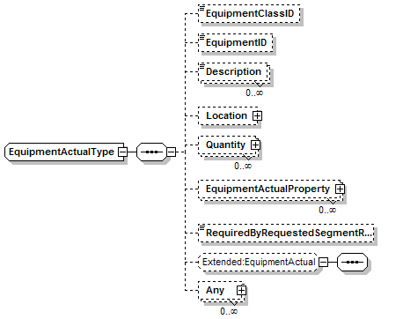
EquipmentlActualProperty  EquipmentlActualPropertyType | Contains a definition of actual equipment resources used, for a subset of the resource identified by a property value. Includes the quantity of the resources used.  [Note: The RequiredByRequestedSegmentResponse element is only used when this is part of a production schedule schema.]  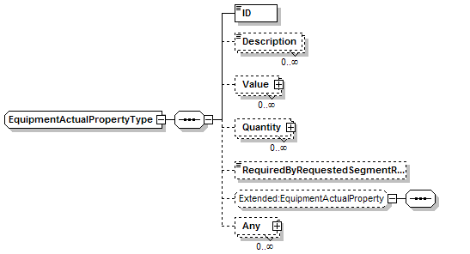
MaterialActual  MaterialActualType | Contains a report on actual material resources used. May define the quantity of the material, or may contain a list of property definitions and quantities for each property subset.  A MaterialActual element may have a set of contained MaterialActual elements to support hierarchical manufacturing bills.  [Note: The RequiredByRequestedSegmentResponse element is only used when this is part of a production schedule schema.]  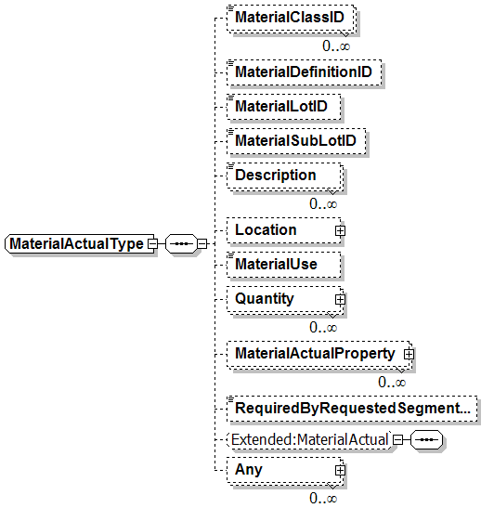
MaterialActualProperty  MaterialActualPropertyType | Contains a definition of actual material resources used, for a subset of the resource identified by a property value. Includes the quantity of the resource used.  [Note: The RequiredByRequestedSegmentResponse element is only used when this is part of a production schedule schema.]  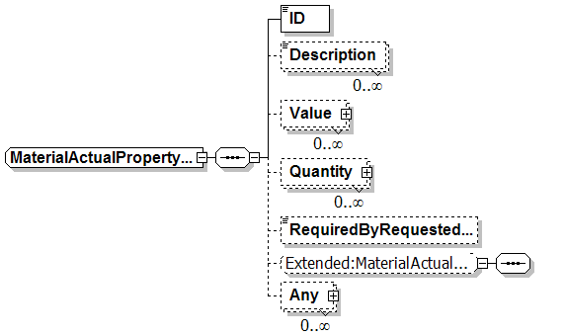
MaterialConsumedActual  MaterialConsumedActualType | Contains a report on actual material resources consumed. May define the quantity of the resource consumed, or may contain a list of property definitions and quantities for each property subset.  [Note: The RequiredByRequestedSegmentResponse element is only used when this is part of a production schedule schema.]  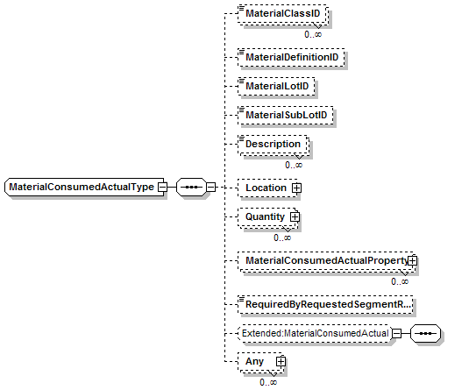  Note: This element is included for backward compatibility. The MaterialActual should be used to specify material requirements.
MaterialConsumedActualProperty  MaterialConsumedActualPropertyType | Contains a definition of actual material resources consumed, for a subset of the resource identified by a property value. Includes the quantity of the resource consumed.  [Note: The RequiredByRequestedSegmentResponse element is only used when this is part of a production schedule schema.]  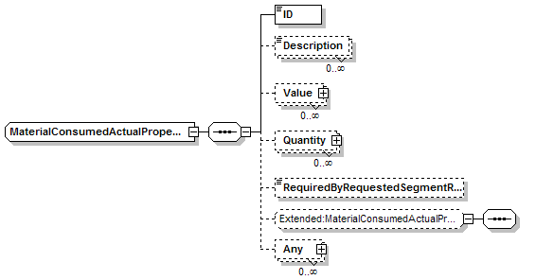  Note: This element is included for backward compatibility.
MaterialProducedActual  MaterialProducedActualType | Contains a report on actual material resources produced. May define the quantity of the resource produced, or may contain a list of property definitions and quantities for each property subset.  [Note: The RequiredByRequestedSegmentResponse element is only used when this is part of a production schedule schema.]  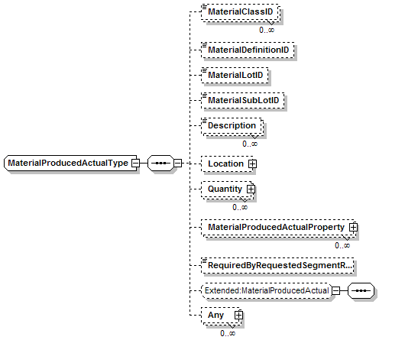  Note: This element is included for backward compatibility. The MaterialActual should be used to specify material requirements.
MaterialProducedActualProperty  MaterialProducedActualPropertyType | Contains a definition of actual materials produced, for a subset of the materials identified by a property value. Includes the quantity of the resource produced.  [Note: The RequiredByRequestedSegmentResponse element is only used when this is part of a production schedule schema.]  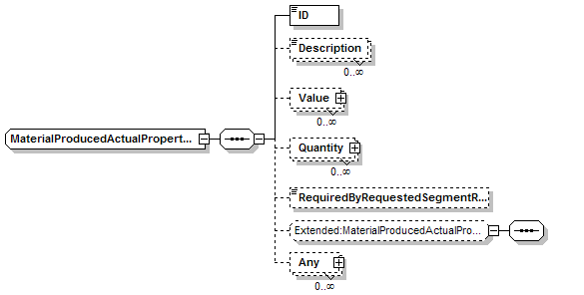  Note: This element is included for backward compatibility.
PersonnelActual  PersonnelActualType | Contains a report on actual personnel resources used. May define the quantity of the resource used, or may contain a list of property definitions and quantities for each property subset.  [Note: The RequiredByRequestedSegmentResponse element is only used when this is part of a production schedule schema.]  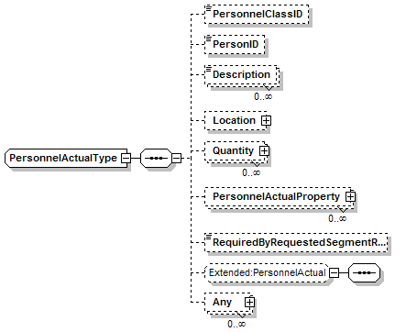
PersonnelActualProperty  PersonnelActualPropertyType | Contains a definition of actual personnel resources used, for a subset of the resource identified by a property value. Includes the quantity of the resources used.  [Note: The RequiredByRequestedSegmentResponse element is only used when this is part of a production schedule schema.]  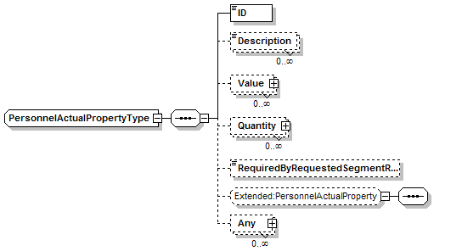
ProductionData  ProductionDataType | Contains a definition of a production data element, corresponding to a process segment or product segment parameter. Includes the ID of the parameter and the value for the parameter.  [Note: The RequiredByRequestedSegmentResponse element is only used when this is included as part of a production schedule schema.]  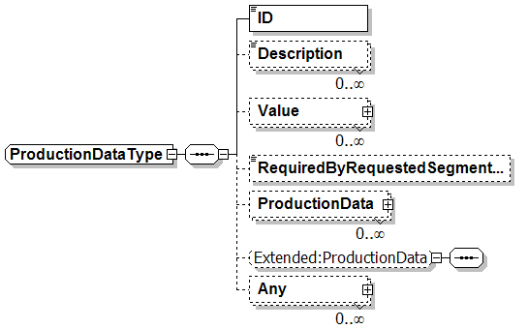

Transaction Elements
The following elements are defined to support the ISA 95 Part 5 transactions, using the transaction data types defined in the B2MML-Common.xsd schema.

Production Performance Elements | Description
GetProductionPerformance | Get ProductionPerformance definition.
ShowProductionPerformance | Returned information from the GetProductionPerformance message.
ProcessProductionPerformance | Process ProductionPerformance definition.
AcknowledgeProductionPerformance | Returned status from the ProcessProductionPerformance message.
ChangeProductionPerformance | Change ProductionPerformance definition.
RespondProductionPerformance | Returned status from the ChangeProductionPerformance message.
CancelProductionPerformance | Cancel ProductionPerformance definition.
SyncProductionPerformance | Published ProductionPerformance definition.

Diagram Convention
The schema diagrams using the following convention to illustrate the structure of the schema elements, the type of the elements and attributes, and the rules for optional elements and repetition.

