UNI-FI
Mesh network developed by MeshUSF
Structure, implementation
and protocol walkthrough
Technical report • Documentation date: 5 October 2026
Implementation snapshot: fd8a149 • feat/heltec-v3-prototype
CURRENT STATUS
GPS-free Heltec V3 prototype. Firmware builds and host/browser tests pass; physical RF, BLE, button, OLED and battery acceptance remain pending.
This report preserves the complete technical walkthrough. Diagrams are rendered figures; the reading guide links to document sections. All example keys, names and IDs are illustrative, not deployment secrets.

Uni-Fi: structure, implementation and protocol walkthrough
Mesh network developed by MeshUSF. Documentation date: 2026-10-05. Implementation snapshot: fd8a149, on feat/heltec-v3-prototype.
This is a ground-up explanation for a technical reader who has never seen the project. It describes the current GPS-free prototype, not the complete future product. Charts are rendered in this document; the authoritative Markdown source uses Mermaid. Directory trees and byte layouts are plain text. All keys, names and IDs in examples are illustrative. No deployment secret appears here.

Reading guide
- 1. What we are building
- 2. The three protocol layers
- 3. Original structure and the comparison baseline
- 4. Current root directory tree
- 5. What was retained, excluded and changed
- 6. How the firmware modules fit together
- 7. Startup, the main loop and stored state
- 8. Features and their implementation
- 9. Uni-Fi application envelope
- 10. MeshCore over-the-air format
- 11. BLE and USB companion protocol
- 12. Connection and incoming-message flow
- 13. Complete SOS and receipt flow
- 14. Presence, expiry, duplicates and queue limits
- 15. Security and privacy boundaries
- 16. Flutter, GPS and maps: what remains
- 17. Verification and how to demonstrate the prototype
- 18. Where to read the code next
- Appendix A: retained companion commands

1. What we are building
Uni-Fi is an off-grid LoRa radio messaging system based on MeshCore. It is not Wi-Fi, a cloud messaging service, or a new replacement for MeshCore's radio protocol. The Heltec V3 runs the radio, encryption, routing and minimal user interface. A phone/browser is an optional, larger interface to that radio.
The current prototype has three software deliverables:
Deliverable | Role | Current state
firmware/ | Heltec V3 device software | Product target compiles; host logic tests pass; physical acceptance pending
web/ | Small real-device hardware-test client | BLE/USB implementations, protocol/session tests and browser layout checks; physical transport tests pending
app/ | Existing Flutter mobile/web application | Earlier Uni-Fi customization retained; not newly slimmed or verified against this prototype

The standalone device can queue SOS, receive distress, and send/recognize a receipt without a phone. GPS is not compiled into this target. There is no working location discovery or map in the current browser test client.
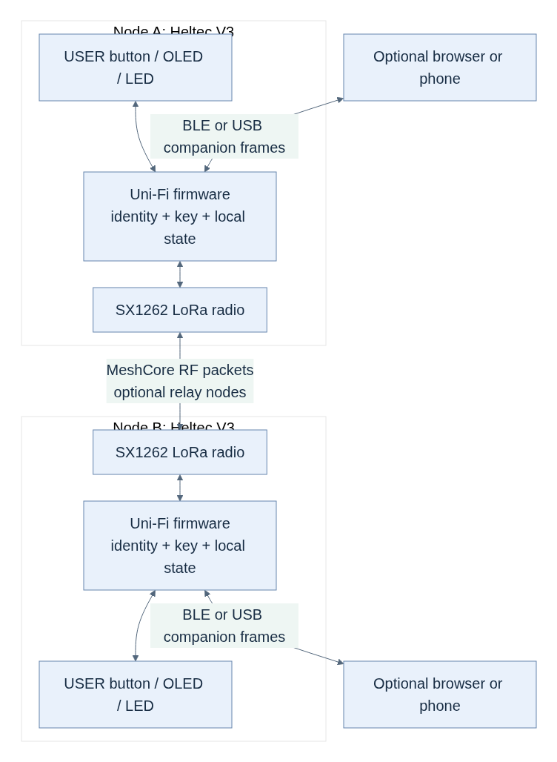
Figure 1. The standalone radios and their optional companion clients
The RF path between nodes is independent of BLE and USB. Losing the phone does not erase the radio's saved identity or deployment key. Losing device power does erase its RAM-only presence, queued incoming messages and incident state.

Terms used throughout
Term | Meaning here
Node | A radio running firmware; not a phone or a cloud account
Companion | A phone/browser connected locally to a node
Radio profile | Frequency and LoRa waveform settings shared by communicating radios
Group channel | An encrypted logical conversation identified using a shared key; not a separate RF frequency
PSK | Pre-shared deployment key; the same secret installed in fleet nodes
Device identity | MeshCore public/private key pair belonging to a node
Advert | Public signed MeshCore identity announcement, distinct from encrypted presence
Presence | Uni-Fi structured group message saying a member was recently heard
Flood | Neighbors relay a packet subject to routing policy and duplicate checks
Direct route | A packet follows a known sequence of node hashes; it may still cross relays
Receipt | A responder's explicit Uni-Fi type=ack message referring to an incident

2. The three protocol layers
There are three formats, each solving a different problem. They must not be treated as interchangeable:
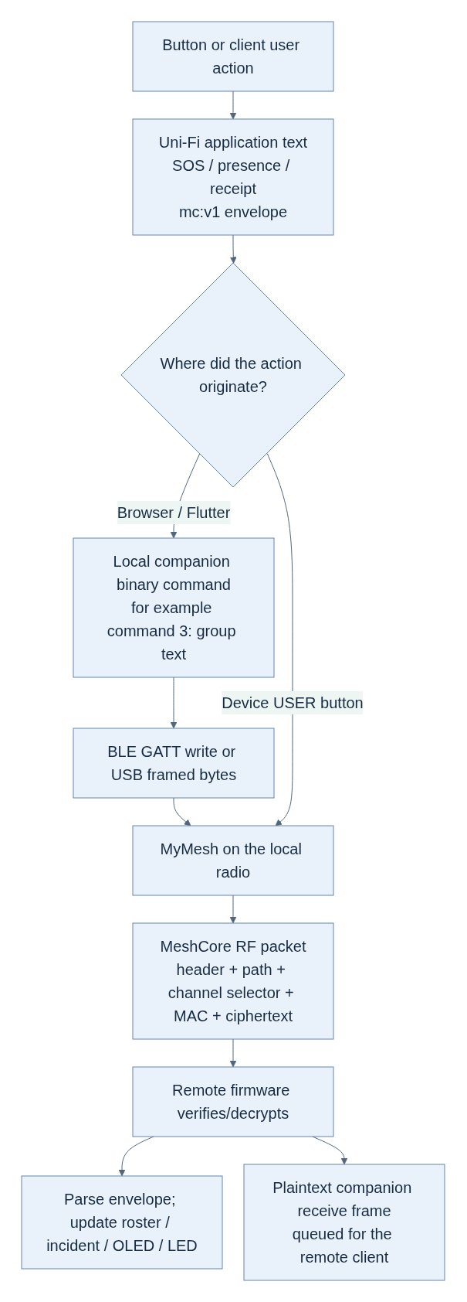
Figure 2. The three protocol layers and the end-to-end data path
- Uni-Fi envelope: application meaning, such as “this is SOS event X.”
- Companion protocol: commands and responses between the client and its own radio. It does not travel unchanged over LoRa.
- MeshCore RF protocol: radio packet routing and encrypted group/direct messages. Uni-Fi reuses this format rather than inventing a new mesh stack.
There are also two different acknowledgements: MeshCore's direct-message hash ACK, and Uni-Fi's human-triggered encrypted group receipt. Only the latter changes the prototype's SOS receipt state. A local companion OK is neither.

3. Original structure and the comparison baseline
There is an important historical limitation: the first repository import, 43cfeef, already contained initial Uni-Fi modifications. There is no pristine, pre-Uni-Fi upstream snapshot in this Git history. We can describe the inherited MeshCore/MeshCore Open structure from the source, but cannot claim an exact pristine-upstream diff.
For an exact before this prototype / after this prototype comparison:
- Before: 80062a7, the organization's integrated main before this work.
- Firmware prototype: c0b22b9.
- New browser client: 925d9e0.
- Tests/build CI: bd79e85 and 593b3a6.
- Decisions and validation documentation: fd8a149.
Across 80062a7..fd8a149, 43 paths were added or modified, zero files were deleted, and app/ was unchanged. “Trimmed firmware” means a narrower compiled product, not a physically stripped-down source repository.

Inherited source organization
This is a selective tree, showing module boundaries rather than every file:
Uni-Fi/
├── firmware/ MeshCore C++ codebase
│ ├── platformio.ini Platform bases, build matrix, native tests
│ ├── variants/ Hardware-specific targets
│ │ └── heltec_v3/ Board wiring, radio/display/clock objects
│ ├── boards/ PlatformIO board descriptions
│ ├── src/
│ │ ├── MeshCore.h Interfaces, sizes and common constants
│ │ ├── Packet.* Packet representation and serialization
│ │ ├── Identity.* Device keys, signing and key exchange
│ │ ├── Dispatcher.* Radio scheduling and packet handling
│ │ ├── Mesh.* Routing, decrypt/verify, receive callbacks
│ │ ├── Utils.* Encryption, hashing and encoding helpers
│ │ └── helpers/
│ │ ├── BaseChatMesh.* Contacts, direct and channel messaging
│ │ ├── StaticPoolPacketManager.*
│ │ ├── SimpleMeshTables.h Recently seen RF packet hashes
│ │ ├── IdentityStore.* Persistent identity
│ │ ├── ArduinoSerialInterface.*
│ │ ├── MultiSerialInterface.h
│ │ ├── esp32/, nrf52/, stm32/, ethernet/
│ │ ├── radiolib/ Radio hardware adapters
│ │ ├── sensors/ GPS and environmental sensors
│ │ ├── bridges/ Bridge implementations
│ │ └── ui/ Display, button, buzzer/vibration drivers
│ ├── examples/
│ │ ├── companion_radio/
│ │ │ ├── main.cpp Setup and main loop
│ │ │ ├── MyMesh.* Companion commands/product behavior
│ │ │ ├── NodePrefs.h Saved configuration
│ │ │ ├── DataStore.* Preferences/contacts/channels storage
│ │ │ ├── AbstractUITask.h Local-feedback interface
│ │ │ └── ui-new/ OLED UI; other UI versions also retained
│ │ ├── simple_repeater/
│ │ ├── simple_room_server/
│ │ ├── simple_secure_chat/
│ │ ├── simple_sensor/
│ │ └── kiss_modem/
│ ├── arch/, lib/, bin/ Architecture/library/tool support
│ ├── test/ Native tests
│ └── docs/ Inherited technical references
├── app/ MeshCore Open-derived Flutter app
│ ├── lib/
│ │ ├── main.dart Constructs app services and providers
│ │ ├── connector/ Companion protocol + BLE/USB/TCP state
│ │ ├── models/ Contacts/channels/messages/settings
│ │ ├── screens/ Chat, contacts, maps, settings and more
│ │ ├── widgets/ Reusable UI and navigation
│ │ ├── services/ Retry/notification/map/image/translation
│ │ ├── storage/ Persisted client data
│ │ └── helpers/, utils/, theme/, icons/, l10n/
│ ├── android/, ios/, web/ Platform runners
│ ├── linux/, macos/, windows/ Desktop runners
│ ├── assets/, test/, tools/, scripts/
│ └── documentation/ Client guides
├── docs/ Uni-Fi decisions/security/protocol/log
├── scripts/gitw Workspace Git wrapper
├── README.md
└── LICENSE
The original architecture was deliberately broad: many boards and device roles in firmware, and a feature-rich cross-platform client. Those modules were useful upstream, but most are unnecessary for one Heltec emergency node.

4. Current root directory tree
The inherited trees remain. The prototype adds the following focused modules:
Uni-Fi/
├── firmware/ Existing core + product-specific changes
│ ├── variants/heltec_v3/
│ │ ├── platformio.ini Explicit minimal Uni-Fi build target
│ │ ├── HeltecV3Board.h Product OLED rail control
│ │ └── target.{h,cpp} Hardware object selection
│ ├── examples/companion_radio/
│ │ ├── MyMesh.{h,cpp} Modified command/receive/emergency flow
│ │ ├── UniFiProtocol.h NEW bounded parser, state and queue policy
│ │ ├── main.cpp BLE + USB and cooperative loop
│ │ └── ui-new/UITask.{h,cpp} Modified original OLED interface
│ ├── src/helpers/ui/
│ │ ├── UniFiButton.h NEW pure debounce/gesture controller
│ │ ├── UniFiLed.h NEW pure nonblocking pattern controller
│ │ └── MomentaryButton.* Existing GPIO adapter, modified
│ └── test/unifi_host/
│ ├── test_controls.cpp NEW real controller logic tests
│ └── test_protocol.cpp NEW envelope/state/queue/routing tests
├── app/ Preserved Flutter foundation; unchanged
├── web/ NEW lightweight hardware-test client
│ ├── index.html, style.css, icon.svg
│ ├── app.js Rendering and user actions
│ ├── transports.js Real Web Bluetooth / Web Serial
│ ├── protocol.js Binary framing and envelope codec
│ ├── session.js Commands, initialization, state, draining
│ ├── test/ Node protocol/session tests
│ ├── package.json No runtime/package-install dependencies
│ └── README.md
├── scripts/
│ ├── gitw
│ ├── provision-unifi.py NEW private provisioning-header generator
│ └── test-unifi.sh NEW strict C++ + Node test entry point
├── .github/workflows/unifi-prototype.yml
└── docs/ Decisions, validation and this walkthrough
Do not confuse root web/ with app/web/: the former is our new small test client; the latter is the Flutter web platform runner.
These local paths are not committed source:
firmware/examples/companion_radio/UniFiProvisioning.h private ignored PSK header
firmware/.pio/ generated builds/dependencies
output/playwright/ ignored browser screenshots
.git-data/ local workspace Git database
The private header and provisioned binaries contain the deployment secret. Open-source source code does not require publishing those files.

5. What was retained, excluded and changed

Build selection: the key structural change

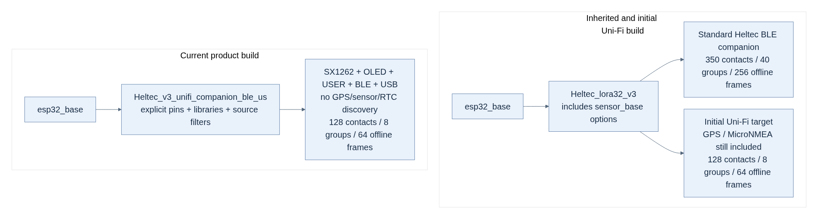
Figure 3. Minimal firmware build selection

The smaller contact/channel/offline limits were introduced in the initial Uni-Fi import, not newly invented in the latest prototype. This iteration removes inherited build coupling and makes the selected product runtime explicit. lib_ldf_mode=chain+ avoids pulling libraries from inactive preprocessor branches. Product behavior is gated by UNIFI_MINIMAL and ENABLE_UNIFI_NETWORK, preserving unrelated upstream targets.

Module change map
Component | What we did | Why / current boundary
Packet, Identity, Dispatcher, Mesh | Retained core formats and implementation | Avoid a new incompatible routing/crypto stack
RadioLib SX1262 adapters | Retained with explicit Heltec wiring | Necessary LoRa hardware support
BaseChatMesh, contacts and group/direct text | Retained; guarded outgoing group length | Keep core messaging; reject truncation of event metadata
DataStore, IdentityStore, NodePrefs, SPIFFS | Retained | Saved names, identity, preferences and contacts survive restart
MyMesh | Modified | Product allowlist, provisioning, presence, receipts, forwarding, queue policy
UniFiProtocol.h | Added | Allocation-free parser/state logic directly exercised by host tests
MomentaryButton + UniFiButton.h | Modified/added | One usable app button; debounce and safe gestures
UITask + UniFiLed.h | Modified/added | Preserve basic OLED UI; deterministic nonblocking alert patterns
OLED Vext controller | Modified for this target | Active-low power ownership, timeout and wake/reinitialization
USB companion interface | Enabled and hardened | Prototype test path; expiry of stale connection state; oversized frames dropped
GPS / MicroNMEA | Excluded, source retained | Hardware integration deferred; cannot enable it by toggling a preference
Environmental sensor implementations | Not selected in product build | No unused device probing or associated drivers
External RTC discovery and RX8130CE driver | Explicitly excluded | Use the ESP32 software-backed clock instead
Wi-Fi/TCP, Ethernet, bridges | Not selected in product target | BLE is the normal companion path; USB is a bench-test alternative
Image/group datagrams, raw/control send, remote telemetry/admin | Companion commands blocked or code gated | Text-only emergency prototype; no expert workflows required
Private-key import/export, signing commands, rescue filesystem CLI | Disabled/gated | Reduce exposed product operations; this does not remove core advert signatures
Ordinary TX LED indication | Not defined for this target | Prevent the radio driver from corrupting emergency blink patterns
Other boards, device roles and UI drivers | Left in repository; not selected | Preserve upstream code, licensing and future comparison
Flutter application | Earlier customization kept; no changes this iteration | Separate mobile pruning/compatibility milestone
Browser hardware-test client | Added separately | Small, testable client without the Flutter dependency tree

“Excluded” is not always “every referenced symbol disappears”: shared base classes, virtual callbacks and generic helper source can remain. The verified claim is that the selected product functionality is disabled and key unused implementations are absent from the linked image—not a total rewrite of the repository or an independently measured speedup.

6. How the firmware modules fit together
The inherited C++ stack is layered by inheritance:
MyMesh Uni-Fi product + companion commands
inherits BaseChatMesh Contacts and text conversations
inherits mesh::Mesh Packet types, decryption, routing
inherits Dispatcher Radio scheduling, receive/send processing
Hardware is supplied through objects/interfaces, so radio scheduling need not know about a particular OLED or button. MyMesh also implements the DataStoreHost interface used to load/save contacts and channels.
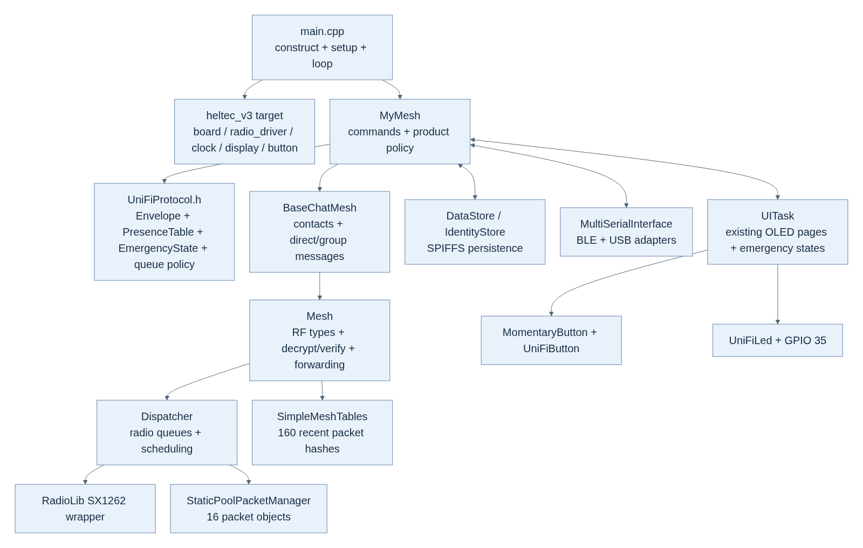
Figure 4. Firmware module responsibilities and connections
Key responsibilities:
- UniFiProtocol.h contains no Arduino, GPIO or radio dependency. Its parser, gesture-independent incident state and queue rules are the same code compiled into firmware and tested on the host.
- MyMesh connects that pure logic to received packets, commands and UI.
- BaseChatMesh creates regular MeshCore group/direct messages.
- Mesh handles MAC checking, decryption, advert signatures and routing.
- Dispatcher schedules actual radio work. UI acceptance does not mean the dispatcher has completed a transmission.

7. Startup, the main loop and stored state

Startup
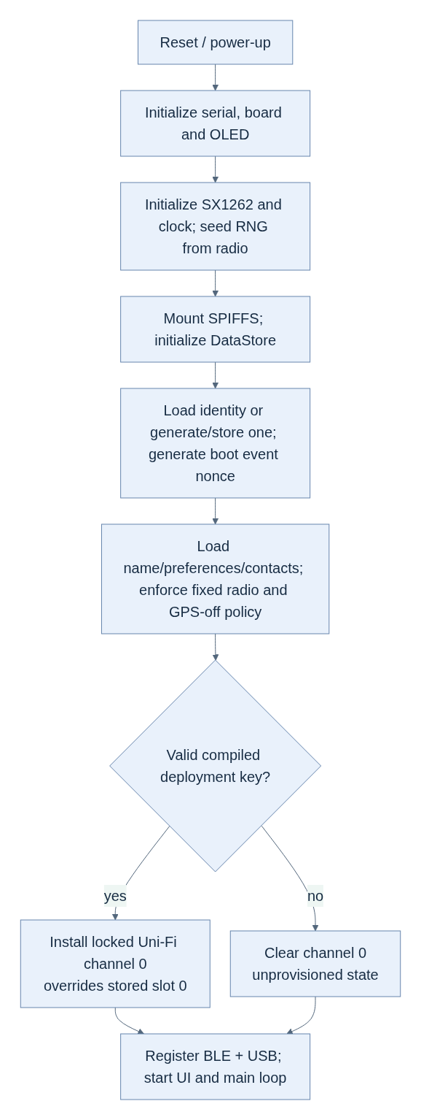
Figure 5. Device startup and provisioning
The deployment key is created by scripts/provision-unifi.py in an ignored header. It is not fetched from a server. The generator uses 16 random bytes, Base64-encodes them, creates the file with private permissions, and refuses to overwrite it. Clean the build after adding/changing provisioning to avoid reuse of objects built under a different header state.
The node loads stored preferences, but the product overrides frequency, bandwidth, spreading factor and coding rate. GPS and remote telemetry stay off. A missing compiled key clears slot 0 even if old provisioning was saved in flash. Such a build cannot send Uni-Fi group events or relay fleet traffic.

Cooperative loop
The main loop runs mesh work, local interfaces, the empty sensor manager, UI work and clock updates, then yields with delay(1) for ESP32 background tasks. Button and LED controllers use elapsed-time checks, not long blocking blink delays. BLE remains active while the OLED sleeps.
This is not a deep-sleep battery guarantee. The radio still needs to receive/relay, and the ESP32 BLE stack remains available. Runtime CPU frequency is set to 80 MHz; actual latency, heap and current need hardware measurement.

Who owns each piece of state?
Data | Owner / storage | Survives restart?
Device public/private identity | Heltec, persistent identity store | Yes
Saved username and preferences | Heltec, SPIFFS | Yes
Contacts and other configured channels | Heltec, SPIFFS | Yes
Authoritative deployment PSK | Compiled firmware/header; installed into channel 0 | Yes, by boot provisioning
Authorized-presence roster | Heltec, 32 RAM entries, local four-hour TTL | No
Current own distress + newest pending received distress | Heltec RAM | No
Recent distress/receipt duplicate cache | Heltec RAM, 16 entries | No
Incoming offline companion queue | Heltec RAM, 64 frames | No
Browser roster, incidents and messages | Browser RAM: 128 / 100 / 150 bounds | No; reload/fresh session clears them
Flutter chat/received-time storage | Existing app persistence | Intended persistent behavior; current compatibility unverified

“Offline queue” means received messages waiting for a companion to collect them. It is different from the dispatcher's outbound RF packet queue.

8. Features and their implementation
Feature | Implementation | Important limitation
Saved node name | Companion command 8; validate, save prefs, read self-info back | Not a cloud account or individually authenticated identity
Fixed radio | Target flags and boot overrides; command 11 disabled | Requested profile is not a regulatory certification
Shared-key group | Compile-time PSK, locked slot 0, masked reads, rejected writes | Key extraction and key-holder impersonation are possible
Standalone SOS | Double-click → sendEmergencyMessage → structured group message | Local queue acceptance, not delivery; no GPS attached
Standalone receipt | Hold → latest pending event ID → type=ack group message | One newest pending incident on device; not emergency dispatch
Phone-independent reception | Mesh receive callback updates RAM and local UI | Device must be powered and in radio range
Quick presets | Browser sendEvent for SOS/medical/pickup/safe/enroute | Only SOS and receipt have dedicated button gestures
Presence | Structured encrypted heartbeat and roster update | Four-hour freshness does not imply a node is still online
Fleet routing | Provisioned nodes forward allowed types with flood cap | No guaranteed path, bandwidth or delivery
Screen timeout | OLED sleeps after 10 s; active-low Vext release; wake reinitializes | Physical display/power behavior remains untested
Web diagnostics | Real BLE/USB frames, serialized commands, status polling | Browser/OS BLE MTU and pairing need hardware tests

Buttons
The board supplies RESET and USER/BOOT. RESET is not a second application button. USER is GPIO 0; holding it while resetting can enter the bootloader.
Gesture | Current behavior
One click | Wake a sleeping display, otherwise advance a page
Two clicks | Queue one SOS from any page
Hold for 2 s | If a received distress is pending, queue its receipt; otherwise select the current page action, such as BLE toggle/hibernate
Held through boot | Suppressed as an emergency gesture

The controller debounces for 30 ms and uses a 280 ms multi-click completion window. Hold consumes the pending click sequence, preventing a hold from also becoming SOS. These timers are tested across 32-bit millisecond rollover.

OLED and LED
The original ui-new interface remains, with Uni-Fi home state, recent network members, radio/BLE information and hibernate. GPS/sensor and manual advert pages are not part of this product UI.
GPIO 35 has one alert writer; normal radio-TX LED control is disabled:
Indication | Meaning | Timing
Three short pulses | A distress was accepted locally for transmission | 160 ms on / 180 ms off between pulses
Two long pulses | New received distress or a matching reply to our distress | 650 ms on / 300 ms off between pulses

Received indications have priority over sent ones. The single LED cannot distinguish those two received cases by color; the OLED distinguishes them. Unrelated/self ACKs do not acknowledge our event. Ordinary presence must not wake the OLED or blink emergency feedback.
“SOS failed” / “Response failed” means the application could not queue the message. A later RF failure or absent reply does not retrospectively make a queued message delivered. There is no automatic SOS retry-until-receipt loop.

9. Uni-Fi application envelope
The envelope is an ASCII metadata block at the end of ordinary encrypted group text. The radio adds its saved username before the message:
<saved name>: <readable label> [mc:v1;type=...;id=...;node=...]
Exact GPS-free example received on another node, 78 UTF-8 bytes:
Sanjay: SOS [mc:v1;type=sos;id=AABBCCDDEEFF1234ABCD00000001;node=AABBCCDDEEFF]
A responder sends a new message with its own node and event ID, referring to the original ID using ack. This example is 120 bytes including the name:
Dispatcher: Received [mc:v1;type=ack;id=11223344556689ABCDEF00000001;node=112233445566;ack=AABBCCDDEEFF1234ABCD00000001]
Presence uses the same format:
Sanjay: Available [mc:v1;type=presence;id=AABBCCDDEEFF1234ABCD00000002;node=AABBCCDDEEFF]

Exact field rules
Field | Requirement
type | Required; exactly presence, sos, medical, pickup, safe, enroute, location, or ack
id | Required; 1–32 ASCII letters/digits/underscore/hyphen; case-sensitive
node | Required; first six public-key bytes encoded as exactly 12 hex characters; hex case is accepted either way
ack | Required only for type=ack; forbidden for other types; same ID character/length rules
lat, lon | Optional but must occur together; fixed decimal syntax, finite, latitude −90..90, longitude −180..180; (0,0) accepted by firmware/web

Unknown or repeated fields, multiple mc:v1 blocks, missing final ], NUL bytes and malformed values are rejected. Field order is not significant. The current GPS-free event generator supplies no coordinates. Valid optional coordinates from a received or manually supplied envelope can still be parsed and forwarded; that does not give this device a GPS provider. A location type is recognized as an extension, but does not by itself imply a valid fix.
The firmware validates incoming name: separately: 1–31 bytes, no control bytes, DEL, colon or brackets. Browser name input also rejects leading/trailing whitespace and decodes incoming UTF-8 strictly. Firmware byte checks are not a complete Unicode validator; do not assume identical validation in old Flutter.

Length and identity checks
The complete decrypted text including name: must fit 160 bytes. This is a byte budget, not a character count. Timestamp/type bytes in the RF payload are additional. Both web and firmware reject oversized outgoing text instead of letting the base group sender truncate the final metadata block.
On a structured outgoing slot-0 message, the firmware checks that node matches its own six-byte public-key prefix. On reception, group encryption does not cryptographically bind the claimed node or name to a device. Full public keys arrive separately in signed adverts; prefix correlation is for discovery/contact association, not proof of the group message's author.

Event ID generation
Hardware-generated ID (28 characters):
node prefix [12 hex] + per-boot random nonce [8 hex] + sequence [8 hex]
Browser-generated ID (20 characters):
node prefix [12 hex] + crypto.getRandomValues random value [8 hex]
The firmware nonce is generated after setup seeds its RNG from the radio. The sequence differentiates actions in the same millisecond; the nonce reduces collision across restarts. IDs are correlation tokens, not cryptographic signatures or a mathematical guarantee that collisions cannot happen.

10. MeshCore over-the-air format
This section describes the vendored code, not an invented Uni-Fi radio standard. The current packet payload version is MeshCore V1, encoded as zero in the header. That is separate from companion protocol version 3 and the mc:v1 application marker.

Outer packet
Offset varies with transport/path mode:
[header:1]
[transport codes:4, ONLY for transport-flood / transport-direct]
[path metadata:1]
[path entries: count × hash-width]
[payload: remaining bytes]
header bits:
7..6 = payload version (0 for current V1)
5..2 = payload type (5 for group text)
1..0 = route type (1 flood; 2 direct; 0/3 transport variants)
path metadata bits:
7..6 = hash-width minus 1 (0→1 byte, 1→2 bytes, 2→3 bytes; 3 reserved)
5..0 = number of path entries
A normal freshly originated group-text flood has header 0x15: version 0, type 5, route 1. With one-byte hashes and no relay entries, path metadata is 0x00. Persisted path-hash settings may select another supported width. Product boot clears default transport/flood scope; normal Uni-Fi events use ordinary flood routing, not transport-region scoping.
Core bounds are 184 payload bytes, 64 path bytes, and a 255-byte transfer unit. Path validity and available payload/packet space still constrain each packet; these are not three simultaneously usable application budgets.

Group-text payload and encryption
RF payload (visible selector, encrypted content):
[channel selector:1][MAC:2][ciphertext: multiple of 16 bytes]
Before encryption:
[timestamp:uint32 little-endian][text type:1 = 0 plain][UTF-8 "name: message"]
Current fleet key construction:
K16 = 16 bytes decoded from the private Base64 provisioning header
selector = first byte of SHA-256(K16)
stored secret = K16 followed by 16 zero bytes
ciphertext = AES-128 block encryption using K16, zero-padded final block
MAC = first 2 bytes of HMAC-SHA256(stored 32-byte secret, ciphertext)
In this implementation each block is encrypted independently: inherited AES-128 ECB, not AES-GCM, with no per-message IV in this packet format. The two-byte MAC is also inherited; it is a short tag, not strong per-device authentication. It covers ciphertext, not the outer routing header/path. We did not add a new cipher or upgrade these properties.
Receivers first match the one-byte selector against configured channels, then try MAC verification/decryption with their actual keys. Selector equality alone does not grant access. Cipher padding is removed logically by text/NUL handling; the received timestamp is not the clock used for our four-hour TTL.

Public adverts and direct text
Public adverts are not group-encrypted. Their payload is:
[public key:32][timestamp:4][Ed25519 signature:64][advert app data]
The signature covers public key + timestamp + app data. The Uni-Fi advert announces the opaque label UniFi-<first four public-key bytes in hex>, the chat node type, and no GPS. It supplies the full key needed for contact/direct messaging; it does not prove fleet membership.
Retained direct text uses MeshCore payload type 2, recipient/source one-byte hashes, a two-byte MAC, and encrypted timestamp/flags/text. Its shared secret comes from the two device identities' existing key-exchange implementation, not the fleet group PSK. Known paths use direct routing; unknown paths flood. The direct-message acknowledgement is payload type 3 and starts with a four-byte message hash; a plain-text ACK can also carry an attempt byte and random byte (six bytes total). That ACK is not our application type=ack receipt.

Forwarding
Provisioned nodes relay configured encrypted group text, chat adverts, direct text, direct ACK and PATH traffic. Group forwarding uses a configured nonzero key's selector hash as a traffic filter, not decryption/authentication as a prerequisite to forwarding. A hash collision or invalid-MAC packet may be relayed without being accepted into local Uni-Fi state. For the normal flooded adverts generated here, the core checks signatures before receive/forward. Intermediate handling of nonempty direct routes occurs earlier in the core, so this is not a promise that every relayed packet is cryptographically checked.
For flood packets, MyMesh::allowPacketForward refuses forwarding when the incoming path already contains three relay entries. The core appends the local node hash on a permitted retransmission. This is a three-relay forwarding cap, not an exact three-radio/link topology guarantee; a final receiver can receive a packet already carrying three entries without relaying it again. Direct routes retain the core's route/path limits rather than this specific flood count check.
The dispatcher keeps inherited scheduling, airtime budgeting and delayed retransmission. We have not measured throughput or changed LoRa into a reliable stream transport.

11. BLE and USB companion protocol
Companion frames are binary local commands/responses with code in byte 0. All numeric multi-byte fields shown below use little-endian on this target. The firmware cap is 176 bytes (BaseSerialInterface.h); the web client's outgoing cap is a conservative 172 bytes, and its USB receiver accepts up to 176. Neither number is the 160-byte group-text budget.

Transport framing
BLE Nordic UART Service | UUID
Service | 6e400001-b5a3-f393-e0a9-e50e24dcca9e
RX, client writes to device | 6e400002-b5a3-f393-e0a9-e50e24dcca9e
TX, device notifications to client | 6e400003-b5a3-f393-e0a9-e50e24dcca9e

One BLE characteristic write is one complete companion command. The web client uses write-with-response; it does not split a command into separate writes. A BLE write response acknowledges the local GATT operation, not RF delivery. Firmware requires encrypted MITM-authenticated pairing. It uses a session PIN when a display is available and no saved PIN overrides it; fallback/saved PIN behavior remains inherited. OS pairing and effective MTU must be tested; we do not guarantee every browser can write the largest frame.
USB uses 115200 baud and a three-byte wrapper:
Client → device: [0x3C '<'][length low][length high][companion command bytes]
Device → client: [0x3E '>'][length low][length high][companion response bytes]
Length excludes the three-byte wrapper. USB may fragment/combine reads; the browser decoder buffers until a complete frame and tolerates unrelated boot text. Oversized incoming commands are discarded in the product firmware, not truncated into a different command. There is no special LoRa encryption inside USB framing: the attached computer receives already-decrypted text.

Essential outgoing commands: exact layouts
APP_START (1):
[0:0x01][1..7:reserved zero][8..:client label, e.g. "Uni-Fi Web"]
→ SELF_INFO (5)
DEVICE_QUERY (22):
[0:0x16][1:0x03 desired companion message version]
→ DEVICE_INFO (13); selects V3 received-message layout
SET_TIME (6):
[0:0x06][1..4:Unix seconds uint32]
→ OK (0)
SET_NAME (8):
[0:0x08][1..:UTF-8 name bytes, no transmitted NUL required]
→ OK (0); browser then APP_START/readback
SEND_CHANNEL_TEXT (3):
[0:0x03][1:text type=0][2:channel index=0]
[3..6:Unix seconds uint32][7..:message body WITHOUT "name: "]
→ OK (0) if queued, or error
SEND_DIRECT_TEXT (2), retained but not exposed by this web test UI:
[0:0x02][1:text type=0][2:attempt]
[3..6:timestamp][7..12:recipient public-key prefix][13..:text]
→ SENT (6) / error; delivery confirmation uses separate direct ACK flow
GET_CHANNEL (31):
[0:0x1F][1:channel index]
→ CHANNEL_INFO (18); slot 0 secret bytes masked to zero
SYNC_NEXT_MESSAGE (10):
[0:0x0A]
→ next received message frame, or NO_MORE_MESSAGES (10)
UNIFI_STATUS (112 / 0x70):
[0:0x70]
→ fixed 101-byte status frame starting 0x70
The send body is not prefixed by the browser: the firmware prepends its saved name. No deployment key is sent by the browser. Other channel slots retain configuration commands, but slot 0 replacement is rejected.

Self-info and received channel frames
Self-info response 5 gives the client these offsets:
Offset | Bytes | Meaning
0 | 1 | Response code 5
1 | 1 | Node advert type
2, 3 | 1 each | Current/max TX power
4 | 32 | Full node public key
36, 40 | 4 each | Latitude/longitude microdegrees; zero by default in GPS-free build
44..47 | 4 | Multi-ACK, advert-location, telemetry and manual-contact flags
48 | 4 | Frequency × 1000, i.e. 910525 for 910.525 MHz
52 | 4 | Bandwidth × 1000, i.e. 62500 for 62.5 kHz
56, 57 | 1 each | SF 7 and coding-rate value 5 (4/5)
58 onward | variable | Saved node name

The channel-info response is 50 bytes: code 18, index, 32-byte name field, 16-byte PSK field. For slot 0 that PSK field is always zero. Zeros are not evidence of missing provisioning; use product status.
Received channel text layout is V3 after the query requests version 3:
V3:
[0:17][1:signed SNR × 4][2..3:reserved]
[4:channel index][5:packed RF path metadata, or 0xFF direct]
[6:text type=0][7..10:sender timestamp][11..:UTF-8 "name: message"]
Legacy:
[0:8][1:channel index][2:path metadata][3:text type=0]
[4..7:sender timestamp][8..:UTF-8 "name: message"]
The path byte is not always the hop count: use its width/count bit fields when it is a packed flood path. No full RF packet/header/ciphertext is needed by the web client to parse a normal received channel frame.

Product status extension: exact response
Offset | Bytes | Meaning
0 | 1 | 0x70
1 | 1 | Status version 1
2 | 1 | Flags below
3 | 1 | Locked network channel index 0
4 | 32 | Current own distress ID, zero-padded
36 | 32 | Newest pending received distress ID, zero-padded
68 | 32 | Pending sender name, zero-padded
100 | 1 | Current retained firmware member count

Flags: bit 0 provisioned; bit 1 own distress awaiting receipt; bit 2 own distress acknowledged; bit 3 received distress pending; bit 4 GPS compiled; bit 5 fleet relay enabled. It exposes no PSK, full roster, coordinates, incident history, timestamp or incident type. The web can reconstruct an own incident after reconnect, but currently labels that synthesized card SOS even if the original distress came from another distress preset.
Generic response meanings: 0 is local OK; 1 is error followed by error code; 15 is disabled. Code 0x83 is an asynchronous “messages waiting” push, not a message body. Code 10 responding to command 10 means the incoming queue is empty.

12. Connection and incoming-message flow
The browser has no server-side account, cloud database or mock device mode. Its modules are:
app.js user actions and safe text-based DOM rendering
session.js DeviceSession + serialized CommandQueue + NetworkState
protocol.js binary offsets, envelope encoding/validation, USB decoder
transports.js actual BLE GATT and USB serial operations

Handshake
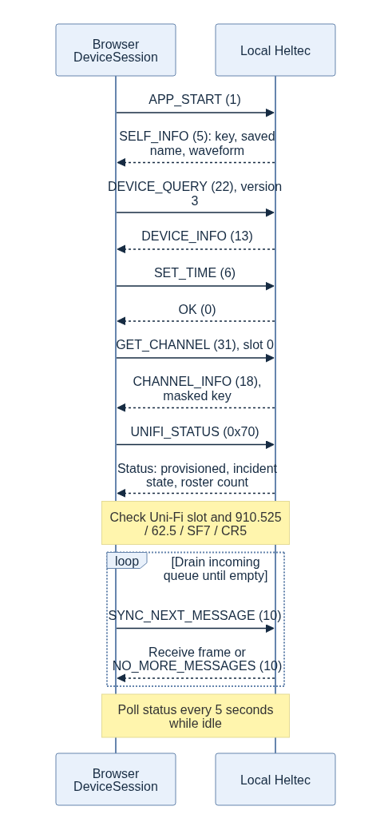
Figure 6. Browser connection and companion handshake
Setting time uses the inherited forward-only check: a timestamp earlier than the node's current time is rejected. An unexpectedly future node clock can therefore prevent this handshake; local TTL still does not trust sender time.
Transmit controls stay disabled until successful initialization. Explicitly unprovisioned firmware is rejected. For older firmware that rejects status, the client keeps an explicitly unverified legacy mode and polls time every 15 seconds; a slot name alone cannot establish key validity.
Commands have no request ID. The web queues them one at a time, associates the response code with the active command, and handles asynchronous pushes separately. Default command timeout is six seconds. Timeout/write failure closes the session rather than letting a delayed generic OK complete a later command. Use one controlling client per node: BLE and USB share the command state, and responses can be written to both registered interfaces.
USB connection state is inferred from completed incoming frames and expires after 30 seconds without activity. Five-second polling keeps it active; a disconnected cable will not leave the UI permanently believing a companion is present.

Reception and companion collection
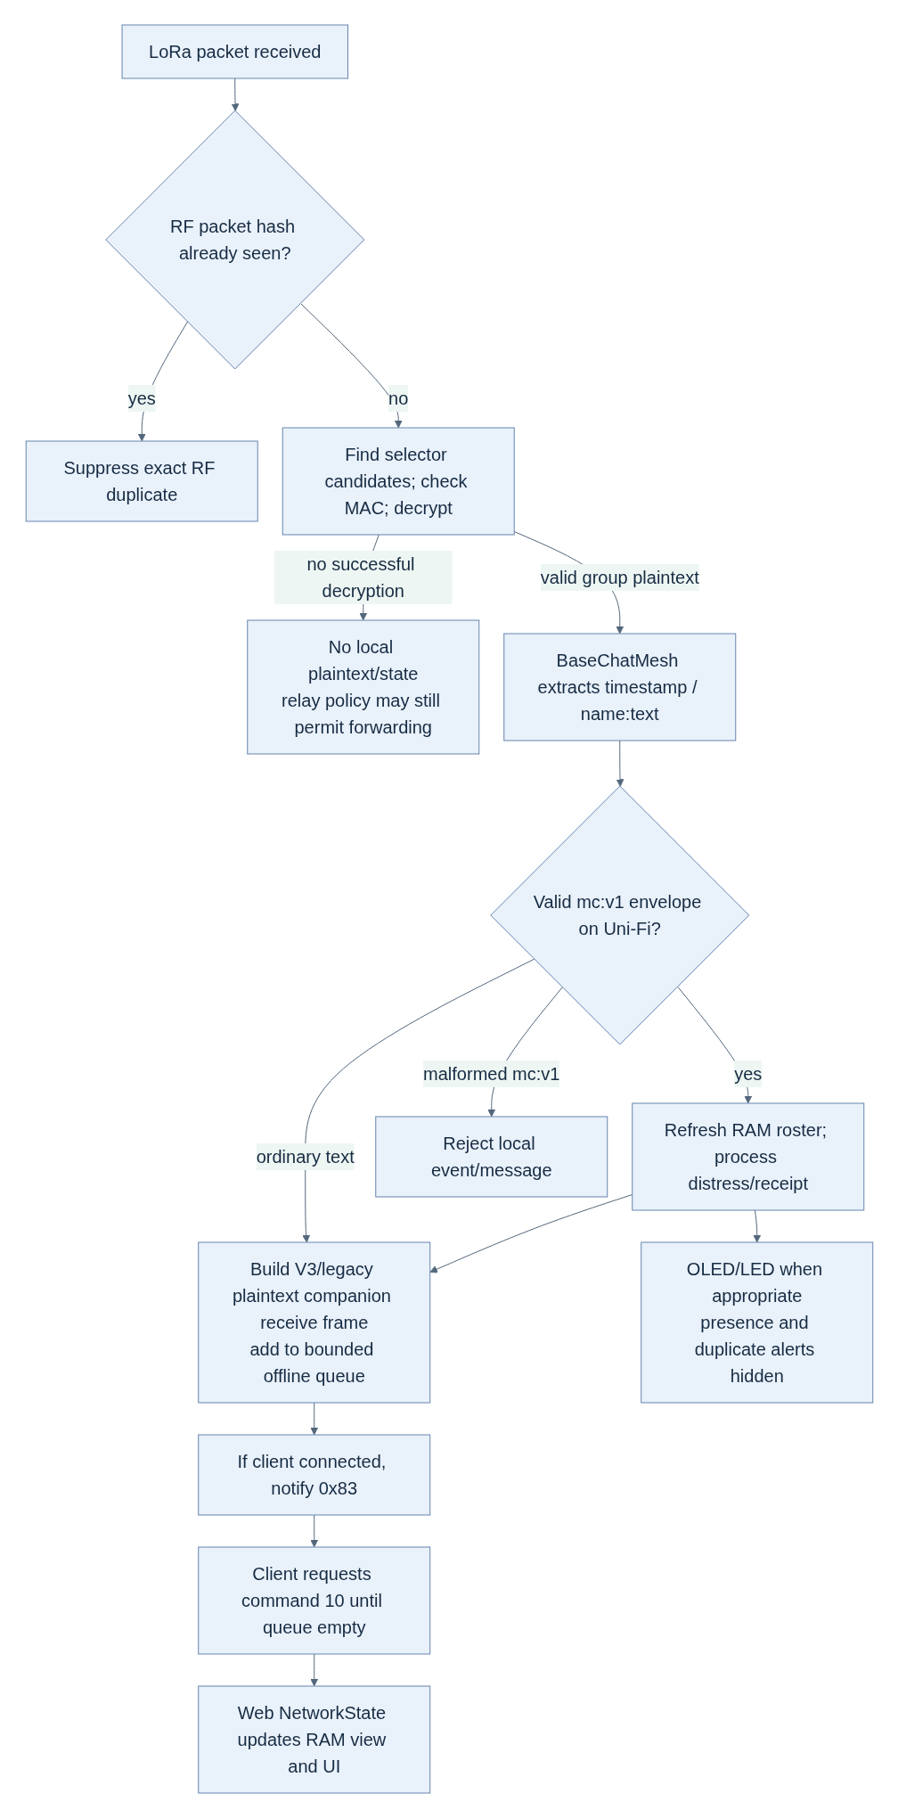
Figure 7. Incoming-message processing and client collection
The firmware queues incoming messages even when a client is connected. The push is just a prompt to pull them. A new browser session can drain queued messages and query the current incident status, but cannot request a complete firmware roster dump; browser presence may differ from the 32-member device table.

13. Complete SOS and receipt flow
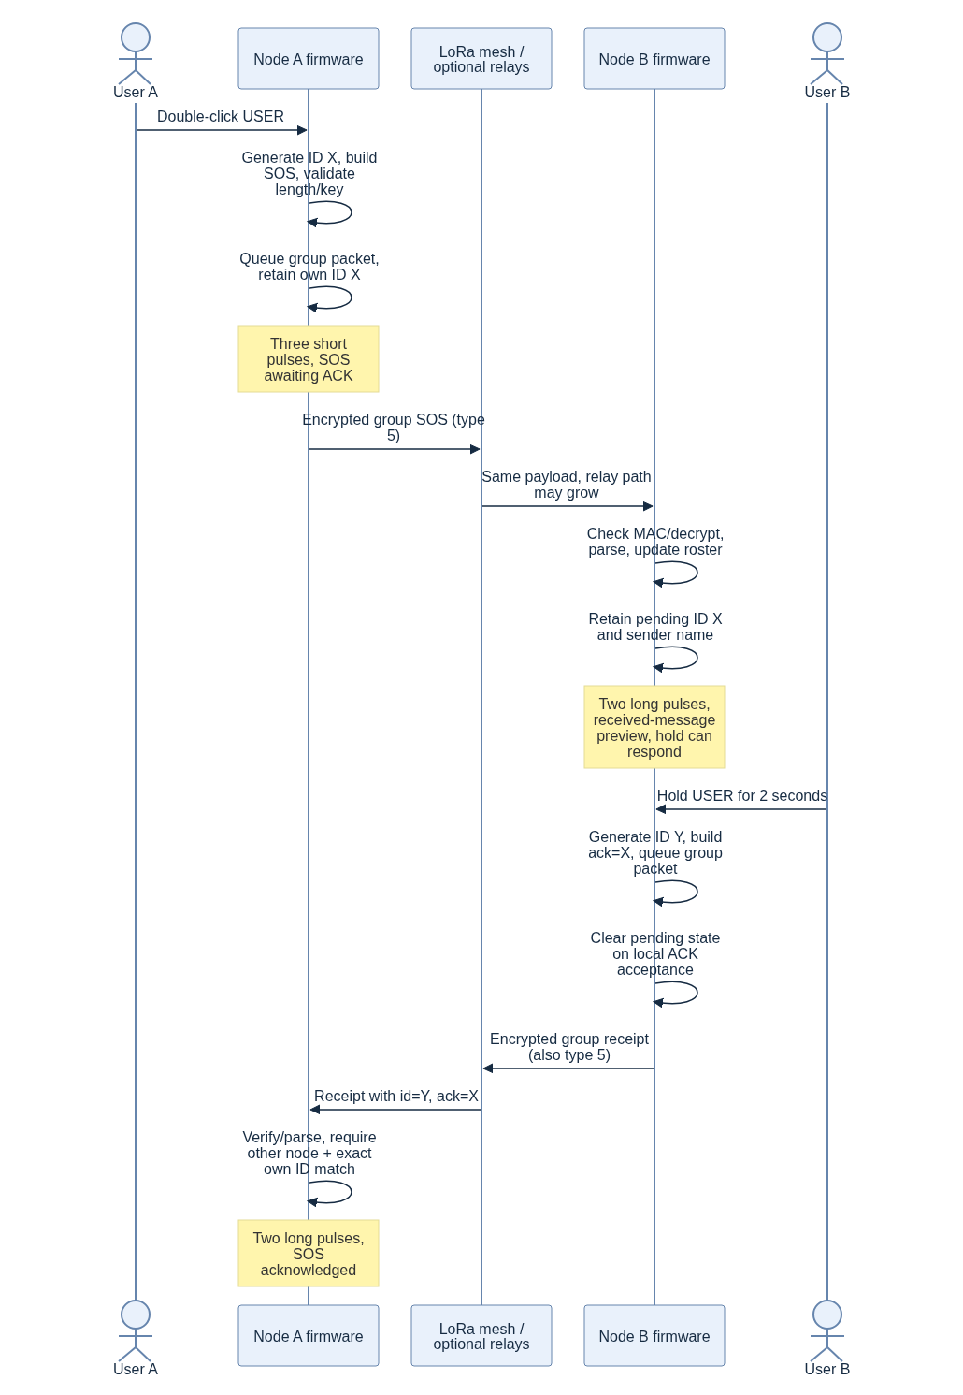
Figure 8. The complete SOS and human receipt exchange
The browser can substitute for either button action: command 3 submits the same event body, and firmware handles own/pending incident state through the same group-message wrapper. Status polling lets it see a physical-button SOS and a receipt received while the browser was absent.
On incoming distress, the immediate OLED page is the received-message preview. The Hold 2s: ACK prompt appears on the home page; the hold gesture can respond from either page. We have not yet polished that raw-envelope preview into a dedicated minimal incident screen.

What the states actually prove
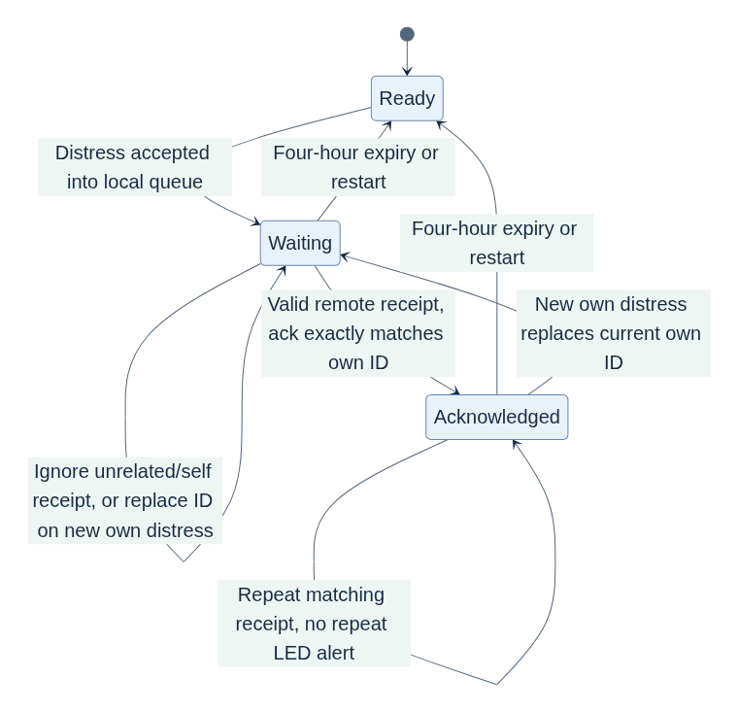
Figure 9. What each incident state does and does not prove
- Queued: the local firmware accepted a message, not that another node heard it.
- Received distress: this receiver decoded a valid event, not that a dispatcher or emergency service has been contacted.
- Receipt queued on B: B accepted its response locally; B clears its pending state at this point even if A never receives that response.
- Acknowledged on A: a different claimed node holding the group key sent a matching receipt. It does not guarantee assistance or identify a trusted person.
Each node retains one current own distress and one newest pending received distress. A later incoming distress replaces the pending one, so a hardware hold is not a menu of every victim. Browser incident cards can retain multiple events and respond to a selected ID. Power loss loses standalone incident state.

14. Presence, expiry, duplicates and queue limits

Presence and contact discovery
The first heartbeat is scheduled around 30 seconds of device uptime; later attempts occur every 15 minutes. A successful presence send also schedules an opaque signed advert, supplying the full public key for direct contacts. No username or coordinates are placed in that public LoRa advert.
A valid Uni-Fi structured envelope—not only type=presence—updates the firmware member table using its claimed node prefix, decrypted name and local receipt time. That makes a just-heard SOS sender visible immediately rather than waiting for the next heartbeat. Existing optional coordinates can be retained when a later compact event omits them; stale-fix policy is future work.
The 32-entry firmware roster expires at four hours without a new accepted envelope. Duplicates reaching the application refresh local time. At capacity, new members replace the oldest locally heard entry. Time calculations are wrap-safe; sender clock and timestamp do not control TTL.

Three distinct duplicate mechanisms
Mechanism | Key / bound | Consequence
MeshCore RF duplicate filter | First 8 SHA-256 bytes over type + payload; 160 recent packet hashes | Exact same RF payload received again is suppressed before application processing; its changed relay path does not make it new
Uni-Fi emergency duplicate cache | Claimed node + case-sensitive event ID; 16 recent events with four-hour expiry | A newly serialized radio packet carrying the same semantic incident can refresh local state but not repeat its alert while cached
Roster upsert / web coalescing | Node for roster; node + ID for structured web messages/incidents | Refresh existing records rather than continually adding rows

Consequently, “duplicate refresh” means a duplicate envelope that reaches the application, not every exact RF copy filtered by MeshCore. Once bounded caches evict an entry or a device restarts, an old replay can be accepted again. This is traffic/state deduplication, not durable cryptographic replay protection.
Firmware own-acknowledged state independently prevents repeat matching receipts from re-blinking while that own state remains active. Repeated incoming distress does not reopen a locally acknowledged pending event while its dedup entry lasts.

Offline queue policy
The 64-frame incoming queue coalesces presence by node. When full, it seeks a presence frame to replace, then an ordinary channel-text frame. If only critical/other frames remain, incoming presence/ordinary/other frames are dropped; a new recognized distress/ACK can displace the oldest frame. Direct messages are protected from routine presence eviction, but this is not a lossless or indefinitely durable queue.
Expired/evicted presence records' queued heartbeats are pruned approximately once per second, so reconnecting clients do not revive obviously expired members from those heartbeat frames. Other queued events do not carry a separate original monotonic-receipt field in the companion format: the browser starts its own local receipt age when it drains them. The two layers' TTLs therefore are not a synchronized shared database.
Browser state is bounded independently and clears on reload/new session. Firmware state clears on restart. Neither performs cloud synchronization.

15. Security and privacy boundaries
The deployment key is not a username password, device identity private key, BLE PIN, or routing hash. These have different roles:
Item | Public or secret? | Role
Node full public key / prefixes | Public | Routing/contact identity; advert signature verification
Node private key | Secret, persistent device storage | Device identity operations and direct key exchange
Deployment PSK | Secret, same across authorized nodes | Group encryption/MAC; normal API masks slot 0
One-byte channel selector | Public and collision-prone | Select candidate keys/traffic; not authorization
BLE PIN | Pairing credential | Local companion link protection; unrelated to fleet PSK
Envelope node/name/ID | Inside group ciphertext on RF | Application metadata; key holders can forge claims

The inherited two-byte group MAC and shared-key model are not individually authenticated messaging. A fleet member can spoof another sender; a signed public advert does not sign a subsequent group envelope. Device-prefix checks on our outgoing API do not prevent a modified malicious transmitter.
Slot-0 masking prevents ordinary companion key reads/replacement. It is not flash encryption, secure boot or tamper resistance. A provisioned binary also contains the key and must remain private. Losing a keyed device calls for a new key and reflashing remaining nodes; enforceable bans/key-rotation UI are not implemented.
Privacy is transport-specific: the LoRa advert hides the saved username, but the inherited BLE adapter advertises UniFi-<saved node name>. Nearby BLE scanners can therefore learn that name. Renaming saves firmware preferences; the BLE advertising label is initialized at boot and may require a restart to reflect the change. The connected companion receives decrypted messages. Do not promise anonymous BLE discovery or secrecy from a paired computer.
For deployment policy, see Security. No part of this prototype promises guaranteed life-safety delivery or regulatory approval of the selected radio/antenna/power combination.

16. Flutter, GPS and maps: what remains
Earlier Flutter work introduced emergency-first navigation, an encrypted presence model, local receivedAt, contact/map filtering, quick presets and incident markers. The main scanner exposes BLE first. Those sources remain, but this iteration did not remove the rest of Flutter's image codecs, translation services, expert screens, USB/TCP connectors or broad dependencies. Some are still constructed from app/lib/main.dart, not merely dead files.
Known compatibility work before calling Flutter a working prototype client:
- Align preset text with the firmware's strict 160-byte budget, including name.
- Port/test the stricter envelope rules; the older mobile parser differs and currently rejects (0,0) whereas firmware/web accept it.
- Add status command 0x70 if physical-button incident recovery is required.
- Run Dart formatting, analyzer, Flutter tests and actual mobile builds.
- Re-test QR, contacts, direct chat and map state with real devices.
- Prune mobile services/dependencies deliberately and verify the resulting app.
No Flutter/Dart SDK is installed in the current environment; compatibility has not been established by the browser tests. The preserved Flutter code is a foundation, not a claim of feature parity.

Planned GPS/map data ownership
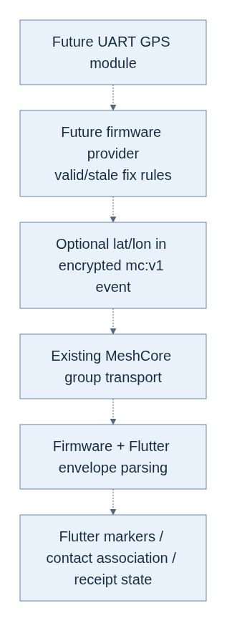
Figure 10. Planned GPS and map data ownership
Dashed arrows are planned. This requires a reviewed free-UART pinout for the actual board revision, driver/target configuration, valid/stale-fix policy, payload budgeting and mobile UI testing. Turning on a setting in the current GPS-free binary will not create a location provider. The node should own fix acquisition and minimal event state; the phone should own maps, history and rich interaction. Neither must own the other's emergency-critical runtime.

17. Verification and how to demonstrate the prototype

What has actually passed
Check | Result / what it establishes
Provisioned ESP32-S3 build + merged image | Compiles/links the product target; private deployment key is present in its image
Isolated unprovisioned build | Compiles without a key; that image does not contain the private deployment key
Pure C++ controller tests | Actual debounce, hold/click, held-at-boot, rollover and LED logic
Protocol host tests | Seven groups, 4,426 assertions over parser, state, retention, queue and policy logic
Existing MeshCore native tests | 40 passing cases across routing/serialization/tables/UTF-8/utilities
Node web tests | 20 passing wire/session/state tests; transport substitutes confined to tests
Real browser page checks | Desktop and 390×844 layout, no console errors/warnings or horizontal overflow; disconnected send controls disabled
Linked-image symbol inspection | No WiFiClass, MicroNMEA, AutoDiscoverRTCClock, rescue CLI handler or group-datagram sender symbols

The provisioned image uses 94,668 bytes static RAM and 1,189,513 bytes application flash. These do not measure free runtime heap, RF latency, battery life, or improvement relative to an independently built upstream baseline. Sanitizer coverage was unavailable due to broken installed runtime links.
No physical Heltec was attached during this work. RF delivery/relay behavior, BLE pairing/MTU, button electrical behavior, OLED power/wake, LED polarity and battery current remain not run. CI is configured; it has not been claimed to have executed remotely because the feature branch has not been pushed.

A ground-up explanation/demo for someone new
- Start with two radios and no phones: explain that each has a persistent identity and the same private deployment key.
- Show the fixed waveform, name and PIN; explain that the group channel is logical encryption, not a second frequency.
- Double-click A; point out “queued/awaiting” and the three short pulses.
- On B, show the received sender/incident and two long pulses. Hold B to respond; then require A's matching receipt state before saying acknowledged.
- Add the browser: it talks only to its own radio, retrieves plaintext queued frames, and offers presets/diagnostics. It is not the RF relay.
- Disconnect the browsers and repeat, showing which work remains on-device.
- Add a third relay with end nodes outside direct range and test the return receipt path. Do not infer mesh range from a two-node desk test.
- Explain GPS/maps and individual-authenticated moderation as future work.
This is the intended demonstration procedure, not a record of completed hardware results. Follow Prototype validation, Hardware/flashing, and Web client guide.

18. Where to read the code next
Question | Entry point
What exactly is compiled? | Heltec target config, target Heltec_v3_unifi_companion_ble_us
How are hardware objects selected? | target.cpp, HeltecV3Board.h
How does boot/loop work? | main.cpp, setup / loop
What does SOS/receipt/parsing do? | MyMesh.cpp, sendUniFiEvent, sendGroupMessage, onChannelMessageRecv; UniFiProtocol.h
What does each gesture/blink do? | UniFiButton.h, UniFiLed.h, UITask.cpp
Where is radio encryption? | Utils.cpp, encryptThenMAC / MACThenDecrypt
Where is the RF packet structure? | Packet.h, Packet.cpp, MeshCore.h
Where are messages constructed? | BaseChatMesh.cpp, sendGroupMessage / sendMessage; Mesh.cpp, createGroupDatagram
Where are receive/routing decisions? | Mesh.cpp, onRecvPacket / routeRecvPacket; Dispatcher.cpp
How is the browser wired? | app.js, session.js, protocol.js, transports.js
What was decided and tested? | ADR 0007, Development log, Validation checklist

To compare source changes locally, use:
./scripts/gitw diff --stat 80062a7 fd8a149
./scripts/gitw diff 80062a7 fd8a149 -- firmware/variants/heltec_v3/platformio.ini
./scripts/gitw diff 80062a7 fd8a149 -- firmware/examples/companion_radio/MyMesh.cpp
./scripts/gitw diff 80062a7 fd8a149 -- app/ # intentionally empty in this iteration
scripts/gitw only addresses this workspace's read-only .git mount; it is not part of the flashed firmware or network protocol.

Appendix A: retained companion commands
This is the current product allowlist from unifi::minimumCommandLength, not a promise that every inherited mobile screen remains usable. Minimum length includes the command byte; optional fields can make a frame longer. Length checking is followed by command-specific validation. MAX_PATH_SIZE is 64 for the contact minimum below.
Decimal code | Name | Minimum bytes | Product behavior
1 | APP_START | 8 | Read self-info
2 | SEND_TXT_MSG | 14 | Direct plain text only; CLI text rejected
3 | SEND_CHANNEL_TXT_MSG | 8 | Group plain text; provisioned fleet required
4 | GET_CONTACTS | 1 | Contact iterator; optional since filter
5 | GET_DEVICE_TIME | 1 | Current node time
6 | SET_DEVICE_TIME | 5 | Set node time
7 | SEND_SELF_ADVERT | 1 | Send opaque signed advert
8 | SET_ADVERT_NAME | 2 | Validate/save node name
9 | ADD_UPDATE_CONTACT | 136 | Existing contact representation
10 | SYNC_NEXT_MESSAGE | 1 | Drain one incoming frame
11 | SET_RADIO_PARAMS | 11 | Allowed into dispatcher but disabled by locked profile
12 | SET_RADIO_TX_POWER | 2 | Retained bounded TX-power control
13 | RESET_PATH | 33 | Existing contact path reset
14 | SET_ADVERT_LATLON | 9 | Retained manual coordinate API; not a GPS driver, not emitted by GPS-free events
15 | REMOVE_CONTACT | 33 | Local contact removal, not fleet ban
16 | SHARE_CONTACT | 33 | Existing contact advert exchange
17 | EXPORT_CONTACT | 1 | Existing signed contact export
18 | IMPORT_CONTACT | 99 | Existing signed advert/contact import
19 | REBOOT | 7 | Requires literal reboot confirmation bytes
20 | GET_BATT_AND_STORAGE | 1 | Local battery/storage
22 | DEVICE_QUERY | 2 | Device info and receive-frame version negotiation
30 | GET_CONTACT_BY_KEY | 33 | Contact lookup
31 | GET_CHANNEL | 2 | Slot 0 secret masked
32 | SET_CHANNEL | 50 | Slot 0 locked; other slots retained
37 | SET_DEVICE_PIN | 5 | Local BLE PIN preference
38 | SET_OTHER_PARAMS | 2 | Retained basic contact/ACK/preferences subset
51 | FACTORY_RESET | 6 | Requires literal reset; destructive device maintenance
56 | GET_STATS | 2 | Local core/radio/packet stats
58 | SET_AUTOADD_CONFIG | 2 | Retained contact auto-add configuration
59 | GET_AUTOADD_CONFIG | 1 | Read contact auto-add configuration
60 | GET_ALLOWED_REPEAT_FREQ | 1 | Fixed 910525 kHz repeat interval
61 | SET_PATH_HASH_MODE | 3 | Supported path hash widths
112 (0x70) | UNIFI_STATUS | 1 | Read-only version-1 product status

All other command values return unsupported before payload access in this target. In particular: private-key import/export; raw packet/data/control; remote login/status/binary/anonymous/telemetry requests; signing workflows; image/group datagrams; tuning; trace/path-discovery commands; custom variables; and transport-scope management are outside the product allowlist. Core advert signature verification and essential PATH/direct ACK handling still remain.
For implementing another client, use the layouts in this document and the referenced MyMesh.cpp as the current product authority. Inherited general MeshCore/Flutter protocol guides cover broader commands that this target intentionally rejects.

