MESMER

Requirements for a Generic Unimolecular Modelling Application

INTRODUCTION

This document lists the requirements for a generic application for the modelling of unimolecular systems (MESMER–Master Equation Solver for Multi Energy-well Reactions). Modelling of unimolecular systems using master equation techniques has been performed for a number of years, and in that time a wide variety of systems have been examined by a number of people. Code development has not been structured, with the result that a system specific code has often been written for every new system investigated. The consequences of this are obvious and include:

- Repetitious development of standard code. Each new system usually requires the development of I/O and data structure manipulation facilities. Clearly, much time is wasted in the development of these facilities that could be better spent in investigating the chemistry of the system under investigation
- Non-transferable algorithms. Often algorithms have been developed for one system that could be used with other systems but workers either don't know they exist or have to waste time in re-implementing algorithms for the situation in which they are interested.
- The maintenance of a large number of programs. As time progresses the number of programs increases and as no development standards have been imposed code is often written in a number of styles. This adds to the maintenance burden of the existing code base.
- No standard data representation. Each worker will have persisted the date for the system they are looking at in whatever format they feel is appropriate. This again makes it hard to compare calculation results and does not promote the idea of a molecular database that can be used to test new algorithms or that can be re-used for different systems.

Some work has been done in the Leeds group to develop a rudimentary library that implements a number of basic methods, however this has not had a significant impact on reducing the amount of code that is routinely generated.

There have been a number of attempts to develop a generic framework. These include:
- UNIMOL. Developed by Gilbert and Smith, this code is limited to single well systems. The code was written in Fortran 77 and is difficult to understand and modify. It does not appear to be being actively developed.
- MultiWell. Developed by Barker and co-workers, this code, as its name suggests, addresses multi-well systems. The code is written in Fortran 77 is being actively developed. The Multiwell implements a monte-carlo approach to solve the underlying eigenvalue problem
- VariFlex. Developed by Klippenstein and co-workers, the focus of this code is methods for calculating microcanonical rate coefficients using flexible transition state theory. Support for unimolecular systems includes isomerization (two well) reactions. VariFlex is written in Fortran 77.

The common theme of these codes are that they are written in Fortran 77, and while some Fortran 90 features are used occasionally (mostly dynamic memory allocation), data structures and I/O facilities are usually basic and difficult to understand and maintain. Given that the underlying problem, from the point of view of the chemist, is one that is naturally described in terms of objects (atoms, molecules, transition states, etc.), it seems desirable to create a generic framework that can be uses to investigate new systems and new algorithms that is based on an object orientated approach.

The end user for such an application will be primarily graduate students and post-doctoral fellows working in the field of gas phase kinetics. Typically, graduate students in this field have limited training in computational methods, but are often required to do some form of system modelling as part of the analysis of results. Post-doctoral fellows also want to analyse results as rapidly as possible, but, in addition, they are often interested in extending a method or algorithm and as such some form of access to the code is necessary. This range of users mandates the following requirements:

Req. 1 The application will be open source.

Req. 2 The application must be portable and run on at least Linux and Win32.

Req.3 The application will be implemented in standard, off the shelf, technologies, for which there are copious documentation sources.

Req.4 The application will be delivered to the end user with build tools.

SYSTEM OVERVIEW

The modelling of unimolecular systems has application in industrial and environmental contexts. The quantities of particular interest are the rate coefficients that describe the evolution of the system being investigated. Unimolecular rate coefficients, typically, have a complex dependency on pressure and temperature. The modelling of industrial or environmental process often involves conditions that are difficult to access experimentally and so it is important to be able to generate experimentally validated rate coefficient models that can be used in large scale simulations.

In recent years a great deal of progress has been made in the understanding and modelling of unimolecular systems. A common feature in much of the work in this area is the use of stochastic techniques for describing the evolution of unimolecular systems and in particular the master equation (ME) - a central component of the proposed application will be the construction and solution of a ME for an arbitrary system.

The Unimolecular System

A unimolecular system is characterised by one or more wells (local minima) on the potential energy surface (PES) describing the motion of the atoms that comprise the system. Each well (depending on depth) represents a (meta-) stable species that can in principle be isolated. Wells are connected by transitions states (TS) and a species in one well may be converted to another by passing through the TS that connects the wells. In many systems the TS can be associated with a saddle point on the system PES and so there is an energy barrier to interconversion of species. Thus, to convert from one species to another, the reactant must be activated, that is energy must be supplied to overcome the barrier separating the two wells. Typically ,energy is supplied through inelastic collisions with bath gas molecules - the reactant will undergo a number of collisions with bath gas molecules some of which will be activating (net increase in reactant energy) some will be deactivating (net decrease in reactant energy). Since collision events and the amount of energy transferred are random quantities the energy transfer process can be regarded as a random walk, and treated using techniques from stochastic process theory.

For unimolecular systems the master equation (ME) has proved a very successful approach to the problem. The details of the approach have been discussed exhaustively elsewhere, but, in brief, the ME for a simple unimolecular dissociation can be represented numerically as an energy grained master equation or EGME, and has the form,
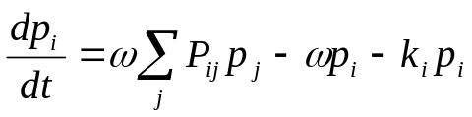 (1)
or in more compact form,
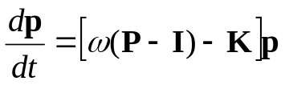 (2)
where is the collision frequency, P is the matrix of transition probabilities, I is the identity matrix, K is a diagonal matrix of microcanonical rate coefficients and p is the population vector, describing the population of each energy grain.

In Eq. (1) there is an upper limit, m, placed on the sum - truncation of the energy space is necessary as there is only a finite amount of storage space available. The energy of the highest grain, and consequently the value of m, must be chosen such that the bulk of the population is far enough below m that transitions to states above m are negligible. Several factors will affect this choice, notably temperature, the collision parameters and the initial distribution.

Setting 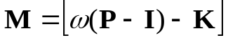 the EGME can be written in the compact form,
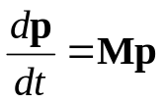 (3)
The solution of this equation can be written as
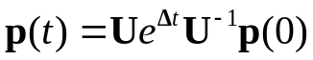 (4)
where p (0) is the initial population vector, U is a matrix whose columns are the right eigenvectors of M and Λ is a diagonal matrix of the corresponding eigenvalues. Typically it is found that the eigenvalue of smallest magnitude is well separated from the rest and it can be shown that the magnitude of this eigenvalue can be equated with the rate coefficient.

DATA STRUCTURES

In this section the content of the principal data structures is discussed, and some implementation details are suggested. In broad terms the data structures can be divided into, Molecular, Reaction, Utility and Framework.

Molecular Data Structures

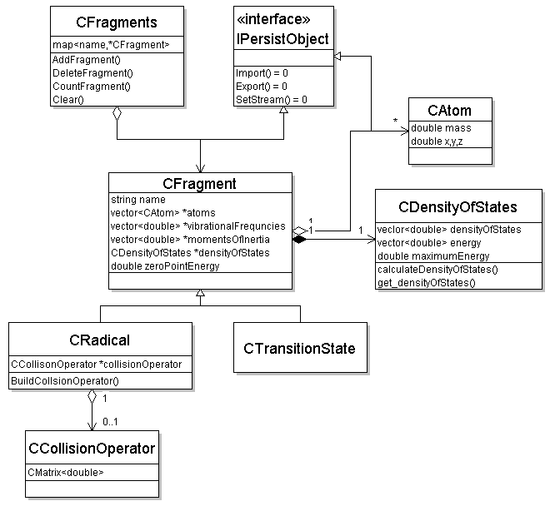

Figure 1. Data structures for radicals

These data structures are sketched out in Fig. 1. The primary objects are of type CFragment. These objects encapsulate the molecular data of the species that they represent, and will usually include vibrational frequencies and moments of inertia. Each fragment is made up of a number of atoms, each possessing mass and location. It will not always be necessary to specify the number of atoms or their properties, as experimental values can be used for quantities such as moments of inertia, but provision needs to be made for those occasions where these quantities are unavailable.

A key quantity in the modelling of unimolecular systems is the microcanonical partition function or density of states (DS) of a molecular fragment. This quantity is calculated from molecular data and is used by a number of other objects. The method of calculation will depend greatly on the structure of the fragment and so the class CDensityOfStates should be regarded as a base class.

The class CFragment is a base class to two classes, CRadical, which represents (meta-) stable species and CTransitionState which represents the instantaneous state of a fragment as it passes from one species to another. From Fig. 1. these two classes are distinguished by the presence of a collision operator. Only the collision properties of radicals are of interest because transition states only represent an instantaneous state of a fragment their lifetime is too short for it to be sensible to consider their collision with a bath gas molecule.

The class CFragments is simple a container to hold all CFragment objects and could be implemented as a wrapping of an stl::map class, as this class is not performance critical. The interface IPersistObject mandates persistence facilities for the CFragement class and is discussed under utility classes.

Reaction Data Structures

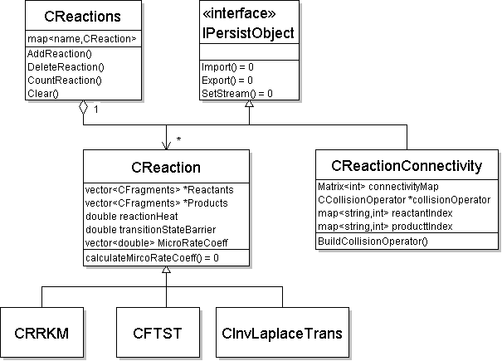

Figure 2. Data structures for reactions

Fig. 2. gives a schematic view of the reaction data structures. The class CReaction encapsulates data about a given constituent reaction, the most important components being the identity of the reactants and products, and the zero-point energy difference of the reaction. These quantities allow thermodynamic quantities, mainly the equilibrium constant, to be calculated. In addition to thermodynamic quantities, the other important quantity that needs to be calculated is the microcanonical rate coefficient, k(E). There are a variety of methods for calculating k(E), depending on the detail available for the PES on which the reaction takes place, some of these methods will involve an explicit transition state (RRKM) and some do not (ILT).

The other important class is CReactionConnectivity which describes how the overall system is composed of the constituent reactants. An object of this class encapsulates the connectivity map which forms the template from which the final collision operator is built. The connectivity describes the connection between the various wells that describe the unimolecular system. Consider the system:

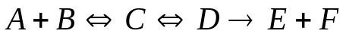 (5)

The connectivity map for this would look like:

 | A+B | C | D | E+F
A+B | 0 | 1 | 0 | 0
C | 1 | 1 | 1 | 0
D | 0 | 1 | 1 | 0
E+F | 0 | 0 | 1 | 0

In reaction (5) the species C and D are stable isomers (PES wells), C is populated by the association reaction of A with B (a source term) and the species E and F are products produced irreversibly from D and area sink term for this reaction. The structure of the over all collision matrix for this system is constructed by first examining the leading diagonal of this table, any terms that are unity indicate a unimolecular species for which a specific collision matrix is requires, in this example C and D, and these matrices should be constructed first and added as diagonal, blocks to the over all collision matrix. Isomer interconversion terms should then be added, making sure that detailed balance relations are observed. Finally, source and sink terms are added.

The connectivity matrix is constructed by parsing the input file, which will contain reaction information. From the numbers of reactants and products and the reversibility of the reaction, it can be classified as an association, isomerization or dissociation reaction, and from this the connectivity table can be constructed.

As with the Molecular classes, the class CReaction is simple a container to hold all CReaction objects and could be implemented as a wrapping of an stl::map class, as this class is not performance critical and the interface IPersistObject mandates persistence facilities for the CReaction class.

Utility Data Structures

The classes in this category include those that deal with object I/O and the wrapping of numerical algorithms. The interface class IPersistObject is inherited by a number of classes will define the I/O methods to be implemented by an object so that it can initialize and save itself as well as give access to I/O resources.

Framework Data Structures
These data structures will contain the above and coordinate the interaction between them. To allow the user to specify things such as temperature and pressures ranges, rate coefficient methods, etc. some form of command language could be used, like a simple set of keywords and parameters, or an off-the-shelf solution such as Tcl or PERL. But if the data file is in XML (q.v.), the preferred solution is to specify these parameters and operations as XML elements.

Req.5 An XML description to give users the flexibility to examine a number of systems in any one run.

Perhaps the most important use case where this flexibility is crucial is the fitting of experimental data. A significant, if not the majority, of work using ME methods is in analysing experimental data.

PERSISTENCE

The representation of molecular data is key to the success of the proposed application. There are clearly a number of solutions: an in-house format can be developed giving ultimate flexibility; a format from an existing application could be used, allowing interaction between the two applications; or a standard data representation format can be used, XML being a clear contender. Since most modern data formats use XML, this has been chosen for this project. The advantages are:
- forward and backward compatibility;
- moderately understandable by a user, making it easy to modify or change for a new system;
- capable of containing any amount of (possibly structured) metadata and other information (e.g. chemical structure)
- compatible with external tools for editing, display and validation, and to some extent with other chemistry programs.

Req.6 The format is extensible so that there are no backward compatibility problems. As time progresses new features are bound to be added and the data format has to accommodate these.

Req.7
Standard editing tools are widely available for XML. The encoding will be UTF8, although it is not envisaged that any characters other than ASCII will be used, so that it will be ASCII compatible.

Req.8 The format must allow for meta-data concerning all aspects of the data and calculation, for example, the origin of molecular parameters. The extent to which this meta-data should be in a standard form like RTF remains to be decided.

Req.9 The format will reflect the object hierarchy of the application.

The output data will also be in XML format. By itself this provides a degree of self-description for the future and, if a schema is provided, complete machine readability. The output can be understood to some extend by humans, but standard tools, such as stylesheets can be used to format it as required. The development of a minimal set of stylesheets will be part of the project.

ALGORITHMS

Diagonalization

Central to the ME approach is the diagonalization of the collision matrix. These matrices are real symmetric and can be addressed using standard linear algebra implementations. It was originally envisaged that the LAPACK suite of routines would be used. But these are written in FORTRAN and it has been decided that the project will require no FORTRAN compilation, which is not easily available for free in a Windows environment. A port of some EISPACK routines into C seems at the moment to be adequate, but there may be a need to identify a suitable open-source C++ numerical library.

When considering medium to high temperature systems (that is for systems where kT is comparable to the TS barriers) these methods work well, however for low temperature systems a serious problem is encountered. For low temperature systems the ratio of the smallest to largest eigenvalue can, and does, exceeds machine precision, with the consequence that the detail of the smaller eigenvalues is lost. As it is the small eigenvalues that are chemical interest this prevents meaningful rate coefficients from being obtained. Recent work in the Leeds group using extended precision methods has gone a long way to resolve this problem. Possible approaches beyond multiprecision arithmetic, such as improved algorithms, are not within the immediate scope of this project.

Req.10 Extended precision methods, based on some existing numerical library, must be accommodated within the application.

Data Analysis and Representation

Once the collision matrix has been diagonalized the eigenvalues and eigenvectors need to be analysed to extract the rate coefficient data. This is a process that can be problematic at high temperatures as rate coefficients become difficult to define.

Req.11 Tools to extract canonical rate coefficients. In particular it would be useful for the application to indicate that rate coefficients cannot be defined because of convergence of eigenvalues.

As discussed above, the fitting of experimental data forms the most significant activity for which ME methods are used.

Req.12 Tools to fit experimental data. The nature of the parameter dependence is such that nonlinear methods will be mandatory.

When data has been generated, for desired temperature and pressure ranges, it needs to be represented in a compact form that can be used by modellers. The accepted approach to this representation is to use the Troe formalism.

Req.12 Tools to generate Troe representations of rate coefficients.

SOURCE CONTROL/BUILD

For such a relatively small application as this source control may seem inappropriate but there benefits to be obtained from formal source control which make this desirable.

A SourgeForge project will be set up. This provides source control, probably through SVN, which is essential when there are multiple developers. It also provides a distribution route and several other services, such as mailing lists for supporting the application, should that be found to be necessary.

The program will need to be released under an Open Source licence acceptable to SourceForge. LGPL seems the best possibility, as it allows a degree of commercial use, but a final decision has not yet been made

Build tools will be critical. In particular the ability to build executables with or without debug options should be as straightforward as possible.

Req.13 Build tools must be simple and generate both debug and production executables.

QA/TEST SUITE

The benefits of regular test runs are well understood. There are a number of existing systems that can form an initial test set and these can be added to over time.

Req.14 An automated test framework.

Req.15 A database of existing systems to be used as tests.

Definitions

Abbreviation | Meaning
ME | Master Equation
EGME | Energy Grained Master Equation
PES | Potential Energy Surface
TS | Transition State

