Workshop2_Intro
AdrienM
2026-05-20
#New chunk shortcuts
Comd + opt I Crtl + Alt I
library(tidyverse)
## ── Attaching core tidyverse packages ──────────────────────── tidyverse 2.0.0 ──
## ✔ dplyr 1.1.4 ✔ readr 2.1.5
## ✔ forcats 1.0.0 ✔ stringr 1.5.1
## ✔ ggplot2 4.0.0 ✔ tibble 3.2.1
## ✔ lubridate 1.9.4 ✔ tidyr 1.3.1
## ✔ purrr 1.0.4
## ── Conflicts ────────────────────────────────────────── tidyverse_conflicts() ──
## ✖ dplyr::filter() masks stats::filter()
## ✖ dplyr::lag() masks stats::lag()
## ℹ Use the conflicted package (<http://conflicted.r-lib.org/>) to force all conflicts to become errors
mpg
## # A tibble: 234 × 11
## manufacturer model displ year cyl trans drv cty hwy fl class
## <chr> <chr> <dbl> <int> <int> <chr> <chr> <int> <int> <chr> <chr>
## 1 audi a4 1.8 1999 4 auto… f 18 29 p comp…
## 2 audi a4 1.8 1999 4 manu… f 21 29 p comp…
## 3 audi a4 2 2008 4 manu… f 20 31 p comp…
## 4 audi a4 2 2008 4 auto… f 21 30 p comp…
## 5 audi a4 2.8 1999 6 auto… f 16 26 p comp…
## 6 audi a4 2.8 1999 6 manu… f 18 26 p comp…
## 7 audi a4 3.1 2008 6 auto… f 18 27 p comp…
## 8 audi a4 quattro 1.8 1999 4 manu… 4 18 26 p comp…
## 9 audi a4 quattro 1.8 1999 4 auto… 4 16 25 p comp…
## 10 audi a4 quattro 2 2008 4 manu… 4 20 28 p comp…
## # ℹ 224 more rows
ggplot(data = mpg) +
geom_point(mapping = aes(x = displ, y = hwy))
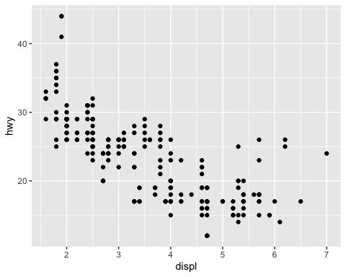
ggplot(data = mpg) +
geom_point(mapping = aes(x = displ, y = hwy, colour = class))
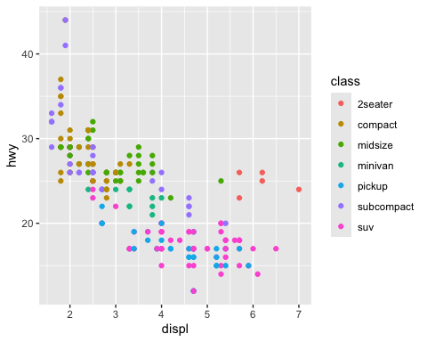
ggplot(data = mpg) +
geom_point(mapping = aes(x = displ, y = hwy, size = class))
## Warning: Using size for a discrete variable is not advised.
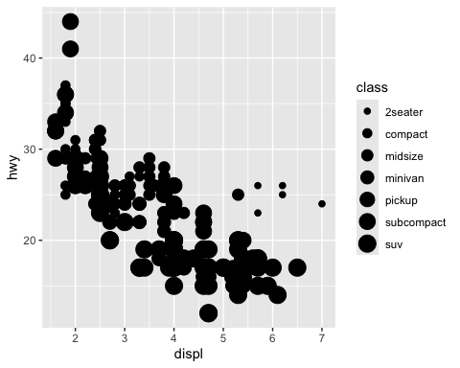
ggplot(data = mpg) +
geom_point(mapping = aes(x = displ, y = hwy, alpha = class))
## Warning: Using alpha for a discrete variable is not advised.
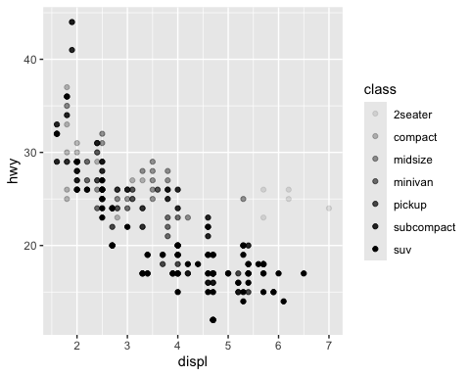
ggplot(data = mpg) +
geom_point(mapping = aes(x = displ, y = hwy), color = "blue")
