MET AD 616 Assignment 2

JingjianGao

2023-11-15

# Question #1

## a)

num_trials <- 10000  
sample_size <- 100  
  
set.seed(100)   
sums <- replicate(num_trials, sum(runif(sample_size, 0, 1)))  
  
mean_sums <- mean(sums)  
sd_sums <- sd(sums)  
  
# i)  
hist(sums, breaks = 30, probability = TRUE, main = "Sum of 100 Uniform Random Variables",  
 xlab = "Sum", ylab = "Density")  
  
# ii)  
curve(dnorm(x, mean = sample_size * 0.5, sd = sqrt(sample_size * 1/12)),  
 col = "Green", lwd = 2, add = TRUE)

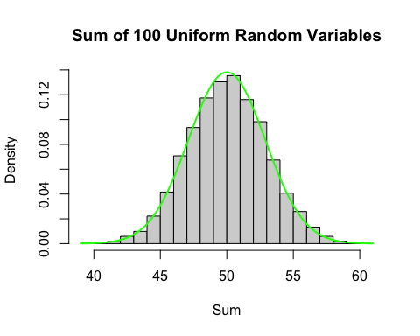

# iii)  
cat("The Mean of simulation is", mean_sums, "\n")

## The Mean of simulation is 50.03697

cat("The Standard deviation of simulation is", sd_sums, "\n")

## The Standard deviation of simulation is 2.92671

## b)

num_trials <- 10000  
sample_size <- 10  
k <- 3  
  
set.seed(101)   
third_lowest <- replicate(num_trials, sort(runif(sample_size, 0, 1))[k])  
  
mean_third_lowest <- mean(third_lowest)  
sd_third_lowest <- sd(third_lowest)  
  
# i)  
hist(third_lowest, breaks = 30, probability = TRUE, main = "3rd Lowest Value of 10 Uniform Random Variables",  
 xlab = "Value", ylab = "Density")  
  
# ii)  
curve(dbeta(x, shape1 = k, shape2 = sample_size + 1 - k), col = "blue", lwd = 2, add = TRUE)

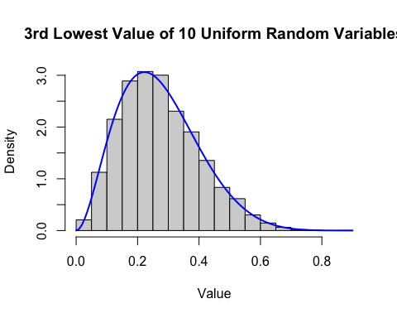

# iii)  
cat("The Mean of simulation is", mean_third_lowest, "\n")

## The Mean of simulation is 0.2732965

cat("The Standard deviation of simulation is", sd_third_lowest, "\n")

## The Standard deviation of simulation is 0.1280419

## Question #2

num_trials <- 10000  
rate <- 10   
  
set.seed(101)  
purchases_per_day <- replicate(num_trials, rpois(1, rate))  
  
hist(purchases_per_day, breaks = seq(min(purchases_per_day), max(purchases_per_day) + 1, by = 1),  
 main = "Number of Customer Purchases per Day", xlab = "Purchases", ylab = "Frequency")  
  
# Poisson Distribution with λ=10  
x <- 0:max(purchases_per_day)  
lines(x, dpois(x, rate), col = "blue", lwd = 2)

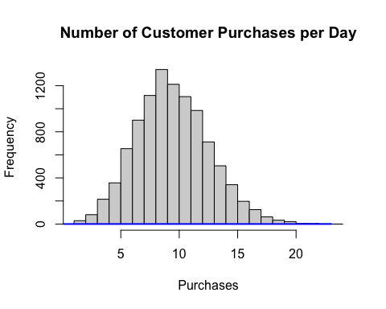

## Question #3

set.seed(103)  
num_trials <- 10000  
shape <- 4.5  
scale <- 39  
term <- 20  
monthly_payment <- 115  
death_benefit <- 1000000  
lapsing_prob <- 0.003  
discount_rate <- 0.065  
initial_cost <- monthly_payment * 12 * term  
  
  
npv_values <- replicate(num_trials, {  
 cash_flows <- initial_cost  
 for (i in 1:term * 12) {  
 prob_death <- 1 - pweibull(i, shape, scale)  
 cash_flows <- cash_flows + monthly_payment * (1 - lapsing_prob) * (1 - prob_death)  
 if (runif(1) < prob_death && cash_flows > death_benefit) {  
 cash_flows <- cash_flows - death_benefit  
 }  
 }  
 cash_flows / (1 + discount_rate)^(1:term*12)  
})  
  
# a)   
hist(npv_values, breaks = 30, main = "Net Present Value (NPV) Histogram",  
 xlab = "NPV", ylab = "Frequency")

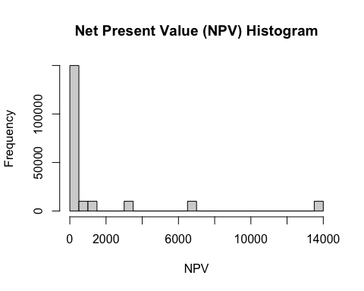

# b)  
mean_npv <- mean(npv_values)  
sd_npv <- sd(npv_values)  
cat("The Mean NPV is", mean_npv, "\n")

## The Mean NPV is 1311.242

cat("The Standard Deviation of NPV is", sd_npv, "\n")

## The Standard Deviation of NPV is 3269.385

# c)   
ci_95 <- quantile(npv_values, c(0.025, 0.975))  
cat("The 95% Confidence Interval for Mean NPV is", ci_95, "\n")

## The 95% Confidence Interval for Mean NPV is 0.008082359 13907.49

# d)   
desired_half_width <- 200  
  
iterations_for_99_ci <- ceiling(qnorm(0.995) * sd_npv / desired_half_width)^2  
cat("The number of Iterations for 99% CI with $200 Half-Width is", iterations_for_99_ci, "\n")

## The number of Iterations for 99% CI with $200 Half-Width is 1849

# e) NPV at 90% and 99% Confidence  
npv_90_percent <- quantile(npv_values, 0.1)  
npv_99_percent <- quantile(npv_values, 0.01)  
cat("The NPV at 90% Confidence is", npv_90_percent, "\n")

## The NPV at 90% Confidence is 0.03469478

cat("The NPV at 99% Confidence is", npv_99_percent, "\n")

## The NPV at 99% Confidence is 0.008082359

# Now with the assumption of having 1,000 policyholders  
set.seed(104)  
num_trials <- 1000  
shape <- 4.5  
scale <- 39  
term <- 20  
monthly_payment <- 115  
death_benefit <- 1000000  
lapsing_prob <- 0.003  
discount_rate <- 0.065  
initial_cost <- monthly_payment * 12 * term  
  
npv_values_all_policyholders <- list()  
  
for (j in 1:num_trials) {  
 npv_values <- replicate(num_trials, {  
 cash_flows <- initial_cost  
 for (i in 1:term * 12) {  
 prob_death <- 1 - pweibull(i, shape, scale)  
 cash_flows <- cash_flows + monthly_payment * (1 - lapsing_prob) * (1 - prob_death)  
 if (runif(1) < prob_death && cash_flows > death_benefit) {  
 cash_flows <- cash_flows - death_benefit  
 }  
 }  
 cash_flows / (1 + discount_rate)^(1:term*12)  
 })  
 npv_values_all_policyholders[[j]] <- npv_values  
}  
  
all_npv_values <- unlist(npv_values_all_policyholders)  
  
# a)  
hist(all_npv_values, breaks = 30, main = "Net Present Value (NPV) for 1000 Policyholders",  
 xlab = "NPV", ylab = "Frequency")

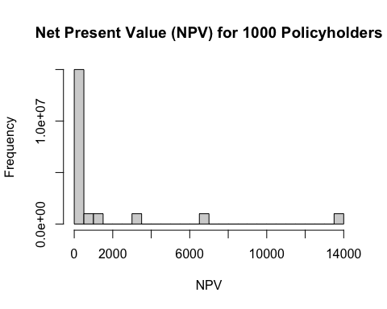

# b)   
mean_npv_all <- mean(all_npv_values)  
sd_npv_all <- sd(all_npv_values)  
cat("The Mean NPV for 1000 Policyholders is", mean_npv_all, "\n")

## The Mean NPV for 1000 Policyholders is 1311.242

cat("The Standard Deviation of NPV for 1000 Policyholders is", sd_npv_all, "\n")

## The Standard Deviation of NPV for 1000 Policyholders is 3269.377

# c)  
ci_95_all <- quantile(all_npv_values, c(0.025, 0.975))  
cat("The 95% Confidence Interval for Mean NPV of 1000 Policyholders is", ci_95_all, "\n")

## The 95% Confidence Interval for Mean NPV of 1000 Policyholders is 0.008082359 13907.49

# d)   
iterations_for_99_ci_all <- ceiling(qnorm(0.995) * sd_npv_all / desired_half_width)^2  
cat("The number of Iterations for 99% CI with $200 Half-Width for 1000 Policyholders is", iterations_for_99_ci_all, "\n")

## The number of Iterations for 99% CI with $200 Half-Width for 1000 Policyholders is 1849

# e) NPV at 90% and 99% Confidence  
npv_90_percent_all <- quantile(all_npv_values, 0.1)  
npv_99_percent_all <- quantile(all_npv_values, 0.01)  
cat("The NPV at 90% Confidence for 1000 Policyholders is", npv_90_percent_all, "\n")

## The NPV at 90% Confidence for 1000 Policyholders is 0.03469478

cat("The NPV at 99% Confidence for 1000 Policyholders is", npv_99_percent_all, "\n")

## The NPV at 99% Confidence for 1000 Policyholders is 0.008082359