**0**

**조정**

**현제**

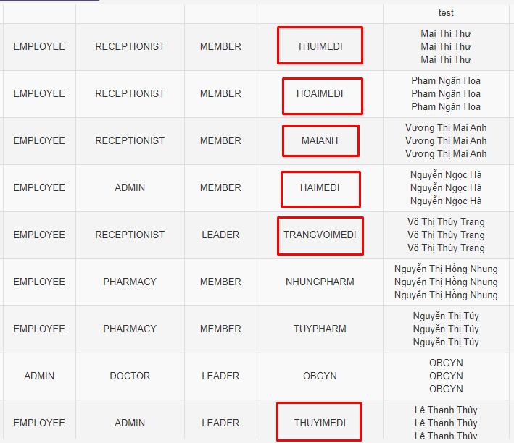

NGANHOAREC

MAITHUREC

MAIANHKOR

NGOCHAADMIN

TRANGADMIN

THANHTHUYADMIN

**현제**

**조정**

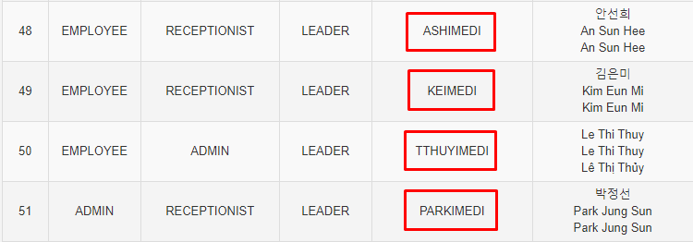

PARKREC

THUYADMIN

KIMPM

ANDERM