metin içeren bir resim

Açıklama otomatik olarak oluşturuldua.

Figure 1: Simulink model for the ecosystems

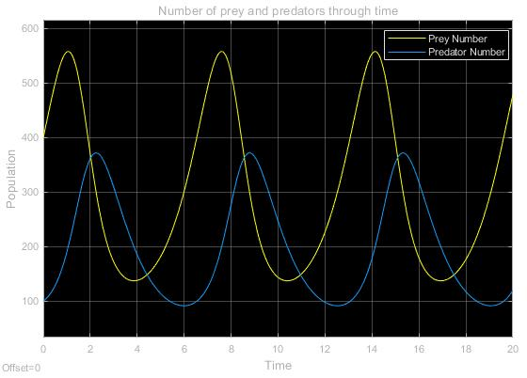b.

Figure : Simulation of the ecosystem model (y1,initial=400, y2,initial=100, mu1=300, mu2=200)

c.

The chosen set of parameters resulted in an operating point where the population of the inhabitants oscillates periodically where the period corresponds approximately to 6 times the sampling interval. As it can be seen in the initial response characteristics of the populations, when the number of preys are greater than the number of predators provided that it has a positive slope; this means there is an increasing amount of food for the predators which results in an increase in the number of predators. On the other hand, when the number of predators increases, the food supply decreases accordingly. Consequently, the population of the predator lags in frequency with respect to the population of prey. A similar behavior can be observed in the blood glycogen level and the number of parasites. The parasite population in the blood keeps pace of the glycogen level with an amount of lag.

e.

D(y1) = (1−y2/η2) y1 (1)

D(y2) = −(1−y1/η1) y2 (2)

A non-zero equilibrium is observed when y1 and y2 are equal to η1 and η2 respectively as the population of the inhabitants does not change. When the initial values of populations are around the equilibrium point but do not have the exact value, the oscillations are again observed as demonstrated in Figure 3. Notice that, the period of the oscillations is not altered; however, the characteristics of each plot behaves more like a sinusoidal. The reason behind this can be explained by small signal approximation. That is, as deviation from the chosen equilibrium point is decreased, a more convergent characteristics to a perfect sinusoid at the output is achieved.

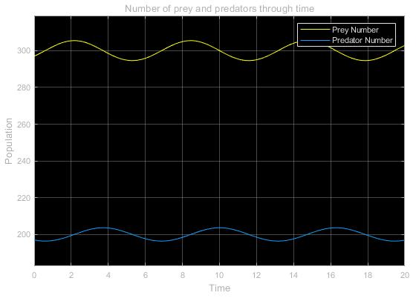f.

Figure : Simulation of the ecosystem model (y1,initial=297, y2,initial=197, mu1=300, mu2=200)

metin, harita içeren bir resim

Açıklama otomatik olarak oluşturuldu

Figure : Simulink model for the ecosystems after imposing growth limiting for prey population

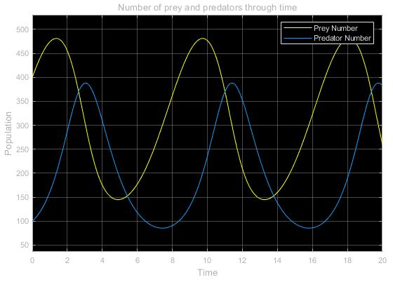g.

Figure : Simulation of the ecosystem model after imposing growth limiting for prey population (y1,initial=400, y2,initial=100, mu1=300, mu2=200)

Notice that, even after adding a term to limit the growth of prey population, the basic population characteristics are not altered. The population of the predators still keeps pace with the population of the preys with a lag. Moreover, the corresponding behaviors are also periodic, however, the period duration is now increased to an amount of approximately 8 times the unit sampling period. This can be an emerging model for an ecosystem where the population of the preys is dependent not only the population of the predators but also a secondary limiting factor such as food or a finite capacity of the habitat for the preys.