

**MIDDLE EAST TECHNICAL UNIVERSITY NORTHERN CYPRUS CAMPUS**

**ELECTRICAL AND ELECTRONICS ENGINEERING PROGRAM**

|  |  |
| --- | --- |
| **Name, Surname** | Doğukan Fikri Arat |
| **Student ID** | 2079648 |
| **Name, Surname** | Saad Yousaf |
| **Student ID** | 2246536 |

**EEE 446 Computer Architecture**

**Lab Module 2**

**8-bit INTEGER ARITHMETIC PROCESSOR DATAPATH DESIGN**

Contents

Objective 2

AP datapath Simulations 3

Multiplication Simulation 11

State Diagram 13

Timing Analyzer Summary 15

Schematic Design Files 15

# Objective

In this lab module, we were responsible for designing an 8-bit arithmetic processor (AP) and a control unit to implement the microinstructions associated with this arithmetic processor. The 8-bit arithmetic processor can do all the required operations specified by the lab manual. The control unit executes the micro-operations according to the uOP code assigned to each instruction. This will then be used later to build our multicycle machine after the ISA is designed to carry out the operations in the benchmark specifications. The booth’s multiplier that was developed in the first lab module has been integrated into this AP datapath by doing some minor modifications to the AP datapath. All the operations and functionality of the datapath has been shown and verified in the report below.

# AP datapath Simulations

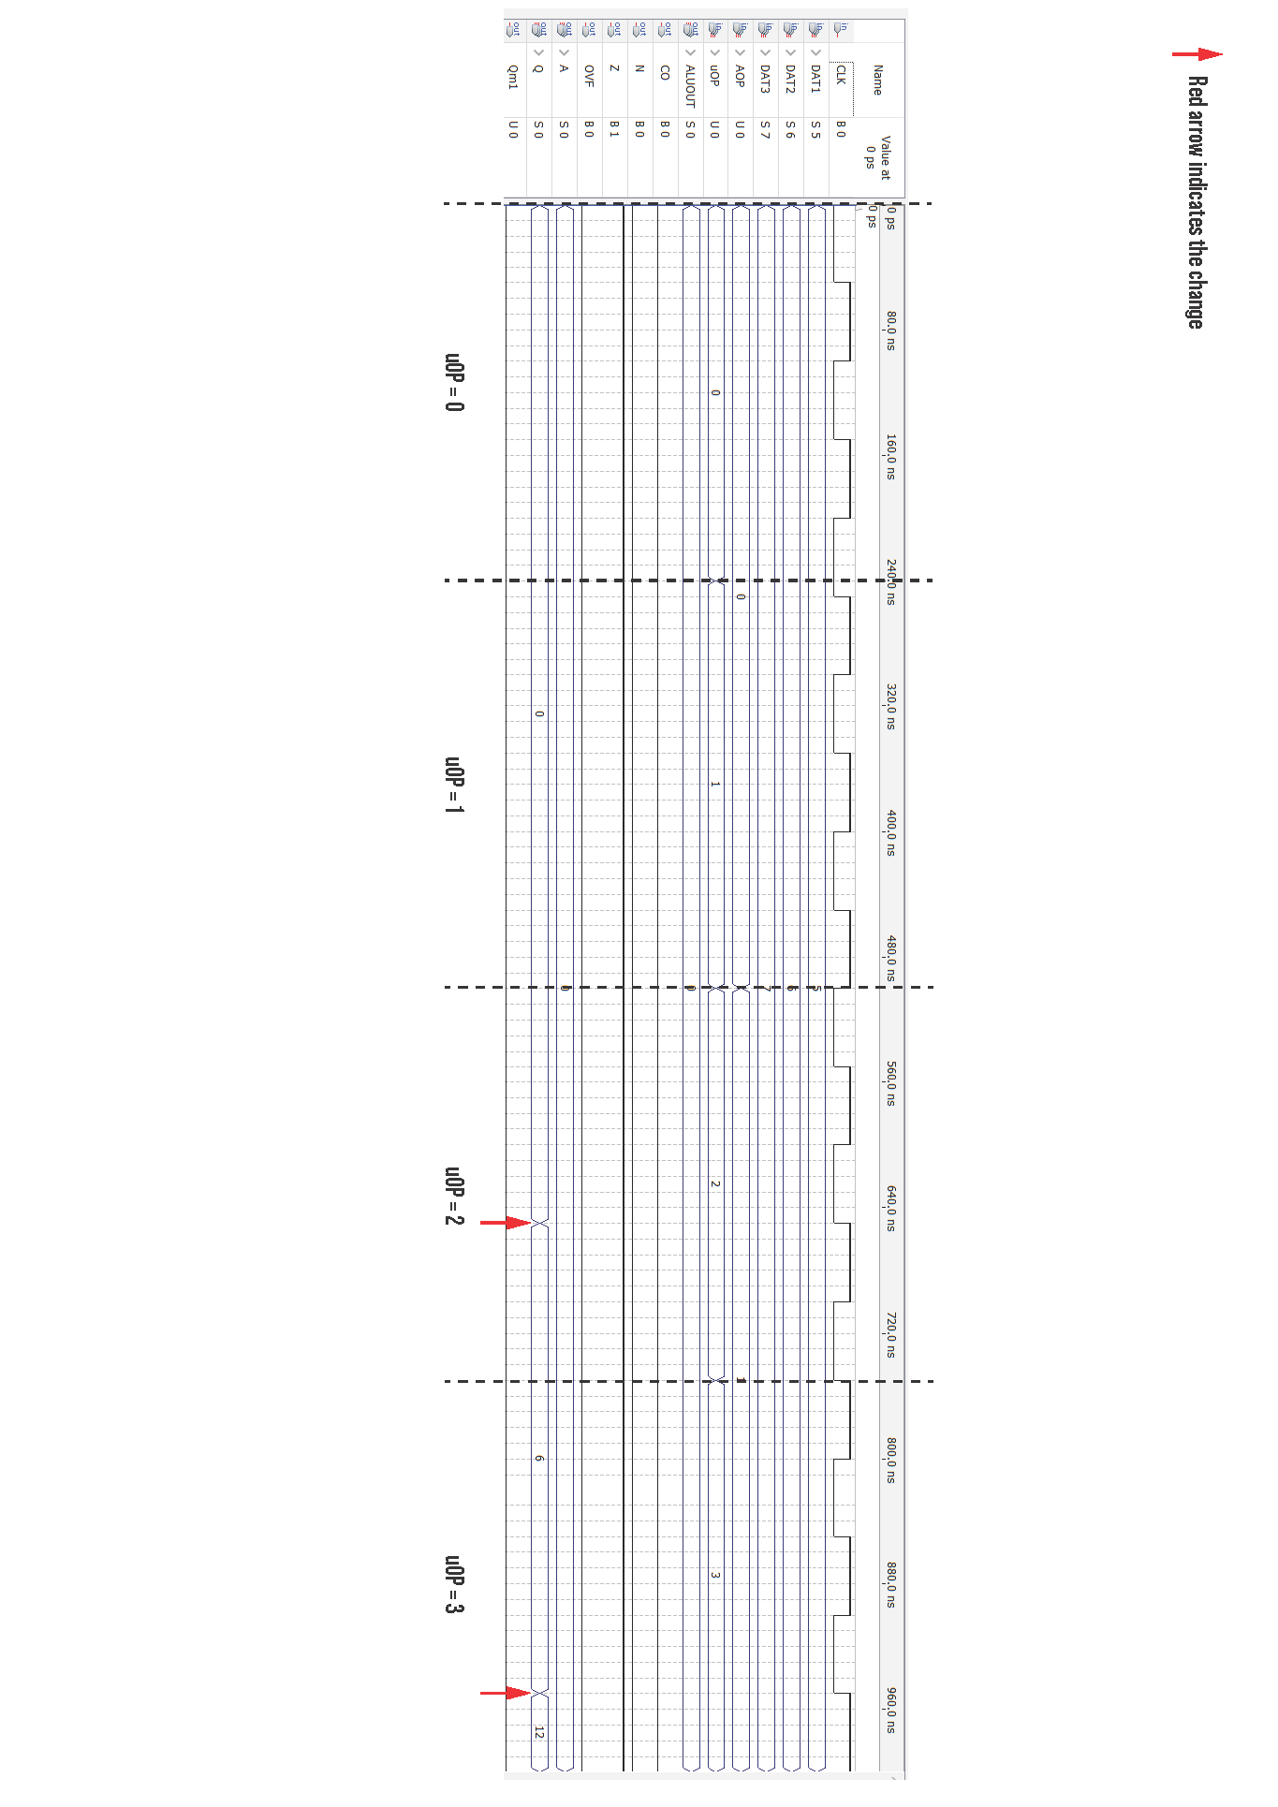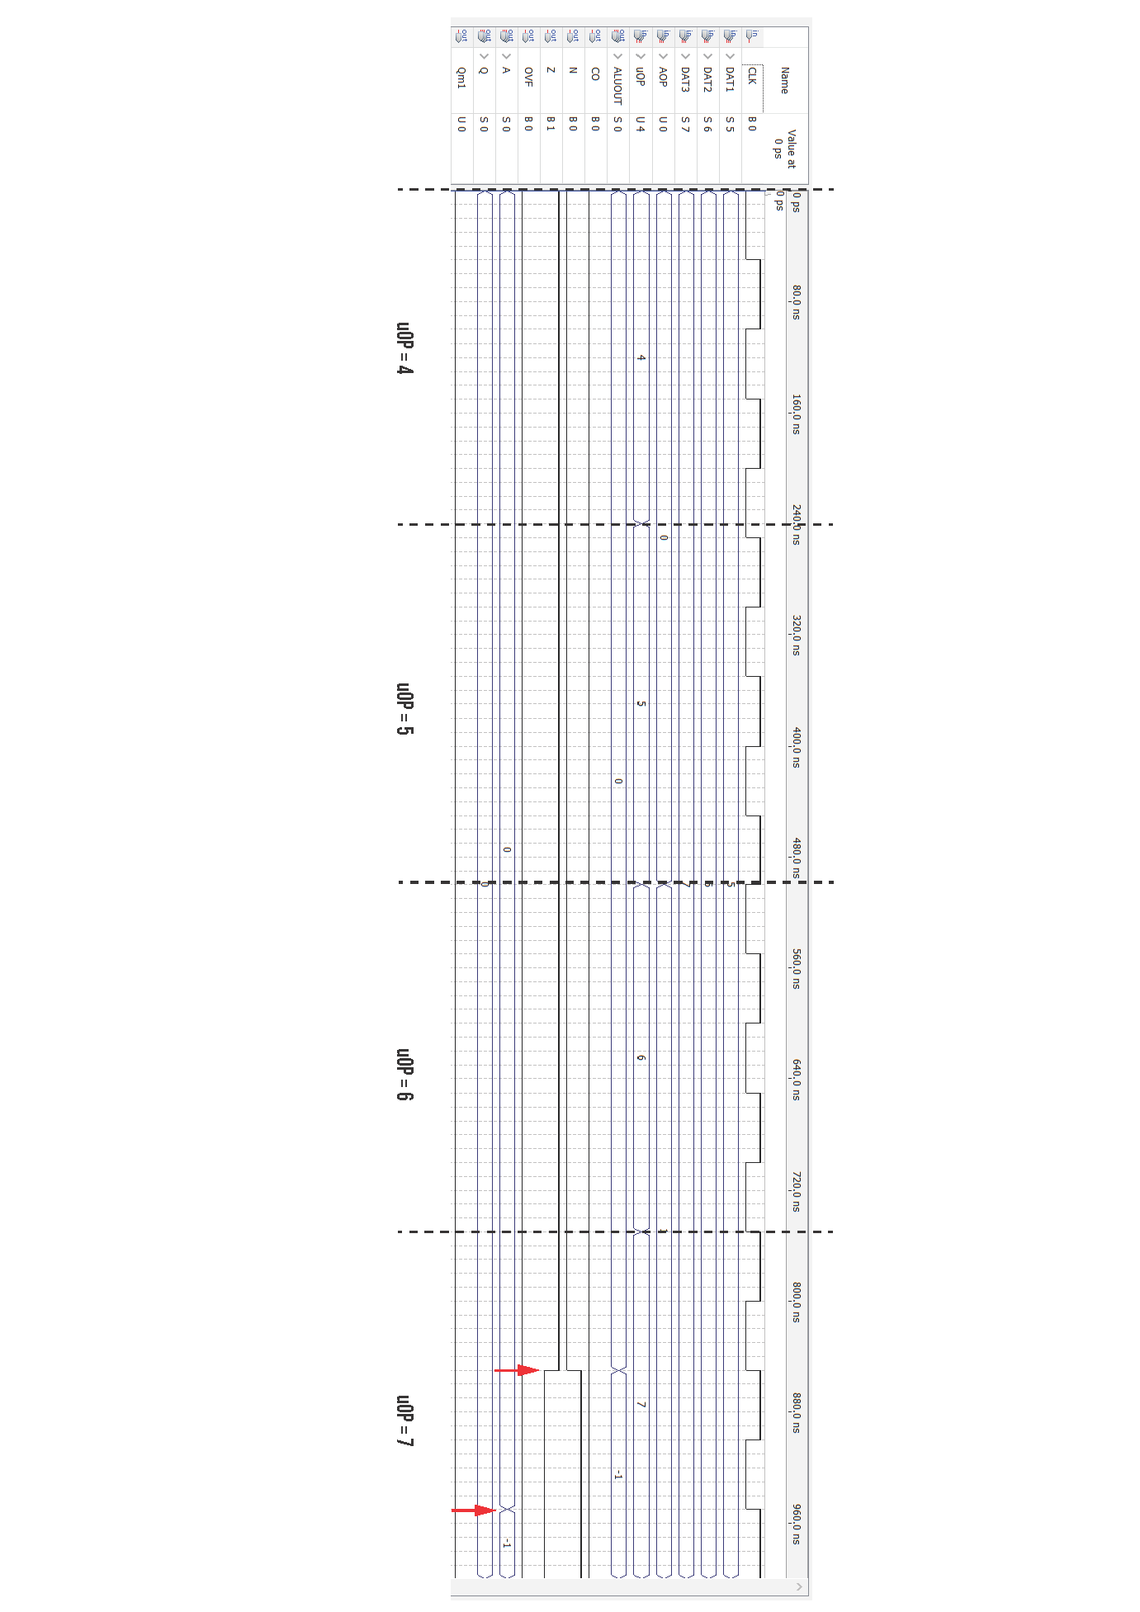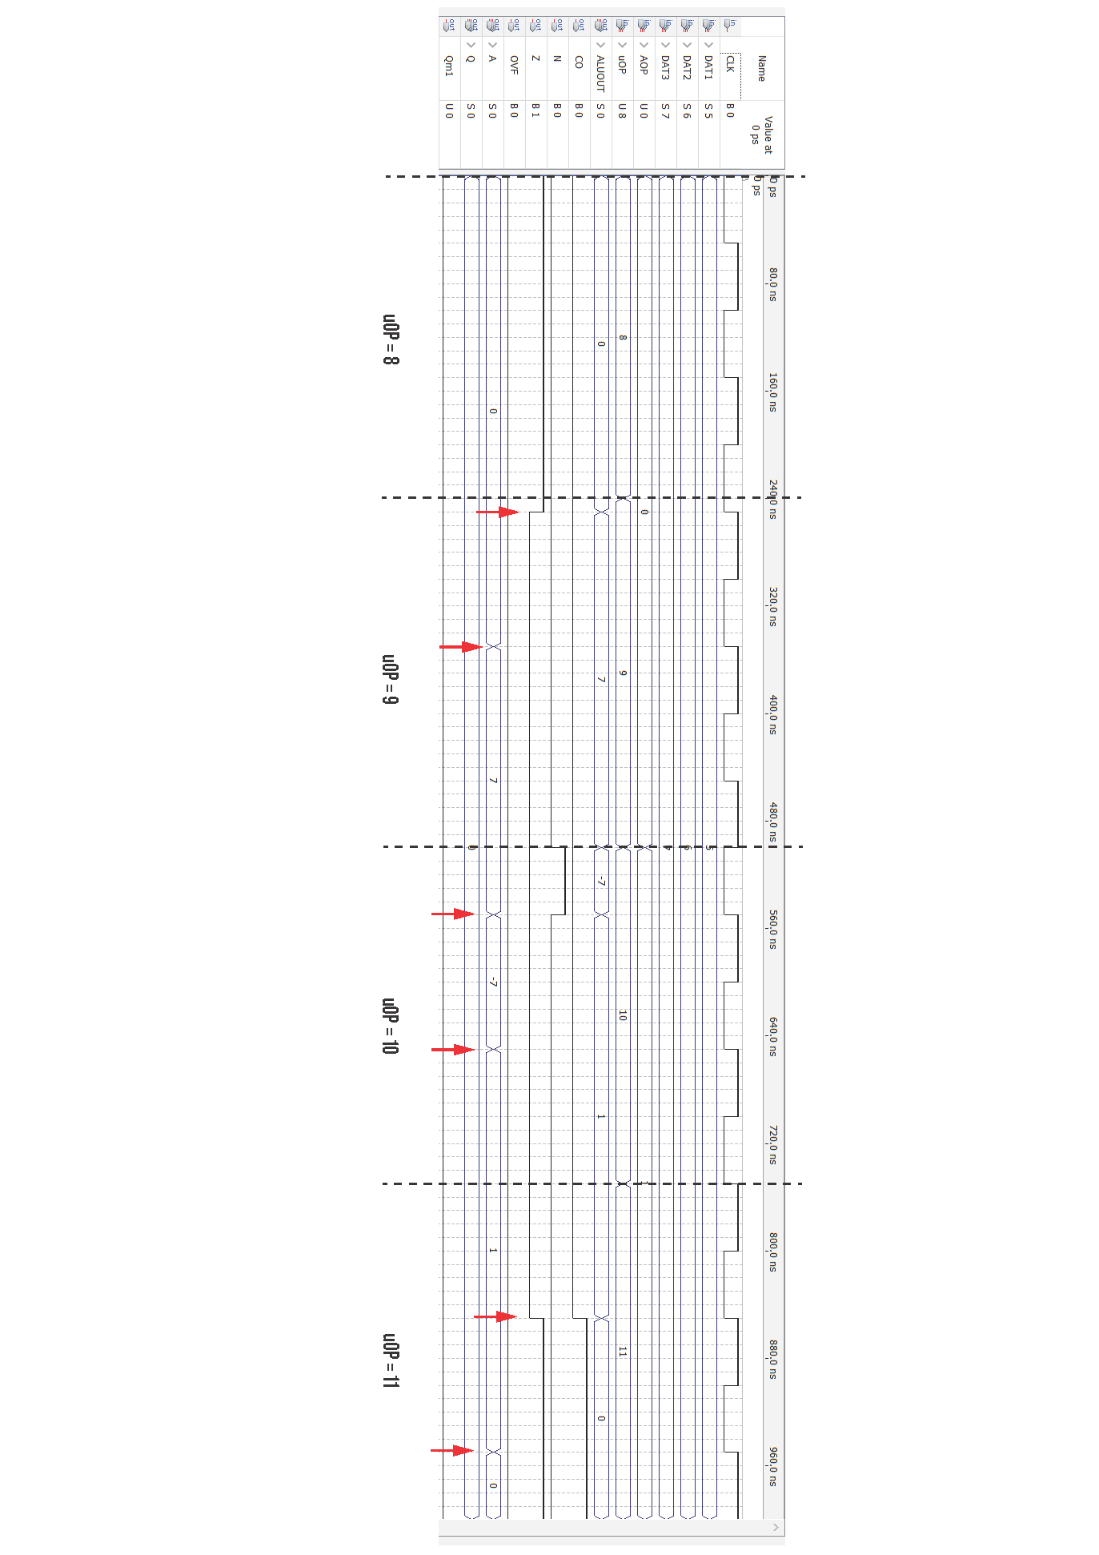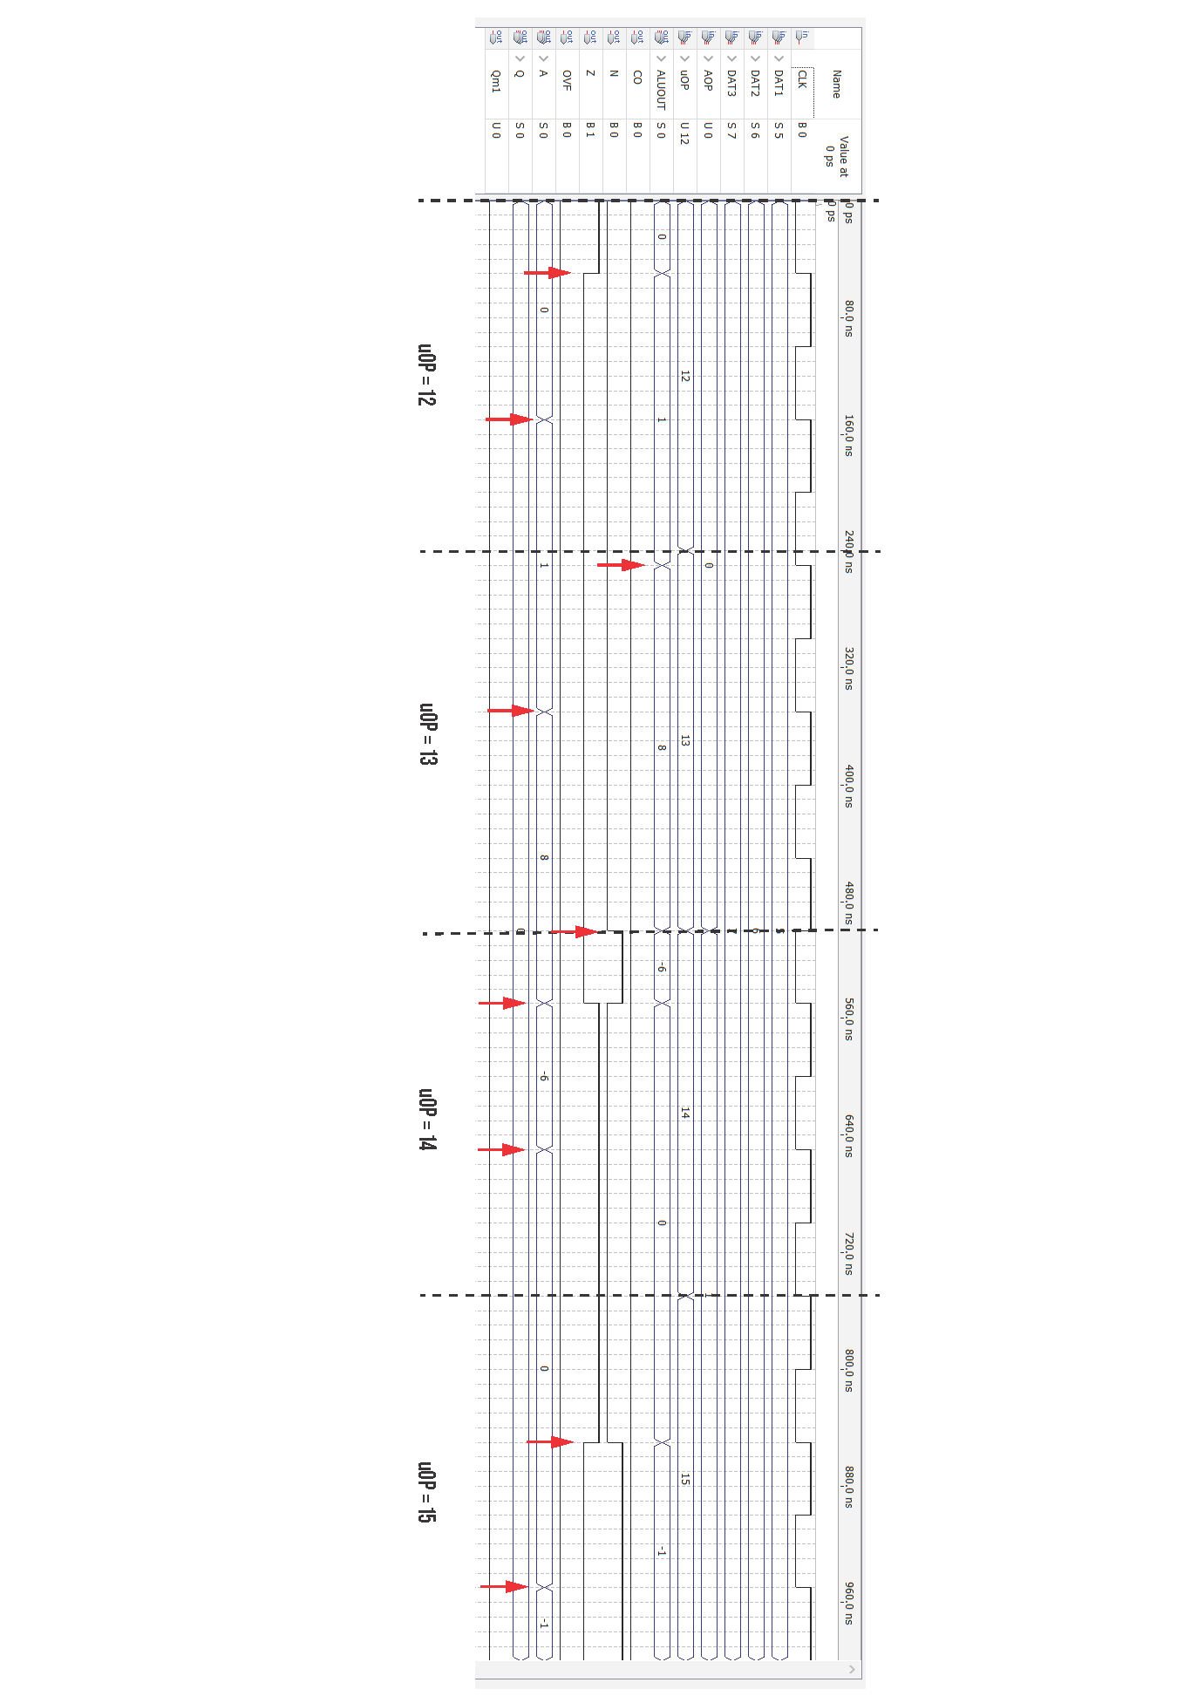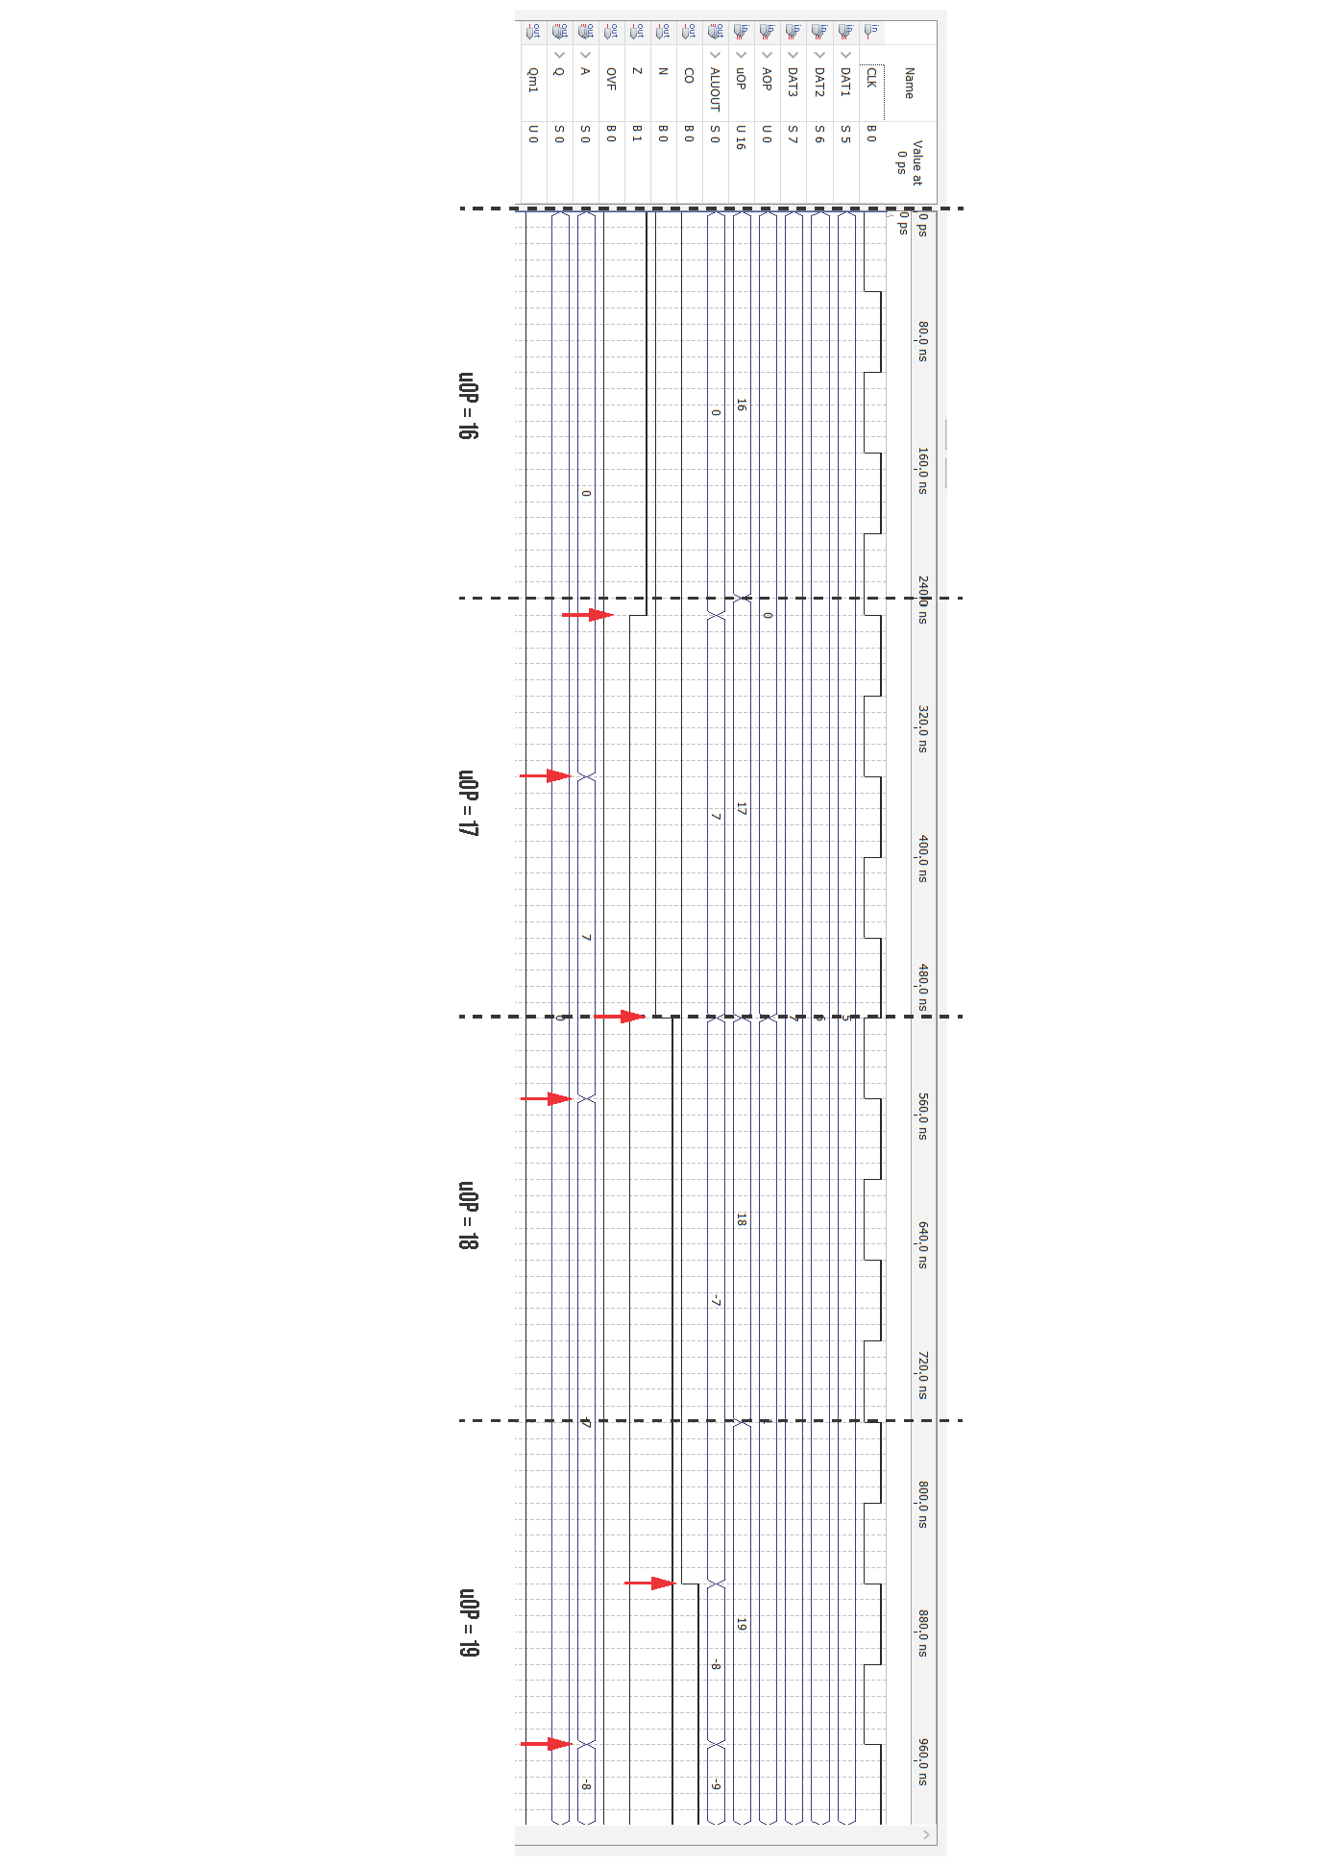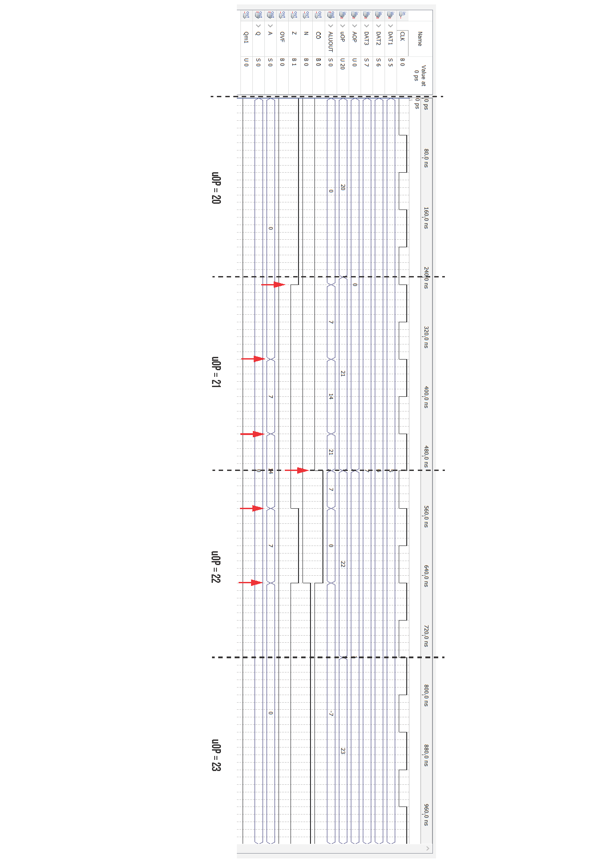

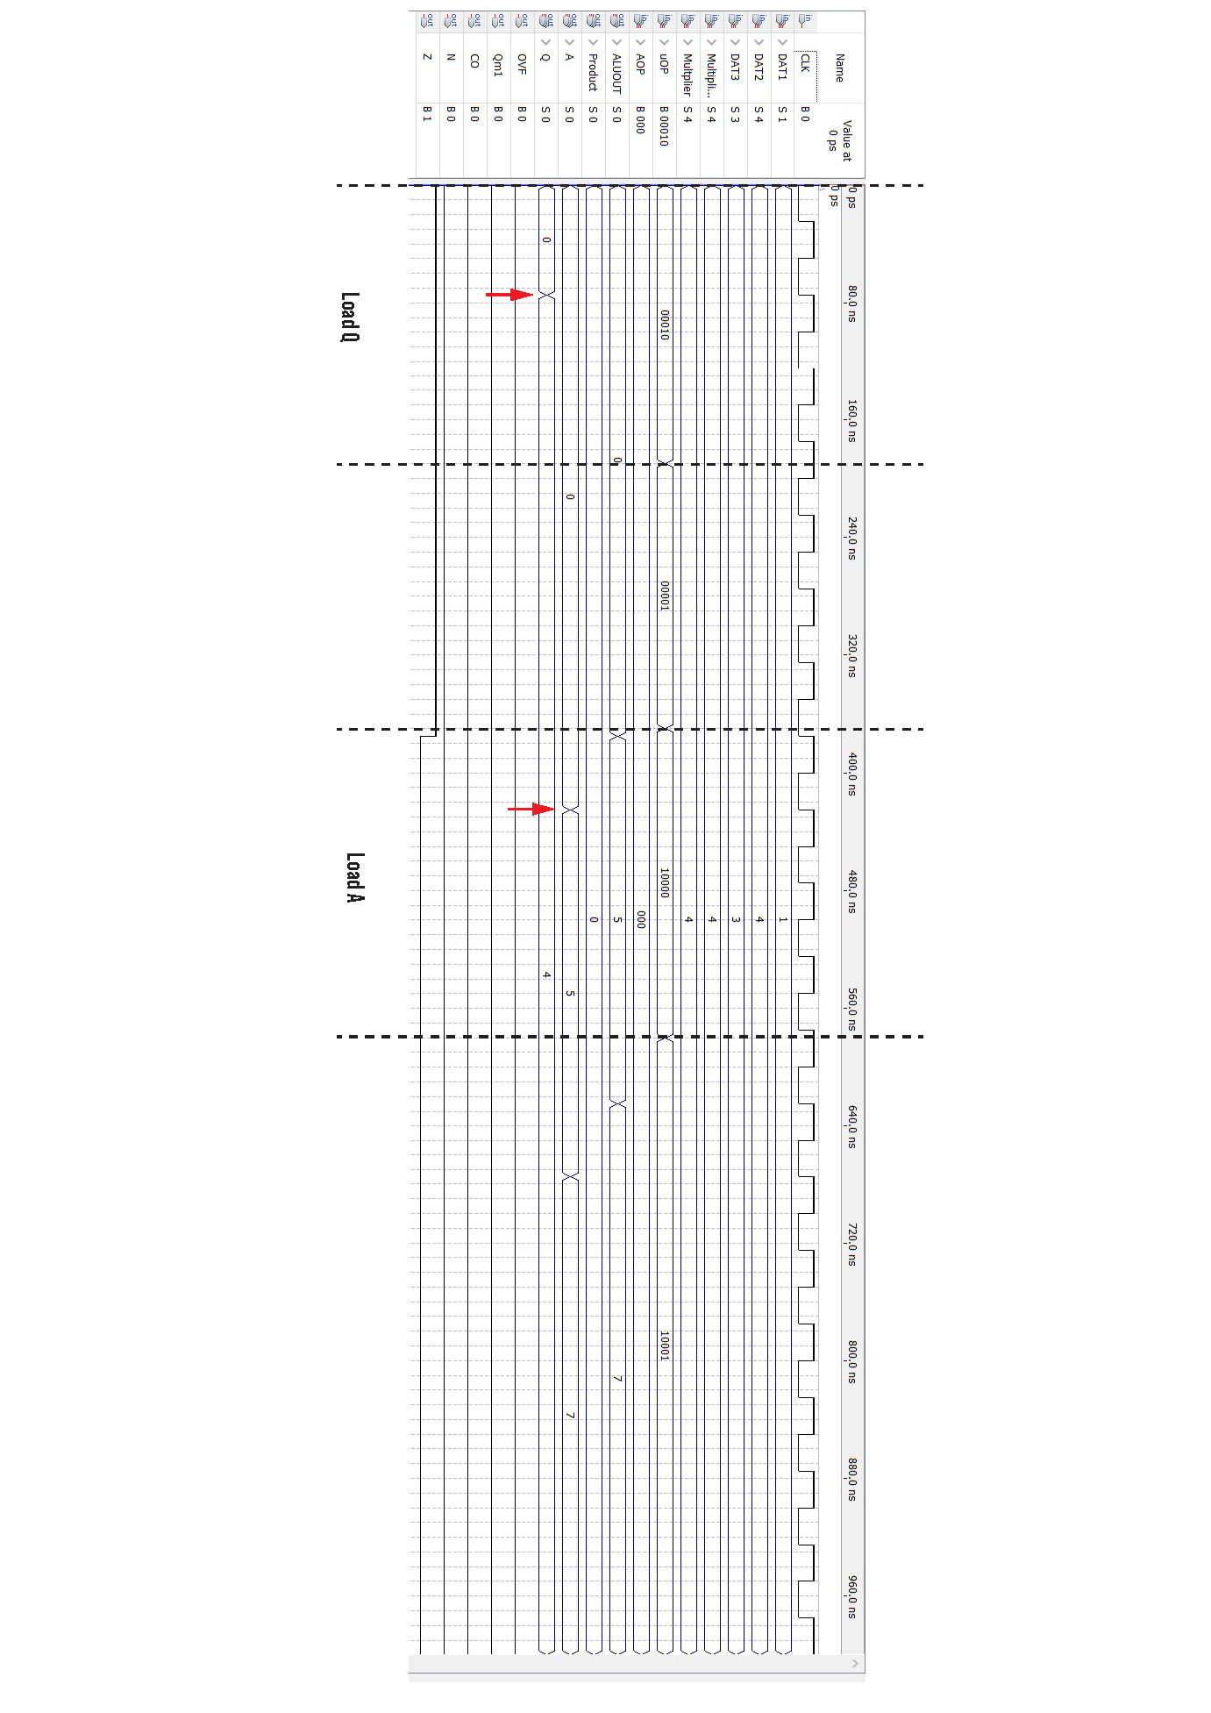

# Multiplication Simulation

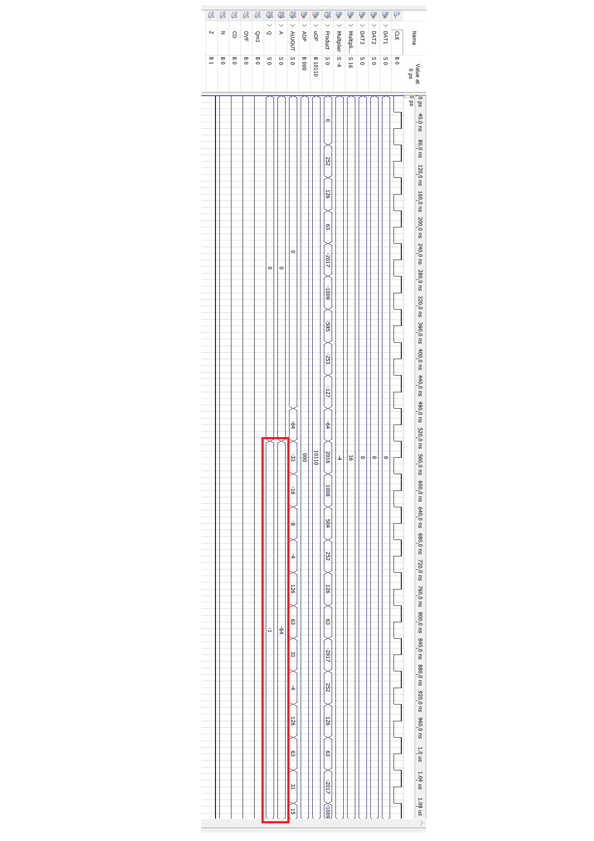

# State Diagram

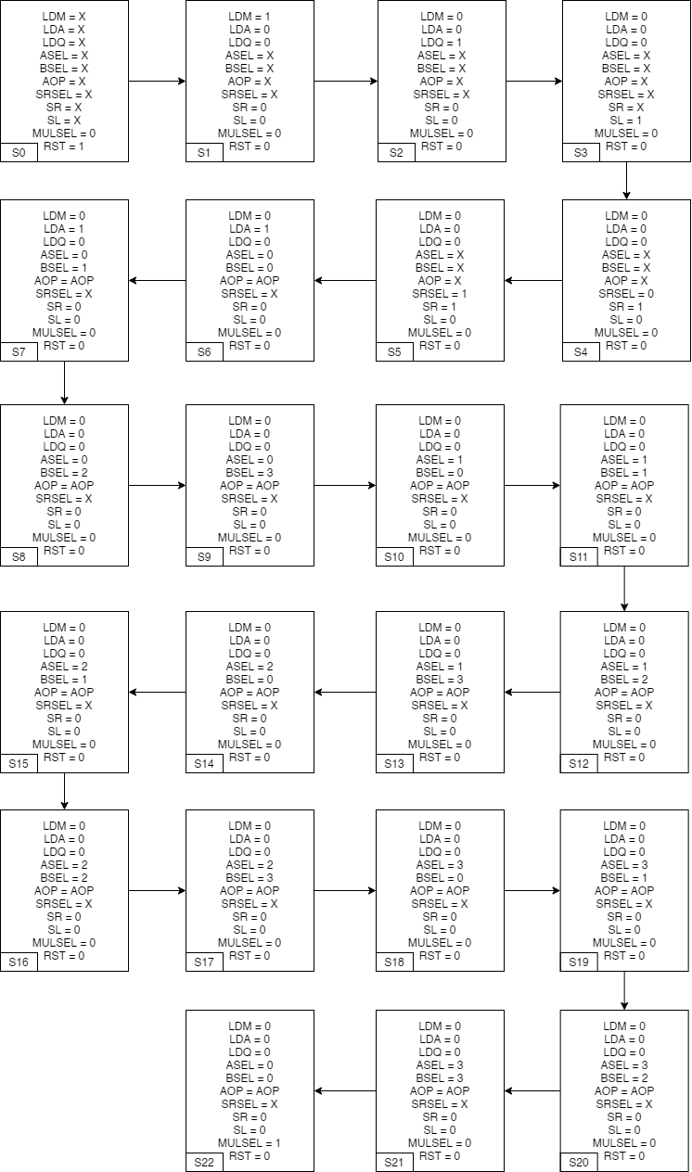

# Timing Analyzer Summary

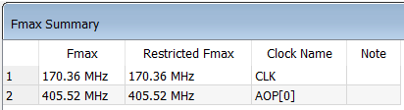

# Schematic Design Files

* Datapath

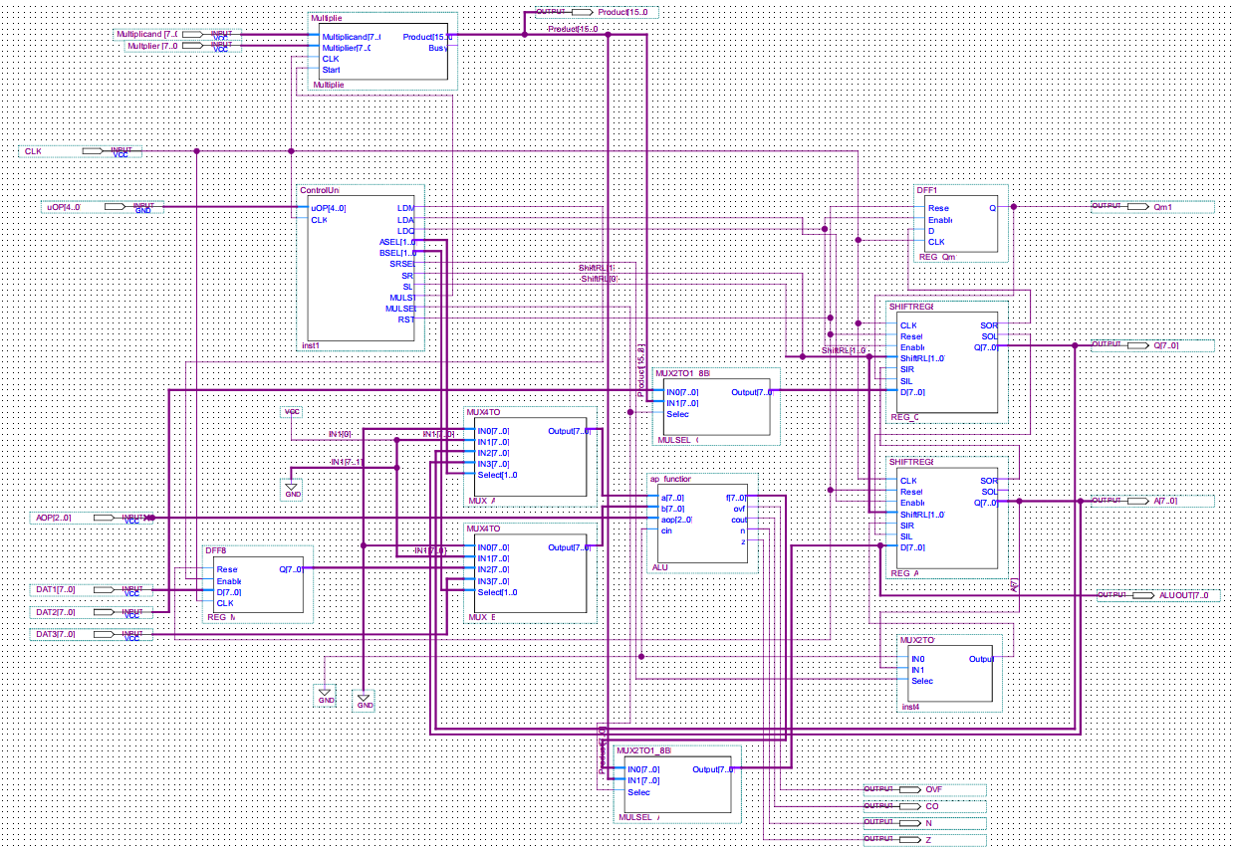

* Control unit

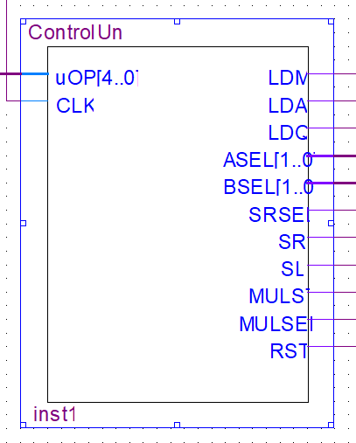

* Arithmetic Processor

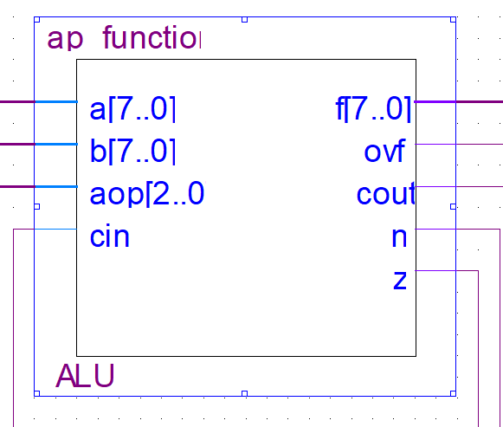

* Register A and Q

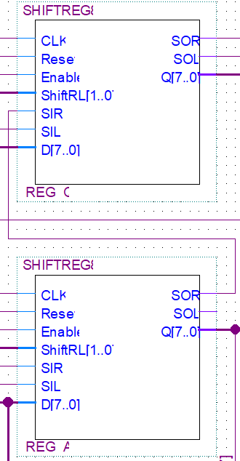

* 4 to 1 MUX

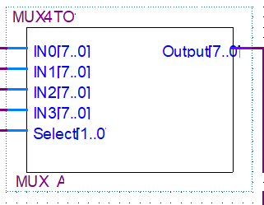

* Booth Multiplier

