Red arrow indicates the change

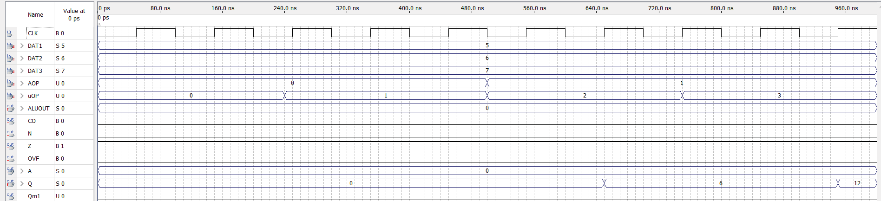

**uOP = 0**

**uOP = 1**

**uOP = 2**

**uOP = 3**

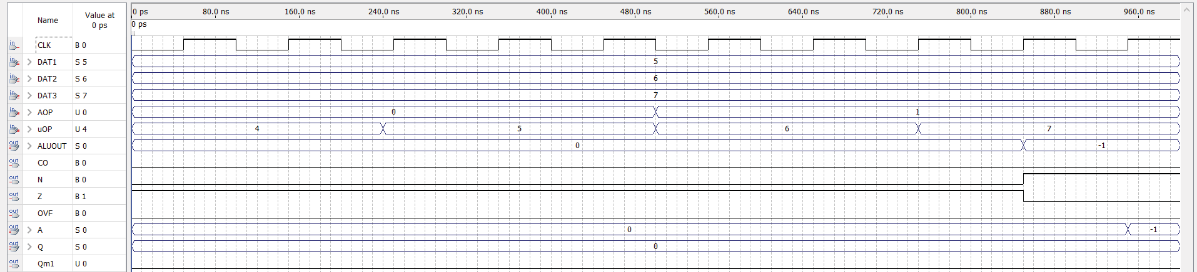

**uOP = 4**

**uOP = 5**

**uOP = 6**

**uOP = 7**

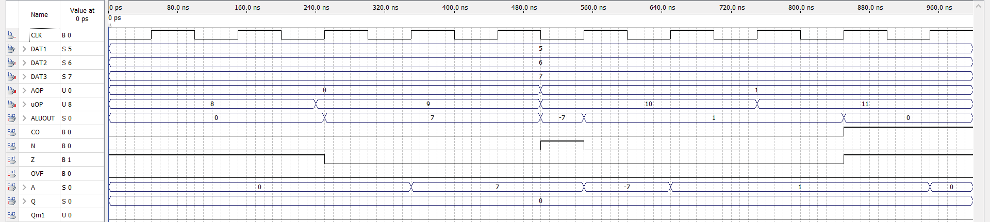

**uOP = 8**

**uOP = 9**

**uOP = 10**

**uOP = 11**

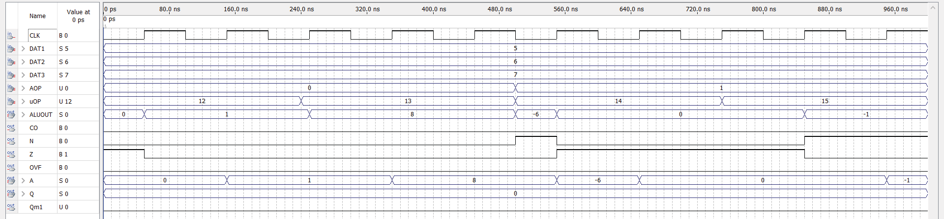

**uOP = 12**

**uOP = 13**

**uOP = 14**

**uOP = 15**

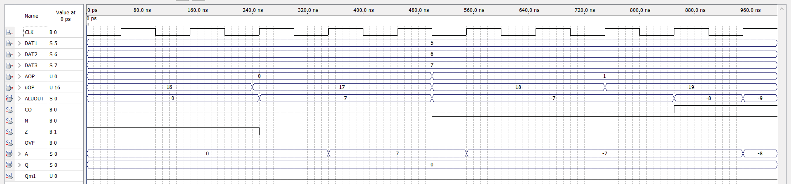

**uOP = 16**

**uOP = 17**

**uOP = 18**

**uOP = 19**

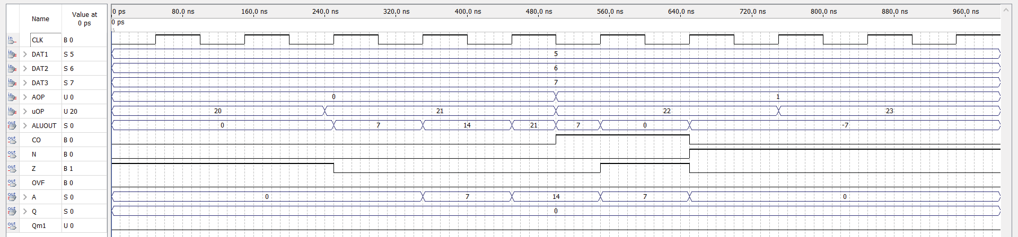

**uOP = 20**

**uOP = 21**

**uOP = 22**

**uOP = 23**