# New sequential and combinational blocks

## CONCANITATING

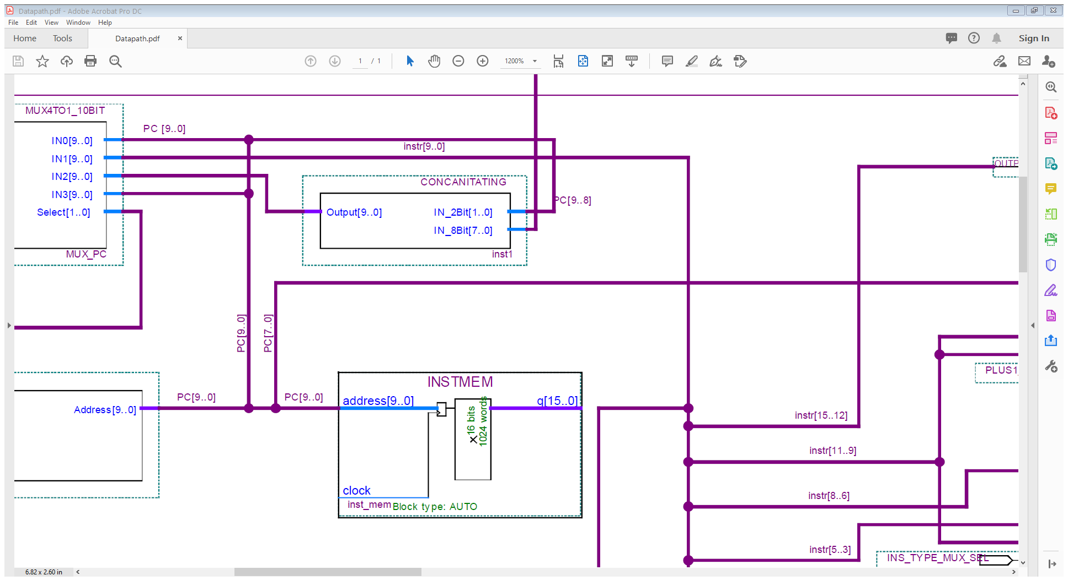

module CONCANITATING(IN_2Bit, IN_8Bit, Output);

input [1:0] IN_2Bit;

input [7:0] IN_8Bit;

output reg [9:0] Output;

always @ *

Output <= {IN_2Bit[1:0], IN_8Bit[7:0]};

Endmodule

## PCREG

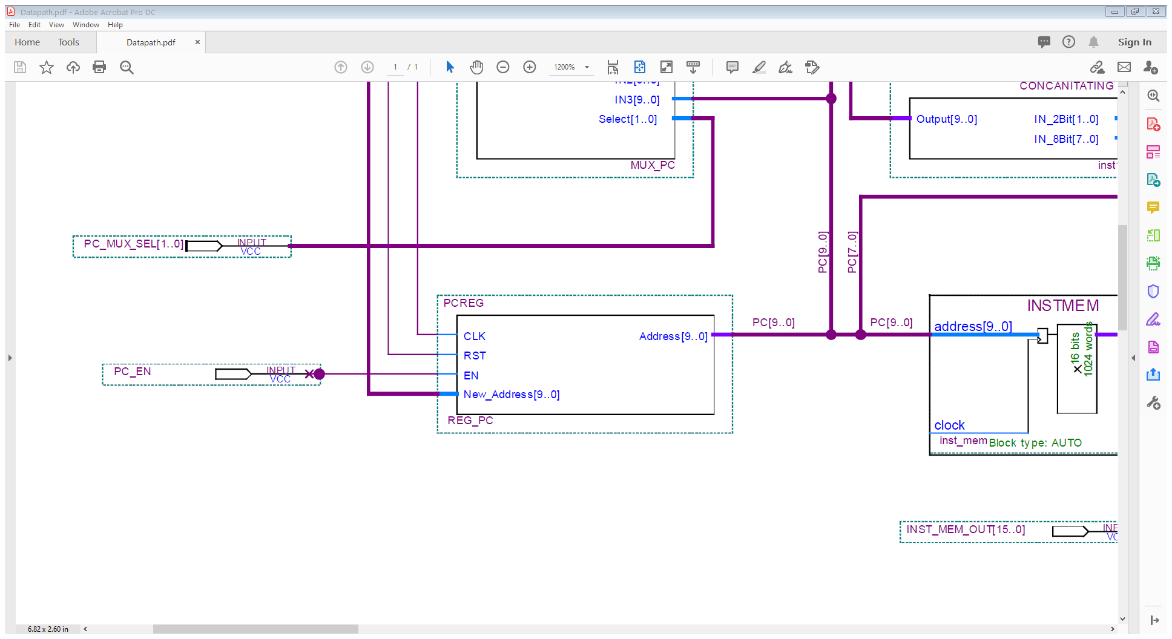

module PCREG(CLK, RST, EN, New_Address, Address);

input CLK, EN, RST;

input [9:0] New_Address;

output reg [9:0] Address;

always @(posedge CLK)

begin

if (RST)

Address <= 10'b0;

else

if (EN)

Address <= New_Address + 1;

end

endmodule

## PLUS1_ADDER

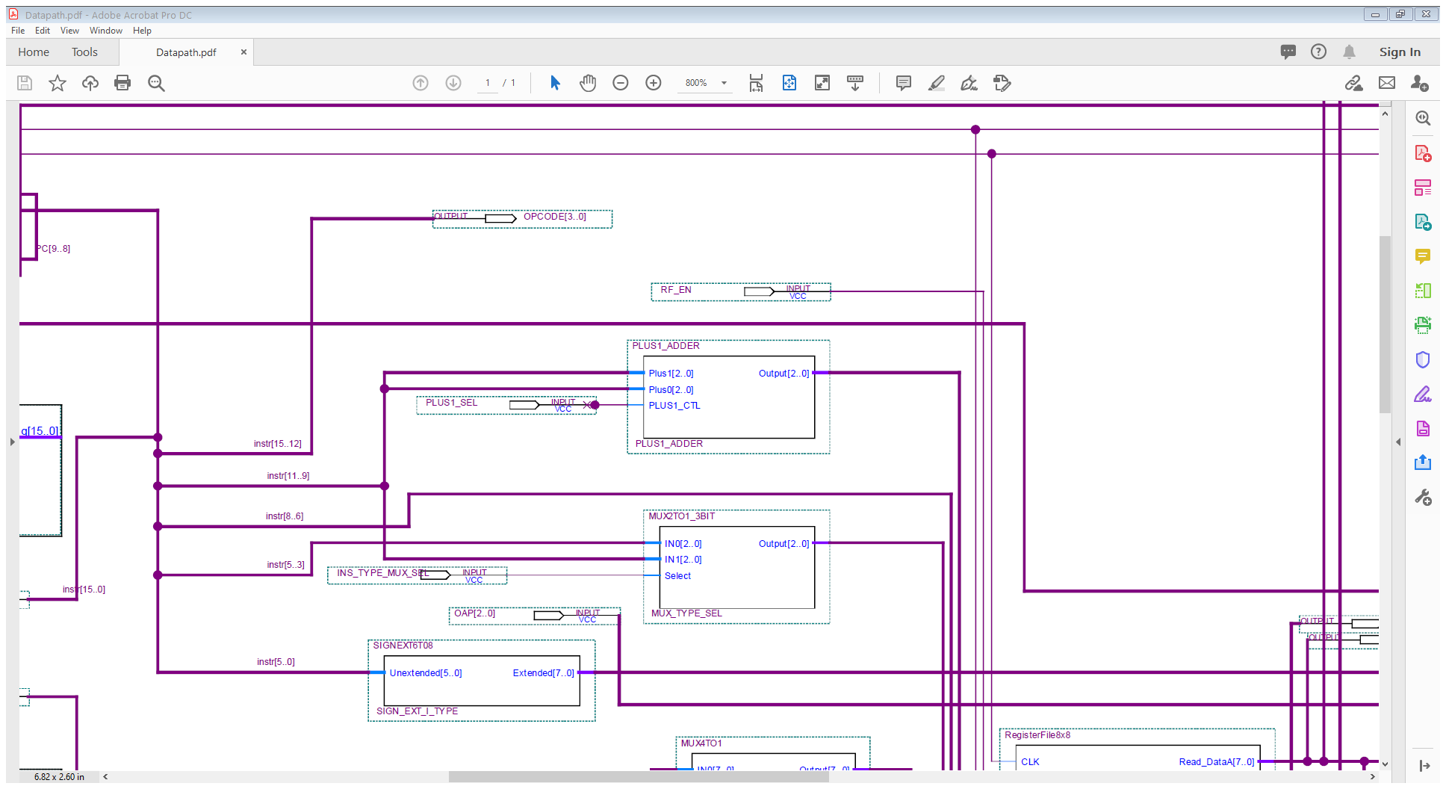

module PLUS1_ADDER(

input [2:0] Plus1,

input [2:0] Plus0,

input PLUS1_CTL,

output reg [2:0] Output

);

always@ *

begin

case (PLUS1_CTL)

1'b0 : Output = Plus0;

1'b1 : Output = Plus1 + 1;

endcase

end

endmodule

## SIGN_EXTENSION

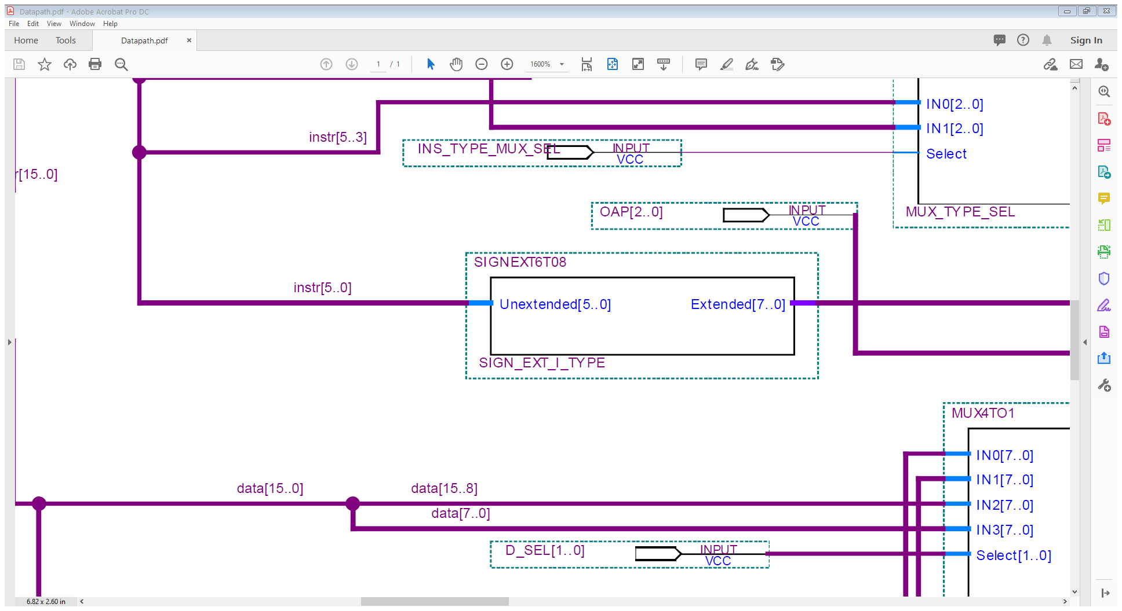

module SIGNEXT6T08(

input [5:0] Unextended,

output reg [7:0] Extended

);

always@ *

begin

Extended[7:0] <= { {2{Unextended[5]}}, Unextended[5:0] };

end

endmodule

## ROUTER

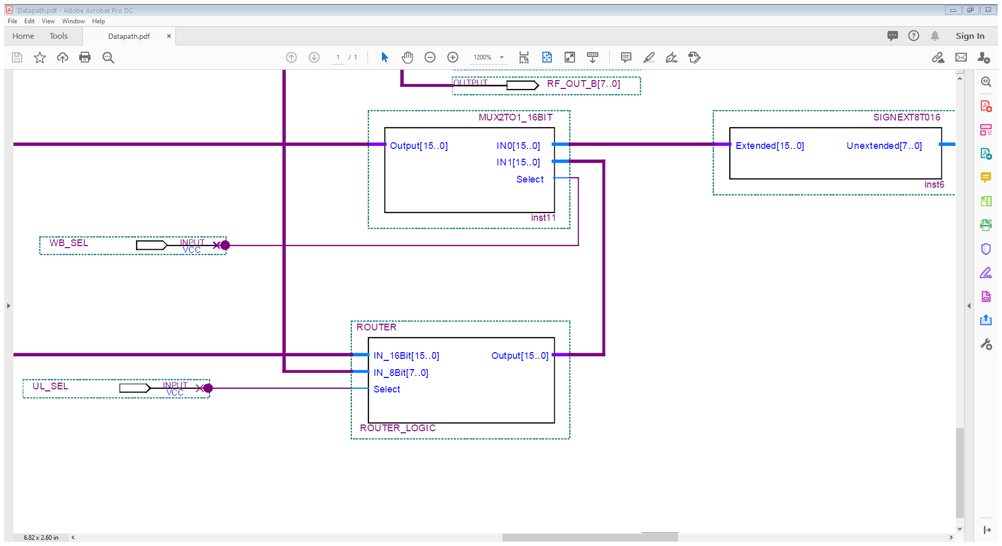

module ROUTER(IN_16Bit, IN_8Bit, Select, Output);

input [15:0] IN_16Bit;

input [7:0] IN_8Bit;

input Select ;

output reg [15:0] Output;

always @ *

case (Select)

1'b0 : Output <= {IN_16Bit[15:8], IN_8Bit[7:0]};

1'b1 : Output <= {IN_8Bit[7:0], IN_16Bit[7:0]};

endcase

endmodule