

**MIDDLE EAST TECHNICAL UNIVERSITY NORTHERN CYPRUS CAMPUS**

**ELECTRICAL AND ELECTRONICS ENGINEERING PROGRAM**

**EEE 446 Computer Architecture**

**Lab Module 4/5**

**MULTI-CYCLE CPU DESIGN w/ SPLIT INSTRUCTION AND DATA MEMORY**

|  |  |
| --- | --- |
| **Name, Surname** | Doğukan Fikri Arat |
| **Student ID** | 2079648 |
| **Name, Surname** | Saad Yousaf |
| **Student ID** | 2246536 |

# Objective

In this lab module, we were responsible for designing our complete CPU by using split Data and Instruction memories, all controlled and synchronized using a hardwired control unit. Our main aim was to obtain functionality of all our ISA instructions while minimizing the CPI. A front panel was also implemented to start and stop the CPU execution and choose between a free running and manual clock for debugging. We made modifications to our datapath to accommodate the few changes we made and fix some errors we encountered while testing the datapath in the previous module. The complete updated datapath is included in Appendix B. We tested all individual instructions to verify their functionality and the results have been reported in this report.

# High Level CPU Design

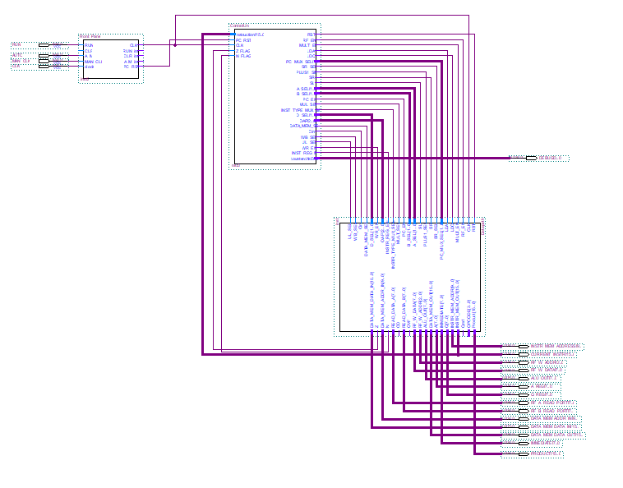

Figure 1: Complete CPU high-level design with front panel (Note: Hi-Res picture in Appendix A)

# MULTI-8 ISA complete list of instructions

|  |  |  |  |  |  |  |
| --- | --- | --- | --- | --- | --- | --- |
| Instruction | Type | Operands | Description | Operation | Opcode | OAP |
| ADD | R | Rd, Rs, Rt, Cin | Add two registers and a carry (Cin) | Rd <= Rs + Rt + Cin | 0 | 0 |
| ADDI | I | Rd, Rs, C | Add a register and a constant ( C ) | Rd <= Rs + C | 1 | X |
| SUB | R | Rd, Rs, Rt, Cin | Subtract two registers and a carry (Cin) | Rd <= Rs - Rt - Cin | 0 | 1 |
| AND | R | Rd, Rs, Rt | Logical AND two registers | Rd <= Rs ^ Rt | 0 | 4 |
| ANDI | I | Rd, Rs, C | Logical AND two registers and a constant ( C ) | Rd <= Rs ^ C | 2 | X |
| OR | R | Rd, Rs, Rt | Logical OR two registers | Rd <= Rs v Rt | 0 | 3 |
| DMADDR | J | C | Set most significant 2-bits of Data Memory Address to least significant 2-bits of constant ( C ) | DM_address[8:9] <= C [1:0] | 3 | X |
| XOR | R | Rd, Rs, Rt | Logical XOR two registers | Rd <= Rs ⊕ Rt | 0 | 6 |
| SLT | R | Rd, Rs, Rt | If Rs<Rt, Rd=1, else Rd=0. | Rs-Rt, Rd <= N (zero flag) | 0 | 5 |
| MUL | R | Rd, Rs, Rt | Multiply two registers | [Rd,Rd+1] <= Rs * Rt | 0 | 2 |
| DIV | R | Rd, Rs, Rt | Divide two registers | Rs / Rt, [Rd,Rd+1] <= [Q, A] | 0 | 7 |
| SLL | I | Rd, Rs, C | Logical shift left Rs and save into Rd with constant amount ( C ) | Rd <= Rs << C | 4 | X |
| SRL | I | Rd, Rs, C | Logical shift right Rs and save into Rd with constant amount ( C ) | Rd <= Rs >> C | 5 | X |
| SRA | I | Rd, Rs, C | Arithmetic shift right Rs and save into Rd with constant amount ( C ) | Rd <= Rs >> C | 6 | X |
| LW | I | Rd, Rs, C | Load 16-bit word from data memory | [Rd,Rd+1] <= MEM [Rs + C] | 7 | X |
| LWU | I | Rd, Rs, C | Load upper byte from data memory location | [Rd, -] <= MEM [Rs + C] | 8 | X |
| LWL | I | Rd, Rs, C | Load lower byte from data memory location | [-, Rd] <= MEM [Rs + C] | 9 | X |
| SW | I | Rd, Rs, C | Store 16-bit word to data memory | MEM [Rs + C] <= [Rd,Rd+1] | 10 | X |
| SWU | I | Rd, Rs, C | Store 8-bit data to upper byte of data memory location | MEM [Rs + C] <= [Rd, -] | 11 | X |

Table 1: List of Instructions

|  |  |  |  |  |  |  |
| --- | --- | --- | --- | --- | --- | --- |
| Instruction | Type | Operands | Description | Operation | Opcode | OAP |
| SWL | I | Rd, Rs, C | Store 8-bit data to lower byte of data memory location | MEM [Rs + C] <= [-,Rd] | 12 | X |
| BREQ | I | Rd, Rs, D | Branch if Rd equals Rs | if Rs-Rd=0, i.e. Z=1, PC <= PC + D | 13 | X |
| BRNE | I | Rd, Rs, D | Branch if Rd not equal to Rs | if Rs-Rd!=0, i.e. Z=0, PC <= PC + D | 14 | X |
| JUMP | J | D | Jump to address location (C) | PC <= PC+C | 15 | X |
| * D is the branch Destination Address, calculated by counting the number of addresses we want to branch less 1.  *C is the jump destination address | | | | | | |

Table 1: List of Instructions

# MULTI-8 Instruction formats:

|  |  |  |  |  |
| --- | --- | --- | --- | --- |
| R-TYPE | | | | |
| 4-bit | 3-bit | 3-bit | 3-bit | 3-bit |
| OPCODE (Op) | DESTINATION (Rd) | SOURCE_1 (Rs) | SOURCE_2 (Rt) | OAP |
|  |  |  |  |  |
| I-TYPE | | | | |
| 4-bit | 3-bit | 3-bit | 6-bit | |
| OPCODE (Op) | DESTINATION (Rd) | SOURCE_1 (Rs) | CONSTANT ( C ) | |
|  |  |  |  |  |
| J-TYPE | | | | |
| 4-bit | 12-bit | | | |
| OPCODE (Op) | CONSTANT ( C ) | | | |

Table 2: Different instruction types supported by MULTI-8 ISA

# MULTI-8 control unit transitions

RUN deserted to show functionality of front panel. Upon reassertion it resumes from last state

## J-type Instructions

Example: Jump instruction: **J 100 (11110000000100)** (i.e. jump to instruction memory address 100)

C

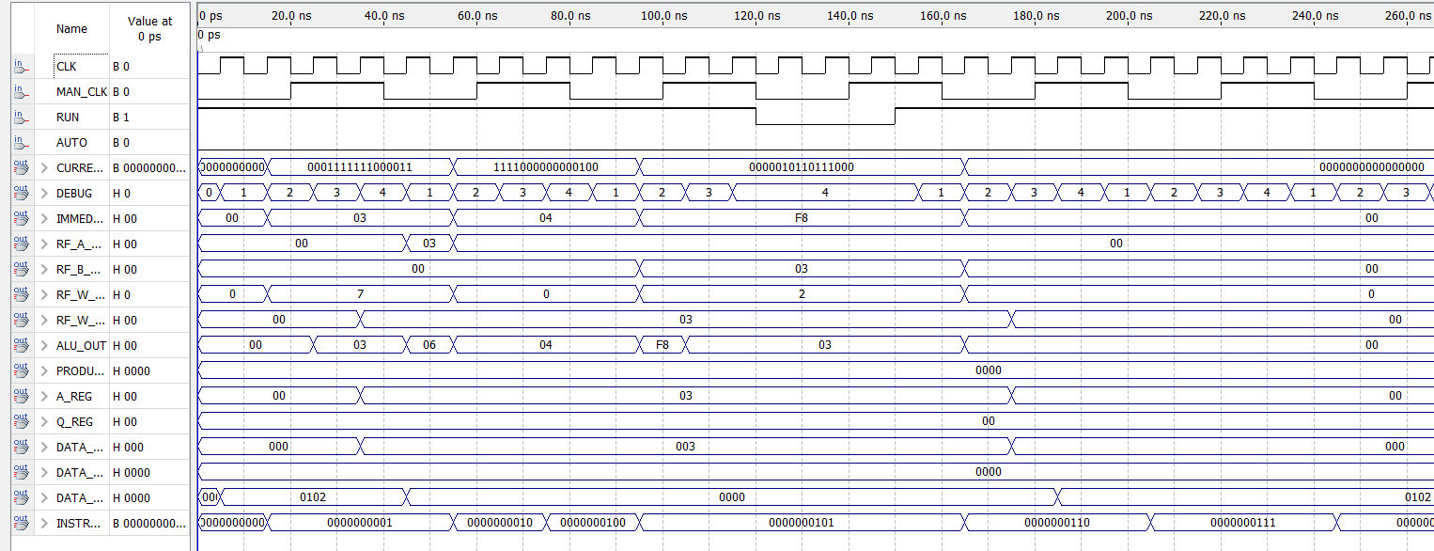

The next instruction at the jump target address 0000000100 fetched

Fetches the jump instruction at address 0000000001 and increment PC to point to next instruction at address 0000000010 in the decode cycle

The PC is now fed the jump target address and once execution is done the next instruction at the jump target is fetched

Figure 2: J type instruction state transitions

## I-type Instructions

Example: Add immediate instruction: **ADDI R7,R7,2 (0001111111000010) (R7=0 initially)** (Add 2 to register 7 and store to register 7)

Reads from source register and adds immediate to it in execute stage

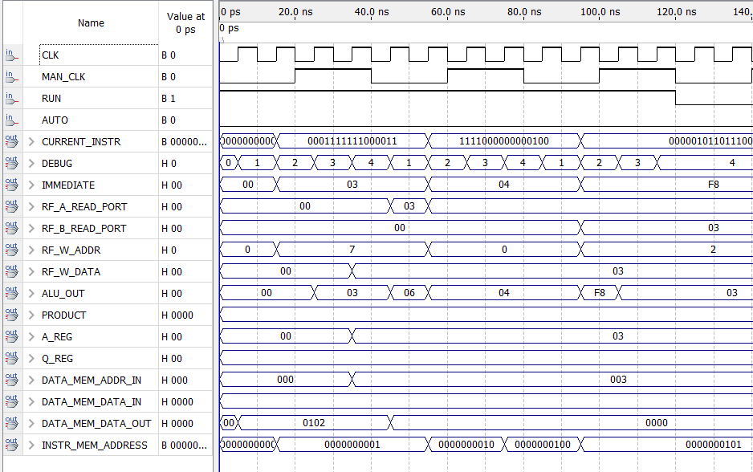

The result is then written back to destination register

Fetches the ADDI instruction at address 0000000000 and increment PC to point to next instruction at address 0000000001 in the decode cycle

Figure 3: I type instruction state transitions (Immediate)

Example: Conditional Branch: **ADDI R7,R7,2 (0001111111000010) (R7=0 initially)** (Add 2 to register 7 and store to register 7)

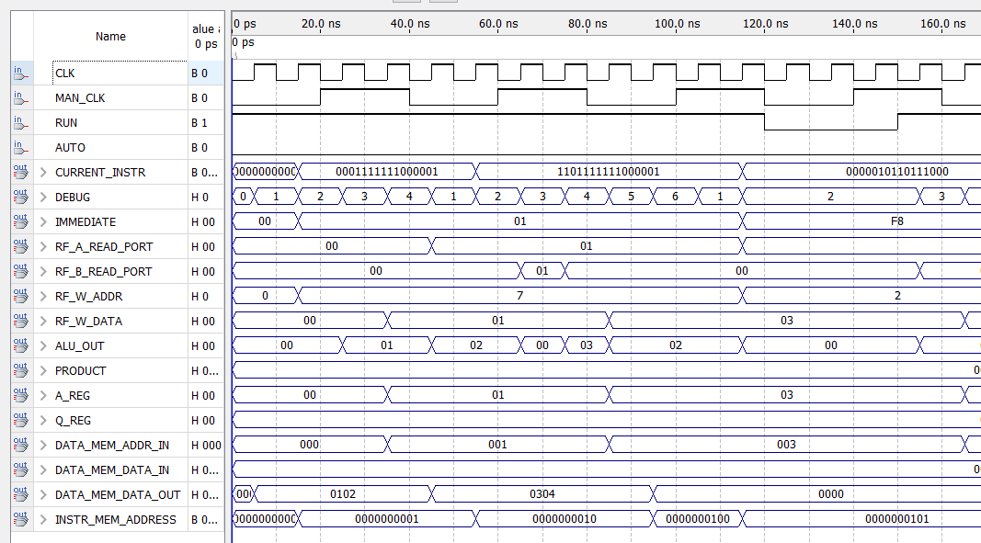

Figure 4: I type instruction state transitions (Conditional Branch)

## R-type Instructions

Example: Add instruction: **ADD R7,R7,2 (0001111111000010) (R7=0 initially)** (Add 2 to register 7 and store to register 7)

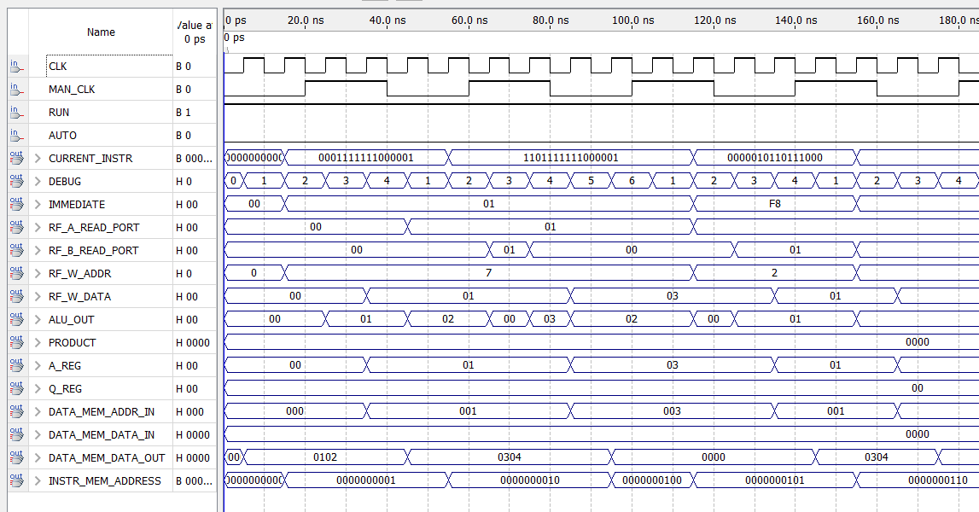

Figure 5: R type instruction state transitions (Conditional Branch)

# Sample code sequence simulation

ADDI $S0, $S0, 12 # $S0 = 12

ADDI $S1, $S1, 2 # $S1 = 2

SUB $S2, $S0, $S1 # $S2 = 10

SW $S2, $S1, 0 # MEM[2] = 000A

LW $S3, $S1, 0 # $S3,$S4 = MEM[2]

BREQ $S3, $S2, 16 # PC = 16

JMP 3 # PC = 3 (@ PC = 16)

