

CARBON EMISSION CALCULATOR
A Project Report
on
CARBON EMISSION CALCULATOR
Submitted in partial fulfillment of the requirements for the course
Object-Oriented Programming using C++
Submitted by:
Name: Shivam Koshyari
Roll No: 23BCA10050
Department: UIC
Institution: Chandigarh University
Submitted To:
Ms Disha Sachdeva

ABSTRACT

The Carbon Emission Calculator is a comprehensive C++-based software project aimed at estimating an individual’s monthly carbon footprint through an analysis of transportation, electricity usage, and dietary patterns. This program is built on the foundation of object-oriented programming principles such as modularity, abstraction, and file handling. By utilizing real-world emission conversion factors, the system provides an accurate estimate of a user’s environmental impact.
This project bridges environmental awareness with computer programming by allowing users to interactively calculate their CO₂ emissions. It demonstrates key C++ concepts like conditional branching, loops, functions, and data persistence through file storage. Furthermore, it enhances social consciousness by promoting sustainable practices. The system not only serves as a technical exercise but also as a tool for spreading awareness about the importance of reducing carbon emissions for a greener planet.
The calculator operates in three main phases — data collection (Input Module), computation (Processing Module), and report generation (Output Module) — making it logically structured and easy to expand. It represents a simple yet powerful integration of technology and sustainability, encouraging users to take small but meaningful steps toward a cleaner future.

INTRODUCTION

Climate change is one of the most critical challenges faced by humanity today. The increasing concentration of greenhouse gases, particularly carbon dioxide (CO₂), in the atmosphere has led to rising global temperatures, erratic weather patterns, and severe ecological imbalances. While large-scale industries and transportation networks are major contributors, individual carbon footprints also play a significant role in the overall emissions scenario.
In this context, the Carbon Emission Calculator provides an accessible means for individuals to assess and understand their personal contributions to carbon emissions. The program uses a console-based interface where users input data about their daily habits—such as kilometers traveled, electricity usage, and dietary choices. The system then computes and displays the total emissions in kilograms of CO₂ per month, along with helpful feedback and recommendations for sustainable living.
The project illustrates how programming can be applied to solve real-world problems. It employs C++ features like conditional logic, modular programming, mathematical operations, and file handling. The end result is a functional, educational tool that not only fulfills the technical requirements of the course but also addresses a pressing global issue: environmental sustainability.

PROBLEM STATEMENT AND OBJECTIVES

Problem Statement
In today’s world, while discussions about sustainability and carbon reduction are common, many individuals lack the means to quantitatively assess their environmental impact. Without such understanding, it becomes difficult for people to modify their habits or track improvement over time. Hence, there is a need for a simple, interactive, and informative application that can compute and present personalized carbon emission data effectively.
Objectives
The main objectives of this project are:
- Develop a user-interactive C++ application to estimate an individual's carbon footprint.
- Integrate file handling to allow saving of user reports for record-keeping.
- Provide detailed category-wise analysis covering transport, electricity, and diet.
- Generate eco-friendly suggestions based on the results obtained.
- Implement modular programming and OOP concepts to ensure reusability and scalability.
- Enhance environmental awareness by helping users understand the consequences of their daily choices.
By achieving these objectives, the project encourages behavioral change through awareness, allowing users to take informed steps toward minimizing their environmental impact.

SYSTEM DESIGN AND APPROACH

The system design is divided into three key modules, each performing a distinct role while maintaining interconnectivity and data flow consistency.
- Input Module
  - This module is responsible for collecting user data, including:
    - Daily travel distance and vehicle type.
    - Monthly electricity consumption in kWh.
    - Dietary preference (Vegetarian, Non-Vegetarian, Vegan).
  - Input validation ensures that incorrect or negative values are handled gracefully.
- Processing Module
  - This component performs all mathematical computations using standard CO₂ emission factors.
  - The data collected from the user is processed using arithmetic formulas:
    - Transport CO₂ = Distance × Emission Factor × 30
    - Electricity CO₂ = Units × 0.85
    - Diet CO₂ = Fixed category-wise value (150–300 kg/month)
  - Finally, all emissions are summed to produce the total monthly footprint.
- Output Module
  - This module handles result presentation and data storage.
  - The output includes:
    - Emission breakdown by category.
    - Total emission in kilograms of CO₂.
    - A personalized sustainability message.
    - File handling (saving results to carbon_report.txt).
- 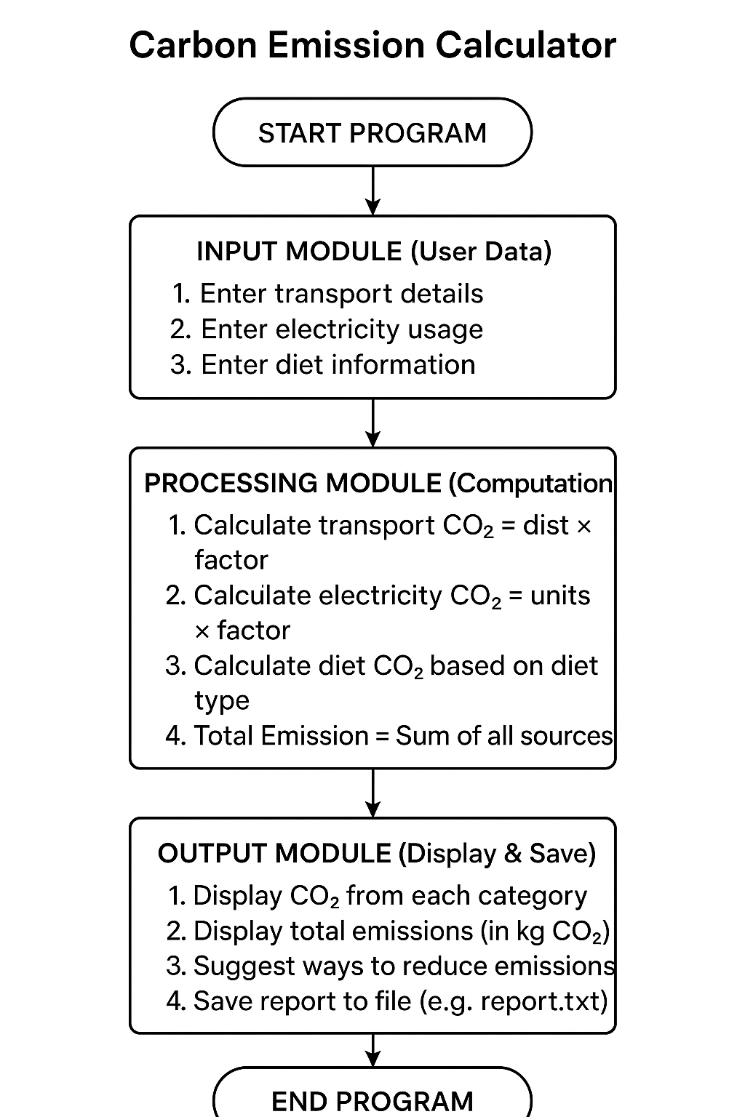

IMPLEMENTATION

The implementation was done in C++ using basic and intermediate programming concepts. The project consists of three major functions: transportEmission(), electricityEmission(), and dietEmission(). These are combined in the main() function, where calculations are performed and final results displayed.
Key Features Implemented:
- Conditional Statements (if, else-if, switch)
- Modular Functions
- File Handling (ofstream for saving reports)
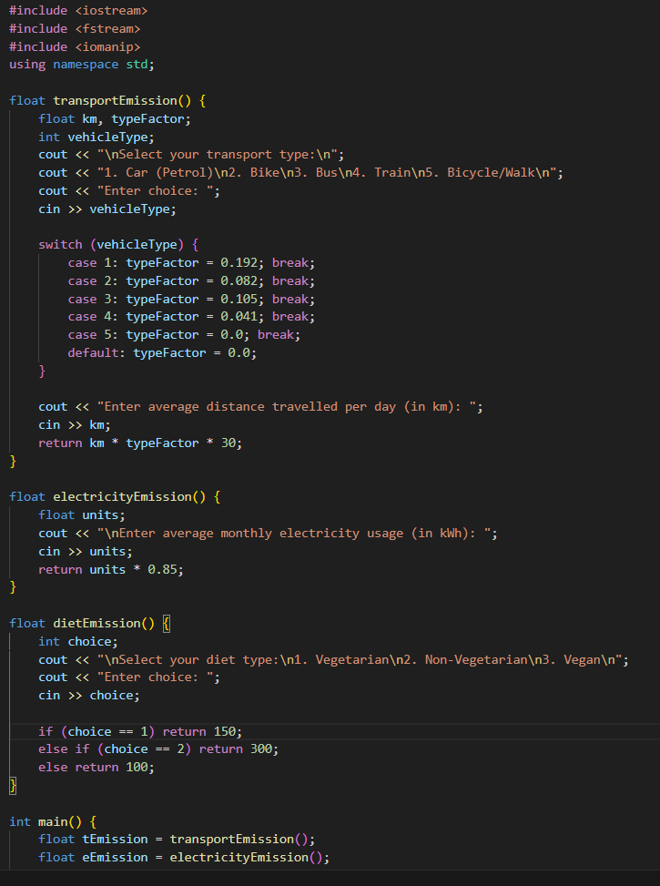

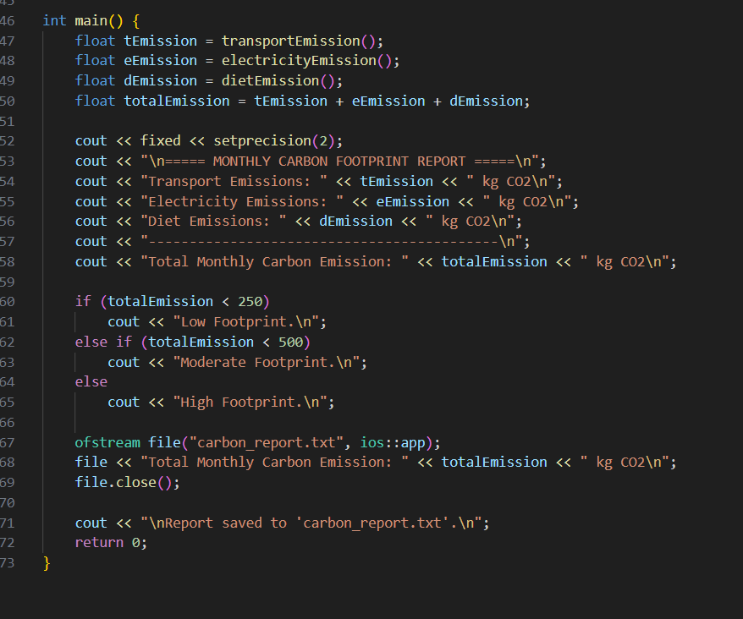

RESULTS AND TESTING

Testing was carried out using various input combinations for validation. The calculator accurately computed emissions and generated appropriate eco-feedback messages.
Sample Input:
Transport: Car (20 km/day)
Electricity: 120 kWh/month
Diet: Non-Vegetarian
Expected Output:
Total Emission: 517.20 kg CO₂
Feedback: High Footprint
Testing included verification of:
- Correct emission calculations for each transport type.
- Proper file saving and report generation.
- Input validation for wrong entries.
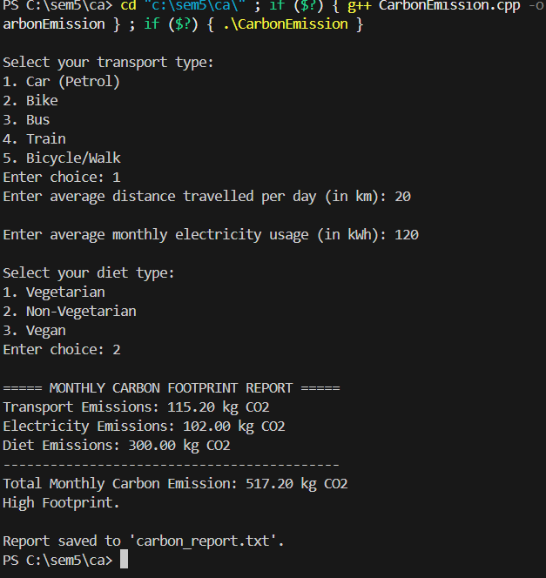

CONCLUSION

The Carbon Emission Calculator successfully demonstrates the integration of environmental awareness and C++ programming. It offers users a personalized carbon analysis with actionable insights. The modular architecture, efficient use of file handling, and clean interface make it an excellent educational and practical tool.
Future Enhancements:
1. Add a graphical interface for improved user interaction.
2. Incorporate database support for multiple user profiles.
3. Include additional categories like water usage or waste management.
4. Generate automatic comparison charts based on previous reports.

REFERENCES

1. GeeksforGeeks – File Handling in C++
2. TutorialsPoint – C++ Conditional Statements and Functions
3. International Energy Agency (IEA) – Carbon Emission Factors Database
4. Government of India – Climate Action Data Portal
5. IPCC Climate Report 2021 – Global Carbon Metrics and Methodologies

