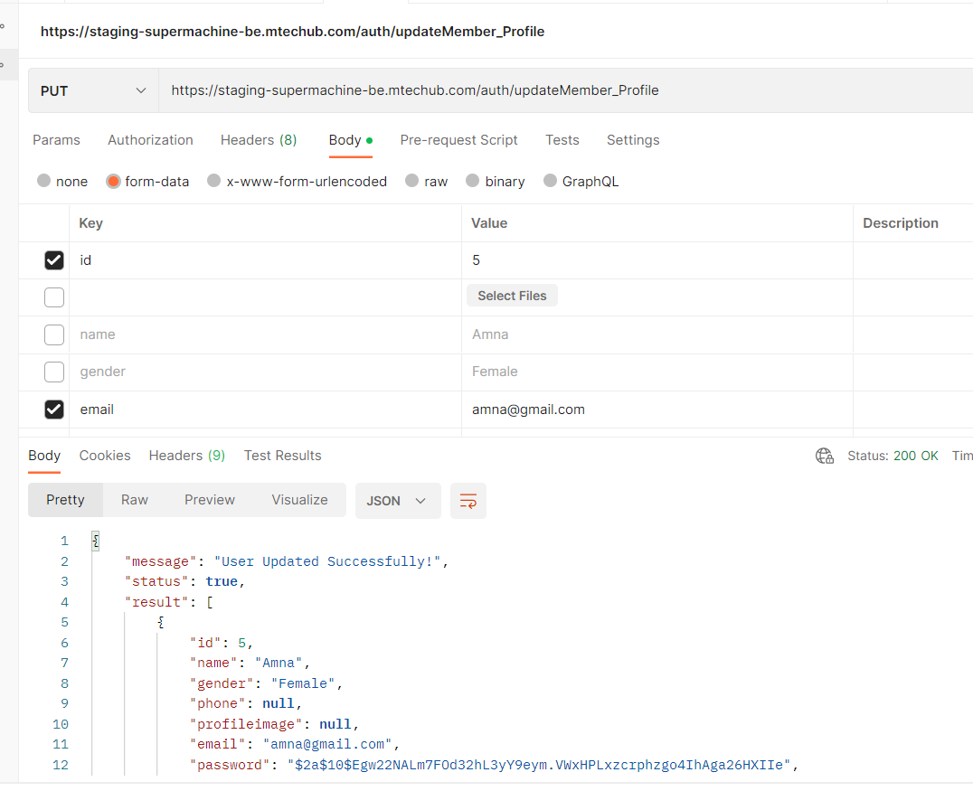

other data will now not make profile image null

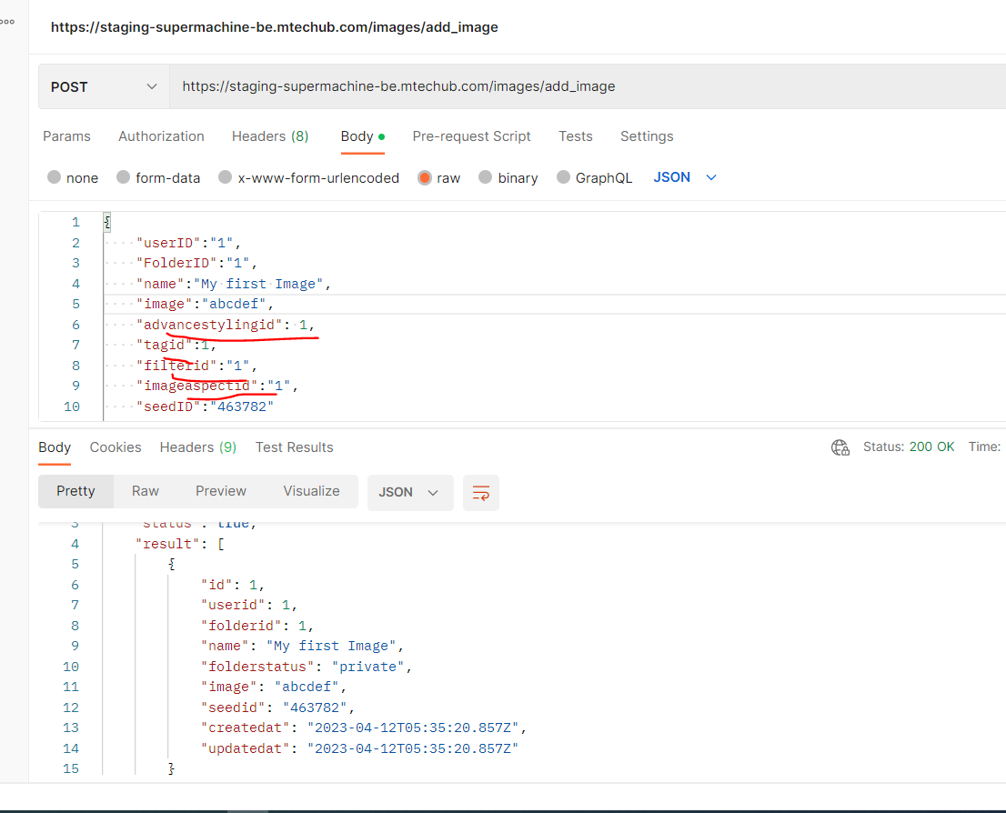

why we add these other ids in database as these are of no use! we only need seed id info folder info user info and Image URL.

user details added

Negative prompt added

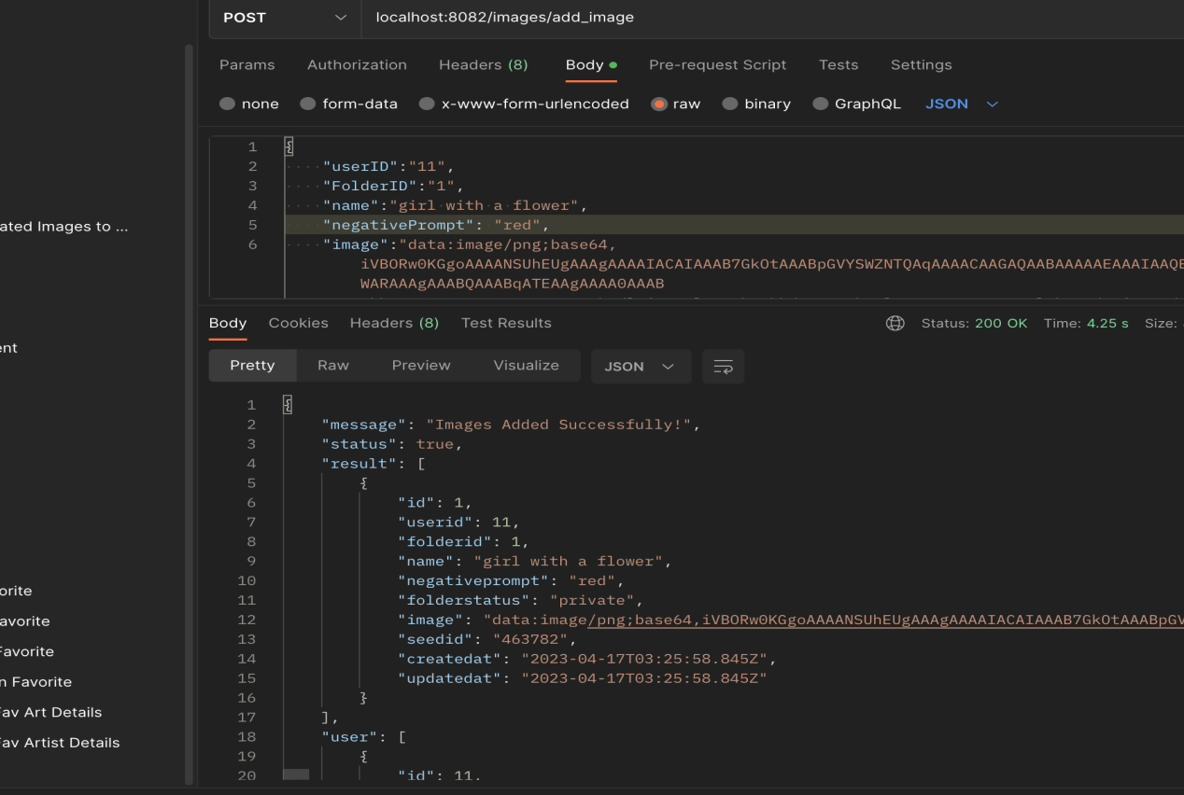

View a specific image → missing Api.

added API in (Uploading Generated Images to Folders) named “specific image”

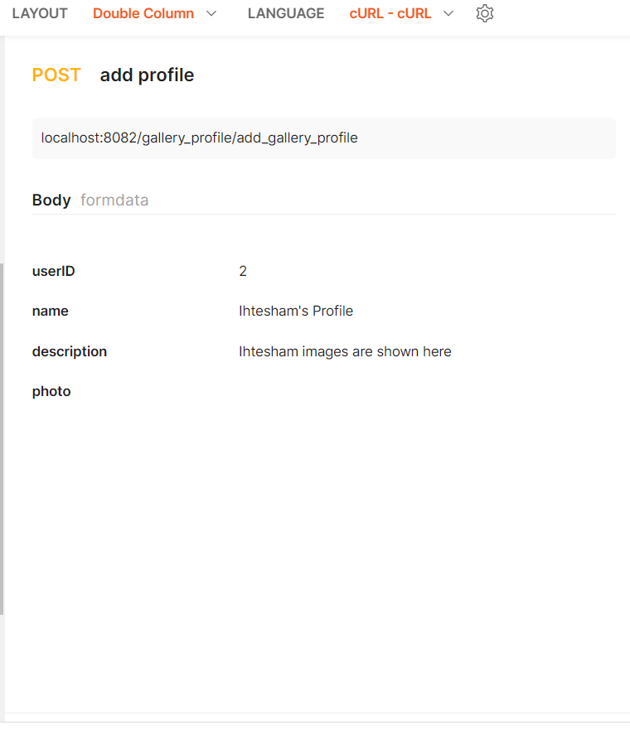

How to add Folder(Public) In any gallery?

according to maam, Every user will have single public gallery and if a user create a folder it will be private by default.

<https://staging-supermachine-be.mtechub.com/folder/update_folder_status>

by calling this api the status will change to public and will shown in that gallery

Get all public galleries of All user → missing Apis.

Every user have single gallery and in profiles--> View all Public gallries

<https://staging-supermachine-be.mtechub.com/gallery_profile/view_all_gallery_profiles>

here is the api of getting all profiles

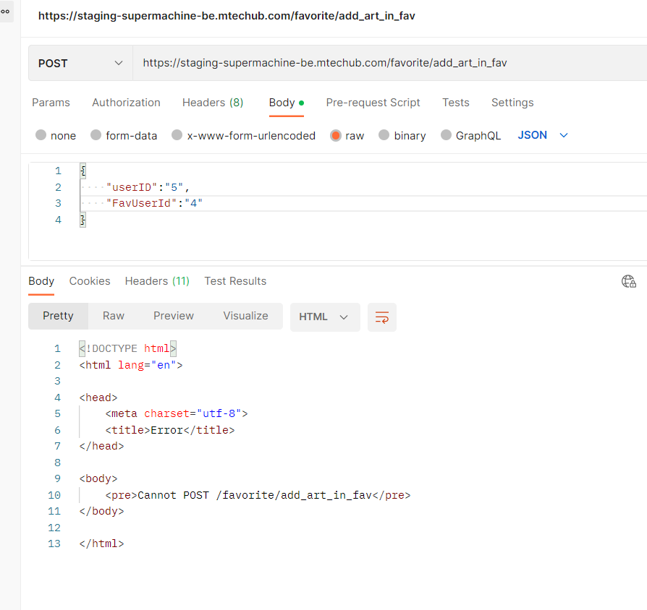

SERVER NOT Updated () Search and Fav server update na hne ki wja s ni chal rahy

To get total likes on any Artist/Art → missing api. (no task for this API)

Created these APIs