**REPORT**

| **Title: React Native**  **INSTRUCTOR: Mr Muhammad Usama**  **Date:** 4 september 2022  **Venue: lab2** |  |
| --- | --- |

**Course Content :**

| Lecture 1 | * Introduction of React Native * Installation Setup |
| --- | --- |
| Lecture 2 | * React Native Components Introduction. * Implementation of Views,Buttons,Textboxes. |
| Lecture 3 | * React Native Hooks. * States,Object Formatting. |
| Lecture 4 | * Introduction of React Native * Installation Setup |
| Lecture 5 | * Hooks,Props |
| Lecture 6 | * Project Structure * Navigation pages |
| Lecture 7 | * Stack Navigator * add icons and svgs |
| Lecture 8 | * Screens * Safe Area Contents |
| lecture 9-10 | * Scrollview * react-native paper |
| Lecture 11-12 | * Project Designing Screen and Navigation * API introduction |
| Lecture 13-14 | * API testing ,responses postman * API requests types |
| Lecture 15 | * API Integration with app * Final Project Completion with integration |

**Attendance:**

| **Sr. #** | **SSC ID** | **Arid #** | **Name** | 25/7/22 | 27/7/22 | 29/7/22 | 1/8/22 | 17/8/22 | 18/8/22 | 19/8/22 | 22/8/22 | 24/8/22 | 26/8/22 | 29/8/22 | 30/8/22 | 31/8/22 | 1/9/22 | 2/9/22 |
| --- | --- | --- | --- | --- | --- | --- | --- | --- | --- | --- | --- | --- | --- | --- | --- | --- | --- | --- |
| 1 |  | 19-Arid-941 | **M. Usman Ghani** | A | P | P | P | P | P | P | P | P | P | P | P | P | P | P |
| 2 |  | 20 Arid 936 | **Ume habiba** | A | P | P | P | A | A | P | P | P | P | A | A | P | P | P |
| 3 |  | 19-ARID-931 | **Muhammad Hamza Munir** | P | P | A | P | P | P | P | P | P | P | P | P | P | P | P |
| 4 |  | 20-Arid-906 | **Muhammad Shahid Faqeer** | A | A | P | A | P | P | P | P | P | P | P | P | P | P | P |
| 5 |  | 21-ARID-841 | **Muhammad Arslan** | P | P | P | P | P | P | P | P | P | P | P | P | P | P | P |
| 6 |  | 2O-ARID-797 | **MUHAMMAD HAQAN ALI RAI** | P | P | P | P | P | P | P | P | P | P | P | P | P | P | P |
| 7 |  | 18-ARID-2685 | **Tayyab Tahir** | P | P | A | P | A | P | A | P | P | P | P | P | P | P | P |
| 8 |  | 20-Arid-1529 | **Muhammad Aeqan Khan** | P | A | A | P | A | A | P | P | P | P | P | P | P | P | P |
| 9 |  | 19-Arid-4582 | **Hanzala Obaid** | P | P | P | P | A | A | P | P | P | P | P | P | P | P | P |
| 10 |  | 19-Arid-4598 | **Isma Hafeez** | P | A | A | P | A | A | P | A | A | A | A | A | A | A |  |
| 11 |  | 18-ARID-2527 | **Muhammad Mesum** | P | P | A | P | P | P | P | P | P | P | P | P | A | P | P |
| 12 |  | 20-ARID-846 | **Ahmed Mehmood** | A | P | A | P | A | A | P | P | P | P | P | P | P | P | P |
| 13 |  | 18-Arid-2802 | **Muhammad Rashid iqbal** | A | A | A | A | A | A | A | A | A | A | A | A | A | A | A |
| 14 |  | 20-ARID-911 | **Muhammad Usman** | P | P | P | P | P | P | P | P | P | P | P | P | P | P | P |
| 15 |  | 19-ARID-1067 | **Usama zafar** | P | P | A | P | A | A | P | P | P | P | P | P | P | P | P |
| 16 |  | 19-Arid-990 | **Fozan Asif** | A | P | A | P | A | A | P | P | P | P | P | P | P | P | P |
| 17 |  | 20-Arid-1528 | **Muhammad Aamir** | A | A | A | A | P | P | P | P | P | P | P | P | P | P | P |
| 18 |  | 20-ARID-796 | **M Hamza Khalid** | P | P | P | P | P | P | P | P | P | P | P | P | P | P | P |
| 19 |  | 20-ARID-799 | **Muhammad Hassaan Zafar** | P | P | A | P | P | P | P | P | P | P | P | P | P | P | P |
| 20 |  | 19-Arid-992 | **Haider Ali** | P | P | P | P | A | A | P | P | P | P | P | P | P | P | P |
| 21 |  | 21-Arid-514 | **Summiya** | P | A | A | A | A | A | P | A | A | P | P | A | A | A | A |
| 22 |  | 21-Arid-745 | **Muhammad Awais Siddiqui** | P | P | P | P | P | P | P | P | P | P | P | P | P | P | P |
| 23 |  | 21-Arid-888 | **Zain ul Abideen** | P | P | P | P | P | P | P | P | P | P | P | P | P | P | P |
| 24 |  | 19-Arid-1012 | **Momin Ali** | P | P | P | P | A | P | P | P | P | P | P | P | P | P | P |
| 25 |  | 18-Arid-2544 | **Naimat Nimra** | P | P | P | P | P | P | P | P | P | P | P | P | P | P | P |

**Pictures:**

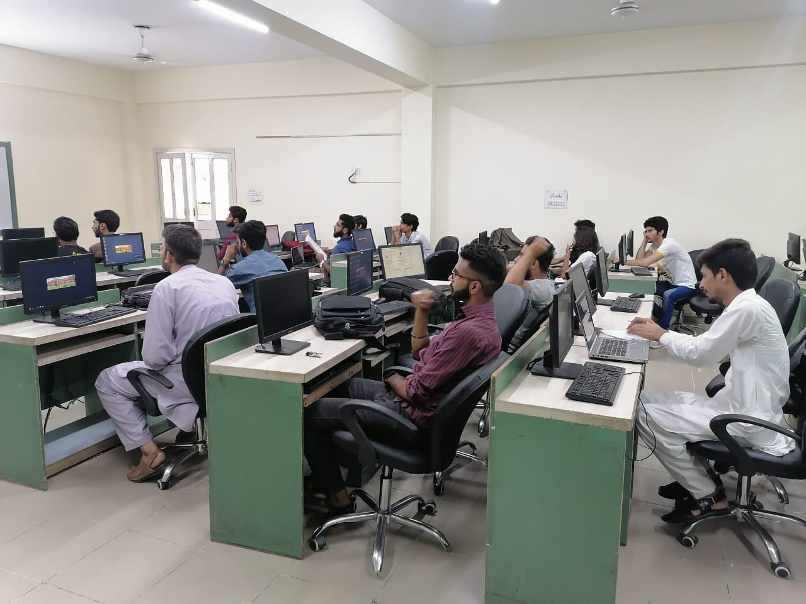

**Course Assistant :**

**Name:** Rimsha Riaz

**Reg #:** 18-Arid-2556

**Designation:** Information Secretary