Paleogeodesy and paleoseismological studies of the earthquake cycle at subduction zones allow for reconstructing multiple earthquake ruptures (e.g., Scoffin et al., 1978; Taylor et al., 1987; Smithers et al., 2001; Meltzner et al., 2015; 2017; Majewski et al., 2018; 2022; Philibosian and Meltzner, 2020). In Sumatra Sunda, South America, Japan, the western US (supplementary data of Philibosian and Meltzner, 2020), the Solomon Islands, and Vanuatu (e.g., Taylor et al., 1987; Taylor et al., 2005, Thirumalai et al., 2015), paleoseismology provides a record of individual ruptures over hundreds to thousands of years. For example, the Sumatran Sunda coral microatolls offer one of the most detailed records of paleogeodesy and paleoseismology over multiple earthquake rupture cycles (e.g., Sieh et al., 2008; Tsang et al., 2015). This record focuses on large ruptures and potential very long-duration slow slip events (Tsang et al., 2015; Mallick et al., 2021) and the interseismic vertical motion rate over two seismic cycles (1100 years). Nevertheless, the existing records lack the necessary resolution to offer a continuous account of sea level changes linked to the earthquake cycle spanning hundreds to thousands of years. This level of detail over secular time scales is essential for addressing coastal risk management in a statistically significant manner. Due to their abundance in the Solomon Islands, coral microatolls serve as a natural tide gauge solution, addressing the absence of long and continuous geodetic records. Each microatoll maintains a continuous yearly record of tectonic motion spanning hundreds of years, capturing multiple earthquake cycles. In this context, coral paleogeodesy emerges as a valuable tool, offering crucial information to constrain and predict the impacts of earthquake hazards and sea level changes for island communities (e.g., Meltzner et al., 2010; Thirumalai et al., 2015; Biemiller et al., 2020). Moreover, it presents a unique opportunity to deepen our understanding of the physical processes behind earthquake generation and long-term uplift/subsidence. Additionally, slip events occurring at such slow rates of deformation that they go undetected by seismological methods (e.g., Ide and Beroza, 2023) may be identified through coral paleogeodesy (Mallick et al., 2020).

The utilization of shallow-living microatolls as natural tide involves analyzing cross-sections of coral heads (Fig. 1 & 2). These cross-sections reveal positive and negative relative sea-level fluctuations, resulting in die-downs and upgrowths in the highest level of survival of coral growth (HLS). For example, the vertical coastal displacement determined by surveys of coral reefs following the Mw 8.1 April 2nd earthquake suggests 0.73±0.14 m of subsidence occurred at Simbo Island, and up to 2.46 ± 0.14 m of coastal co-seismic uplift was generated at Ranongga Island located on the overriding plate only 8 km away (Fig. 2) (Taylor et al., 2008). Annual density growth bands in corals, analogous to tree rings, facilitate band counting and provide an internal chronometer with annual resolution. The application of this technique enables dating events with a precision of approximately ±1 year relative to the living surfaces at the time of collection (e.g., Buddemeier and Taylor, 2000). This high precision allows for accurate determination of the timing and amounts of both uplift and subsidence for living or fossil corals (Biemiller et al., 2020).

Figure 2 illustrates the capability of coral paleogeodesy, showcasing large Porites heads (microatolls) that record several hundred years of annual growth, capturing sea level changes. A slice of a Porites head from Parara Island (Fig. 2, lat:, long:) is sliced and X-rayed, and its morphology is interpreted. By examining the recent El Niño event record, two small kills (green, Fig. 5C) events corresponding to ENSOs in 1942-44 BP and 1992-94 BP are identified. The 2007 Mw 8.1 earthquake is recorded, indicating an uplift of 70 cm above mean sea level. Preseismic subsidence occurs from the 90s to 2007, and postseismic subsidence is observed after 2007. Two additional events in 1955 and 1972, causing ~15 cm of uplift accumulated over 5 to 10 years, initiate over 1 year and decay exponentially. Both events are characterized by a preceding subsidence lasting approximately 10 years, with an amount lower than the subsequent uplift, leading to accumulated permanent uplift. The observed permanent uplift suggests a tectonic origin for these events. Their prolonged duration, combined with the absence of post-event subsidence, indicates they were not abrupt earthquakes but rather very large slow slip events (SSEs) lasting 15 to 20 years. Even though these observations are promosing, coral paleogeodesy does not provide a continuous record of the seismic cycle which would be critical to understand the parameters controlling the size and recurrence of earthquakes in the western Solomons. This limitation arises because coral morphology only captures relative sea level changes that are large enough to trigger coral emergence, resulting in a recognizable die-down or "kill event" on the coral surface. Subtler or shorter-term variations in tectonic motion typically go unrecorded.



**Figure 1**: **Sea level change at the Honiara B tide gauge (Guadalcanal, Solomon Islands) from 1994 to 2013.** The raw sea level record is shown in red, with a 12-month moving average overlaid in blue. A sharp sea level drop of up to ~30 cm is observed between 1997 and 1999, coinciding with the strong 1997–1998 El Niño event. Over the full period, sea level shows a net rise of approximately 10 cm. The moving average captures both interannual variability linked to the ENSO Index (e.g., El Niño/La Niña cycles; see [ref]) and the longer-term trend associated with recent global sea level rise (see [ref]).

To resolve this issue, Mike Gagan and colleagues (2008; 2009) preliminarily introduced an innovative technique to investigate vertical tectonic movements. This method involves analyzing δ13C in coral growth bands (Fig. 2). When shallow-living corals experience sudden shallowing due to tectonic uplift, δ13C shifts to more positive values. Conversely, subsidence leads to lower concentrations of skeletal δ13C. The typical vertical motion has an impact that exceeds the 2-sigma error for 13C analyses (~0.01 per mil) by approximately 50-100 times. Although there is significant annual variability in shallow-living coral δ13C due to differences in night vs. daytime lowest tides between winter and summer (e.g., Buskirk et al., 1981), this variability is irrelevant as our focus is on mean values. Averaging yearly cancels out most of the annual cycle, leaving a relatively small interannual variation. On Fig. 7b, the available δ13C measurements show excellent agreement with what is expected in terms of vertical motion before, during, and after an earthquake. The shift of 2o/oo for 73 cm maximum uplift during the April 2007 earthquake suggests a rate of change of 36.5 cm/o/oo in sea level. This conservative estimate of uplift combines the vertical extent of the 2007 kill event with the measured water depth above the coral top at the time of sample collection. The minimum uplift, excluding the water depth component, is 63 cm (Figure 2a). **Here, we revisit Gagan’s initial hypothesis that δ¹³C variations in coral skeletons can serve as a proxy for relative sea level change to identify tectonic signals. Using the Porites coral slice shown in Figure 2a, we begin by sampling the coral vertically to test whether a consistent relationship exists between δ¹³C and water depth.**

**Methods**

**Data Sources for sampling with water depth**

**Figure 2: a.** X-ray radiograph of a ~1 cm-thick slice of a fossil *Porites* coral collected in 2012, following the April 2007 Mw 8.1 earthquake that killed the coral surface (green line) by uplifting it by at least 63 cm. The slice is leveled horizontally using multiple reference nails. The coral growth bands reveal vertical extension rates ranging from <1 cm to 1.5 cm/year, and the horizontal section captures over 80 years of growth history. Several prior die-down surfaces, likely due to emergence events, are evident in the 1950s, 60s, and 70s. We sampled the coral at high resolution (2 mm spacing, ~6 samples per year or ~1.2 cm/year) for δ¹³C and δ¹⁸O analyses along both vertical and horizontal paths. Vertical sampling paths (blue and red) were used to explore the relationship between δ¹³C and relative sea level change, while horizontal paths targeted the coral’s geochemical record of sea-level fluctuations and the seismic cycle. Ages of the samples were assigned by counting annual density bands in the X-ray image back from the known surface date. **b.** Path H was located at 30–40 cm depth based on water depth at the time of slice collection, while path H′ was positioned at ~80 cm depth. Both transects intersect the same annual growth bands from 1997 to 2006 and were sampled at identical resolution for δ¹³C (red curves). Both sites experienced the ~63 cm uplift from the 2007 earthquake. Path H′ continued to grow after 2007 below the dead surface (green line) and recorded a clear geochemical signal of the earthquake: a ~2‰ increase in δ¹³C from –2.9‰ to –0.9 ‰. A moving average of δ¹³C for both paths (H and H′) reveals a similar decline of ~1.25‰ between 1997 and 2006, preceding the 2007 uplift.

**Sea level data were obtained from the tide gauge station in Honiara, Solomon Islands, spanning the period from 1994? to 2012 (Figure 1). Monthly mean sea level values were converted to water depth relative to a local datum and expressed in centimeters. A 12-month moving average (in blue) was computed to highlight longer-term trends. The 1998 El Niño event is clearly identifiable as a ~20 to 40 cm sea level drop. A long-term sea level rise is also evident, averaging approximately 1 cm per year. Coral skeletal δ¹³C time series were derived from a Porites coral slice collected at Parara (lat, long) (Figure 2). We sampled the coral at 2 mm intervals for the years 2006–2007 along the outer edge (paths A, B, C, D, E, F, G in yellow) to obtain a relationship between water depth and δ¹³C prior to the 2007 uplift event. Additional sampling paths (A’, B’, C’, D’, and E’) were selected to span years likely to record the 1998 El Niño event, providing a secondary calibration point for the δ¹³C–depth relationship. Finally, two longer time series (paths H and H’), spanning 1997 to 2006 and 1997 to 2012 at depths of approximately 40 cm and 80 cm respectively, were analyzed to assess whether they captured similar δ¹³C histories and to evaluate the sensitivity of δ¹³C incorporation in coral skeletons to water depth (Figure 2).**

The raw results are shown in Figure 3, where each δ¹³C data point is plotted against the estimated water depth at the time the corresponding coral slice was deposited (Figure 2). The data reveal a linear trend, indicating increased ¹³C depletion with greater water depth. The correlation coefficient is R² = 0.456, suggesting a moderate relationship. This supports the influence of water depth on δ¹³C, though it also implies that other factors contribute significantly, particularly within the 2 mm sampling resolution (about 2 months at a growth rate of 1 cm/year) or within annual cycles. However, profiles A’ to E’ must be corrected for post-growth subsidence and water depth changes.

**Figure 3**

Previous studies (e.g., Grottoli and Wellington, 1999; Grottoli, 2010; Prad et al., 2019; Rosenfeld et al., 2003) have shown that skeletal δ¹³C values decrease significantly with reduced light availability, a trend often linked to increased zooplankton abundance at greater depths. Importantly, these studies also indicate that the sensitivity of δ¹³C to light reaches a saturation point under ambient light conditions shallower than one meter. This suggests that at very shallow depths, skeletal δ¹³C becomes relatively insensitive to further increases in light intensity. To capture the relationship between skeletal δ¹³C and water depth, we tested a range of nonlinear models that reflect the expected physiological and environmental controls on coral isotopic composition. Among these, we selected the arctangent function as the most appropriate model. The arctangent function increases monotonically but gradually plateaus at shallow depths, consistent with the saturation of light near the surface. This behavior reflects the decreasing sensitivity of δ¹³C to small depth changes in well-lit shallow waters, where light is no longer limiting photosynthetic activity. It also effectively captures the steep change in δ¹³C at greater depths and its flattening at shallow depths, without introducing unrealistic curvature or overshooting known shifts. In addition, the arctangent model yields more conservative δ¹³C gradients at shallow depth. This is particularly important for our study, as it avoids over-amplifying isotopic excursions linked to known coseismic uplift events. The atan model is robust, smooth, and avoids divergence or instability across the full δ¹³C range. This makes it practical for inversion or forward modeling tasks.

To minimize the influence of annual variability and account for changes in water depth over time, δ¹³C values are compared only among coral samples that were formed at the same time and for which the water depth at the time of growth is approximately known. To achieve this alignment, we use the seasonal cyclicity in δ¹⁸O (ref) as a chronological marker, allowing us to synchronize samples taken at different depths that were incorporated into the coral skeleton during the same seasonal period. In addition, since we expect the skeletal δ¹³C to be most sensitive at greater depth studies (e.g., Grottoli and Wellington, 1999; Grottoli, 2010; Prad et al., 2019; Rosenfeld et al., 2003) we use the minima of the annual variability to obtain the δ¹³C values. Supplementary Figures 1 and 2 show the best annual cyclic fits to δ¹⁸O measurements along paths A to G and A’ to E’. For samples A to G, which were measured from oldest to youngest, we use the first minimum in δ¹⁸O to identify the seasonal period corresponding to early 2006. These more negative δ¹⁸O values reflect cooler water conditions typical of that time of year. Samples A’ to E’ span the period from 1997 to 1999. Within these records, the δ¹⁸O minimum corresponding to cooler water during the strong 1998 El Niño event is clearly visible, supported by coral banding-based age constraints. Using this reference, we extract the corresponding δ¹³C values and apply corrections to their water depths based on tide gauge data.

At the time of the 1998 El Niño event, relative sea level was approximately 31 cm lower than in 2006, suggesting a necessary correction of about 30 cm to the inferred water depths. However, the coral also experienced rapid vertical growth between 1997 and 2007, likely in response to local subsidence, requiring an additional ~20 cm depth correction. To simplify the analysis, we assume that the effects of subsidence and the El Niño-related sea level drop approximately cancel out.

The final fitted model takes the form:

**(1)**

Where is the estimated water depth (in cm), is the measured skeletal carbon isotope ratio (‰), , b, c, and d are fitted parameters that control slope, inflection, and plateau behavior. **Figure 4a shows the plot of measured** δ¹³C against the water depth measured from the water depth above coral deepened by the minimum uplift measured on the corals (Figure 2). In red we fit by regression an exponential relationship with a confidence of ~92% that relates water depth to δ¹³C (in cm).

**This relationship suggests that as water depth deepens the coral skeleton is more depleted in** ¹³C. This can be directly fit to the decrease in light irradiance following the …. law as:

**(2)**

**with a goodness of fit of .**

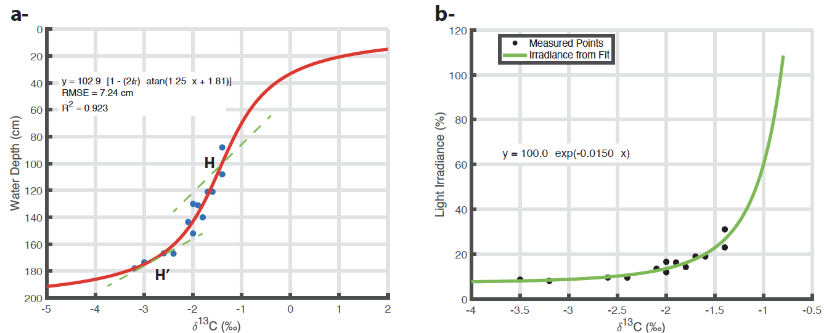

Figure 4: k=0.0146 cm-1, =0.979.

**Grottoli, A.G., & Wellington, G.M. (1999)**. Effect of light and zooplankton on skeletal δ13C in coral Montastraea annularis. Coral Reefs, 18(1), 29–41.

Errors in measurements and our choice of relationship likely lead to large uncertainties in relative sea level change experienced by the Porite

**Discussion**

The analysis revealed a **systematic relationship between water depth and coral δ¹³C**, consistent across multiple time series. In all records, **more negative (depleted) δ¹³C values correspond to deeper water conditions**, while more enriched δ¹³C values are associated with shallower depths. Furthermore, the **slope of the δ¹³C–depth relationship decreases with depth**, suggesting that δ¹³C becomes **less sensitive to sea level fluctuations at greater depths**.

This observation aligns with known **ecophysiological controls on coral δ¹³C**. Near the surface, δ¹³C in coral skeletons is influenced by light availability and photosynthetic activity of symbiotic zooxanthellae, which preferentially fix ¹²C and leave behind ¹³C-enriched DIC (dissolved inorganic carbon) during calcification. At **shallower depths**, where light intensity is higher, the photosynthetic effect is stronger, leading to **higher (less negative) δ¹³C values**. Conversely, **at greater depths**, reduced light intensity limits photosynthetic fractionation, resulting in **lower δ¹³C values**.

The reduced slope at depth may also reflect **a damping of seasonal sea level influence** on water depth experienced by the coral. As the absolute depth increases, a given change in sea level has a proportionally smaller effect on light availability and photosynthetic rate, diminishing its impact on skeletal δ¹³C. This implies that δ¹³C may serve as a **more precise water depth proxy** in shallow reef settings (<60 cm) and becomes less sensitive but still informative at greater depths.

**Time Series for path H and H’ Interpolation and Alignment**

To enable comparison between δ¹³C and sea level data, both time series were interpolated to a uniform monthly time base using linear interpolation. This was necessary due to differences in the original temporal resolution and sampling intervals between the tide gauge and coral records.

In the Solomon Islands, coral δ¹³C records are expected to reflect at least part of the Suess effect (Sonnerup et al., 1999; Eide et al., 2017), he anthropogenic decline in atmospheric δ¹³C due to the combustion of ¹³C-depleted fossil fuels. While the magnitude of this signal varies regionally based on the ocean-atmosphere CO₂ exchange, the Western Pacific Warm Pool generally behaves as a weak CO₂ sink or near-neutral zone, with limited upwelling and relatively stable stratification. As such, the δ¹³C of surface ocean dissolved inorganic carbon (DIC) in this region can partially equilibrate with atmospheric values, allowing the Suess effect to be recorded in coral skeletons over multidecadal timescales. However, the expression of this trend may be dampened or confounded by local factors, including biological fractionation related to light availability and water. While the Suess effect—a long-term anthropogenic decline in atmospheric δ¹³C—is expected to be present in coral records from the Solomon Islands, its magnitude (~0.005–0.008‰ per year) is relatively small compared to the isotopic shifts caused by tectonic uplift, sea-level changes, and ENSO variability. Given the strong influence of these environmental processes and the resulting complexity in the δ¹³C signal, isolating the Suess effect with confidence is not feasible in the present dataset. Therefore, quantifying or correcting for this effect is beyond the scope of this study.

.

**Correlation and Linear Relationship Extraction**

To explore the relationship between δ¹³C and sea level, we detrended both tide gauge (Fig. 1) and δ¹³C times series (Fig. 2b) using a yearly moving average. We applied a moving window correlation (12 months) between both detrended δ¹³C times series and the detrended tide gauge time series. We retained segments where the Pearson correlation coefficient approached 0.9. For these high-correlation segments, linear regression was used to establish the relationship between sea level (as a proxy for water depth) and δ¹³C. Separate regressions were performed for each coral core. with relatively good correlation coefficient which suggest a robust relationship. These relationships suggest that the coral skeleton is more depleted in ¹³C at deeper water depth and that it is more sensitive a shallower (slope -35.11 cm/‰) than at deeper water depth (slope -23 cm/‰).

To further explore the relationship between

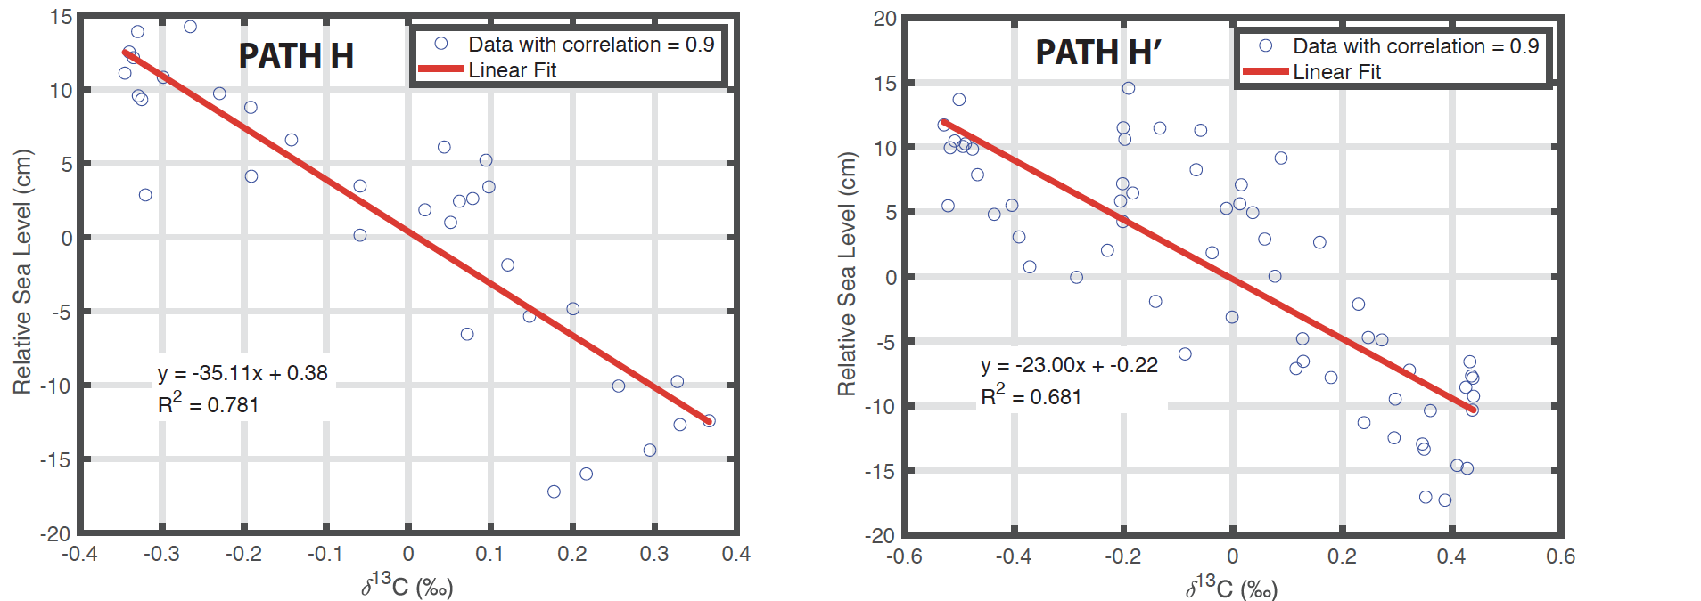

**Figure 3:** **Time Series for path H and H’ Interpolation and Alignment.** Long-term trends in both time series were removed using a 12-month moving average, isolating seasonal to interannual variations. The detrended (high-frequency) components were used for correlation analysis and calibration. We obtain two linear relationships with a negative slope of -35.11 cm/‰ for path H and -23 cm/‰ for H’.

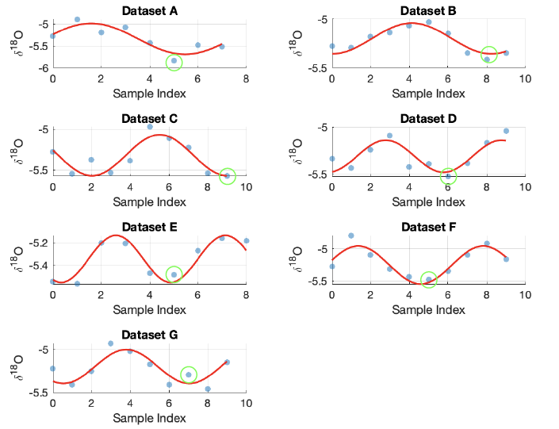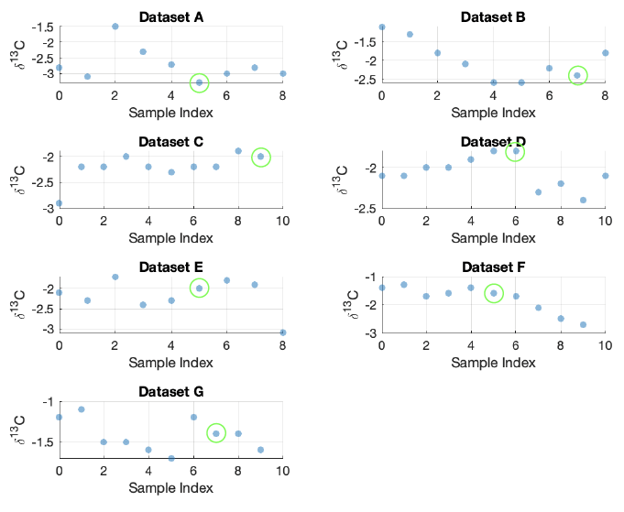

Figure 5:

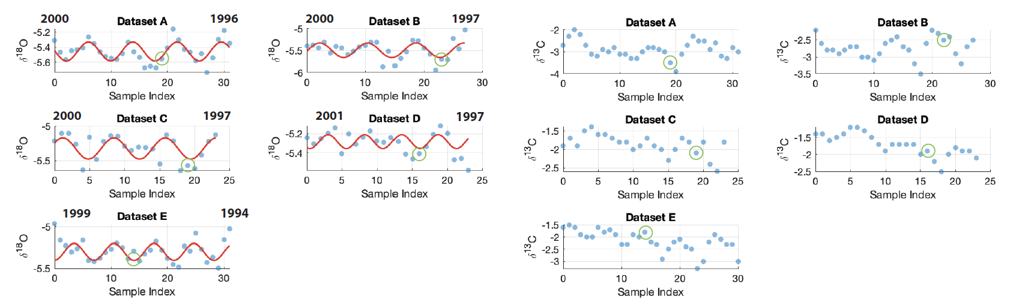

Figure 6:

**Application to the horizontal profile:**

