Methods
The corals in this study are part of a research corroboration took place in 2012 from New Georgian Island Group from Western Solomon Islands. Specifically corals 12-SPL-A and 12-SP-A from inner part of the lagoon on the western end of the Vonovono Island. The coordinates for 12-SPL-A are 8.221 S,157.0049 E and for 12-SP-A are 8.2164 S,156.9837 E. Both microatoll are about 4 m in diameter and have very similar surface topography, Nearby microatolls appear very similar. 12-SPL-A was still living when sampled and had emerged during 2007 Mw8.1 event. The slabs are taken with a underwater functional chainsaw and the slabs are separated into 30-40 cm pieces for logistic purposes.
There are 2 different drilling campaigns on the coral 12-SPL-A. During both sampling campaigns there were one temporal focused time series and multiple short samplings for a depth-d13c curve for the calibration purposes. First campaign was conducted in 2021(?) and published in Kendall et al 2026 as primary results with a compelling overlap with InSAR result from the region. During that campaign 118 continuous samples are taken covering the 2007 Mw8.1 event as well as 68 calibration samples from 7 different depths. The second and main drilling campaign for this paper took place in late 2024. We collected 574 samples from 8 different horizontal parallel paths for the temporal coverage of the tectonic history and 140 samples from 5 different depths for the depth-d13c calibration.
The drilling paths are set horizontally for capturing the temporal change of the stable isotopes responding to vertical tectonic motion of the coral. For a tectonically stable setting sampling of the coral in vertical or horizontal direction does not differ for the isotope ratios (Sr/Ca) shown by DeLong et al. (2013).
The drilling process for the samples is conducted with a computer controlled micro drill with a diamond bit. Each sample is gathered from 1.5 x 1.5 x 1 mm cube, and each sample is contained in an isolated Eppendorf tube until the chemical analysis. Since the drilling results in a fine particle size, we assume that the samples are highly homogenized for the specific sampling volume, so we didn’t rework the samples in mortar for homogenization or fine graining.
Both isotope ratios are standardized with international norms. $\delta^{13}$C is standardized by Pee Dee Belemnite (PDB) \citep{craig1957isotopic }, similarly the $\delta^{18}$O are standardized by the Standard Mean Ocean Water (SMOW) \citep{ craig1961standard}. d18O was later on converted to PDB by using the relation derived from \cite{ coplen1983comparison}:
  - d¹⁸O_{VPDB} = 0.970 * d¹⁸O_{VSMOW} - 29.983 ‰

@article{coplen1983comparison, title={Comparison of stable isotope reference samples}, author={Coplen, Tyler B and Kendall, Carol and Hopple, Jessica}, journal={Nature}, volume={302}, number={5905}, pages={236--238}, year={1983}, publisher={Nature Publishing Group UK London}}

Age Model
We developed our own age model based on known methods from prior research. We prioritize matching our age model to local climate data set and than extrapolate the time window for the ages before the data set is available. We decided to not use the X-Ray growth band, since they might be misleading but the X-ray bands are used for spatial connections between different data sets gathered from the coral slab.
Each piece of slab is X-ray scanned individually after they were sampled for the isotope analysis. In order to position each sample on their path on X-Ray image, indicator notches carved at the end of every 6 sample. Each slab piece is carefully patched together in digital environment. Based on our X-ray images, each sample’s position in slab is known and this information is used to anchor the relative age of each individual path according to its neighboring paths.
As we also realized in our earlier age models, the density bands gathered from X-Ray radiography might deliver inaccurate age information.
The common counting errors based on false bands or stress bands lead to10 years older age for the last sample of the coral in our initial growth band counting. The growth band counting might be misleading in terms of absolute age modeling, however their barcode like unique structure allows us to use it for temporal-spatial interchanges. Beside the relative ages of the paths along the slab, we also use X-ray bands to match both of the coral’s morphology observations to each isotope results. The X-ray bands of 12-SPLA is used as a reference age model also for the 12-SPA.
Since we are working on a recent coral, our age model is based on pseudo coral forward model of Thompson et al (2011). Tie points are set between the pseudo coral and the d18o measurements we got. The forward model is a simple linear relationship based on sea surface temperature (SST) and sea surface salinity (SSS) where the coral is located. We used the geographically designated coefficients proposed by Thomspon et al (2011), alpha_1=-0.22 (‰/°C) and alpha_2=0.45. For both SSS and SST we used monthly ORAS5 from 1958 until 2007. We identified Annual cycles visually in the coral signal and matched one-to-one to the corresponding climate cycles. This produced a set of cycle boundary anchors in x-ray based pseudo-year space mapped to real calendar years. The anchor pairs from the peak matching were used to build a piecewise-linear warp function, converting the raw pseudo-years into a calibrated calendar years. The result spans 1958–2007 with r = 0.595 against the climate reference. For the years before climate data was available, we applied tie points based on the pseudo coral’s annual climate average.

https://cds.climate.copernicus.eu/datasets/reanalysis-oras5?tab=overview

Age Model Discussion
The growth rates based on our age model seems reasonable for an average growth rate of a porite around 1.1? (fig XX). One should also consider that we drilled our samples vertically which opposes to general drilling direction, so the growth rates might differ in horizontal direction than vertical growth rates in the literature. We also located our paths strategically avoiding any bioturbated tissues or getting close to the exposed surface, therefore we weren’t always able to follow optimal sampling path, apex of fan. Therefore the sampling rates have artefacts due to combination of sampling bath irregularities and our age modeling.

Main arguments supporting the robustness of the time series:
- δ¹⁸O – Annual climate correlation
- δ¹⁸O & δ¹³C – Enso correlation
- δ¹³C – morphology correlation especially the trends!
- 2007 event

Time Domain

Morphology
Most valuable observation about d13c signal in time domain is its strong alignment with the coral’s morphology. Both die down and steady subsidence or uplift events observed on the morphology are also appearing in the d13c levels and sometimes in d18o. The main motivation of this research is based on the observations gathered after the M8.1 2007 Earthquake. Results from the first drilling campaign (Kendall et al 2026) show clearly that M8.1 2007 Earthquake has a significant effect on both isotope ratios derived by transect H’. d13C levels rise after the event and decreases characteristically after coming months. d18O levels do not show a strong increase, however the yearly periodicity disappears abruptly after the event.
There is a clear die down surface in 1945 in both corals 12-SPL-A and 12-SP-A and unexpectedly d18o has a sudden drop after the event. Another remarkable observation is both the periodicity, and the long-term trend stays unchanged after the event. There is also 5 years of declining trend in d13c levels after the 1945 event and this trend is captured by two different drilling paths (end of N & start of M). Both independent samples and measurements align with each other as well as with both morphologies gathered from the corals. The decline lasts until 1950 and during this decline the annual periodicity is significantly disturbed until it recovers temporarily after June1952. Between 1950 and 1959 we observe a decadal long unchanged trend while the morphology in constantly growing which means both a relative sea level rise or a steady time in a deeper relative sea level. The strong increase of d13c starts in 1959 which is 4 years before the direction switch in down going morphology trend. Both the morphology and d13c reach the peak at the beginning of the year 1970 and they both start to decline afterwards. The sudden change in 1976 in morphology is we believe due to some recent erosion afterwards (But I need to check that again when we are at UTIG), because the growth bands are perpendicular at the upper part of the slab. Beside this there is only one single time frame where the morphology and the d13c signal showing opposite directions and it is between 1985-1993. These years also cover 2 major ENSO events but what most stands out is that d13c has strong reverse correlation with both Honiara tide gauge as well as SST during these years. After that there is 18 months of steady time followed by a strong subsidence until the M8.1 event.
Taylor et al. (2008) observed in the field that the corals were uplifted up to 2.5 m after the earthquake event in the region. 12-SPL-A is uplifted 73 cm and 12-SP-A is uplifted 44 cm. While 12-SPL-A was able to survive the uplift event, 12-SP-A died completely. 12-SPL-A morphology shows a 6 cm of vertical growth recovery which indicates at least 6 cm of post seismic subsidence in the following years. The uplift and subsidence rates during the event and its aftermath are validated also with InSAR observations from the region by Kendall et al. (2026).
One should consider that the coral morphology analysis works in a mechanical way. The die-downs indicate an absolute relative sea level on a specific age which is a very valuable data. However one should always consider that the times when the coral is freely growing never shows the correct relative sea level, but the coral has subsided enough for a vertical growth. On the other hand (we claim that) d13c is a proxy for the relative sea level, so the trends could differ from each subsidence or uplift interval however each piece of multiannual time window of vertical motion can be compared with d13c levels piecewise.

Spectral Analysis
As a general nature of the paleoclimatic data, the sampling intervals usually cannot be kept machine precisely constant. We used two main approaches to run our spectral analysis on our coral data, first resampling the data in 2-month intervals and second we used lomb-scargle analysis \cite{ press1989fast} for our raw unevenly sampled time-series.
All the spectral analysis indicates clearly there are three groups of dominant frequencies in both isotope signals:
- Annual
- ENSO
- Low Frequency components

Annual Climatic Signal
Annual signal is the yearly variation dominated by the solar cycle as a direct influence on SST and partly solar irradiance effected by cloudiness and rainfall. Since our research area is in the equatorial belt the seasonal SST variations are in the range of +-3°C which is not responsible solely for the annual signal in the d18o and d13c. The rainy seasons affect the cloudiness and thereby both isotopes show a clear peak for the annual period.
The monthly averages of d18o and d13c show a 1–2-month shift in their throughs and the show a general difference in their pattern for the annual behavior which also indicates that they are influenced by different processes. D18o is much more robust and shows a clear peak between May and December while in January until April the signal is quit stable and low. D13c on the other hand shows a much more dynamic and noisier signal with one major peak at September and another minor one in March. This characteristic behavior of d13c aligns well with the monthly average of SST curve. Fig XXX shows that d18o has a negative correlation with SST while d13c has a slightly positive relationship. 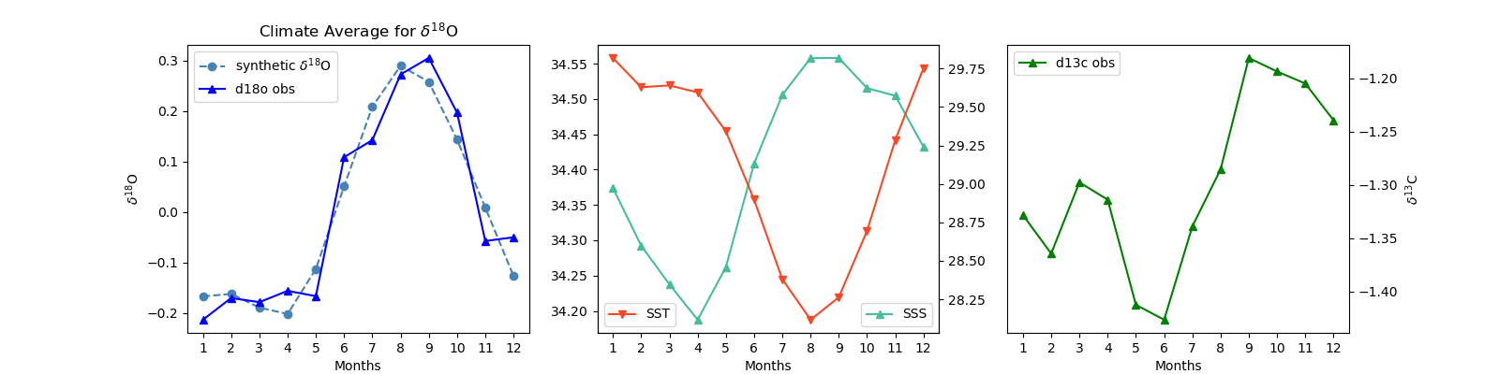

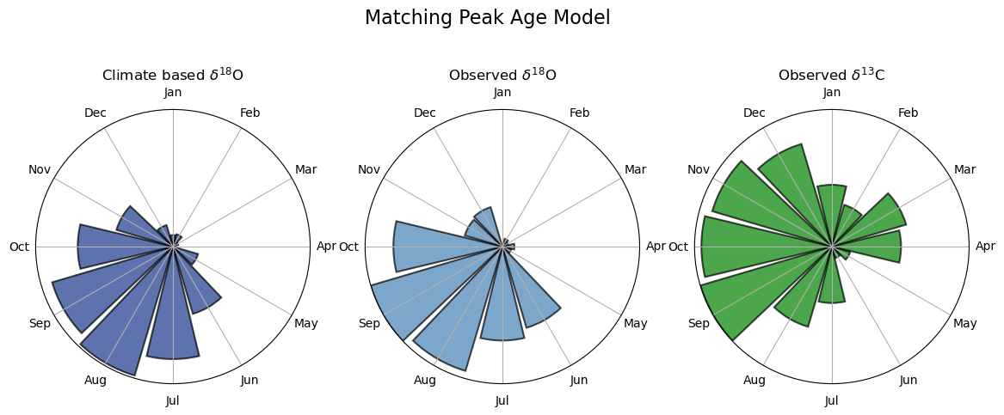

@article{press1989fast, title={Fast algorithm for spectral analysis of unevenly sampled data}, author={Press, William H and Rybicki, George B}, journal={Astrophysical Journal, Part 1 (ISSN 0004-637X), vol. 338, March 1, 1989, p. 277-280.}, volume={338}, pages={277--280}, year={1989} }

ENSO
There are 4 major ENSO events in the last century also captured by the tide gauge in Honiara; 1982/02-1984/01, 1986/09-1988/01, 1992/01-1993/01 and 1997/02-1998/10. All these events are captured with a significant rise in the d18o levels. On the other hand, d13c shows a more complicated pattern. La Nina events (positive ENSO) lead to increased SST, slightly increased rainfall, as well as lower sea levels in Western Pacific \cite{ murphy2014varied }. El Nino events result in much insignificant results compared to La Nina event however one should consider that the El Nino events also differ in two subcatogories: “Warm Pool” event with slightly positive SST and slightly negative rainfall and “Cold Tongue” events with very subtle negative SST and more negative rainfall effects. Due to this complicated multiparameter working in opposite directions for d13c, ENSO events are not always observable in d13c time series. 1977, 1987, 2005 events are observed via correlation with SST, Sea Level and ENSO-index.
Nonetheless lomb-scargle spectrograms shows several significant peaks for indicating ENSO. The strongest one on 3.1 years and the minor ones on 2.6 and 4.0 years.

@article{murphy2014varied, title={The varied impacts of El Ni{\~n}o--Southern Oscillation on Pacific island climates}, author={Murphy, Bradley F and Power, Scott B and McGree, Simon}, journal={Journal of Climate}, volume={27}, number={11}, pages={4015--4036}, year={2014}}

