Laboratory Report

I have written Assembly program in the MIPS which is taking 4 inputs from the user and then compute the value of the equation ax2 + bx + c

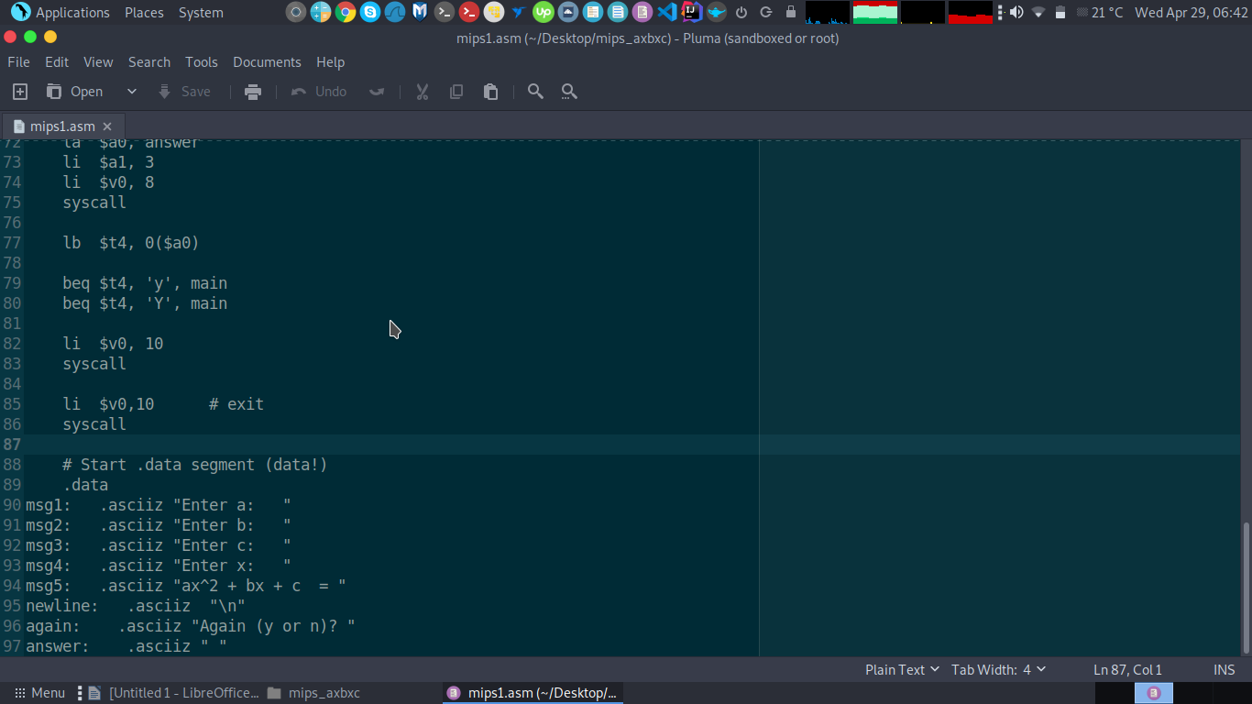

and when the program prints the result of the equation I ask from the user weather he wants to run again or wants to exit

Sample Run :

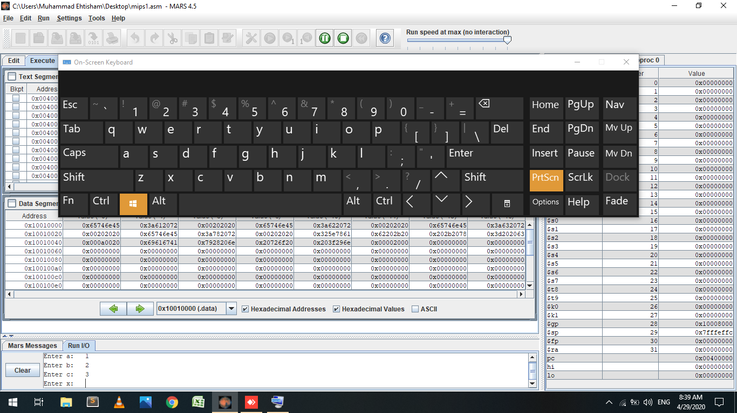

Output of Sample Run :

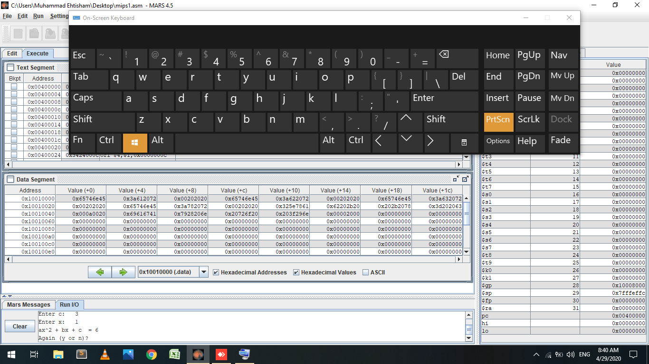

Now Asking from user he wants to run again or not

User Entered y:

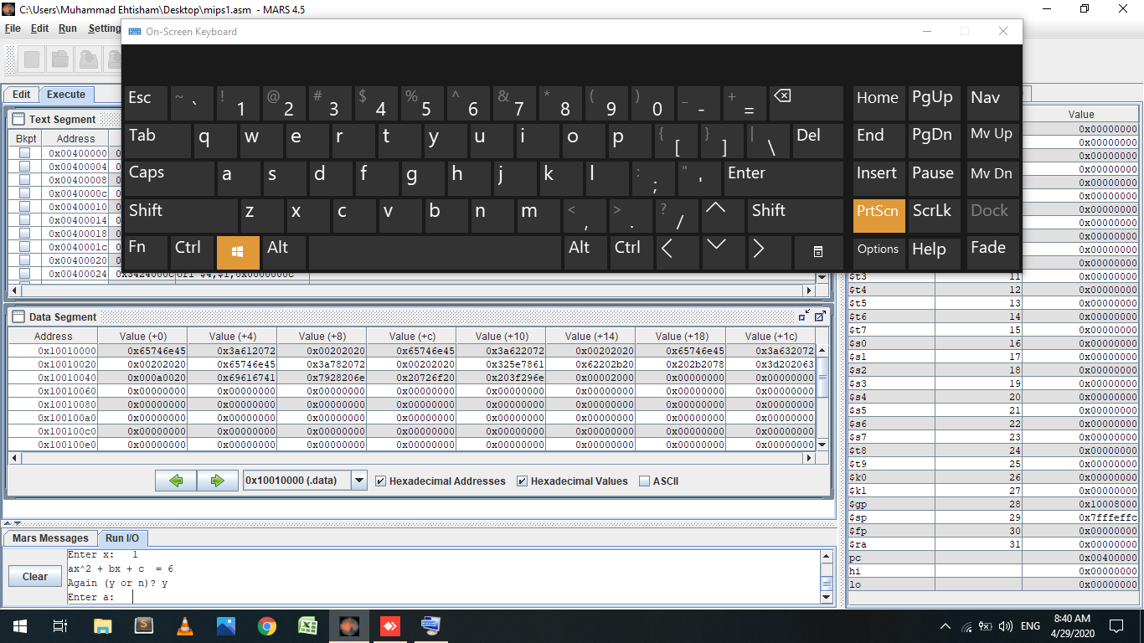

And program run again

Now User enters n ( NO ):

