# Data Analysis Report for the Year 2017

**Executive Summary:** This report provides a detailed analysis of key business performance indicators for the year **2017**, based on the provided dashboard. The data, sourced from the Orders, Managers, and Returns tables, highlights the company's performance in sales, customer growth, and operational efficiency. In 2017, the company achieved strong overall sales and a growing customer base. The analysis identifies key products driving revenue, significant regional disparities in performance, and an overall return rate of 8.73%. The findings provide a clear snapshot of the company's performance and suggest actionable insights for strategic planning.

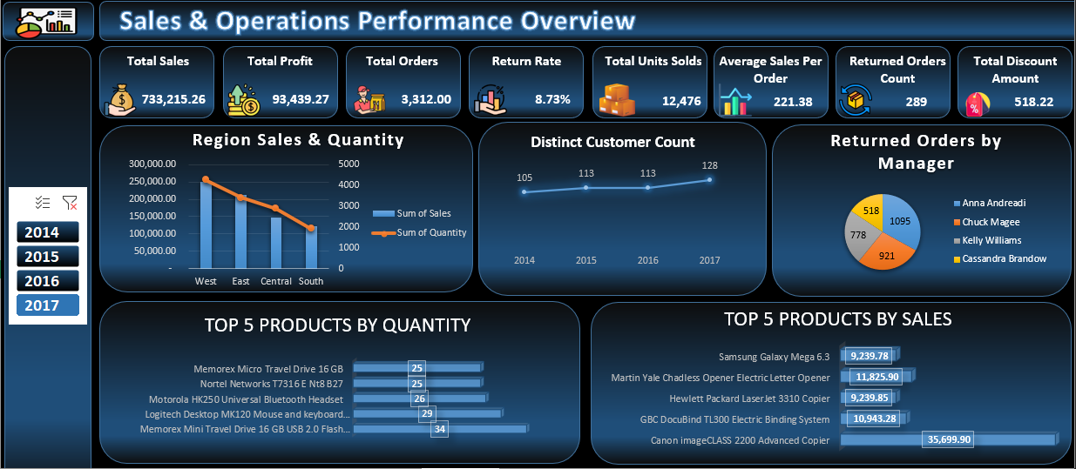

**Key Performance Indicators (KPIs) for 2017:** The dashboard for the year 2017 shows the following key metrics:

* **Total Sales: 733,215.26**
* **Total Profit: 93,439.27**
* **Total Orders: 3,312**
* **Return Rate: 8.73%**
* **Total Units Sold: 12,476**
* **Average Sales Per Order: 221.38**
* **Returned Orders Count: 289**
* **Total Discount Amount: 518.22**

**Regional Performance:** In 2017, the sales and quantity data showed significant differences across regions. The **West** region was the top performer by a substantial margin, while the **South** region lagged significantly behind.

* **West:** Achieved total sales of **250,128.37** and sold **4,270** units.
* **East:** Recorded sales of **213,082.90** and sold **3,411** units.
* **Central:** Totaled sales of **147,098.13** and sold **2,880** units.
* **South:** The lowest-performing region, with **122,905.86** in sales and **1,915** units sold.

The clear correlation between sales and quantity in each region indicates that the same factors are driving both revenue and volume.

**Product Analysis:** The analysis of product performance in 2017 reveals a distinction between high-value and high-quantity products. The top-selling products by sales value are primarily large, expensive items, whereas the top-selling products by quantity are smaller, more affordable goods.

**Top 5 Products by Sales in 2017:**

* **Canon imageCLASS 2200 Advanced Copier: 35,699.90**
* **Martin Yale Chadless Opener Electric Letter Opener: 11,825.90**
* **GBC DocuBind TL300 Electric Binding System: 10,943.28**
* **Hewlett Packard LaserJet 3310 Copier: 9,239.85**
* **Samsung Galaxy Mega 6.3: 9,239.78**

**Top 5 Products by Quantity in 2017:**

* **Memorex Mini Travel Drive 16 GB USB 2.0 Flash Drive: 34 units**
* **Logitech Desktop MK120 Mouse and keyboard Combo: 29 units**
* **Motorola HK250 Universal Bluetooth Headset: 26 units**
* **Nortel Networks T7316 E Nt8 B27: 25 units**
* **Memorex Micro Travel Drive 16 GB: 25 units**

This balanced portfolio indicates a healthy market presence for both premium and mass-market products.

**Returned Orders:** In 2017, there were a total of **289** returned orders. The distribution of these returns across the sales managers is as follows:

* **Anna Andreadi: 213 returns**
* **Chuck Magee: 186 returns**
* **Kelly Williams: 128 returns**
* **Cassandra Brandow: 97 returns**

This data highlights a potential area for further investigation to understand the factors contributing to the higher return rates associated with specific managers.

**Distinct Customer Count:** The number of distinct customers has shown a steady increase over the four-year period from 2014 to 2017. The count grew from **595** in 2014 to **693** in 2017, showing a positive trend in customer acquisition.

**Conclusion and Recommendations:** The 2017 data provides a clear picture of the company's performance, marked by strong sales, a growing customer base, and a stable return rate.

Based on this analysis, the following recommendations are made:

1. **Strategic Regional Focus:** Implement targeted marketing and sales strategies to boost performance in the Central and South regions, which have the lowest sales and units sold.
2. **Product Portfolio Strategy:** Continue to leverage the high-value, high-margin products while exploring ways to increase profitability from the high-quantity, lower-cost items, potentially through bundling or promotions.
3. **Investigate Return Causes:** Conduct a deeper analysis into the reasons for returned orders, particularly under managers Anna Andreadi and Chuck Magee, to identify and address any underlying operational or product quality issues.