**Contents**

|  |  |  |
| --- | --- | --- |
| **Sr.No** | **Title** | **Page No.** |
| 1 | Contents | 2 |
| 2 | Introduction | 3 |
| 3 | Block Diagram | 4 |
| 4 | System Description | 5 |
| 5 | Flow Chart | 6 |
| 6 | Circuit Diagram | 7-11 |
| 5 | Operating Procedure | 12 |
| 9 | Check List | 13-14 |

**Introduction**

1. The 30 channel remote input status monitoring system is a microcontroller based data acquisition and displaying system for chiller and pumps status.
2. The system has 30 inputs/channels of 220VAC, 50Hz input status of 3 chillers and 6 pumps.
3. The system comprises of a Master and Slave module which communicate with each other via a serial RS-485 link.
4. The Master module is responsible for signal conditioning, data acquisition and transmitting to formatted data to slave along with checksum byte.
5. The Slave module receives the data form master and displays it on the panel.
6. Checksum error detection is incorporated in the communication protocol.

**Block Diagram**

Master Module

**30 Channel Input status**

Signal Conditioning Card

**Pulses (0-5V) for each ON channel**

Slave Module

**Serial Link (RS-485)**

Slave Card

Master Card

**Data packet of 5 bytes (4 data + Checksum)**

**To Display panel**

**System Description**

The system consists of two modules namely master and slave. The description of each module is as under.

* **Mater Module:** This module is responsible for signal conditioning and transmitting the formatted data to the slave module. It consists of two cards
  + **Signal conditioning card:** This card receives 30 channel input status sine wave AC signal for each channel and converts it into pulses (0 – 5V) with a period of 20ms when it is ON. When a channel is OFF 5V is present on it.
  + **Master card:** It converts the respective channel status (ON or OFF) into a formatted data packet comprising of five bytes (4 data + checksum).
* **Slave Module:** This module consists of **Slave Card** and is responsible for receiving the formatted data packet, processes it and display it if no transmission errors are found.

Chiller 3 Chiller 2 Chiller 1

Byte 0

|  |  |  |  |  |  |  |  |
| --- | --- | --- | --- | --- | --- | --- | --- |
| OFF | ON | TRIP | OFF | ON | TRIP | OFF | ON |

Pump 3 Pump 2 Pump 1 Chiller 3

Byte 1

|  |  |  |  |  |  |  |  |
| --- | --- | --- | --- | --- | --- | --- | --- |
| ON | TRIP | OFF | ON | TRIP | OFF | ON | TRIP |

Pump 5 Pump 4 Pump 3

Byte 2

|  |  |  |  |  |  |  |  |
| --- | --- | --- | --- | --- | --- | --- | --- |
| TRIP | OFF | ON | TRIP | OFF | ON | TRIP | OFF |

Byte 3

Spare Pump 6

|  |  |  |  |  |  |  |  |
| --- | --- | --- | --- | --- | --- | --- | --- |
|  |  | TRIP | OFF | ON | TRIP | OFF | ON |

**Flow Chart**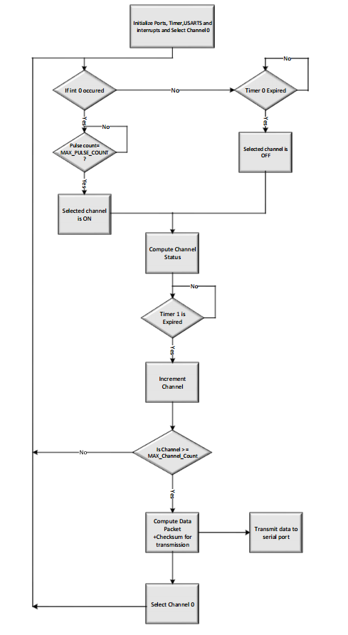

## Circuit Diagram

* Master Module

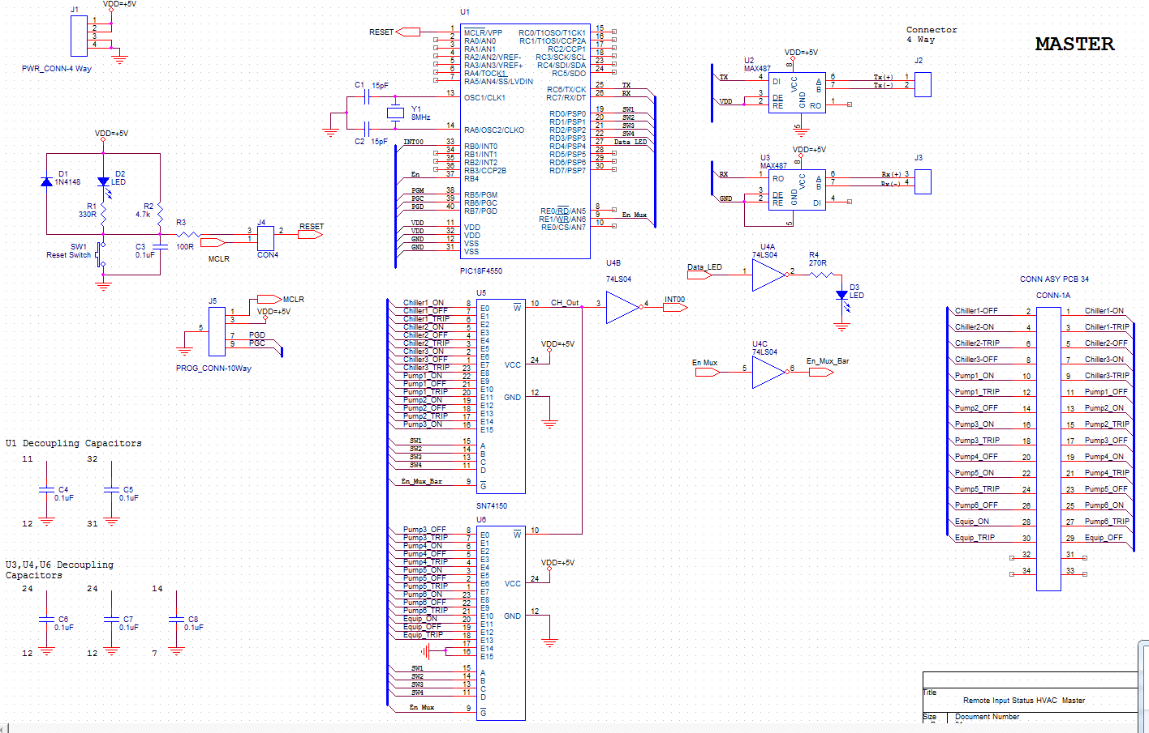

## Slave Card-1

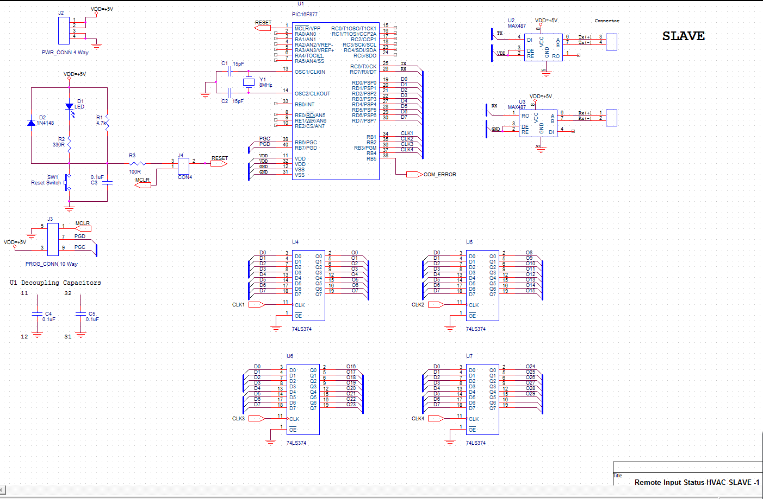

* Slave Card-2

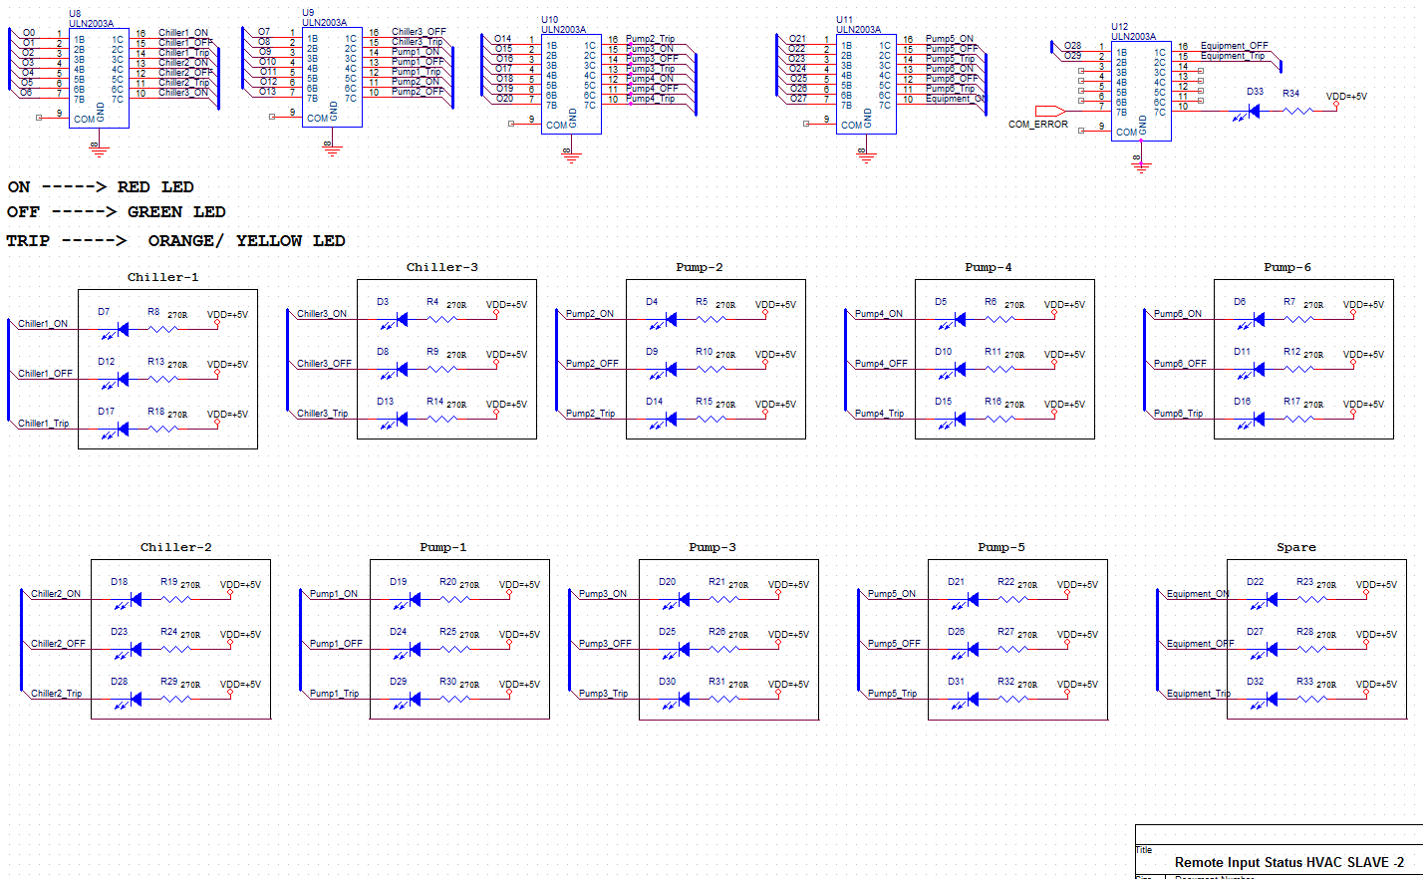

## Signal Conditioning Card-1

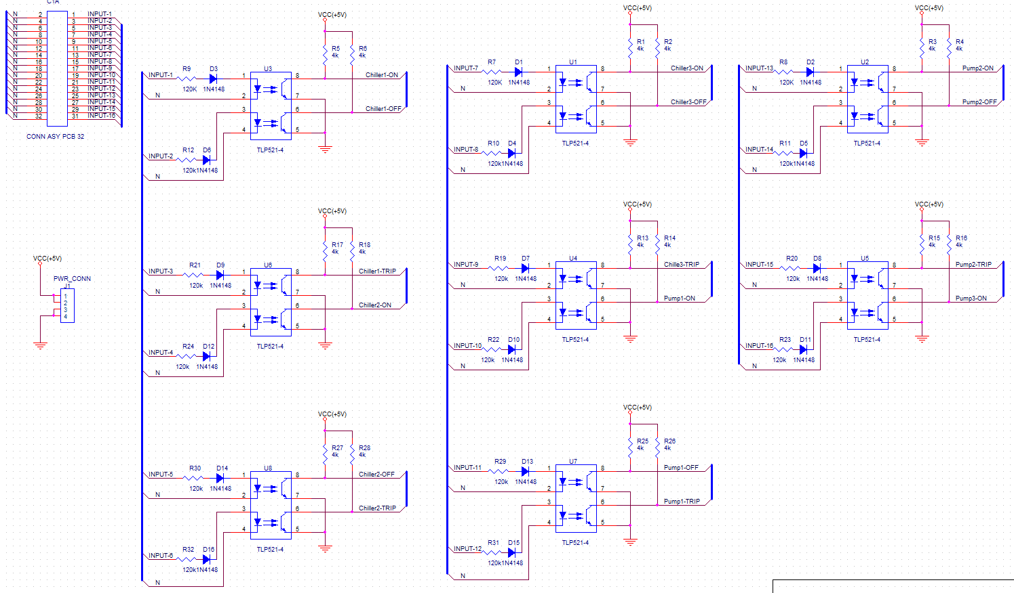

## Signal Conditioning Card-2

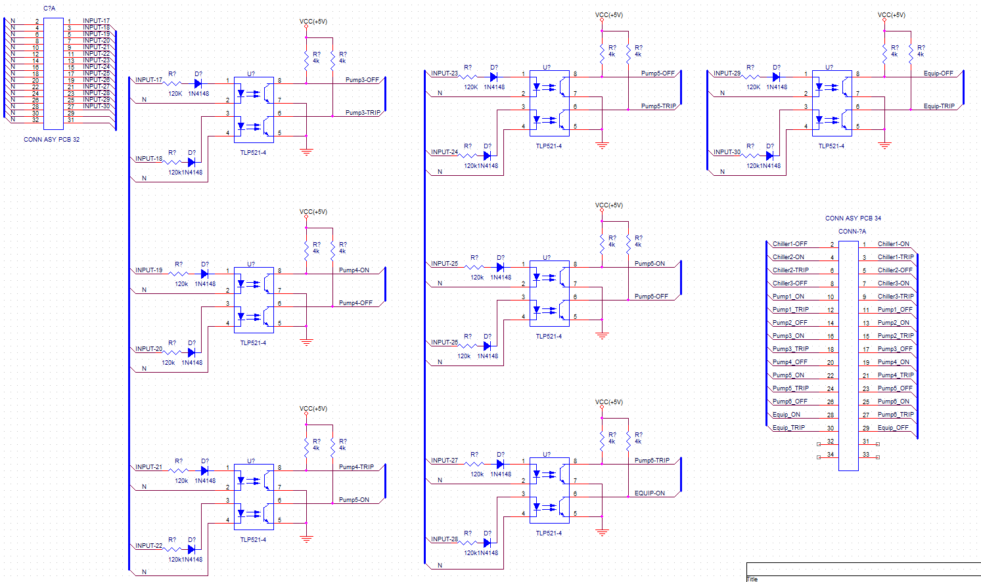

## Operating Procedure

Follow the steps as under.

|  |  |  |  |
| --- | --- | --- | --- |
| Steps | **Action** | **Indication** | **Status** |
|  | Switch ‘ON’ the Main Switch on the rear side of Master and Slave module | Power ON (Green) LED on front panel will be ‘ON’ | OK |
|  | Press Switch ‘Reset’ on the front panel of Master Module. | Reset LED on the Front panel OFF after blinking once.  Data Acquisition LED starts blinking | System is Ready for Operation  Data acquisition + transmission started |
|  | Press Switch ‘Reset’ on the front panel of Slave Module. | Reset LED on the Front panel OFF after blinking once. | System is Ready for Operation |
|  | Communication Error LED on Slave Module is OFF | There is no communication error | Data on Panel is Valid. |
|  | Communication Error LED on Slave Module is ON | There is a communication error | Data on Panel is InValid. |
|  | Compare the Display Panel status to the actual status of Chillers and Pumps | If Status matches then system is OK, otherwise faulty. |  |

**CHECK LIST**

|  |  |  |  |  |  |  |
| --- | --- | --- | --- | --- | --- | --- |
| **Sr. No** | **Item/Components** | **Description** | **Check/Test** | **Pass** | **Fail** | **Remarks** |
| 1. | Power | Master Module  Slave Module | Indication |  |  |  |
| 2. | LEDs | Reset  Power  Data Acquisition, Communication Error | Indications |  |  |  |
| 4. | Reset switch | Master Module  Slave Module | Press reset |  |  |  |
| 5. | Chiller-1 | ON  OFF  Trip | Indication |  |  |  |
| 5. | Chiller-2 | ON  OFF  Trip | Indication |  |  |  |
| 5. | Chiller-3 | ON  OFF  Trip | Indication |  |  |  |
| 5. | Pump-1 | ON  OFF  Trip | Indication |  |  |  |
| 5. | Pump-2 | ON  OFF  Trip | Indication |  |  |  |
| 5. | Pump-3 | ON  OFF  Trip | Indication |  |  |  |
| 5. | Pump-4 | ON  OFF  Trip | Indication |  |  |  |
| 5. | Pump-5 | ON  OFF  Trip | Indication |  |  |  |
| 5. | Pump-6 | ON  OFF  Trip | Indication |  |  |  |
| 5. | Spare | ON  OFF  Trip | Indication |  |  |  |