LAB#2

**Laplacian of Gaussian**

By the term laplacian we mean taking second order partial derivative of a function(here we take image). Mathematically it is given as

Eqn:eqnlog1

Where I(x,y) is our image. The Laplacian of an image highlights regions of rapid intensity change and is therefore often used for http://homepages.inf.ed.ac.uk/rbf/HIPR2/mote.gifedge detection.

The guassian function or normal dirtribution function is given as


f(x) = \frac{1}{\sigma\sqrt{2\pi}} e^{ -\frac{(x-\mu)^2}{2\sigma^2} }.
 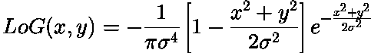

Where sigma is the Standard Deviation and µ = width of the distribution.

Laplacian of Gaussian is obtained by taking 2nd order derivative of Gaussian function and is given by LoG

The first task of the assignment was to plot Laplacian of Gaussian function with different spatial support and standard deviation. The results are as follows

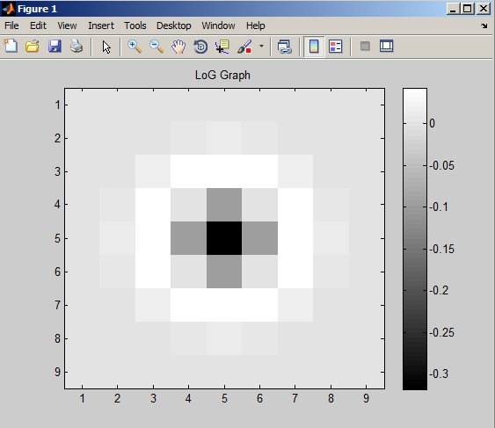 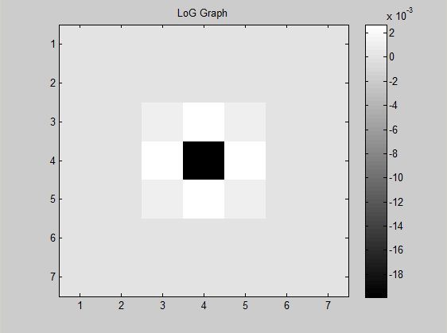

Spatial width = 4 sigma =1 Spatial width = 3 sigma =1.5

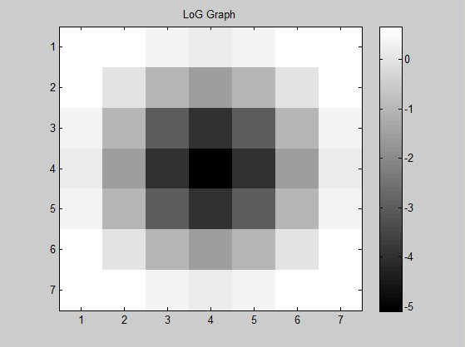 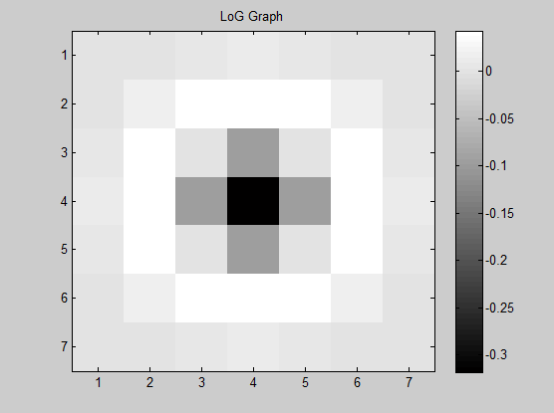

Spatial width = 3 sigma =2 Spatial width = 3 sigma =1

We see form the above graphs that the best value with covers the most of LOG is spatial width 3-4 with sigma =1-1.5 .

The second task was to convolve the given images with the kernel produced with LoG function.

**The LoG karnel obtained with sigma= 1 and Spatial Width = 3 is**

z = 0.0003 0.0026 0.0086 0.0124 0.0086 0.0026 0.0003

0.0026 0.0175 0.0392 0.0431 0.0392 0.0175 0.0026

0.0086 0.0392 0 -0.0965 0 0.0392 0.0086

0.0124 0.0431 -0.0965 -0.3183 -0.0965 0.0431 0.0124

0.0086 0.0392 0 -0.0965 0 0.0392 0.0086

0.0026 0.0175 0.0392 0.0431 0.0392 0.0175 0.0026

0.0003 0.0026 0.0086 0.0124 0.0086 0.0026 0.0003

This kernel was convolved to our test images and results were sigma = 1 spatial width is 3

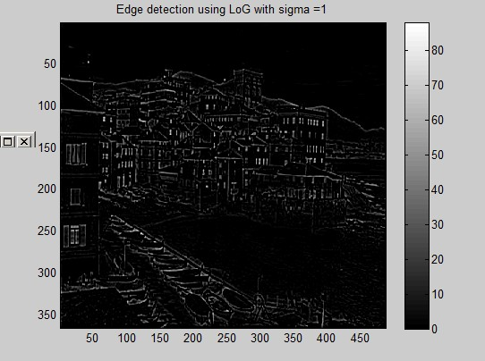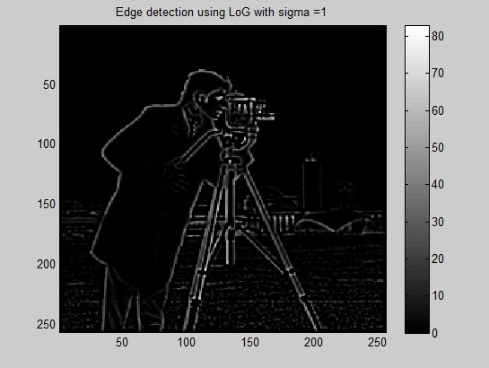

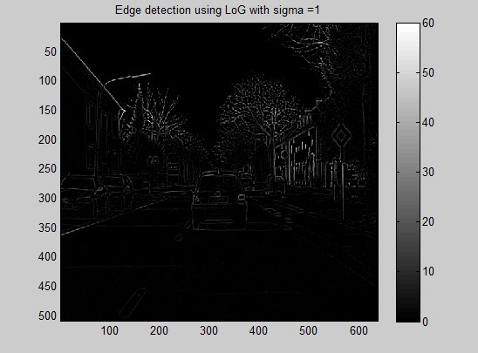

The third task was to detect edges along the rows and columns of the obtained convolved image X.

We scan along each row and detect zero crossings along the gradient by just subtracting each element of the row or column with its previous one and at a given threshold e.g. at threshold ==0. Zero crossing are at (+,-), (+, 0,-), (-, +) and at (-, 0, +) of the rows or columns of the Convolved image X. Then finally we display sum of row +columns edges. The results are as follows. For different threshold values.

Here these results specify to sigma = 1.5 spatial width =4 and threshold =1

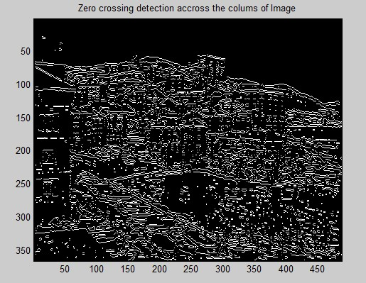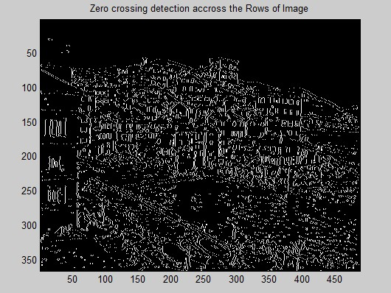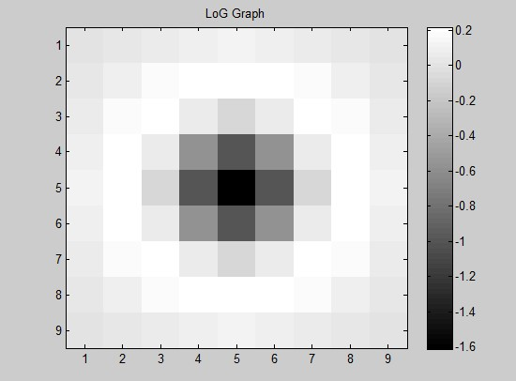 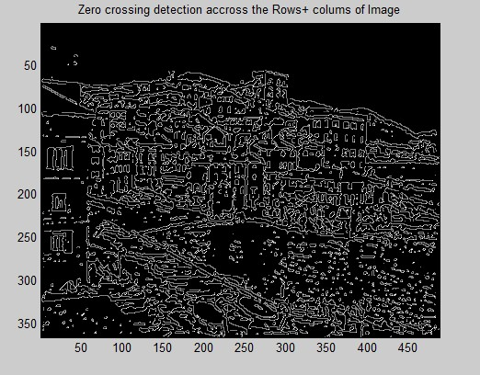

**The coding has been done in Matlab . we have three files 1. LoG.m( function )2. LoG edge detection.m 3. Zero Crossing detection.m**