Computer Vision LAB#3

Report Submitted By Ahmed, Muhammad Farhan , EMARO

**Color Based Segmentation**

By color, based segmentation we mean to segment or filter the given image based on a specific color. In this LAB, we were given six different images and were asked to display them in there corresponding RGB and HUE (HSV) components. The images were converted form RBG to HSV by rgbtohsv() function of MATLAB . The results are below.

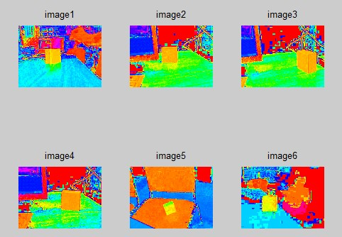

Next, we were asked to select the area of yellow cube in Hue component of first Image. In addition, calculate the Mean and Standard Deviation. We selected two points of yellow cube and calculated the matrix corresponding to that area. The Mean and Standard deviation was calculated using Mean and Std function of MATlab.

Then the threshold was calculated and applied to all the images sequentially by calling a function color_seg. The results were as follows.

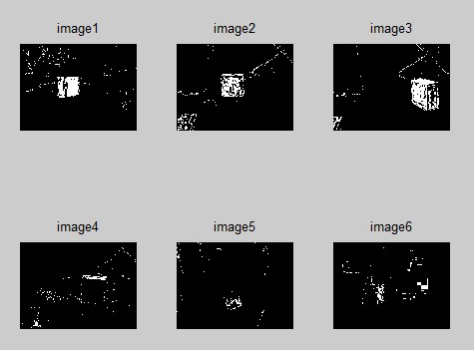

***OBSERVATIONS***

The white area of yellow cube is hardly visible in figure 5 and 6 because of different intensity level of illumination. This problem and solved by calculating mean and standard deviation of each image separately and then applying the threshold.