Neural Networks Lab 2 Report

Submitted by Ahmed, Muhammad Farhan

**Task 1**

**ADALINE** (**Adaptive Linear Neuron** ) is an early single-layer neural network . It was developed by Professor Bernard Widrow and his graduate student Ted Hoff at Stanford University in 1959. It is based on the McCulloch–Pitts neuron. It consists of a weight, a bias and a summation function. In contrast to Perceptron , Adaline has r(membrane potential) available outside to user for adjusting and minimizing error by LMS Algorithm.

The difference between Adaline and the standard (McCulloch–Pitts) perceptron is that in the learning phase the weights are adjusted according to the weighted sum of the inputs (the net). In the standard perceptron, the net is passed to the activation (transfer) function and the function's output is used for adjusting the weights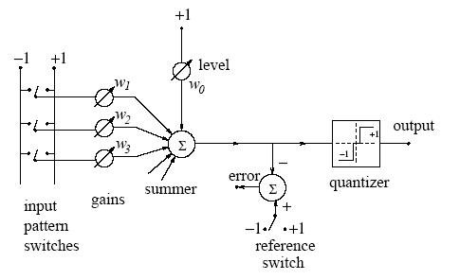

Figure 1.1 **Adaline**

An Adaline was created with delta rule as learning algorithm. The data for training was obtained form iris.txt file form 1st lab. The functioning of Adaline was as follows

1. Load sample training set.

2. Obtain Number of Training samples

3. classify the class Lables.

4. Feature Vactor.

5. Add one to last column of feature vactor for Bias

6. save no. of feature vactors + bias

7. Generate random set(row vactor) of weights

8. Initial value of Learning rate eta.

9. Specify max no of Iterations e.g 1000.

10. Specify max MSE(mean square errors) e.g 0.1.

11. Start learning procedure.

12. calculate weights and MSE.

13. Exit display results whether convergence achieved or not.

11. Set a stopping criteria , in this case no. of MSE > max MSE.

**Was unable to calculate following in Task 1**

1. Norm of the gradient (for online learning)

And stopping criteria for these performance indexes.

Reason --- > lack of time

**Task 2**

The given data set had 10 classes in total. Our main task was to find the solution to the given semeion data problem by training 10 Adalines for each class. The data was first formatted into a readable form using readdigits.m file/code. And then for each formatted class set the training set was passed to corresponding Adaline. The steps involved were as follows.

1. Load Data in the format specified in readdigits.m file

2. Start matlab stopwatch function (to record elapsed time).

3. Pass the input arguments (training set, class labels ,eta)to our Adaline function(developed in Task 1).

4. Display errors, error percentage and sum of errors.

5. show elapsed time.

**Was unable to calculate following in Task 1**

1. Norm of the gradient (for online learning)
2. Performance with perceptron.

And stopping criteria for these performance indexes.

Reason --- > lack of time