Name: Muhammad Farhan
Roll no: 25K-0538
Section: BCS-3K
Course: Computer Organization and Assembly Language – Lab
Lab: Lab 5 Revision
Date: 24/09/2026

Task 1:
INCLUDE Irvine32.inc

.data
products BYTE 100, 200, 150, 80, 60
arrSize BYTE LENGTHOF products
.code
main PROC

mov esi, 3
add products[esi], 25

movzx ecx, arrSize
mov esi, 0

L1:
movzx EAX, products[esi]
call WriteDec
mov EAX, ' '
call WriteChar
add ESI, TYPE products
Loop L1

call CRLF
call dumpregs

exit
main ENDP
END main
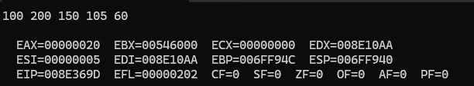

Task 2:
INCLUDE Irvine32.inc

.data
meter DWORD 00780056h

.code
main PROC

movzx EAX, WORD PTR meter
call WriteHex

mov AL, ' '
call WriteChar

movzx EAX, WORD PTR meter[2]
call WriteHex

exit
main ENDP
END main

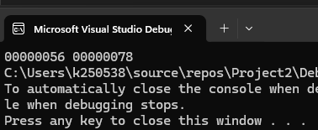

Task 3:
INCLUDE Irvine32.inc

.data
sales WORD 1200, 1500, 900, 1750, 2000

.code
main PROC
mov ESI, OFFSET sales
mov ECX, LENGTHOF sales
mov EAX, 0

L1:
movzx EBX, WORD PTR [ESI]
add EAX, EBX
add ESI, TYPE sales
loop L1

call WriteDec

exit
main ENDP
END main
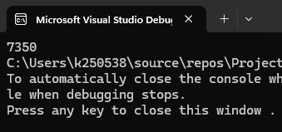

Task 4:
INCLUDE Irvine32.inc

.data
menu DWORD 300, 450, 600, 250, 800, 550, 700

.code
main PROC
mov ESI, 4
mov EAX, menu[ESI*TYPE menu]
call writeDec

exit
main ENDP
END main
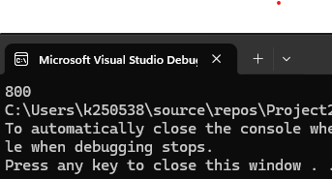

Task 5:
INCLUDE Irvine32.inc

.data
items DWORD 250, 899, 1500, 375
num BYTE "Number of Items Scanned: ", 0
Memsize BYTE "Total Memory used: ", 0
total BYTE "Total Bill is: ", 0

.code
main PROC
mov ESI, 0
mov ECX, LENGTHOF items

mov EDX, OFFSET num
call WriteString
mov EAX, ECX
call WriteDec

call Crlf

mov EDX, OFFSET Memsize
call WriteString
mov EAX, SIZEOF items
call WriteDec

call Crlf

mov EAX, 0
L1:
add EAX, items[ESI]
add ESI, TYPE items
loop L1

mov EDX, OFFSET total
call WriteString
call WriteDec

exit
main ENDP
END main
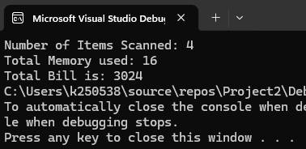

Task 6:
INCLUDE Irvine32.inc
.data
SensorID DWORD 14
SensorStatus BYTE 1
SensorReading WORD 69
msg1 BYTE "Gap Between SensorID and SensorStatus: ", 0
msg2 BYTE "Gap between SensorStatus and SensorReading: ", 0
.code
main PROC

mov EDX, OFFSET msg1
call WriteString
mov EAX, OFFSET SensorStatus
sub EAX, OFFSET SensorID
call WriteDec

call Crlf

mov EDX, OFFSET msg2
call WriteString
mov EAX, OFFSET SensorReading
sub EAX, OFFSET SensorStatus
call WriteDec

exit
main ENDP
END main
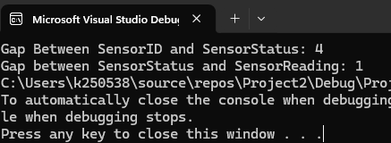

Task 7:
INCLUDE Irvine32.inc

.data
fahrenheit DWORD 32, 68, 104
msg BYTE " ", 0
.code
main PROC
mov ECX, LENGTHOF fahrenheit
mov ESI, 0

L1:
mov EAX, fahrenheit[ESI]
sub EAX, 32

mov EBX, 5
mul EBX

mov EDX, 0
mov EBX, 9
div EBX

call WriteDec
mov EDX, OFFSET msg
call WriteString

add ESI, TYPE fahrenheit
Loop L1

call Crlf

exit
main ENDP
END main
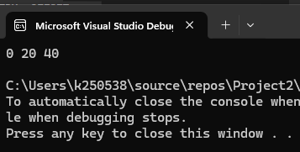

Task 8:
INCLUDE Irvine32.inc

.data
trucks DWORD 80, 45, 90, 60
msg BYTE " ", 0
.code
main PROC
mov ESI, TYPE trucks
add DWORD PTR trucks[ESI], 20

mov ECX, LENGTHOF trucks
mov ESI, 0

L1:
mov EAX, trucks[ESI]
call WriteDec
mov EDX, OFFSET msg
call WriteString
add ESI, TYPE trucks
loop L1

exit
main ENDP
END main
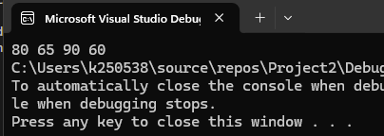

Task 9:
INCLUDE Irvine32.inc

.data
rain DWORD 45, 120, 75, 30

.code
main PROC
mov ESI, OFFSET rain

mov EAX, 0
mov ECX, LENGTHOF rain
L1:
add EAX, [ESI]
add ESI, TYPE DWORD
loop L1

call WriteDec

exit
main ENDP
END main
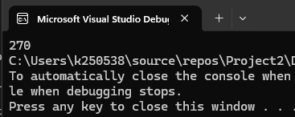

Task 10:

INCLUDE Irvine32.inc

.data
salaries DWORD 45, 60, 38, 72, 50
msgNum BYTE "Number of employees recorded: ", 0
msgSize BYTE "Total memory used (bytes): ", 0
msgTotal BYTE "Combined total salary: ", 0

.code
main PROC

mov EDX, OFFSET msgNum
call WriteString
mov EAX, LENGTHOF salaries
call WriteDec
call Crlf

mov EDX, OFFSET msgSize
call WriteString
mov EAX, SIZEOF salaries
call WriteDec
call Crlf

mov ESi, OFFSET salaries
mov ECX, LENGTHOF salaries
mov EAX, 0

L1:
add EAX, [ESI]
add ESI, TYPE salaries
loop L1

mov EDX, OFFSET msgTotal
call WriteString
call WriteDec
call Crlf

exit
main ENDP
END main
